Century College

CSCI 2005 Fall 2016

PA3

Due date 11/03/2016 at 11:30PM

(Project 2 with some additions: chapter5)

* You will create the three column layout using absolute positioning and margin setting as described in Section 5.4.1.
* Within the main column, the company and client addresses will use floats rather than positioning.
* Within the boxes for recent messages, weekly changes, and top sellers, you will need to use floats, block display, and padding values.
* When the calendar link from the navigation menu is clicked a new page (calendar.html) including a calendar similar to the one you made for lab5 should be displayed. Make sure to use the same css for both pages.

**Note:** In this example the products sold are textbooks. Try to make your web site different by selling different items such as electronics, clothes, etc. No images are provided you need to come up with your own.

***Requirements:***

* You must submit valid and semantically appropriate HTML5.
* Your Successful validation as an HTML5 page by using the W3C validation site (<https://validator.w3.org/#validate_by_upload>). Capture the web page that reports successful validation and paste it to a word document.
* Use the same css file for both pages.

***Submitting***

Put your assignment in a folder named pa3. Put all resources used by your assignment into this folder. Upload this folder to the PA3 dropbox (make sure to zip it first). You will lose marks if you do not follow these submission instructions.

***Page One:***

1. This file **must** be named index.html.

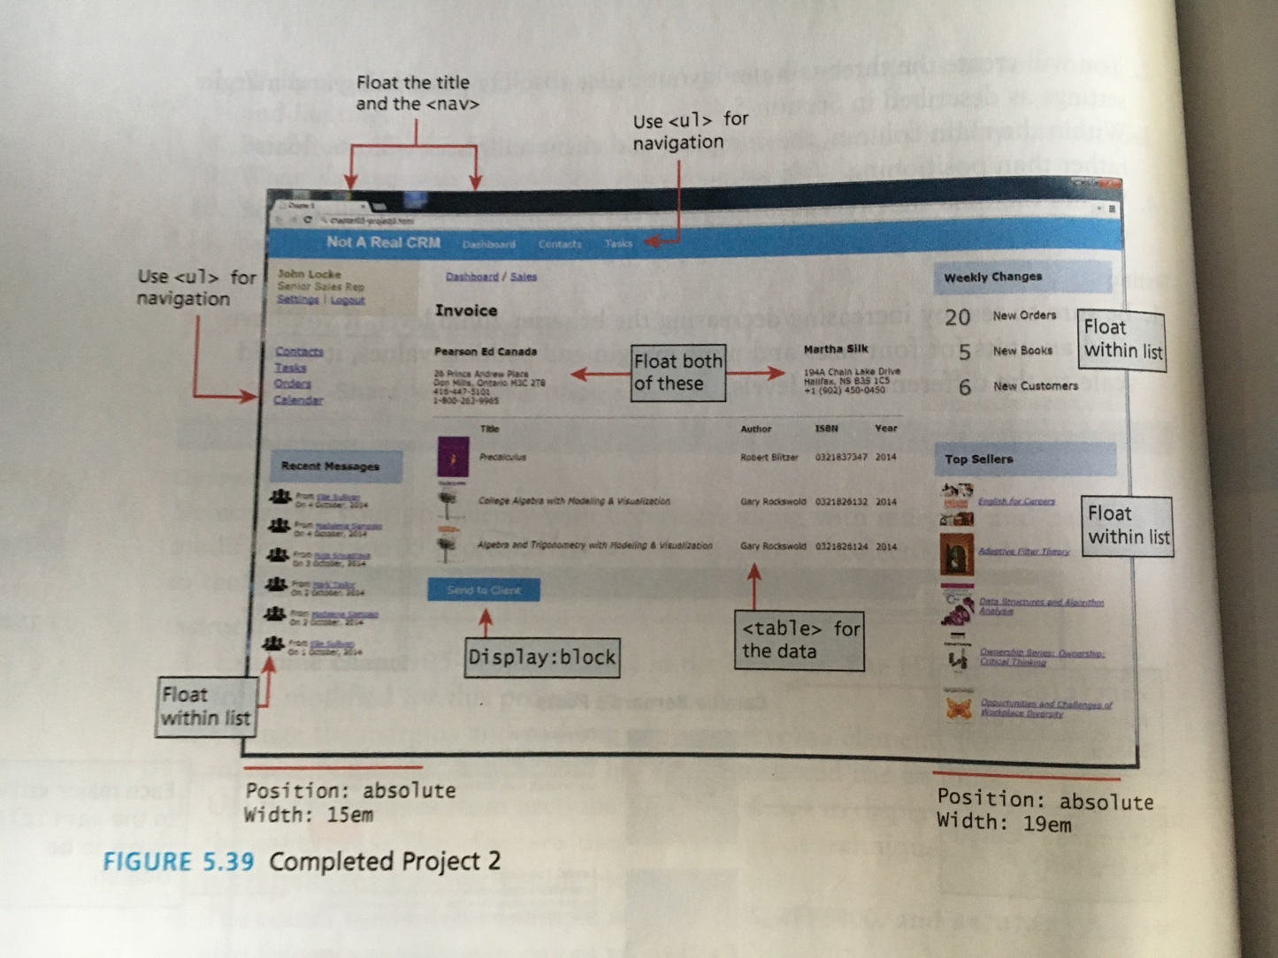

***Page Two***

1. This file **must** be named calendar.html.

