**Big Mountain Resort Data Science Project: Summary Report**

Big Mountain resort (also known as Whitefish Mountain resort) is a ski resort located in Montana with spectacular views of Glacier National Park and Flathead National Forest. Up to now the resort’s pricing strategy was to charge a premium above the average price in its market segment. The problem with this pricing scheme is two folds, first it does not capitalize on the facilities the resort possesses. Second, it doesn’t provide any sense of how important certain facilities are compared to others which in turn hampers investment strategy.

The objective of this project is therefore to develop a model to predict prices which takes into account the importance of each and every facility available. The model would be able to identify facilities that have higher impact on pricing as well as those facilities that have little to no effect on ticket prices.

A random forest regression model is built using the data provided to predict the ticket price as well as identify important facilities that have higher impact on ticket prices. In order to avoid biasing the model by the current pricing scheme, the Big Mountain resort’s information is not included in the training the model. Our model predicts a price of $95.87 with an error of +/- $10.39. The predicted price is relatively higher than the current price of $81. However, looking at the most important variables that have high impact on ticket pricing, Big Mountain values are in the top of the competition, suggesting the resort have facilities that are widely appreciated by customers and thus increasing ticket prices could be justified.

The figure below shows the impact of each variable on ticket pricing sorted according to their imporatance. FastQuads, Runs, Snow_making_ac, vertical_drop, skiableTerrain_ac and total_chairs are the top six variables.

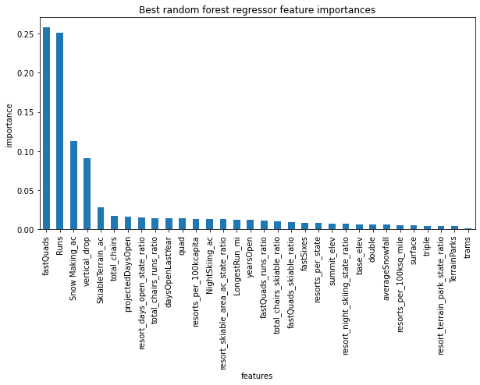

Figure 1. Distribution of important features sorted by their importance.

Comparing Big Mountains’s values of these important variables with the rest of the competition shows that the resort is in the top in almost all of these features (see figure below)



Figure 2. Distribution of the 6 top important features identified by the model.

The red dashed line shows the position of Big Mountain for each feature

We used the model to run some scenarios to see the impact of adding or reducing some facilities on ticket prices. The simulations were conducted with the assumptions of 350000 visitors per season, and 5 days of skiing on average per visitor.

One of the scenarios tested was to see the impact of closing up to 10 least used runs. From the figure below, we can see that closing one run does not have any impact on prices. However, closing 2 and 3 runs will reduce the ticket price and thus the revenue. The figure also shows that closing 5 runs and 3 runs have the same impact on pricing and hence Big Mountain may close 5 runs instead of 3 if this the route the management takes. Closing more than 5 will reduce ticket prices further.

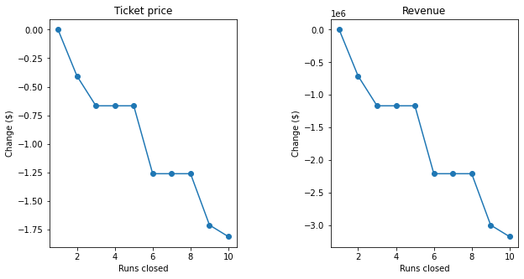

Figure 3. The effect of closing least used runs on prices and revenue

Another scenario conducted is increasing the vertical drop by 150 feet by adding a run, and installing an additional chair lift. This scenario has a potential to increase the ticket price by $1.99 which resulted on increase in revenue by $3.5M (with the aforementioned assumptions). This increase in revenue comes with additional operation cost for the newly added 1 run and 1 chairlift. Assuming the operational cost of adding a chairlift is the same as the one recently added ($1.54M operational cost), subtracting this operational cost from the revenue, will still give us an increase of $1.96M in revenue within one season.

Based on our model prediction and scenario tests, we recommend the following measures for the Big Mountain management to consider in order to increase the revenue:

* Increase the ticket prices. The current average ticket pricing scheme is too low. Big Mountain resort possesses facilities that are highly valued by consumers and should take advantage of that.
* Invest on increasing the vertical drop. This has the highest potential to support higher ticket prices.
* Close at least one least used run, it has zero impact on ticket pricing and thus will save the resort the operational cost for that particular run.
* There is a potential to close up to 5 runs. This will depend on the operation cost of each run (the information we don’t have currently). If the total operational cost of these 5 runs is greater than the reduction of revenue caused by their closure (estimated to be ~ 1.2M by our model), then there is a room to increase profit by closing these facilities.

One important variable missing from our data was the operational cost of each facility. This would have helped us greatly in our scenario testing. However, Big Mountain management can use the model generated in this project to run different combination of scenario tests and compute the adjusted revenue for adding or removing any facility. This would allow the management to do a strategic targeting of which facilities to close or increase investment on.