**TESTING PROCESS WITH RESULTS**

1. Getting user’s details with “GET” HTTP Response:



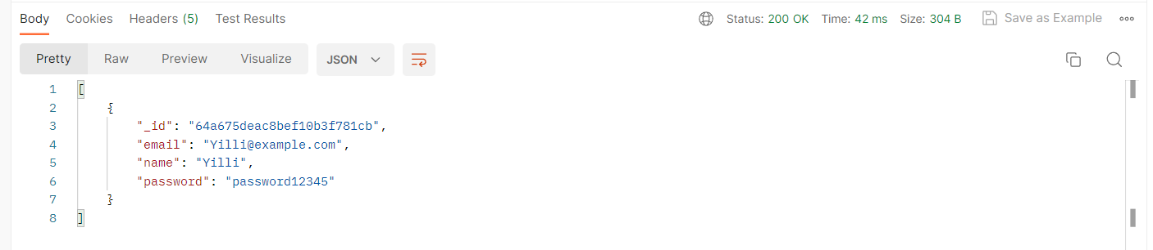

2. Updating user’s details with “POST” HTTP Response:

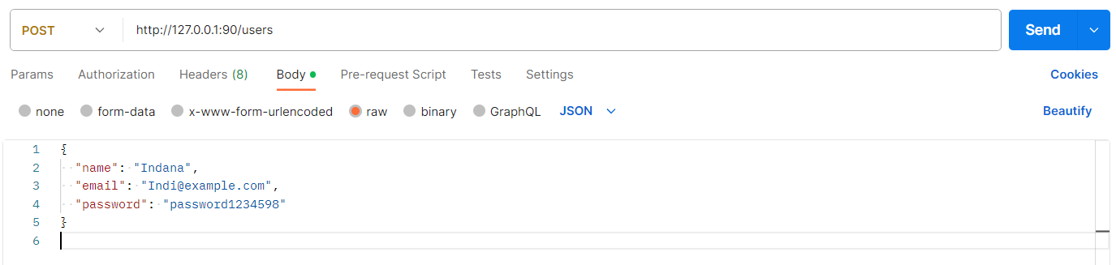

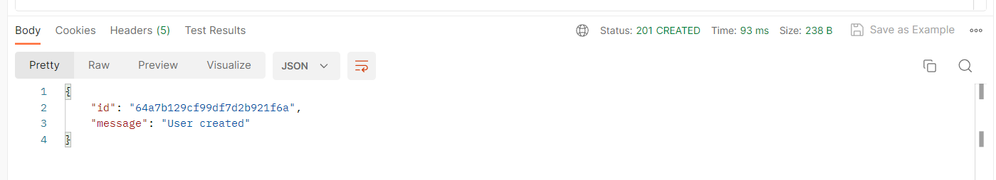

3. Alternating user’s details with “PUT” HTTP Response:

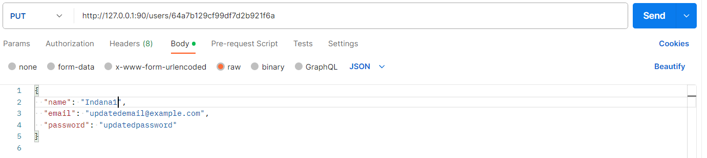

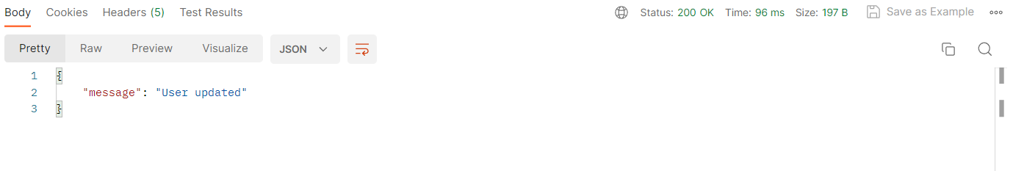

**4. Deleting user’s details with “DELETE” HTTP Response:**

We can enter the selected User ID to delete them.



