Day – 11
- Folders in JAVA are called as packages. Whatever classes you use in JAVA, belongs to a package.

- We do not need to explicitly mention java.lang.* to use System.out.print or other System classes, because it is by default imported.
The * means all the files in the current directory.

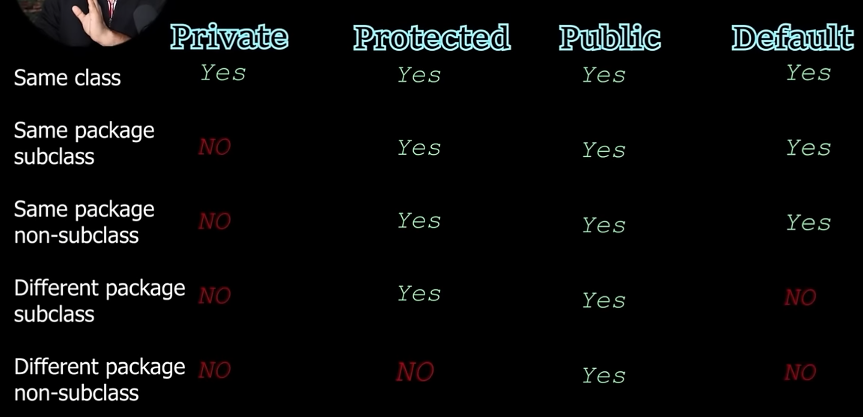

- If a variable inside a package is not defined with any access modifier, it cannot be accessed from outside of that package. To make it accessible, the variable has to be made public.

- Inside the same package, even if a variable of a different class has not been defined with an access modifier, it can be accessed easily.

- Try to make your classes public, but remember that you cannot have more than 1 public classes in the same file.
Try to keep your instance variables private.
Try avoiding default.
Try using protected if you want your methods and variables to be accessed only in the subclass from other packages.

