A 100-neuron two-leg spinal CPG
Progress report on the neuron and synapse reduction study
22 September 2026 · NEST 3.9.0, Izhikevich neurons · 8 seeds × 60 s per condition

1. Summary
The two-leg spinal CPG was reduced from the k = 1 baseline (1,200 neurons, 118,208 synapses) to 100 Izhikevich neurons and 2,710 synapses (2.3 %). Tested on 8 seeds never used for tuning, the reduced network passes every acceptance rule at all three gait speeds (350, 520 and 780 ms steps). It keeps flexor/extensor alternation, both legs, left–right anti-phase and 60 s stability, with STDP on. It follows the baseline more closely than the earlier 480-neuron control did: the flexor now switches fully off each cycle (trough 0.87 vs 3.78 at 520 ms).
Two changes made this possible at 100 neurons. The first is a minimum of 4 inputs per neuron, with the total weight conserved; without it every pathway has a single input and results depend on the seed. The second is a flexor rhythm-generator setting that changes with gait. The main remaining difference from the baseline is that at 520 ms the reduced network alternates more cleanly (−0.987 vs −0.955).

2. Goal and method
Starting point: the 480-neuron control (k = 0.20, m = 0.40, corr_F ≈ −0.94). Goal: 100 neurons in total (50 per leg; relay parrots not counted), matching the k = 1 baseline over 60 s, with STDP on or off.
- Model: cpg_small.py, a copy of the original model with per-population sizes and extra switches. The originals were never edited.
- Measurement: 8 seeds, 1 thread, 60 s, first 10 s discarded. Two-pass readout gate per leg: pass A uses the stock threshold, pass B the threshold each leg's own RG-F band prescribes. Only pass B is reported.
- Main metric: corr_F = correlation of extensor and flexor force (−1 = perfect alternation). corr_RG is the same for the rhythm-generator rates and does not depend on the gate.
- Pass rules (A1–A8), judged against the baseline at the same gait: corr_F within ±0.02 (the band is 0.02 wider on the more-alternating side for STDP-on cells); flexor trough ≤ 4; seed SD ≤ 0.03; force not ahead of rhythm; stable across run thirds; right leg in band; L–R phase 0.5 ± 0.05; rhythm no more than 0.02 weaker than baseline.
- Evidence: only runs on the Mac with NEST 3.9.0 count. The final recipe was confirmed on held-out seeds (13579…83579).

3. What was done
Step | Change tested | Outcome
E0 | Re-run the k = 1 baseline and the 480 control at 60 s | Both reproduce. Found that a 20 ms trace/muscle step (the old default) breaks the model; 100 ms is required
E1 | 240 neurons; fixed in-degree vs random wiring | Fixed in-degree passes (−0.955 ± 0.010); random wiring fails (seed SD 0.11)
E2 | Ladder 180 → 140 → 100 | 140 passes; 100 fails (SD 0.046) — every pathway has only 1 input per neuron
E3 | Minimum 3 inputs per neuron + E→InE→F inhibition ×1.5 | 100 neurons pass at 520 ms (−0.970 ± 0.020)
E6 | STDP on (λ 1e-5 → 1e-6) | 1e-6 settles in 60 s; passes
E8 | All gaits, both legs, L–R phase | 520 ms passes everything; 350 ms seed SD 0.038; 780 ms rhythm too weak
E5 | Make RG-F burst (Izhikevich c −50, adaptation d ≤ 2) | Fixes 780 ms; at 520 ms the right leg alternates more than the baseline
E5b | Minimum 4 inputs + RG-F setting chosen per gait | Every gait passes (350 ms SD 0.038 → 0.018)
E8f | Final recipe on 8 held-out seeds, STDP on and off | Confirmed: passes all rules at all gaits (STDP on)
E3g, E8g | Weaker E→InE→F inhibition (×0.67–×1.0) to close the 520 ms gap | Closer mean, larger spread; ×1.0 fails 520/780 on held-out seeds → not adopted

4. Final result (held-out seeds)
Gait | Network | corr_F left | corr_F right | corr_RG | Flexor trough
350 ms | k = 1 baseline (1,200 n.) | −0.918 ± 0.014 | −0.917 | −0.895 | 2.52
 | 100 neurons | −0.927 ± 0.019 | −0.922 | −0.921 | 2.10
520 ms | k = 1 baseline | −0.955 ± 0.013 | −0.942 | −0.938 | 0.83
 | 100 neurons | −0.987 ± 0.005 | −0.982 | −0.958 | 0.87
 | 480-neuron control | −0.943 ± 0.024 | −0.907 | −0.948 | 3.78
780 ms | k = 1 baseline | −0.994 ± 0.003 | −0.993 | −0.930 | 0.25
 | 100 neurons | −0.992 ± 0.003 | −0.993 | −0.921 | 0.28

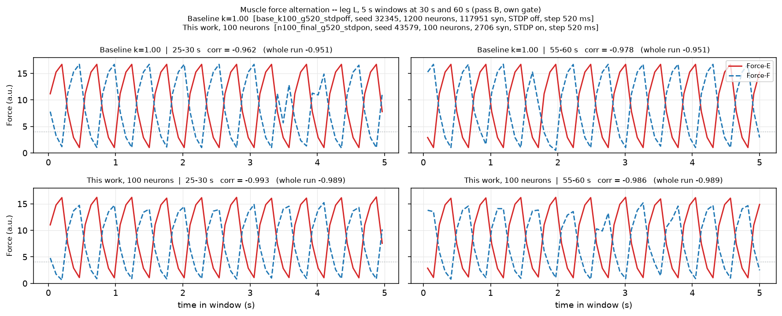
Figure 1. Muscle force at 520 ms, left leg, 5 s windows at 30 s and 60 s. Top: k = 1 baseline. Bottom: 100-neuron network (held-out seed 43579).

5. Final recipe
- Sizes per leg: RG-E 10, RG-F 10, InE 6, InF 8, Ia-interneurons 4 + 4, MN-E 4, MN-F 4 (50 per leg); connectivity k = 0.20; 40 relays.
- Wiring: fixed in-degree with at least 4 inputs per neuron, weights scaled to keep the total input unchanged (--indeg-min 4 --indeg-min-conserve).
- Inhibition: E→InE→F pathway ×1.5 over the k = 0.20 recipe (--inh-comp 5.625).
- Flexor rhythm generator by gait: c −55, d 4 at 350–520 ms; c −50, d 2 at 780 ms (--rgf-c, --rgf-d).
- STDP: on, λ = 1e-6 (the result is the same with STDP off, except at 520 ms, see limitations).

6. Key findings
- The trace/muscle update step must be 100 ms; the old 20 ms default gives a different model (rhythm −0.63 vs −0.95).
- Each leg needs its own flexor gate: the legs receive opposite RG-F bias currents.
- At small sizes, random wiring fails through seed spread; fixed in-degree fixes it.
- At 100 neurons, raising connectivity k cannot help: every pathway rounds to 1 input. A minimum in-degree (3–4) is the lever.
- E→InE→F inhibition is the sensitive hand-tuning knob. Less inhibition brings the mean closer to the baseline but increases seed spread.
- Reduced networks never reproduce the baseline's 0–500 Hz RG-F bursting. Lower RG-F adaptation is needed for the slow gait.
- Choosing from many variants on the same seeds is optimistic; the held-out check changed one decision (×1.0 inhibition).

7. Limitations
- At 520 ms the reduced network alternates more cleanly than the baseline (−0.987 vs −0.955). It passes only through the wider STDP-on band; with STDP off it misses by about 0.02–0.03.
- STDP has no measurable effect in the final network (differences ≤ 0.005).
- RG-F fires at ~80–230 Hz without the baseline's deep bursts; RG-E carries most of the rhythm.
- One parameter (RG-F adaptation) must change with gait; the baseline needs none.
- Results are bit-reproducible on one machine and NEST 3.9.0, not across NEST versions.

8. Code and reproduction
All code is in the repository folder cpg100/: the model (cpg_small.py), thin drivers per step (cpg_e0 … cpg_e8g.py), runners (run_E*.sh, with --local for a laptop and Slurm arrays), the summarizer (summarize_small.py) and figures (plot_final.py). Full log: ROADMAP_PROGRESS.md; findings: FINDINGS_100neurons.md.
Reproduce the final result: bash run_E8f.sh check && bash run_E8f.sh --local all (needs results_E8/ for the baselines; about 30–40 min on a laptop).

