# VEOS by Data Driven Planning

## 测试条件:

* 固定测试场景
* 固定工况
* 不开空调(减少空调能耗干扰)
* 往返路线(减少地形差异干扰)
* 观测噪声: 地形,压缩机,电池SOC,(大灯,tbox,…)
* 测量驾驶风格:纵向控制问题中,特定工况下油门踏板(和刹车踏板)的使用情况
* 通过独立的UDP数据记录交叉验证测量和性能

### 驾驶风格

* 无AI和带AI的基准驾驶风格比较

|  |  |
| --- | --- |
| Driving Style no AI | Driving Style with AI |
| 图1.1 无AI的基准风格分布 | 图1.2 带AI的基准风格总平均分布 |

* 驾驶风格按周期变化: 驾驶风格相对同一个司机是固定的

|  |
| --- |
| Driving Style with AI |
| 图2 驾驶风格变化按KL散度评估, 风格相对固定 |

### 能耗

* 电动力默认Pedal Map (PM) vs 自建 Pedal Map
  + 默认PM:高速时请求力矩会降低
  + 自建PM:分段线性(14个关键点近似),请求力矩分段线性单调

|  |  |
| --- | --- |
|  |  |
| 图3.1 EP默认PM | 图3.2 自建PM |

|  |
| --- |
|  |
| 图6 EP默认PM与自建PM能耗比较, |

* 具备较强能量回收的pedal map

## 实验结果

### 驾驶风格比较:

* 总分布和KL散度定量比较

1.无AI基准: 默认表 vs 手工表

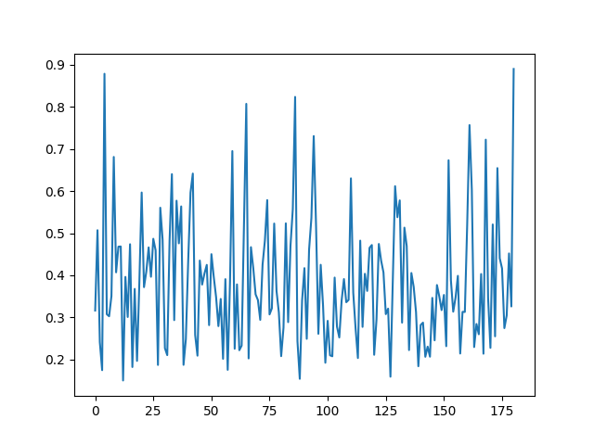

No AI

2.不同驾驶员: 驾驶员 1 vs. 2. vs 3.

3.不同初始表

4.历次带AI tensorboard - 襄阳vs.上海(解决时间同步问题和漏帧问题) - 确认收敛过程 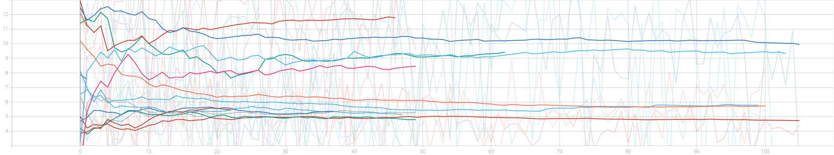

## 上海优化改进过程

* 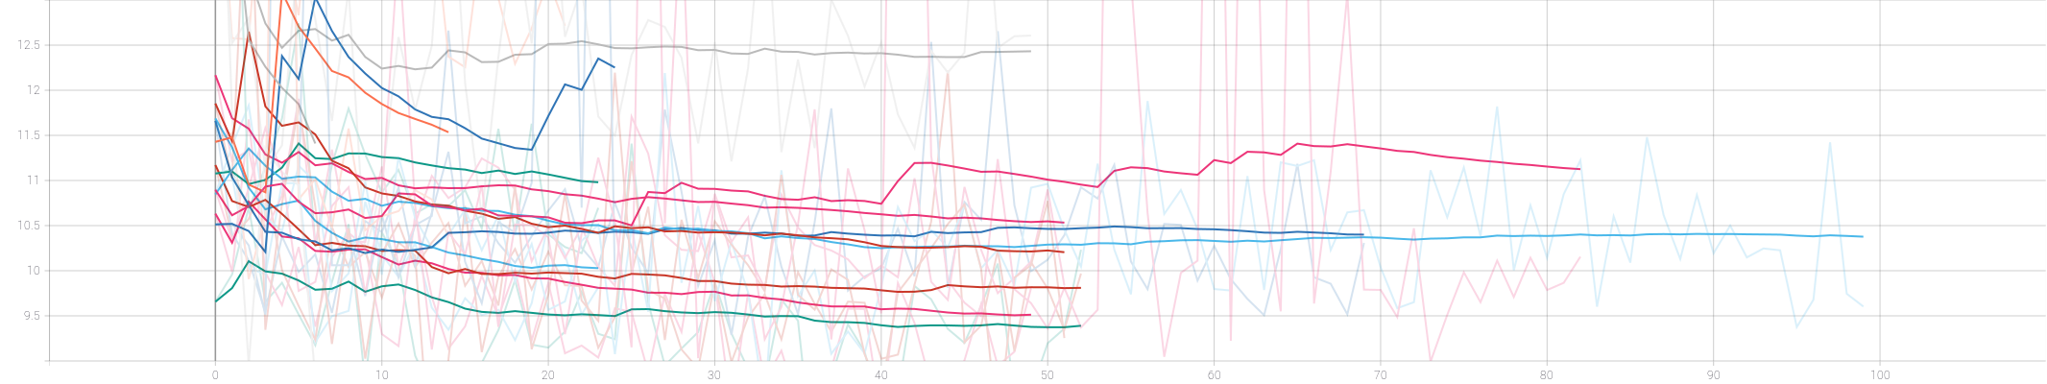
* 上海优化

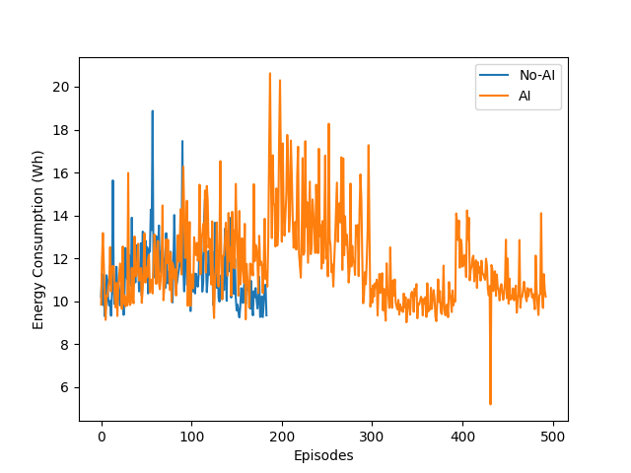

AI-comp

5.(无AI vs.有AI)各50次 6.有AI持续模式 7.不同驾驶员带AI优化过程 8.怠速表关闭/打开 9.熵变小/策略趋向确定性 10.DDPG vs. SAC

* baselines
  + driver styles analysis (analysis)
  + pedal map comparison
  + A2C
  + different initial map
* Declining in each epoch
  + RL agent cooperative / Human driver adapting?
  + Epoch tendcy
  + declining in total loss / inclining in total reward
  + entropy declining / becoming more and more deterministic
  + expected wh declining
  + seems cooperative, at least no conflict
  + baseline: strong regen –> higher efficiency
  + methods
  + achievements
  + status
* long-term in resume mode (model and table resumed)
* weak regen (fix coastdown / constrained action space)
* strong regen (exploit coastdown / relax action space)

## Analysis

weaker regen: not stronger regen, but better motion control for the test case

* possible models

debug

* tools
  + **driving style analysis (quantitative)**
    - vehicle interfaces and systems (stable and reliable)
    - synchronization
  + data logging (for analysis and offline algo)
  + udp episodic analysis (cross check)
  + energy consumpt cross-check by UDP messages
  + model resume tool
  + different driver storage with resume and from scratch
  + debug (latency analysis)
  + verifying DL algo with cpu only resources
  + analysis
  + optimal motion planning
  + limiting action space,
  + exploit regen, activate coastdown part
  + better assistance for manual motion control for eco
  + reward shaping (penalize braking could be cooperative)
  + need recurrency to encode system dynamics
  + observing, acting rate, BP rate

## 方法

强化学习方法, 以大数据为基础的奖励驱动优化方法 - **没有模型** - 车辆动力学的模型和知识 - 电机模型 - 电源管理系统模型 - 符合学习直觉: - 利用大数据建立内部模型 - 自适应动态过程 -

## 理论分析

* not like this: big data –> NN –> label ==> good result
* learn from data (distribution) not label (label is supervision)
  + distribution, law of large number n>30, (multiplicity with samples)
  + dynamic environment –> drifting distribution
  + **advantages**: previously impossible cases can be solved elegantly by big data.
* basic observability/controllability
  + observation enough? fully observable –> which should I observe?
  + control signal sufficient/efficient?
  + long-term dependency
* Model
  + Complete observable model (MDP)
  + human driver model
  + pedal map
  + Objective: Optimal Motion Planning
    - * follow the optimal motion planning (follow the optimal speed curve)
      * reduce unnecessary large torque
      * maintain a speed when regenerative brake occurs (exploit regenerative brake)
  + Implementation, POMDP

## Outlook

### fully autonomous

1. optimal motion control/prediction
2. exploit regen

### assistance system

1. fix driving style and analysis
2. different reward

### Challenge

动态过程未知，奖励不完全知道，并非简单将数据灌入神经网络,需要考虑几个因素。

* sample efficiency
* offline data utilization
* reward shaping
* memory

### Counter measures