Peak Energy — Corporate Network Architecture
Firewall: PEAK-CORP-FW (OPNsense) · Generated 2026-10-09
This document describes VLANs, WAN links, Omada switching/Wi‑Fi, DHCP reservations, WireGuard (Peak Energy VPN), and access policy for PeakPulse / ACS.

Architecture diagram
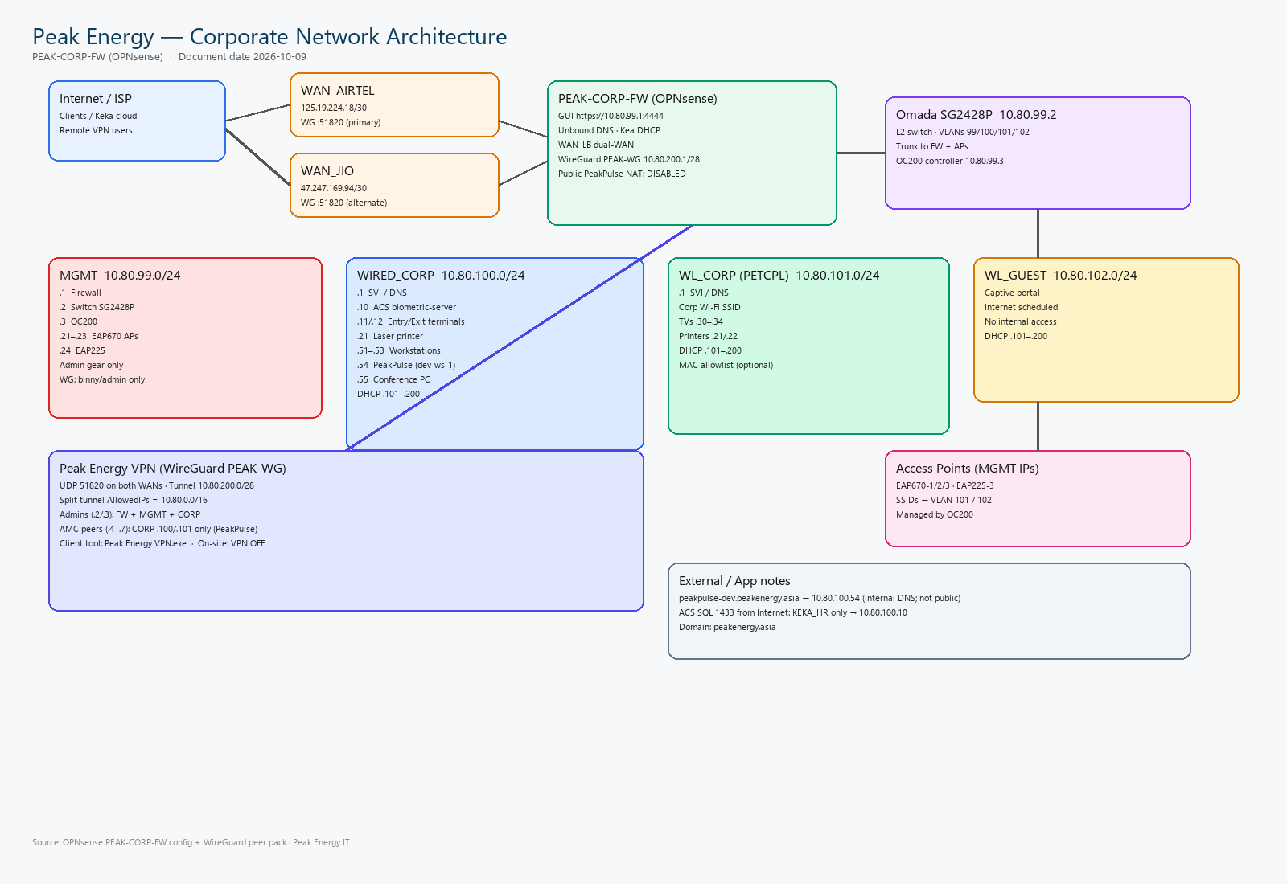

1. WAN links
WAN | Public IP | Gateway name | Notes
Airtel Fiber | 125.19.224.18/30 | WAN_AIRTEL | Primary; WG endpoint default
Jio RF | 47.247.169.94/30 | WAN_JIO | Failover / alternate WG endpoint
WAN_LB | — | WAN_LB | Dual-WAN load balance + failover

2. VLANs / subnets
VLAN / Role | Subnet | Gateway (FW) | DHCP pool | Interface
MGMT (admin gear) | 10.80.99.0/24 | 10.80.99.1 | 10.80.99.101–200 | lan / re0
WIRED_CORP | 10.80.100.0/24 | 10.80.100.1 | 10.80.100.101–200 | opt2 / VLAN 100
WL_CORP (PETCPL) | 10.80.101.0/24 | 10.80.101.1 | 10.80.101.101–200 | opt3 / VLAN 101
WL_GUEST | 10.80.102.0/24 | 10.80.102.1 | 10.80.102.101–200 | opt4 / VLAN 102
WireGuard VPN | 10.80.200.0/28 | 10.80.200.1 | static peers | opt6 / wg0

3. MGMT hosts (10.80.99.0/24)
IP | Hostname | Role
10.80.99.1 | PEAK-CORP-FW / OpnSense | Firewall GUI :4444, SSH, Unbound DNS
10.80.99.2 | sg2428p | Omada switch SG2428P
10.80.99.3 | oc200 | Omada OC200 controller https://10.80.99.3/
10.80.99.21 | eap670-1 | Wi-Fi AP EAP670
10.80.99.22 | eap670-2 | Wi-Fi AP EAP670
10.80.99.23 | eap670-3 | Wi-Fi AP EAP670
10.80.99.24 | eap225-3 | Wi-Fi AP EAP225

4. WIRED_CORP hosts (10.80.100.0/24)
IP | Hostname | Role
10.80.100.1 | — | WIRED_CORP SVI / DNS
10.80.100.10 | biometric-server | ACS / Attendance SQL
10.80.100.11 | biometric-entry | Biometric entry terminal
10.80.100.12 | biometric-exit | Biometric exit terminal
10.80.100.20 | biometric-server-new | ACS new (reservation)
10.80.100.21 | laser-printer | HP LaserJet (Ethernet)
10.80.100.51 | peak-ws-1 | Workstation 1
10.80.100.52 | peak-ws-2 | Workstation 2
10.80.100.53 | peak-ws-3 | Workstation 3
10.80.100.54 | dev-ws-1 | PeakPulse / peakpulse-dev.peakenergy.asia
10.80.100.55 | peak801-in-conf | Conference room PC

5. WL_CORP hosts (10.80.101.0/24)
IP | Hostname | Role
10.80.101.1 | — | WL_CORP SVI / DNS
10.80.101.21 | laser-printer | HP LaserJet (Wi-Fi)
10.80.101.22 | printer-md | MD HP Smart Tank Wi-Fi
10.80.101.30 | tv-conferance | TV Conference Room
10.80.101.31 | tv-kalaam | TV Abdul Kalaam
10.80.101.32 | tv-ratan | TV Ratan Tata
10.80.101.33 | tv-onm | TV Operations & Mgmt
10.80.101.34 | tv-md | TV MD

6. WireGuard / Peak Energy VPN
Peer | Tunnel IP | Access
PEAK-WG server | 10.80.200.1/28 | OPNsense wg0 listen UDP 51820
binny.andrews | 10.80.200.2/32 | Admin: FW GUI/SSH + MGMT + CORP
admin | 10.80.200.3/32 | Admin: FW GUI/SSH + MGMT + CORP
jagadeshwar | 10.80.200.4/32 | AMC: CORP only (.100/.101)
venu.gopal.reddy | 10.80.200.5/32 | AMC: CORP only
poovarasu | 10.80.200.6/32 | AMC: CORP only
sanoj.james | 10.80.200.7/32 | AMC: CORP only

7. Security & access policy
Topic | Current policy
PeakPulse public WAN | DISABLED — no public HTTP/HTTPS port-forward
PeakPulse access | WireGuard or on-site LAN only → 10.80.100.54
WG DNS | Client DNS 10.80.100.1 (Unbound); also listens on WG
WG AllowedIPs | 10.80.0.0/16 split tunnel
WG endpoints | 125.19.224.18:51820 (Airtel) or 47.247.169.94:51820 (Jio)
MGMT via VPN | Only WG_FW_ADMINS (binny + admin)
FW GUI via VPN | Only WG_FW_ADMINS → (self) :4444 / SSH
AMC peers via VPN | CORP .100 + .101 only (PeakPulse etc.)
ACS SQL from Internet | KEKA_HR only → 10.80.100.10:1433
Guest Wi-Fi | VLAN 102 + captive portal; scheduled internet Mon–Fri 07:00–19:00
On-site + WG tip | On PETCPL turn VPN OFF (Peak Energy VPN.exe); remote turn ON

8. Logical traffic paths
On-site (PETCPL / wired): Clients use the VLAN gateway directly. Peak Energy VPN should be OFF so 10.80.x is not forced into the tunnel.
Remote: Peak Energy VPN ON → UDP 51820 → PEAK-WG → CORP (.100/.101). Admins also reach MGMT (.99) and the firewall GUI.
Guest: VLAN 102 captive portal; blocked from MGMT/CORP; internet by weekday schedule.

Confidential — Peak Energy IT. Derived from OPNsense config-PEAK-CORP-FW and WireGuard peer pack.

