PEAK Corporate Network
Landscape, Devices, Attendance Integration &
FortiGate → OPNsense Migration Guide
Source config: PEAK-CORP-FW_7-2_1762_202609160923.conf.yaml
Appliance: FortiGate 100F · FortiOS 7.2.13 build 1762
Document generated for migration planning

Contents
1. Executive summary
2. Current network landscape (visual)
3. Device inventory
4. VLAN and addressing plan
5. Dual WAN and SD-WAN
6. Firewall policies and NAT
7. Biometric attendance, ACS, Akrivia and Keka
8. Wireless and FortiSwitch
9. Remote access (SSL VPN → WireGuard)
10. Security findings
11. OPNsense target architecture
12. Cutover checklist
13. File annex (migration kit)

1. Executive summary
PEAK operates a FortiGate 100F (hostname PEAK-CORP-FW) as the edge firewall with dual ISP connectivity (Airtel fiber and Jio RF), a FortiSwitch core (PEAK-CORE-SW), and three FortiAP 431F access points. Corporate wired and wireless networks use VLANs 100–102. An attendance/ACS server at 10.80.100.10 on the wired corporate VLAN stores biometric punch data; that database is exposed to the Internet on TCP 1433 so an external HR stack (Akrivia named in the firewall; Keka used operationally) can pull attendance.
OPNsense can replace the FortiGate as router/firewall, but cannot run FortiLink or FortiAP controller functions. The FortiSwitch must be converted to standalone and wireless APs must be replaced or re-homed before a full cutover. A migration kit under opnsense-migration/ provides aliases, DHCP maps, NAT/firewall mapping, WireGuard peers, and a fill-in-the-NICs seed XML.

2. Current network landscape
Figure 1 shows ISPs, FortiGate, switch, major device classes, and cloud HR exposure.
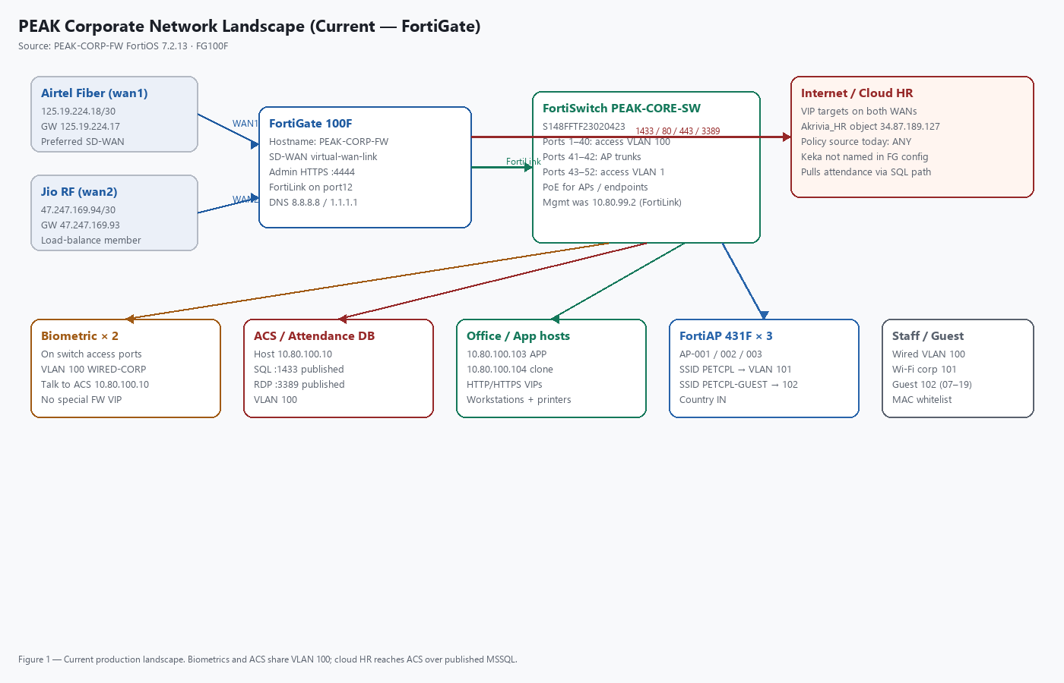

3. Device inventory
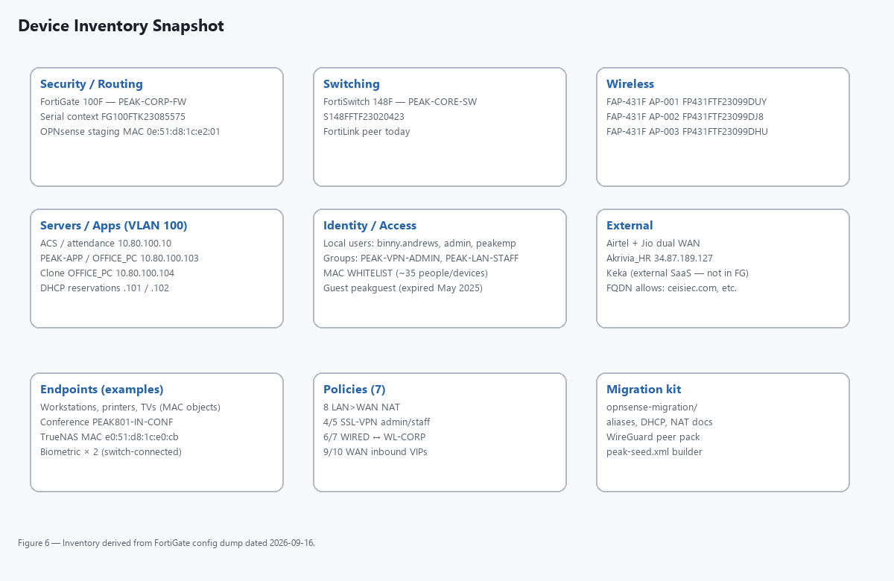

3.1 Core infrastructure
Role | Device | Identity / addressing | Notes
Firewall | FortiGate 100F | PEAK-CORP-FW | Admin HTTPS :4444
Core switch | FortiSwitch 148F | PEAK-CORE-SW / S148FFTF23020423 | FortiLink managed
AP | FAP-431F | AP-001 FP431FTF23099DUY | Remote WTP
AP | FAP-431F | AP-002 FP431FTF23099DJ8 | Remote WTP
AP | FAP-431F | AP-003 FP431FTF23099DHU | Remote WTP
Staging | OPNsense | MAC 0e:51:d8:1c:e2:01 | Already present as FG object

3.2 Servers and key hosts (VLAN 100)
Host | IP | Role
ACS / attendance | 10.80.100.10 | Biometric DB; SQL 1433 + RDP 3389 published
OFFICE_PC / PEAK-APP | 10.80.100.103 | HTTP/HTTPS VIP target
Clone of OFFICE_PC | 10.80.100.104 | Secondary host object
PEAK-WS-1 | 10.80.100.101 | DHCP reservation 4c:d7:17:a4:2a:d0
PEAK-WS-2 | 10.80.100.102 | DHCP reservation 4c:d7:17:a4:2b:11

3.3 Endpoints called out in config
Two biometric attendance machines are connected to the FortiSwitch (access VLAN 100). They are not individually named as firewall address objects; they reach the ACS server on the same LAN. Staff devices appear as MAC address objects inside the MAC WHITELIST group used by the wired captive-portal exempt list. Printers, meeting-room TVs, conference PC, and TrueNAS are also represented as MAC objects.

4. VLAN and addressing plan
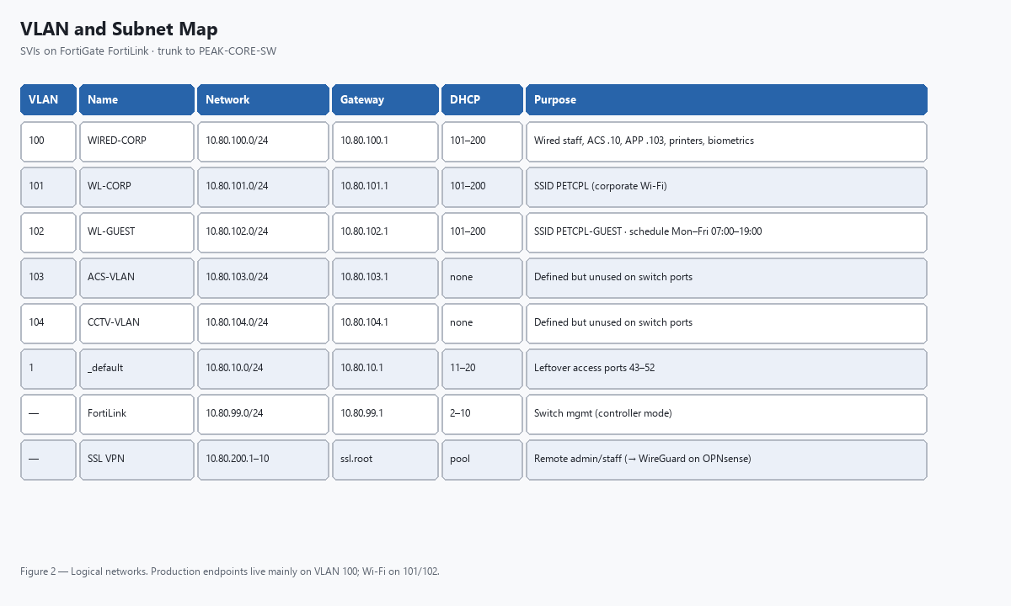
Inter-VLAN allow rules exist only between WIRED-CORP and WL-CORP. Guest, ACS-VLAN, CCTV, and default VLAN have no east-west permits beyond what same-interface routing would require—and ACS/CCTV VLANs are unused on the switch today.

5. Dual WAN and SD-WAN
Member | Interface | Address | Gateway | Role
2 (preferred) | wan1 Airtel-FIBER | 125.19.224.18/30 | 125.19.224.17 | Priority in LB service
1 | wan2 JIO-RF | 47.247.169.94/30 | 47.247.169.93 | Second LB member

SD-WAN service Default_Internet_LB uses load-balance mode with SLA Default_DNS (latency 250 ms, jitter 50 ms, loss 5%). Default route uses sdwan-zone virtual-wan-link. On OPNsense this becomes gateway group WAN_LB with monitoring to 8.8.8.8 / 1.1.1.1.

6. Firewall policies and NAT
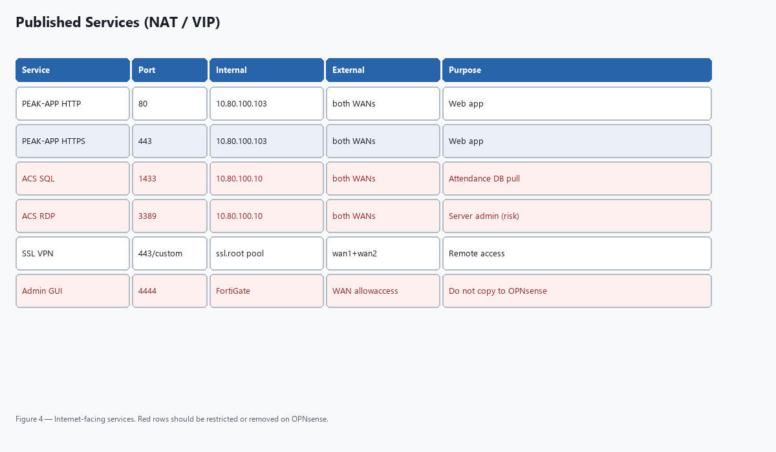

6.1 IPv4 policies
ID | Name | From → To | Action / NAT | Notes
8 | LAN > WAN | VLAN 1/100/101/102 → SD-WAN | Accept + NAT | UTM + PEAK-POLICY webfilter
6 | WIRED → WL-CORP | 100 → 101 | Accept | Inter-VLAN
7 | WL-CORP → WIRED | 101 → 100 | Accept | Reverse of 6
4 | SSL-VPN ADMIN | ssl.root → LAN VLANs | Accept | Group PEAK-VPN-ADMIN
5 | SSL-VPN USER | ssl.root → 100/101 | Accept | Group PEAK-VPN-STAFF (empty)
9 | Akrivia_HR>LAN | WAN → ACS VIPs | Accept + NAT | 1433/3389; src=all
10 | WAN > WiredCorp | WAN → APP VIPs | Accept | 80/443 to .103

6.2 VIP / port forwards
VIP | External | Port | Internal
PEAK-APP-1-Airtel / Jio | Both WAN IPs | 80 | 10.80.100.103
PEAK-APP-2-Airtel / Jio | Both WAN IPs | 443 | 10.80.100.103
ACS-SERVER-Airtel / Jio | Both WAN IPs | 1433 | 10.80.100.10
RDP of ACS-SERVER-* | Both WAN IPs | 3389 | 10.80.100.10

7. Biometric attendance, ACS, Akrivia and Keka
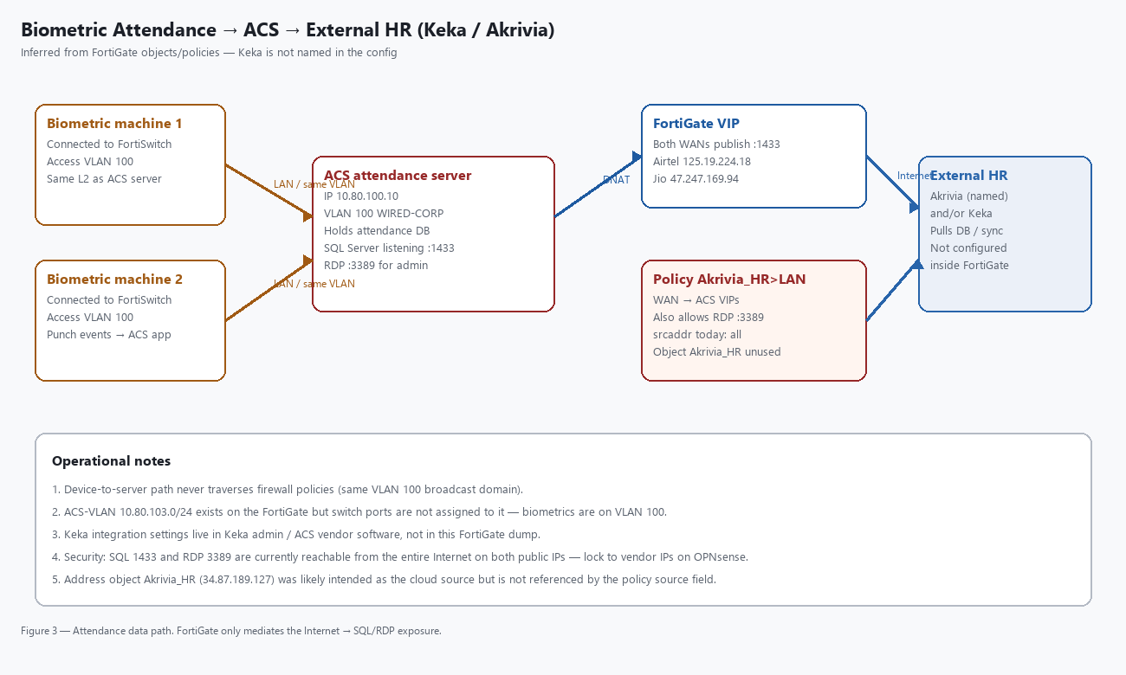

7.1 How it works on site
The two biometric machines connect to the FortiSwitch on normal access ports (VLAN 100). Punch data is sent to the ACS/attendance application on 10.80.100.10. Because devices and server share the same VLAN, this traffic does not require a FortiGate firewall policy.

7.2 How external HR pulls data
The FortiGate publishes Microsoft SQL Server port 1433 from both public WAN addresses to 10.80.100.10. Policy Akrivia_HR>LAN permits that path (and RDP 3389). An address object Akrivia_HR (34.87.189.127) exists but is not used as the policy source—the source is all.

7.3 Where Keka fits
Keka does not appear anywhere in the FortiGate configuration. Operationally, Keka is the HR application that consumes attendance. That usually means either (a) Akrivia/ACS middleware syncs to Keka, or (b) a Keka connector reaches the on-prem SQL database through the published VIP. Confirm the exact connector URL/IP inside Keka admin and the ACS vendor console—those settings are outside this firewall dump.

7.4 Unused ACS VLAN
Interface ACS-VLAN (VLAN 103, 10.80.103.0/24) is defined on the FortiGate, but switch ports are not assigned to it. Do not assume biometrics use VLAN 103 unless you change switch config later.

8. Wireless and FortiSwitch
SSID | VLAN | Schedule | Notes
PETCPL | 101 | always | Corporate Wi‑Fi, local-bridging
PETCPL-GUEST | 102 | peak_optimised Mon–Fri 07:00–19:00 | Guest; passphrase encrypted in dump

Switch port summary: 1–40 untagged VLAN 100; 41–42 trunks (allowed-vlans-all) for APs; 43–52 untagged VLAN 1. Converting the switch to standalone is mandatory before OPNsense cutover.

9. Remote access
FortiGate SSL VPN listens on wan1 and wan2 with pool 10.80.200.1–10. PEAK-VPN-ADMIN members are binny.andrews and admin (full LAN including ACS/CCTV). PEAK-VPN-STAFF has no members. The migration kit replaces this with WireGuard on 10.80.200.0/28 (client configs for both admins). OpenVPN remains an option if FortiClient must be retained.

10. Security findings
Finding | Risk | Recommendation
SQL 1433 open to Internet on both WANs | High | Restrict to Keka/Akrivia source IPs or VPN only
RDP 3389 open to Internet on both WANs | Critical | Remove public RDP; use WireGuard
WAN allowaccess https ssh | High | Do not replicate on OPNsense; LAN/MGMT only
Akrivia policy src=all despite named object | High | Use AKRIVIA_HR / vendor IP alias
Guest not isolated from corp by policy | Medium | Add deny guest → RFC1918 on OPNsense
FortiGuard / cert-inspect not portable | Info | Unbound DNSBL + optional Zenarmor

11. OPNsense target architecture
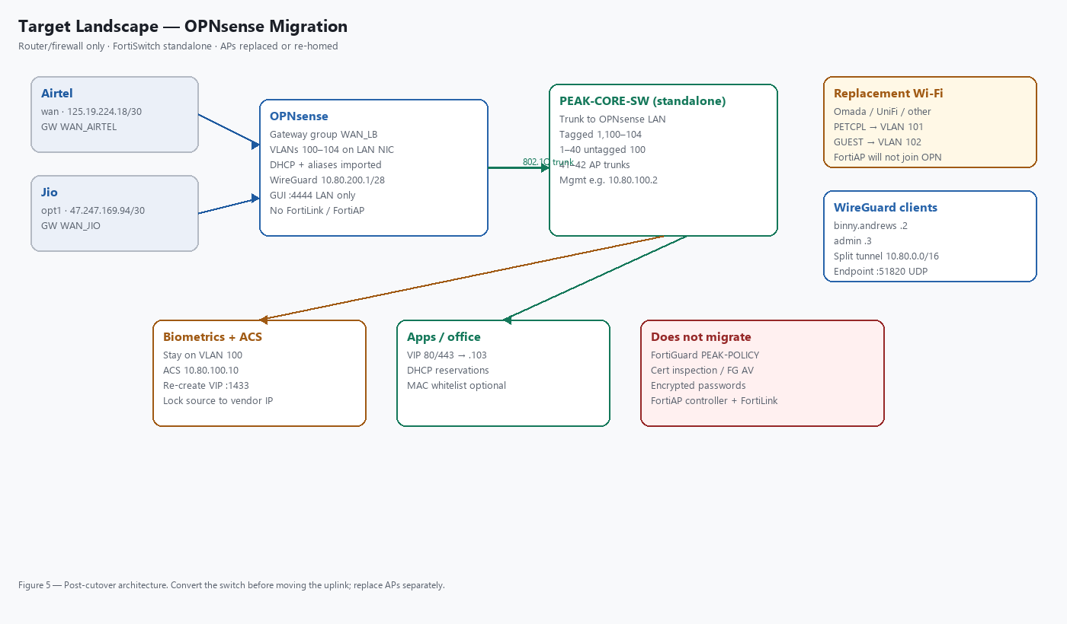
Suggested OPNsense roles: wan=Airtel, opt1=Jio (WAN2), LAN parent with VLAN interfaces opt2–opt7, opt8=WireGuard. Import aliases.csv, apply NAT/firewall from nat-and-firewall.md, edit nics.env and run build-opnsense-seed.py for peak-seed.xml.

12. Cutover checklist
- Stage OPNsense on spare NIC/VLAN; import aliases; configure WAN_LB and VLANs.
- Convert PEAK-CORE-SW to standalone; set trunk to OPNsense; static mgmt on VLAN 100.
- Replace or re-home FortiAPs (PETCPL→101, GUEST→102).
- Recreate DHCP pools and reservations; verify ACS 10.80.100.10 and APP .103.
- Recreate port forwards; lock 1433 to vendor IPs; do not publish 3389/GUI.
- Bring up WireGuard; test binny.andrews and admin tunnels.
- Confirm biometric punches still land on ACS; confirm Keka/Akrivia sync after VIP move.
- Move switch uplink from FortiGate port12 to OPNsense LAN; keep FortiGate powered until verified.
- Decommission FortiGate WAN allowaccess and SSL VPN when stable.

13. File annex — migration kit
Path | Purpose
opnsense-migration/README.md | Migration overview
opnsense-migration/nics.env | Fill real NIC names
opnsense-migration/build-opnsense-seed.py | Builds peak-seed.xml
opnsense-migration/aliases.csv | Firewall aliases import
opnsense-migration/mac-whitelist.csv | Captive portal / MAC list
opnsense-migration/dhcp-static-maps.csv | DHCP reservations
opnsense-migration/nat-and-firewall.md | NAT + rule order
opnsense-migration/switch-and-wifi.md | Switch/AP conversion
opnsense-migration/wireguard/ | Server keys + client confs
opnsense-migration/docs/images/ | Diagram PNGs used in this document

End of document. Diagrams are also stored as PNG files alongside this Word file for reuse in presentations.

