**OEO FY 2019 Annual Report**

* Contracting Categories: Public Works (PW), Service, Supplies, and Equipment (SSE), Personal & Professional Services (PPS), Miscellaneous Purchase Orders (MPO), Small Order Purchases (SOP), and City-wide SSE
* At the time of publication there were **3,115** firms in the OEO Registry
  + Registering **280 new diverse businesses** in the OEO Registry, reaching a total of 3,115 M/W/DSBEs registered—a 5 percent increase from the previous year.
  + Removing **invalid 216 businesses** from the registry.
* In city contracts
  + 36.02 % of contract dollars for diverse business enterprises (total $254 million)
  + 31.3 % of all contracting including quasi-public agencies
  + 31.3 % increase of MWDSBE participation compare to FY 2018

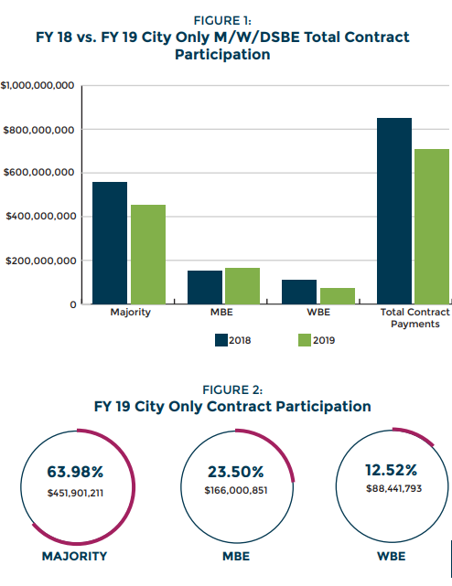

* FY 2019 Total Contract Participation of MWDSBE
  + These participation numbers come from contract commitments rather than payments, and they reflect dollars committed to primes and subs at the time the contract is conformed.
  + Contract awards provide a useful indicator of the amount that will be paid to M/W/DSBE firms
  + The most useful tool the City currently has is the B2GNow Contract Compliance Reporting System, and OEO is working with the Administration to properly maintain all of the City’s contracts in this system.

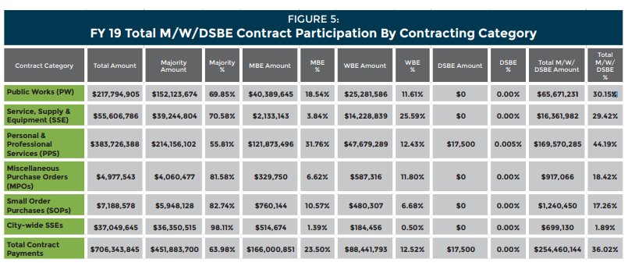

* + PPS(Personal & Professional Services) had the greatest increase
* MWDSBE participation by demographics

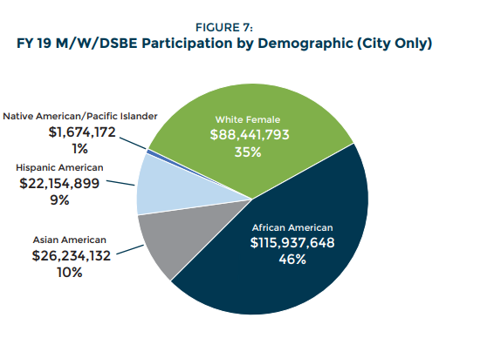

* MWDSBE participation by geographic area

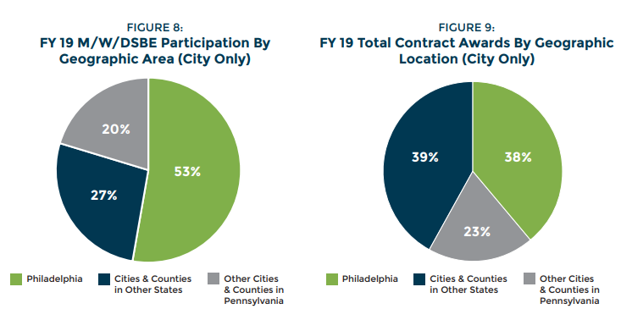

* Five-year trending data on MWDSBE

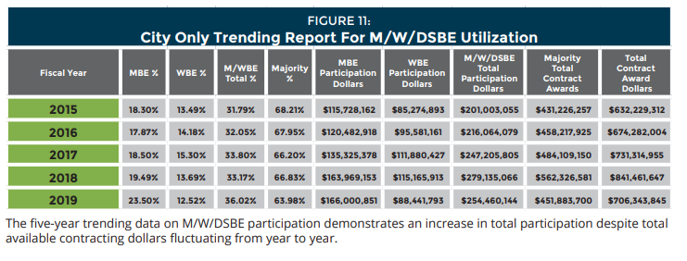

* FY 2019 City Department MWDSBE participation

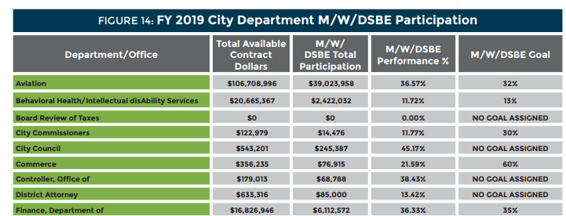

* TOP 10 MBE and WBE by dollar awarded

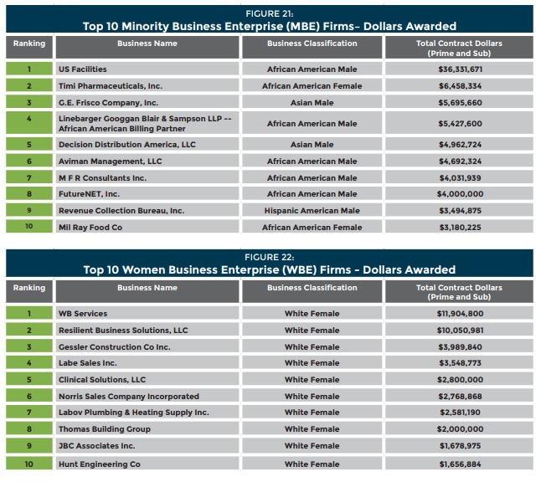

* Registry by business classification and location

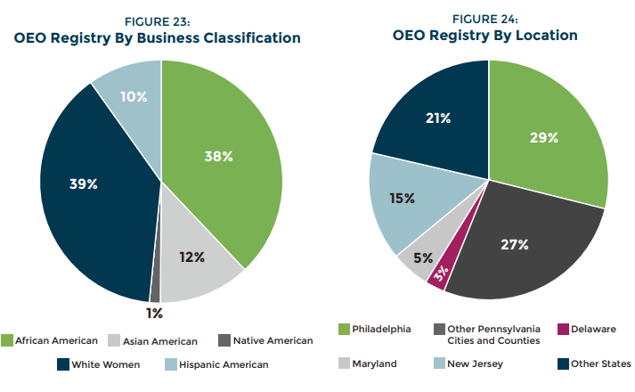

* Economic Opportunity Plans(EOP): agreement between the City and a prime contractor or project owner
  + all projects valued at more than $5 million
  + use of minority, women, and disabled-owned businesses on contracts over $100,000