**ANALYSIS ON MWDSBE**

*Office of the City Controller*

**What we’ve done**

* Downloaded the OEO registry
* Geocoded the businesses: added latitude/longitude to each business
* Matched this registry against other publicly available datasets, based on vendor name

**The data**

* Registry: all registered MWDSBE, downloaded from the OEO’s website
* Public datasets:
  + Business Licenses: Commercial Activity Licenses. Information includes license information such as license number, activeness, etc.
  + State Licenses: list of sales tax licenses, exemption and wholesaler certificates as maintained by the Department of Revenue (DOR) that are active
  + City Payments: includes checks and ACH (direct deposit) payments made by the City during 2017 fiscal year.
  + Professional Services: Professional Services Contracts by fiscal quarter from 2013 to 2019

Across all of the datasets, we’ve matched about 60% of the companies in the registry (about 1,800 companies)

**Goal:** Build out interactive dashboard + map highlighting major trends around geographic location, payment amounts, certification type, etc. (similar material as presented in the OEO’s annual report).

**Matching Records**

* Registry + Business Licenses
  + Fuzz 95 + TF-IDF 85: 1566 out of 3119
  + Data path: MWDSBE\analysis\data\processed-data\Registry-OpendataLicense\fuzz95_tfidf85.csv
* Registry + General Fund
  + Fuzz95 + TF-IDF 80 – wrong matches manually: 150 – 14 = 136
  + Data path: MWDSBE\analysis\data\processed-data\Registry-GeneralFunds\joined-136-total-payments.csv
* Registry + Business Licenses + General Fund
  + 1603 out of 3119 (51.4 %)

**Neighborhoods with the most registered businesses**

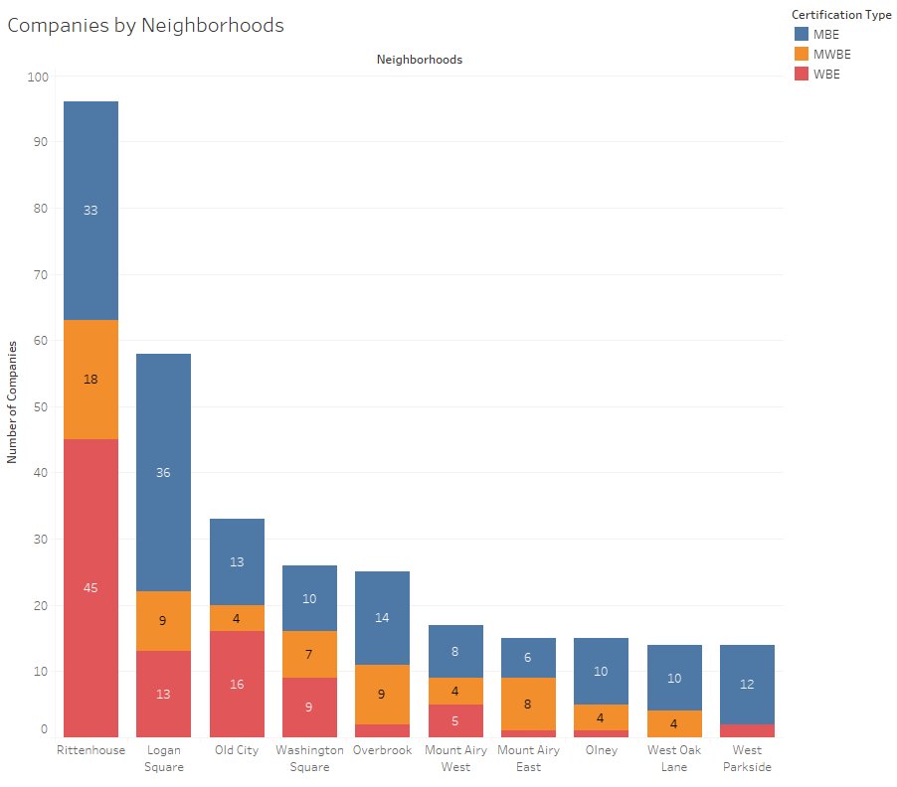

**Locations of registered businesses in Philadelphia**

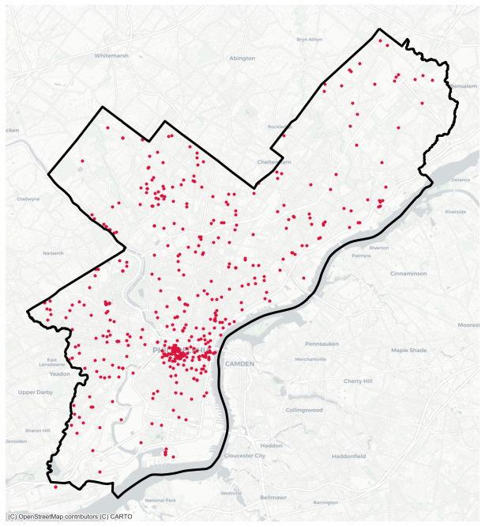

**Trends around In-State vs Out-of-State / In-City vs Out-of-City**

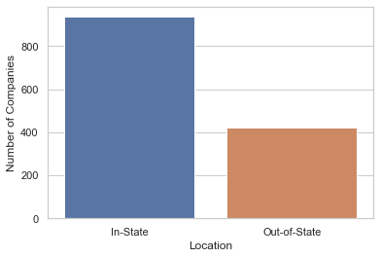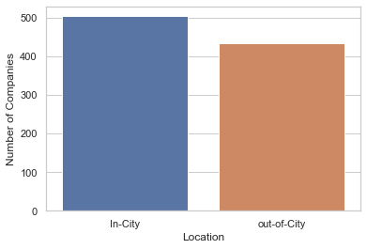

**Registry + General Funds**

*Top 10 Vendors by payments*

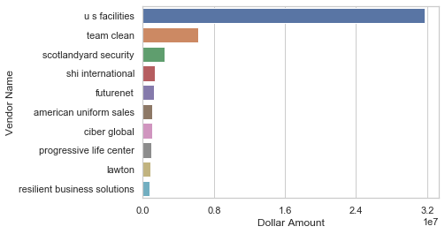

*Top 10 Departments by payments*

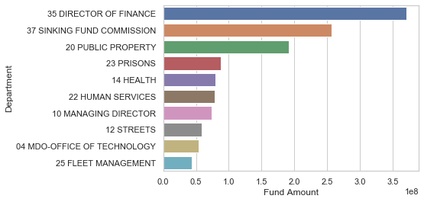

**Top 10 Neighborhoods by payments and number of businesses**

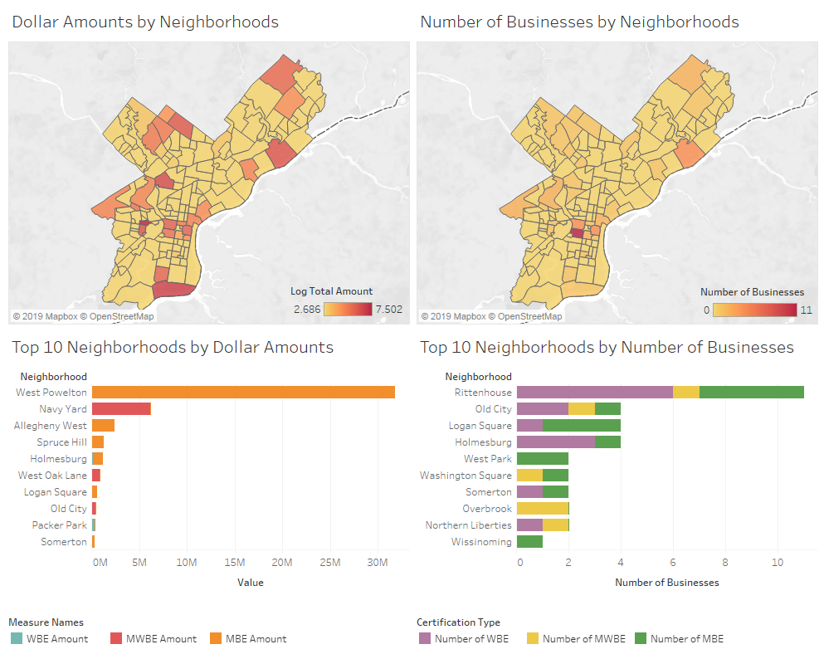

**Philadelphia Metropolitan Statistical Areas (MSA)**

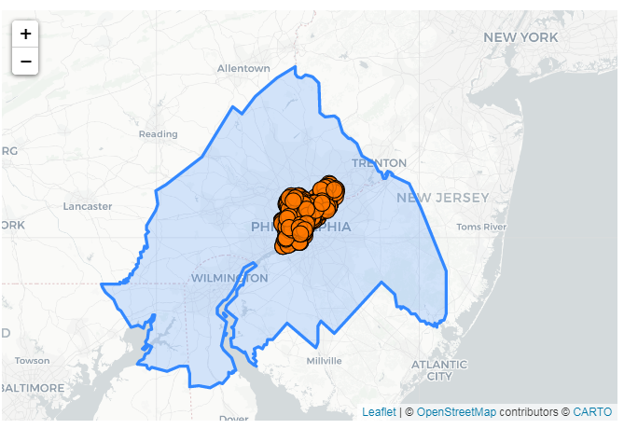

**Analysis of business locations by Number of businesses and Payments**

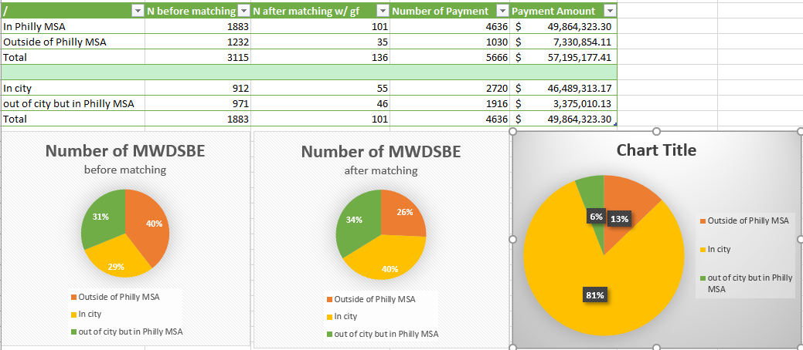

**Top 10 In-City Businesses by Payments**

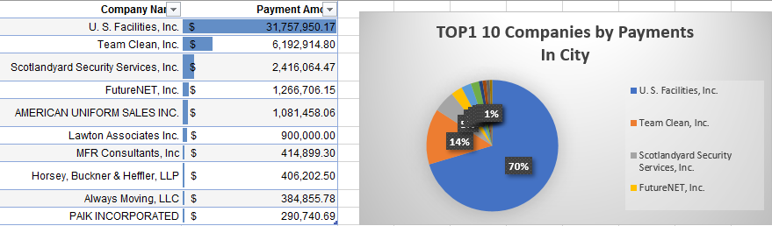

**Analysis of Certification Types of different locations**

