1. Construct 4 bit Serial In parallel Out shift register using D- flip flop. Explain the Working mechanism of the circuit taking Serial input 1010. Also draw the timing diagram according to the given input.

**Answer:**

|  |  |  |  |  |  |
| --- | --- | --- | --- | --- | --- |
| **Clock** | **Input** | **Q3** | **Q2** | **Q1** | **Q0** |
|  | Initial | 0 | 0 | 0 | 0 |
|  | 0 | 0 | 0 | 0 | 0 |
|  | 1 | 1 | 0 | 0 | 0 |
|  | 0 | 0 | 1 | 0 | 0 |
|  | 1 | 1 | 0 | 1 | 0 |

**Describe:** The circuit shown in the following diagram outputs parallel data while accepting serial input. The clock values change to 1 and the value is delivered to Q3 when the value 0 is used as input. The clock values then change from 1 to 0 and back to 1 as input 1 is used. Q3's value is then transferred to Q2 and Q3 is then set to 1. After that, input 0 is used, the clock values switch from 1 to 0 to 1 again, Q2's value is transferred to Q1, and Q3's value is determined by input 1's value. The clock values are then altered to 0 and 1, Q2 becomes Q1, Q1 becomes Q0, and Q3 is given the value 1.

**Timing Diagram:**

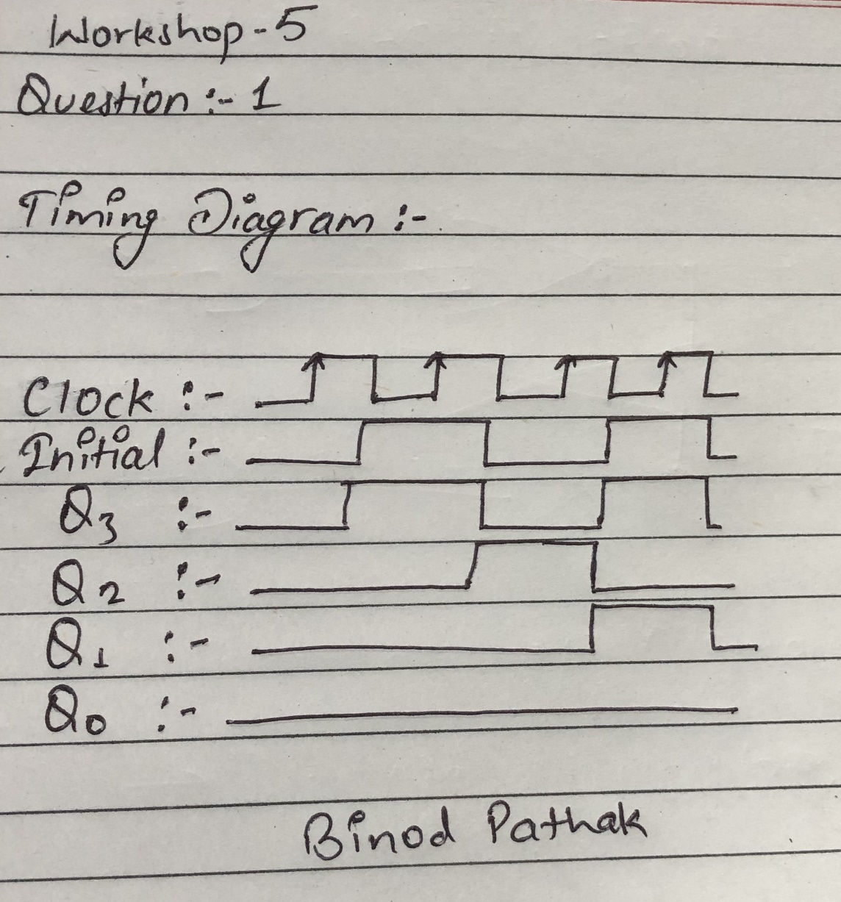

1. Design a 3 bit counter using Toggle D-flip flop and draw the timing diagram.

**Answer:**

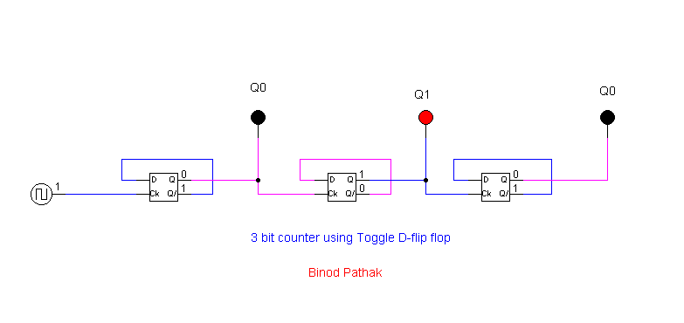

**Table:**

|  |  |  |  |
| --- | --- | --- | --- |
| Clock Transition | Q2 | Q1 | Q0 |
| 0 | 0 | 0 | 0 |
| 1 | 0 | 0 | 1 |
| 2 | 0 | 1 | 0 |
| 3 | 0 | 1 | 1 |
| 4 | 1 | 0 | 0 |
| 5 | 1 | 0 | 1 |
| 6 | 1 | 1 | 0 |
| 7 | 1 | 1 | 1 |

**Timing Diagram:**

1. Load alu.cct file from the logsim folder. The circuit should look like this

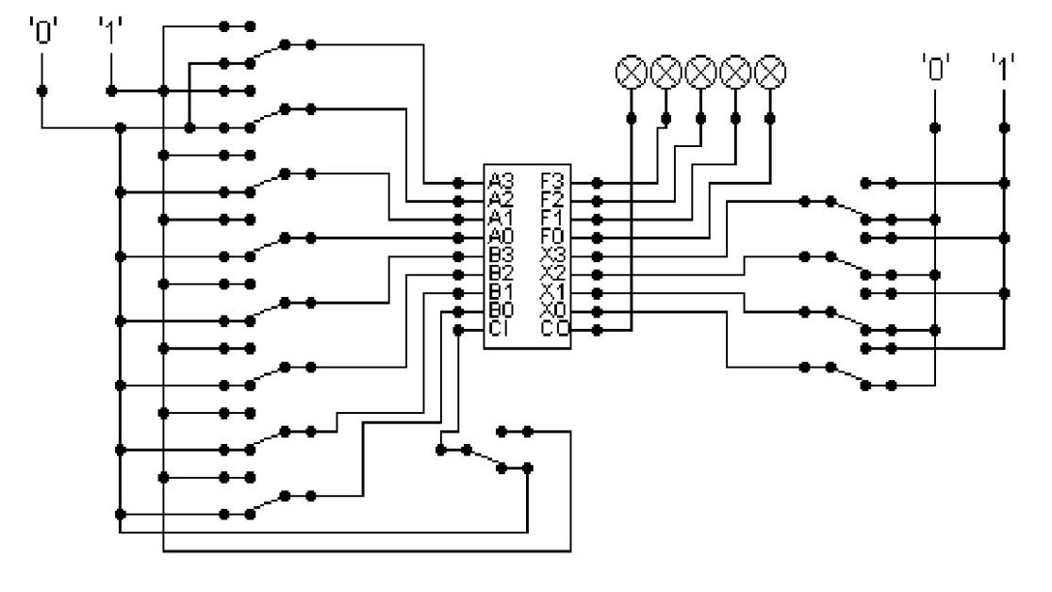

The circuit behaves like a simple arithmetic logic unit. The inputs A0-A3 represent a 4 bit binary number. Inputs B0-B3 represent another binary number. A0 and B0 are the least significant bits respectively. The following table details the functions supported by the chip. All other control lines = 0.

|  |  |  |
| --- | --- | --- |
| Function | Add | Subtract |
| X3-X0 | 1010 | 1011 |

1. Use A= 15 and B = 7
2. Use A = 13 and B = 9

Write the corresponding result of the operations. Manually provide each operation has provided the correct result.

**Answer:**

* 1. Use A= 15 and B = 7

|  |  |  |
| --- | --- | --- |
| Inp  uts | Functi  on | Result |
| A = 15  = 111  1  B = 7 =  011  1 | Add - 1010 |  |

|  |  |  |
| --- | --- | --- |
| A = 15  = 111  1  B = 7 =  011  1 | Subtr act - 1011 |  |

* 1. Use A = 13 and B = 9

|  |  |  |
| --- | --- | --- |
| Use A = 13  and B  =  9Inpu ts | Functi on | Result |
| A = 13 =  1101  B = 9  = 1001 | Add - 1010 | Sum = 1011  Carry = 1   |
|  |  |  |

|  |  |  |
| --- | --- | --- |
| A = 15 =  1111  B = 7  = 0111 | Subtra ct - 1011 | Difference = 0001  Borrow = 1   |