Chapter 3: Design

Introduction

This is a third phase, which shows how the system looks, runs and perform a certain function that is used by customers. As it includes application, database, user interface, and system interface design.

In the Design phase, I am modeling design into five types which are Structural, Behavioral, Database, Architectural modeling, and Prototype design. Inside these different types of design, there will be sub-design also. As the design is important in every project. So, in my projects also design plays an important role by changing the SRS documents into a logical structure. That logical structure contains a detailed and complete set of description that can be implemented in a programming language and design ensure successful completing of the project. So, I am doing a design phase in my projects.

There are five types of design which are:

3.1 Structural Modelling

3.2 Behavioural Modelling

3.3 Database Modelling

Database Modelling is a logical structure and representation of the database. It describes how the data can be stored, processed and manipulated within it. In my project database modeling helps me in designing blueprint of the database that will make me easier to develop a system.

3.1.1 Data Dictionary

Data Dictionary is a set of information that contains database metadata. It describes the format, structure, and content like column name, data type, length, null, key and constraints of a database. Data dictionary also used to manipulate the database, to control access and shows the relationship between its different components.

1. Data dictionary of Customer

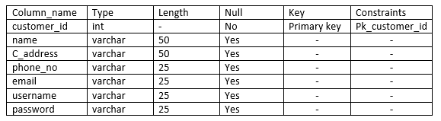

1. Data dictionary of Product

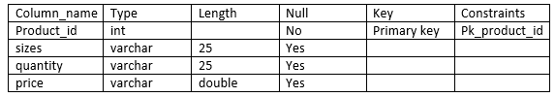

1. Data dictionary of Order

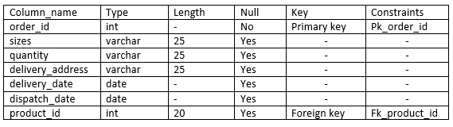

1. Data dictionary of Vehicle

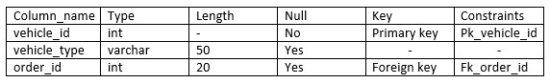

1. Data dictionary of Customer_Order

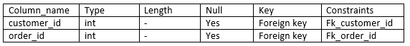

1. Data dictionary of Order_Product

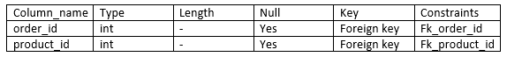

3.1.2 ER Diagram

Entity Relationship(ER) diagram is a technique of data modeling that graphically depicts(represents) entities of an information system and relationship among those entities.

The components of the Entity-Relationship(ER) diagram are:

* Entities
* Relationships
* Attributes

3.4 Architectural Modelling

3.5 Prototype Design