Chapter-1: Introduction

* 1. Introduction

Local Tiles Online Order is a software that will be used for managing and recording data and information about staff, trainer, training member, and equipment in an efficient way of every gym company.

Nowadays, Every Gym company has been running recently using files or paper-based system to a kept record of all those data and information. So, my is to eradicate that paper-based system and perform all those tasks digitally.

* 1. Problems Statements

Chapter-3: Development Methodology

3.1 Description of Methodology Choose

This software will be designed for gym company. So, I have a clear cut and fixed requirement of the company. Hence, I will choose the Waterfall model as my software development methodology.

The waterfall model is a linear, sequential approach to the software development life cycle(SDLC). This is mean that any phases in the development process begin only if the previous phase in complete. In this model, the phases do not overlap, goals are set for each phase of development and can not be revisited after completion.

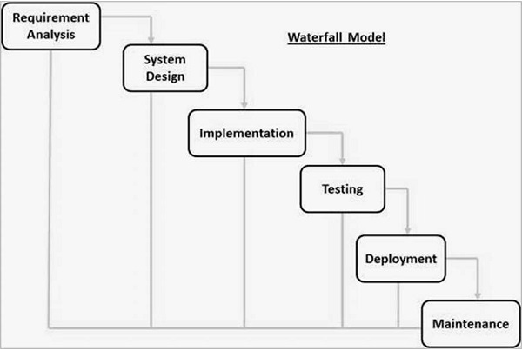

Figure: Waterfall Model

1. Requirement Analysis: All possible requirements, deadlines, and guidelines for the projects are analyzed and captured in this phase and documented in a requirement specification document.
2. System Design: Documented requirement specification from the first phase are studied in this phase and prepared the system designed.
3. Implementation: In this phases coding of the system is done in small programs called units.
4. Testing: When coding is finished once in implementation phases then the testing is done to report issues that may need to be resolved.
5. Deployment of the system: Once non-functional and functional testing is done; the product is deployed to a live environment or customer environement.
6. Maintenance: After the released into customer environment some issues arises in the software. To fix these issues, patches updates or new version are released.