Testing

Introduction

This is the fourth phase of Structured System Analysis and Design Methodology(SSADM). In this phase, codes or system are evaluated against the user requirement to make sure that if it meets requirements that were gathered. Here, it is also possible to find number errors and those errors are tried to be solved within the software program.

There are two types of testing:

1. White Box testing

* In this testing internal code or structure is known to the tester and test how the system performed based on the code.

1. Black Box testing

* In the black box, system functionality is verified and a complete test suite is required to execute in this type of testing.

For my project I have chosen to the performed black box and unit testing:

Black Box Testing

Test 1: Registration Testing Test Planned Date: 27-06-2019

Test Priority (High/Medium/Low): High Test Executed By Binod Rana

Test Completion Date: 27-06-2019

Test Title: User Registration testing

Pre-condition: New user can register details

Dependencies: Once registration details are entered by the user, to enter the system.

|  |  |  |  |  |  |
| --- | --- | --- | --- | --- | --- |
| Test No | Test Cases | Test Date | Excepted Result | Actual Result | Outcomes |
| i. | Check for empty fields | 27-06-2019 | User should be given an error message of empty fields. | Errors message is displayed to the user | Pass |
| ii. | Provide invalid data | 27-06-2019 | A user should not be registered and the message should be displayed | A user was not registered | Pass |
| iii. | Entered valid details | 27-06-2019 | A new user should be registered | A new user is registered | Pass |

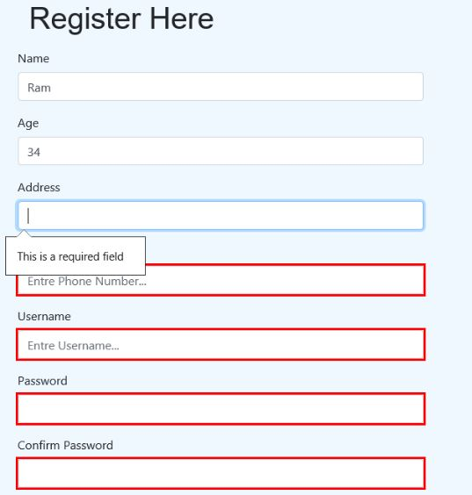

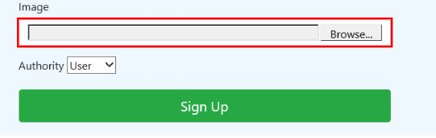

Test 2: Login Testing

Test title: User and Admin login testing Test Planned Date: 27-06-2019

Test Priority (High/Medium/Low): High Test Executed By Binod Rana

Test Completion Date: 27-06-2019

Pre-condition: Both admin and user enter login details

Dependencies: For login both admin and the user enter login details

|  |  |  |  |  |  |
| --- | --- | --- | --- | --- | --- |
| Test No | Test Scenarios | Test Date | Excepted Result | Actual Result | Outcomes |
| i. | Check the data entered | 27-06-2019 | Entered data need to be verified | Data was verified | Pass |
| ii. | Entered wrong data | 27-06-2019 | Error message to the user should be displayed | Error message displayed | Pass |
| iii. | Provide empty field | 27-06-2019 | An empty field error message should be displayed | Empty field error message displayed | Pass |
| iv. | Check logged in data if it is a user or admin | 27-06-2019 | If admin then redirect to admin home otherwise to the user home | Admin and user are redirected to their own home page as per data entered | Pass |

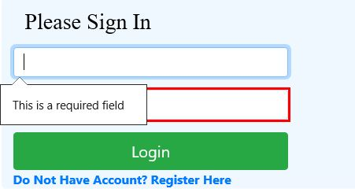

Test 3: Add Product Testing

Test title: Adding product testing by admin Test Planned Date: 27-06-2019

Test Priority (High/Medium/Low): High Test Executed By Binod Rana

Test Completion Date: 27-06-2019

Pre-condition: For adding new product admin need to login

Dependencies: To add new product details admin need to login to the system

|  |  |  |  |  |  |
| --- | --- | --- | --- | --- | --- |
| Test No | Test Cases | Test Date | Excepted Result | Actual Result | Outcomes |
| i. | Provide empty field during adding product | 27-06-2019 | The new product should not be added and should display errors message. | Error message displayed with the product not add. | Pass |
| ii. | Wrong input of data | 27-06-2019 | A message with the wrong input of data should be pop up | Message pop up with wrong input type | Pass |
| iii. | Provide valid product details | 27-06-2019 | The product should be added and displayed in both admin and user pages | Product added successfully and displayed in both admin and user page | Pass |

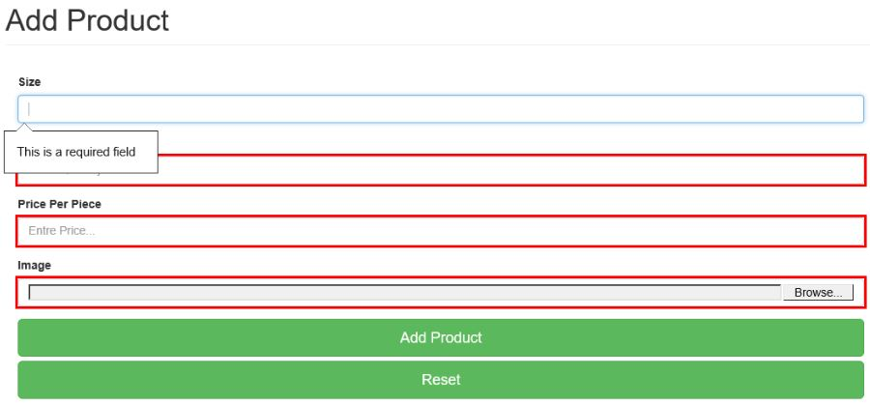

Test 4: Update product testing

Test title: Update product testing by admin Test Planned Date: 27-06-2019

Test Priority (High/Medium/Low): High Test Executed By Binod Rana

Test Completion Date: 27-06-2019

Pre-condition: For updating product admin need to login

Dependencies: To update product admin need to login to the system

|  |  |  |  |  |  |
| --- | --- | --- | --- | --- | --- |
| Test No | Test Scenario | Test Date | Excepted Result | Actual Result | Outcomes |
| i. | Select product by product_id | 27-06-2019 | Details of selected product_id should be displayed | Product details of selected product_id are shown | Pass |
| ii. | Check edited details for the update | 27-06-2019 | Details of the edited product should be checked | Edited details of product checked successfully | Pass |
| iii. | Update details of selected product_id | 27-06-2019 | Details of selected product_id should be updated | Product update successfully and displayed in both admin and user page | Pass |

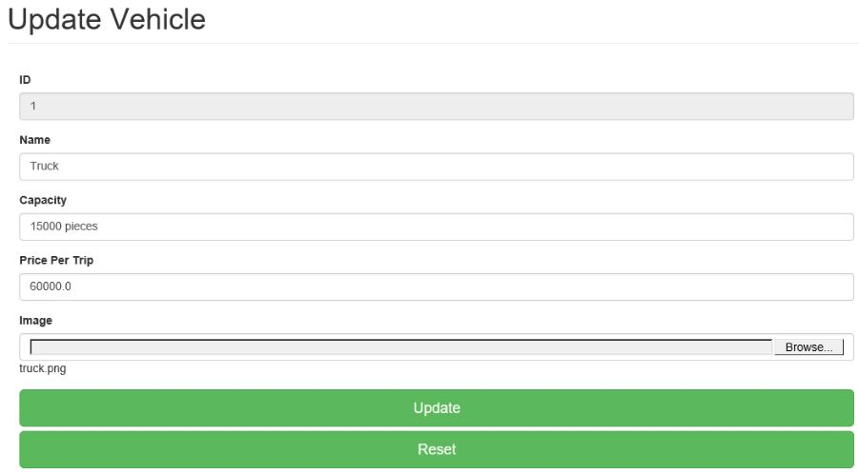

Test 5: Delete product testing

Test title: Delete product testing by admin Test Planned Date: 27-06-2019

Test Priority (High/Medium/Low): High Test Executed By Binod Rana

Test Completion Date: 27-06-2019

Pre-condition: Admin needs to log in and product id need to available

Dependencies: To delete the product admin need to login to the system

|  |  |  |  |  |  |
| --- | --- | --- | --- | --- | --- |
| Test No | Test Scenarios | Test Date | Excepted Result | Actual Result | Outcomes |
| i. | Select product_id for delete | 27-06-2019 | Selected product_id should be retrieved | Product_id retrieved for delete | Pass |
| ii. | Delete selected product_id | 27-06-2019 | Selected product_id should be delete | Selected product_id deleted from both admin and user page | Pass |

Test 6: User make order testing

Test title: User make order testing Test Planned Date: 27-06-2019

Test Priority (High/Medium/Low): High Test Executed By Binod Rana

Test Completion Date: 27-06-2019

Pre-condition: Login user can make an order of available product

Dependencies: To order product user need to login to the system

|  |  |  |  |  |  |
| --- | --- | --- | --- | --- | --- |
| Test No | Test Cases | Test Date | Excepted Result | Actual Result | Outcomes |
| i. | Select product to make an order | 27-06-2019 | Selected product details should be retrieved | Product detailed retrieved | Pass |
| ii. | Provide wrong input details | 27-06-2019 | Errors message should be displayed | A message displayed of wrong input | Pass |
| iii. | Provide the right detail for order | 27-06-2019 | The order should be made | An order made and displayed in both admin and user page | Pass |

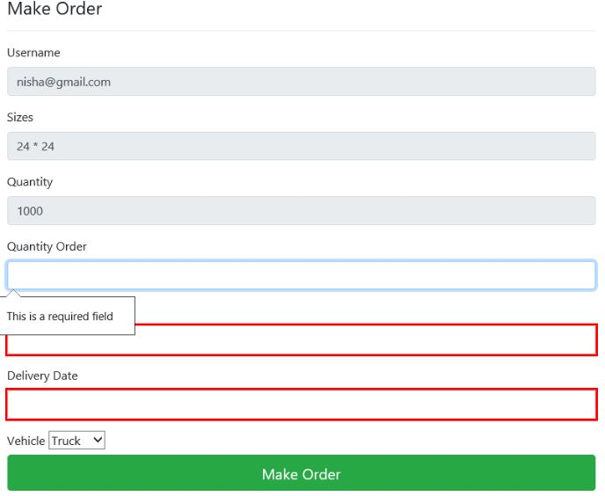

Test 7: Dispatch order testing

Test title: Dispatch order testing Test Planned Date: 27-06-2019

Test Priority (High/Medium/Low): High Test Executed By Binod Rana

Test Completion Date: 27-06-2019

Pre-condition: Admin need to login to the system to dispatch the order

Dependencies: To dispatch order admin need to login to the system

|  |  |  |  |  |  |
| --- | --- | --- | --- | --- | --- |
| Test No | Test scenarios | Test Date | Excepted Result | Actual Result | Outcomes |
| i. | Select order_id for dispatch | 27-06-2019 | Selected order_id details should be retrieved | Details of selected order_id displayed | Pass |
| ii. | Dispatch selected order | 27-06-2019 | Selected order should be dispatch and product should be deducted | Order dispatch success and displayed and product deducted | Pass |

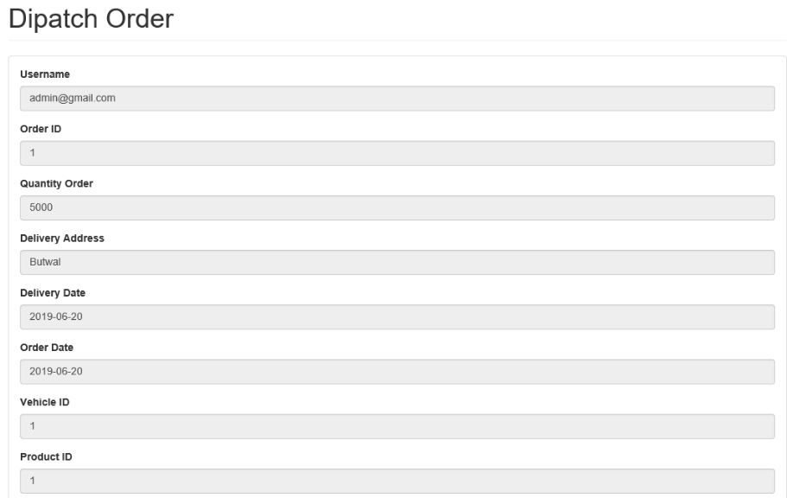

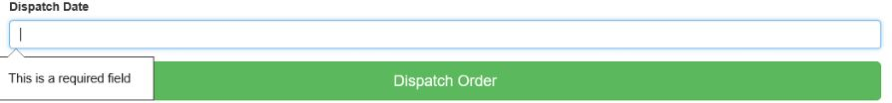

Test 8: Edit user testing

Test title: Edit user testing Test Planned Date: 27-06-2019

Test Priority (High/Medium/Low): High Test Executed By Binod Rana

Test Completion Date: 27-06-2019

Pre-condition: Admin need to login to the system to edit user

Dependencies: To edit user admin need to login to the system

|  |  |  |  |  |  |
| --- | --- | --- | --- | --- | --- |
| Test No | Test Scenarios | Test Date | Excepted Result | Actual Result | Outcomes |
| i. | Select user by user_id | 27-06-2019 | Details of the selected user by user_id should be retrieved | Details of the selected user by user_id retrieved | Pass |
| ii. | Provide empty field | 27-06-2019 | Errors message should be displayed | The error message of the empty field displayed. | Pass |
| iii. | Update user by valid details | 27-06-2019 | User should be updated | User updated successfully | Pass |

