

Mawlana Bhashani Science and Technology University
Santosh, Tangail-1902.

Department of Information and Communication Technology
Assignment On
Course Title | : | Bioinformatics
Course Code | : | ICT - 3203

Submitted By | Submitted To
Name: Binodon  ID: IT-17046  Year: 3rd Semester : 2nd  Dept. of Information & Communication Technology , MBSTU. | Bikash Kumar Paul ,  Lecturer.  Dept. of Information & Communication Technology , MBSTU.

What is cell?
Cell is the basic structural, functional, and biological unit of any life.
Types of cell?
There are two types of cells : a)Prokaryote b)Eukaryote
a) Prokaryote: This type of cells has no nucleus or membrane-bounded organelles. Ex- Bacteria
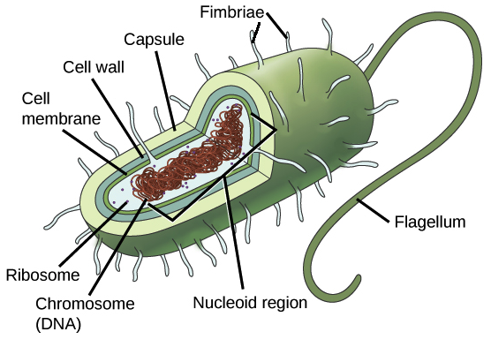

b)Eukaryote – This type of cells have nucleus and other membrane-bounded organelles. Ex- Human
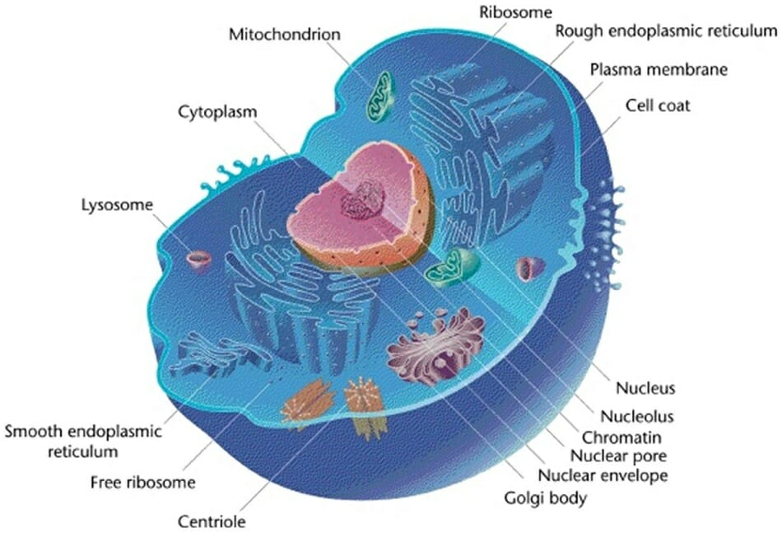

List down the Cell Contents -
Mitochondria,Lysosomes,Golgi Apparatus (body),Endoplasmic, Reticulum, Nucleus ,Cytoplasm

Mitochondria: Power House of Cell
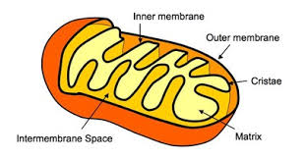

Lysosomes – Holds enzymes created by a cell
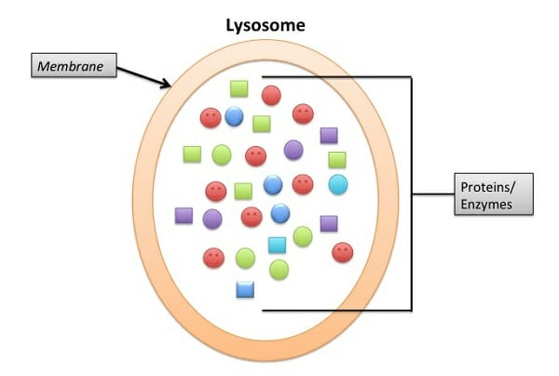

Endoplasmic Reticulum – Involved in protein and lipid synthesis
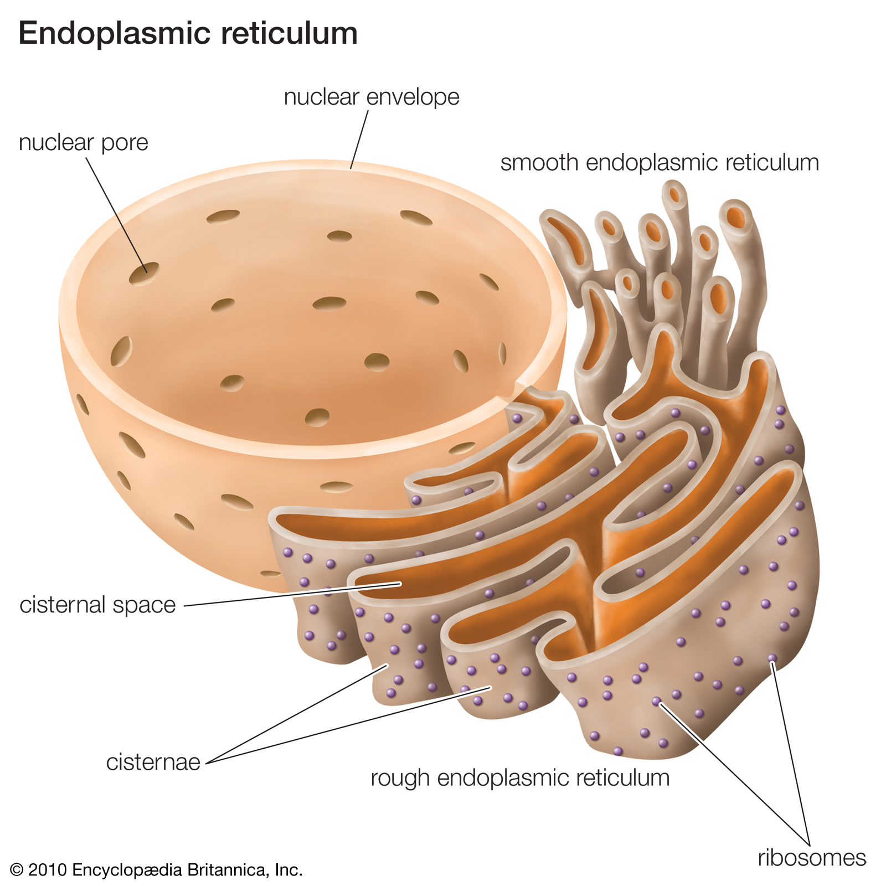

What is Neucleus?Write down its contents?

Nucleus: The nucleus is a membrane-bound organelle that contains the cell's chromosomes

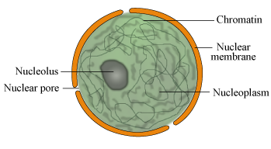
Nucleolus : The nucleolus is a round body located inside the nucleus of a eukaryotic cell.
Chromatin :Packed inside the nucleus of every human cell is nearly 6 feet of DNA, which is divided into 46 individual molecules, one for each chromosome and each about 1.5 inches long. 23 pairs of chromosome, 22 pairs of common autosome, 1 pair sex chromosome
Nucleoplasm : Liquid inside nucleus where all components are floating.

What is Chromosome?

DNA of any cell are packaged in a Structure called Chromosome. Chromosome contains all types of
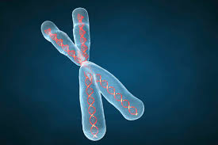
DNA.

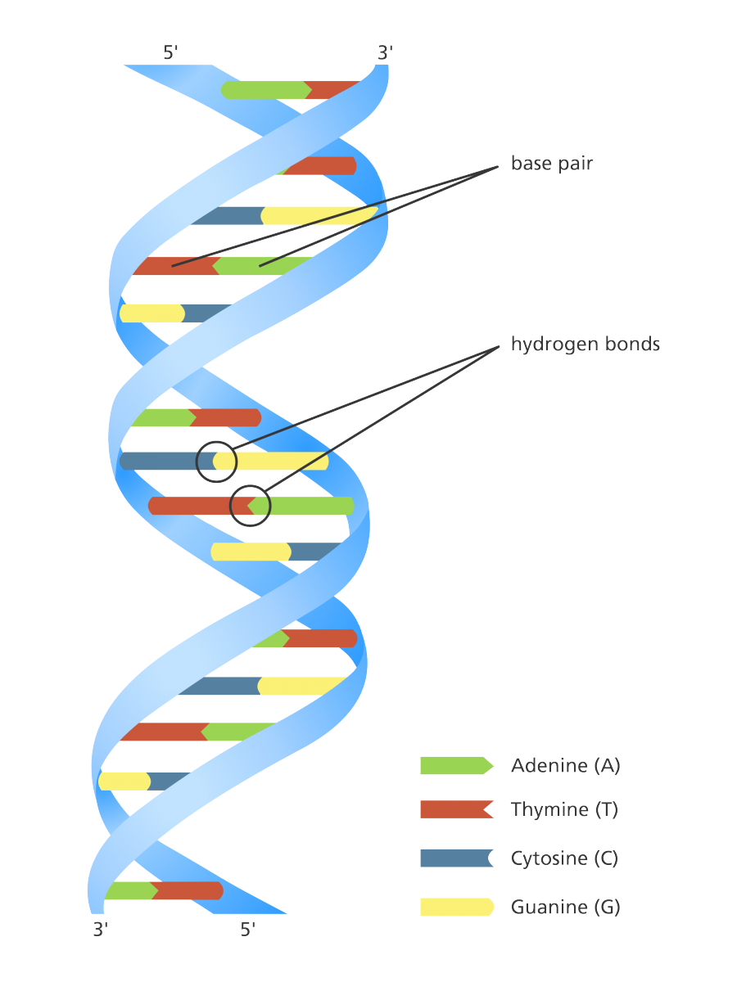
Write down about DNA?
DNA:Deoxyribonucleic acid is a Double helix structure,Having two polyneuclotide chain containing A,T,C,G

A=Adenine
T=Thymine
G=Guanine
C=Cytosine

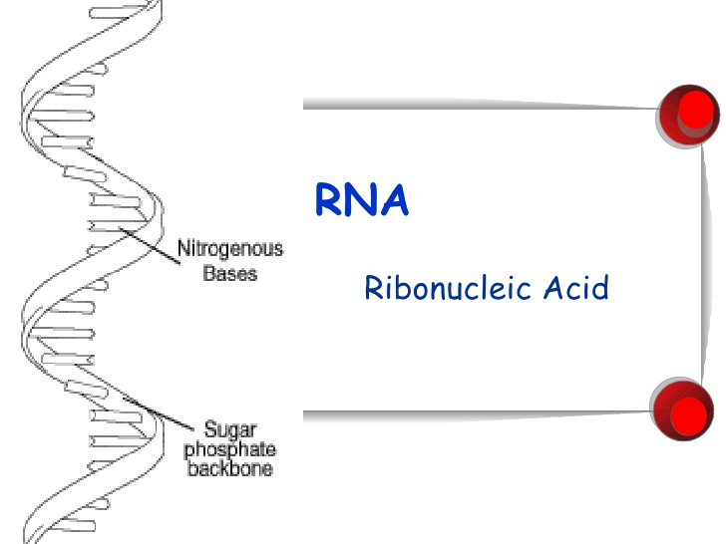
What is RNA?Types of RNA?
Ribonucleic acid (RNA).The nucleic acid that is used in key metabolic processes for all steps of protein synthesis in all living cells and carries the genetic information of many viruses. Unlike double-stranded DNA, RNA consists of a single strand of nucleotides.

3 types of RNA are :
messenger RNA (mRNA)
ribosomal RNA (rRNA)
transfer RNA (tRNA).

