**Lab Report No:** 01

**Lab Report Name:** Networking in Linux.

Name : Binodon

ID : IT-17046

**Objective:-**

In this lab we come to know about Linux and other operating systems . This lab deals takes a look at Linux services that deal with network capabilities like connecting to a network and file sharing are applications or a set of applications that run in the background, enabling certain capabilities as and when they become necessary.

**Introduction :**

An IP address is an address having information about how to reach a specific host, especially outside the LAN. An IP address is a 32-bit unique address having an address space of 2³².

IPv4 address is divided into two parts:

Network ID

Host ID

In classful addressing,the class of IP address is used to determine the bits used for network ID and host ID and also the number of hosts possible in that particular class.

For example in

First, 8-bits are reserved for network ID, the higher-order bit in the first octate in **class A** is always zero, therefore we will have 7 bits to represent network ID and 32-8 (24) for the host ID. Number of network ID 2⁷-2 = 126 (0.0.0.0 and 127.x.y.z are special address)Host ID = 2²⁴ -2 = 16,777,214 Similarly for class B and class C number of host IDs are 65534 and 254 respectively.Now if someone wants 260 IP addresses there are two options:Get two Class C IP blocks: This is hard to maintain and with more IP address we have to maintain more Class C blocks.One IP block of Class B: This will result in many IP addresses not being used.

Here comes Classless addressingto rescue.

Let’s see how CIDR notation look like

a.b.c.e/n eg: 192.164.40.12/24

Here n represents the number of bits for the network ID and 32-n represent the number bits for the host ID.

There are three rules which must be fulfilled by the range of IP addresses in order to be a CIDR block.

All IP addresses are contiguous.

Block size (number of IP addresses in block) must be the power of 2. This makes finding the block id very easy. Eg: if the block size is 2⁵ then, Host ID will contain 5 bits and network ID contain 32–5 = 27 bits.

First IP address of the Block must be evenly divisible by the size of the block.

Here someone can choose any number of IP addresses from 2¹-2³². This will help us to choose the block size which results in less wastage of IP addresses.

Let’s take an example: weather IPs 100.1.2.32 to 100.1.2.47 is a valid CIDR block.

All IP addresses are contiguous.

IP addresses are 100.1.2.32, 100.1.2.33, …, 100.1.2.47. which is 16 = 2⁴.

If we represent first IP address in binary will look like -> 01100100.00000001.00000010.00100000. Since host ID will contain last 4 bits and all the least significant bits are zero.

**Find IP and Mac:-**

Login to your Ubuntu operating system. After that open settings windows on your Ubuntu Desktop machine as shown in the below screen.

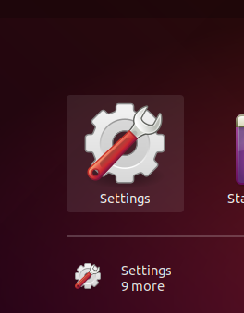

In the left sidebar click on the Network tab. After that click icon to open the settings for your systems network interface as shown in the below screen.

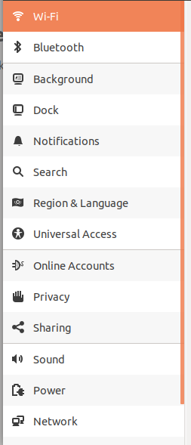

**Method-2:-**

Press CTRL + ALT + T to launch the terminal on your Ubuntu system. Now type following IP command to view current IP addresses configured on your system.

$ ip address

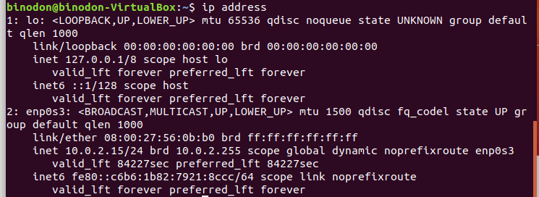

**$ hostname –I**



**Mac:-**

MAC address is another critical parameter of a network device, including your PC’s hardware or a server. Every PC’s network device should have a unique MAC address.

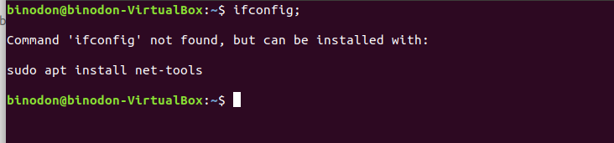

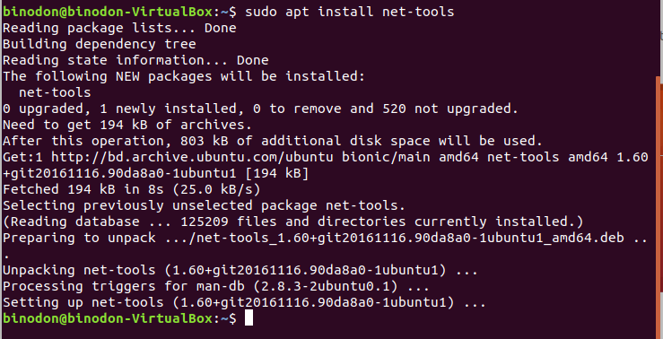

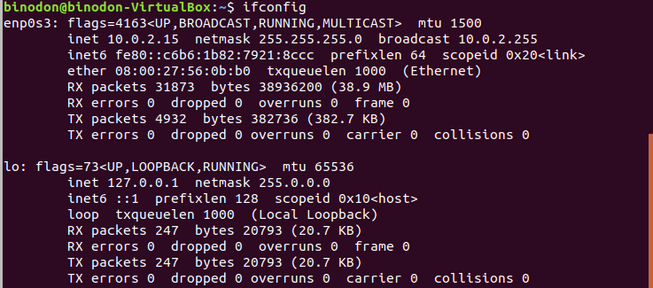

**3)Routing Table basics:-**

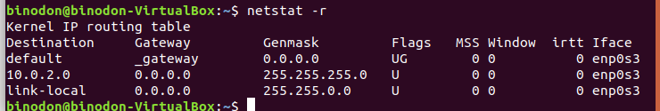

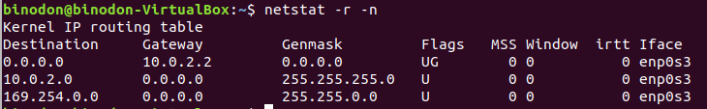

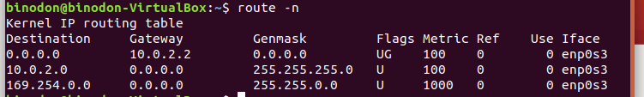

**Conclusion** : In this lab we come to know about Networking through linux. IP address ,hostname,netstat,rout etc and many other thing. To do this lab we didn,t face any problem **.**