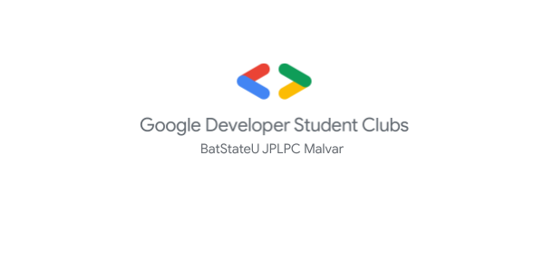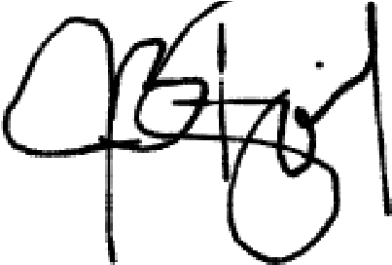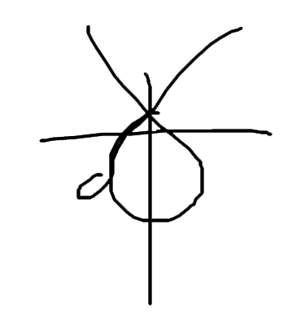

**Jedaiah Bitol**

GDSC-CEC ADVISER

Kenn C. Secusana

CERTIFICATE

THIS CERTIFICATE IS PRESENTED TO

For actively participating in

**JavaStart(): Getting Started with Java**

held on

Saturday, 19 March 2022.

**Joanna Camille Butil**

GDSC-CEC LEAD