分檔
src ->右鍵 ->New ->HeaderFile
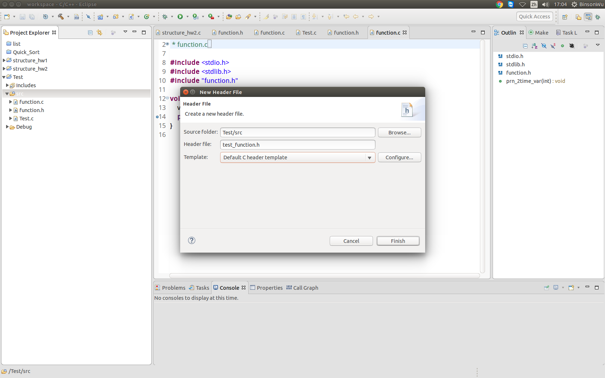
src ->右鍵 ->New ->SourceFile
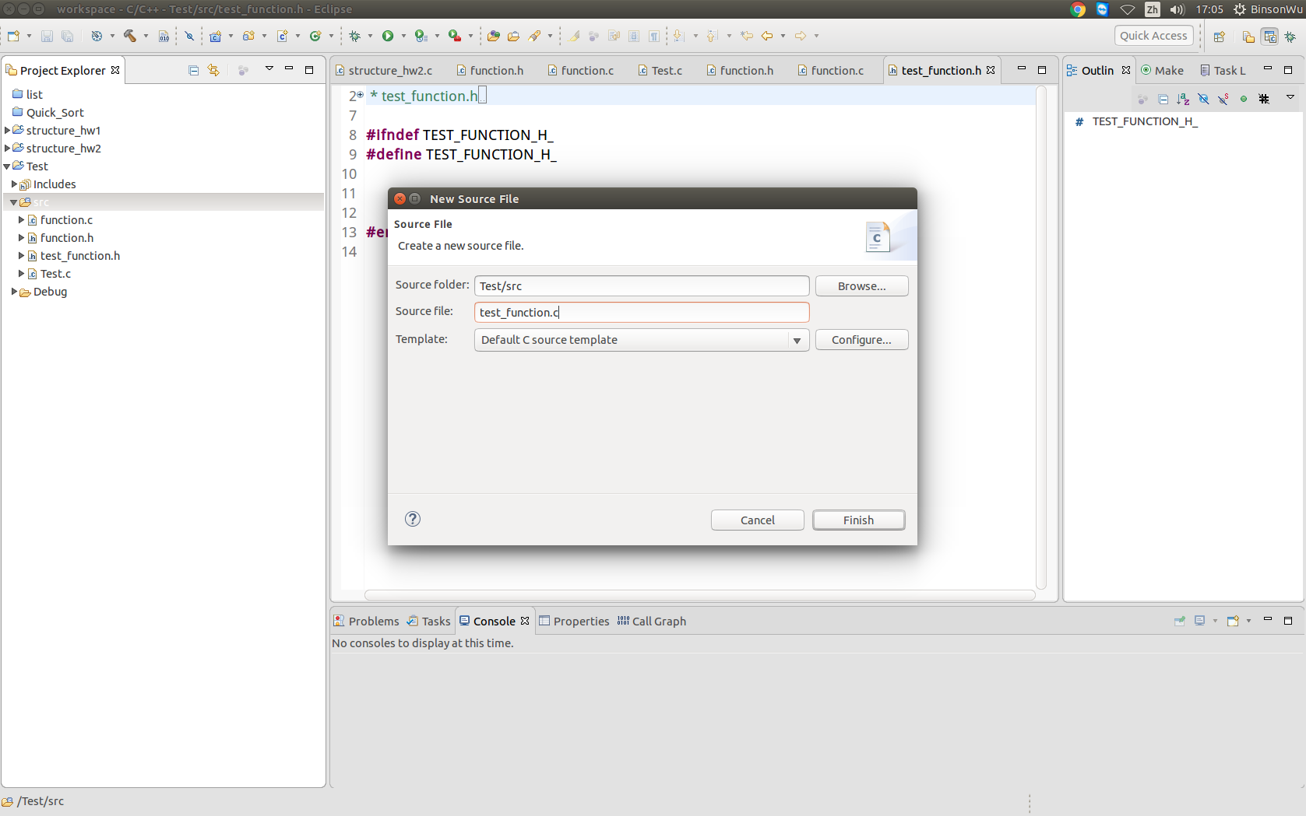
build ->Debug ->Run.

