**Nama : Amartya Bintang Wijat Ranti**

**NIM : L200180193**

**Kelas : Informatika 3**

**Percobaan 3 : Melihat di dalam BCD-to-7segment Decoder**

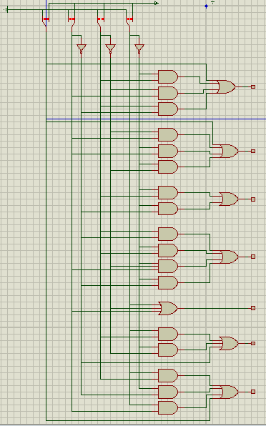

|  |  |  |  |  |  |  |  |  |  |  |  |  |  |
| --- | --- | --- | --- | --- | --- | --- | --- | --- | --- | --- | --- | --- | --- |
| Decimal  Digit | Input | | | | | Output | | | | | | | Display  Output |
| LT | D | C | B | A | a | b | c | d | e | f | g |
| 0 | H | L | L | L | L | H | H | H | H | H | H | L | 0 |
| 1 | H | L | L | L | H | H | H | H | H | H | H | H | 8 |
| 2 | H | L | L | H | L | L | H | H | H | L | H | H | y |
| 3 | H | L | L | H | H | H | H | H | H | L | H | H | 9 |
| 4 | H | L | H | L | L | H | H | L | H | H | L | H | 2 |
| 5 | H | L | H | L | H | H | H | L | H | H | H | H | e |
| 6 | H | L | H | H | L | L | L | H | H | H | H | H | b |
| 7 | H | L | H | H | H | H | L | H | H | H | H | H | 6 |
| 8 | H | H | L | L | L | L | H | H | L | L | L | L | 1 |
| 9 | H | H | L | L | H | H | H | H | L | L | H | H | q |
| LT | L | X | X | X | X | H | H | H | H | H | H | H | 8 |

Berbeda dengan table IC 4511