Software quality assurance
What is SDLC?
SDLC (Software Development Life Cycle) is a structured process used to develop software efficiently. It defines the steps, activities, and tasks needed to build high-quality software that meets user requirements.
Think of it as a recipe for creating software, where every step ensures the software is done correctly, on time, and within budget.

Goals of SDLC
- Produce high-quality software that meets requirements.
- Complete software within time and cost limits.
- Ensure error-free and maintainable software.

Phases of SDLC
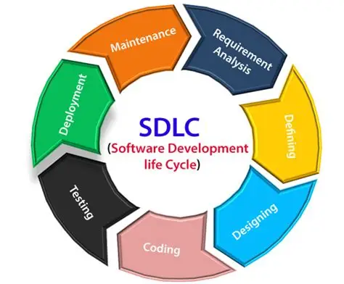

- Requirement Analysis
  - Gather and understand what the client/user wants.
  - Document functional and non-functional requirements.
  - Tools: Requirement Specification Document (SRS).
  - Example: Client wants a school management system to track students, teachers, and classes.
- Planning/defining
  - Decide the project scope, resources, timeline, and budget.
  - Identify risks and prepare mitigation plans.
  - Example: Team size = 5, Duration = 3 months, Tech = MERN Stack.
- Design
  - Architect the software (how it will work).
  - Create UI/UX design, database schema, and system architecture.
  - Example: Designing tables for students, teachers, and classes; creating wireframes.
- Implementation / Coding
  - Developers write the actual code.
  - Follow coding standards and guidelines.
  - Example: Build modules for student registration, attendance, and exam results.
- Testing
  - Check if the software works as expected.
  - Types: Unit testing, Integration testing, System testing, User Acceptance testing (UAT).
  - Example: Test if a student can be successfully added to the system.

- Deployment
  - Release the software to the client or production environment.
  - Can be done in phases or full release.
  - Example: Deploy the school management system online for use.
- Maintenance
  - Fix bugs, update features, improve performance.
  - Ensure software continues to meet user needs.
  - Example: Add a new feature to generate student performance reports.

SDLC Models
SDLC can follow different models depending on project needs:
- Waterfall Model – Linear and sequential.
- V-Model – Testing at each stage.
- Iterative Model – Build in repeated cycles.
- Agile Model – Flexible, incremental, user-focused.
- Spiral Model – Focus on risk analysis.
- RAD- Fast development and quick delivery of software.

What is the Waterfall Model?
The Waterfall Model is the traditional SDLC model where each phase of software development flows downward like a waterfall.
- Each phase must be completed before moving to the next.
- There’s no going back to previous phases easily.
Think of it like building a house: you finish the foundation → then walls → then roof → then painting.

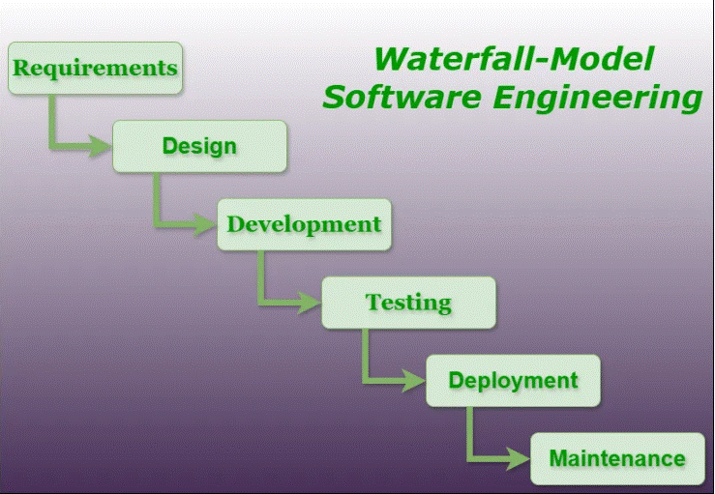
Phases of Waterfall Model

- Requirement Analysis
  - Gather all requirements from the client.
  - Create a Requirement Specification Document (SRS).
  - No changes are expected later.
  - Example: Client wants an online shopping system with login, product listing, and checkout.
- System Design
  - Convert requirements into system architecture.
  - Decide database design, technology stack, and UI design.
  - Example: Tables for users, products, orders; wireframes for shopping pages.
- Implementation / Coding
  - Developers write code according to the design.
  - Done module by module.
  - Example: Build login module → product module → checkout module.
- Testing
  - After coding is complete, testers check the software for bugs.
  - Types: Unit Testing, Integration Testing, System Testing.
  - Example: Test if the login works with correct credentials, test checkout payment process.
- Deployment
  - Software is delivered to the client or released in production.
  - Example: Upload the shopping system to the live server.
- Maintenance
  - Fix bugs, add minor updates after deployment.
  - Example: Add a feature for discount coupons, fix payment gateway issues.

Characteristics of Waterfall Model
- Linear & Sequential: One phase after another.
- Documentation Heavy: Each phase is well-documented.
- Easy to Understand & Manage: Especially for small projects.

Advantages
- Simple and easy to manage.
- Well-documented phases.
- Clear milestones at the end of each phase.

Disadvantages
- Not flexible – changes are very hard once a phase is done.
- Late testing – bugs are found only after coding is complete.
- Not suitable for complex or evolving projects.
- High risk if requirements are not clear from the start.

Example: Imagine building a library management system. In Waterfall:
- First, gather all requirements → design database → write all code → test everything → deploy → maintain.
- If the client wants a new feature after coding, it’s difficult and expensive to add.

What is Agile?
Agile is a flexible and iterative software development methodology where:
- Software is built incrementally in small parts called iterations or sprints.
- Customer feedback is continuously incorporated.
- Teams collaborate closely and adapt to changes quickly.
Think of it like baking a cake layer by layer and letting the customer taste each layer—you can adjust sweetness, flavor, or decoration as you go.

Key Principles of Agile
From the Agile Manifesto:
- Individuals and interactions over processes and tools.
- Working software over comprehensive documentation.
- Customer collaboration over contract negotiation.
- Responding to change over following a plan.
- Face to face conversations

Agile Process
[In Agile, a backlog is a list of all tasks, features, improvements, and bug fixes that need to be done in a project. Think of it like a to-do list for the whole project.
Key Points
- Backlog items are called user stories or tasks.
- Items can be added, removed, or reprioritized anytime.
- Helps the team stay organized and focused on important work.

Example:
Imagine you are building a food delivery app.
- Product Backlog: All features the app will ever have (login, menu, payments, reviews, tracking).
- Sprint Backlog: Features you’ll build this week (login + menu display).]

- Product Backlog – List of all features or tasks needed.
- Contains all features and requirements for the product.
- Managed by the Product Owner.
- Items are prioritized based on importance.
- Example:
- User login
- Add products to cart
- Checkout process
- Push notifications

- Sprint Planning – Decide which features to develop in the next sprint (usually 1–4 weeks).
- Contains tasks selected from the product backlog for the current sprint.
- Managed by the development team.
- Represents what the team will work on in this sprint.
- Example:
- Implement login feature
- Create UI for cart page
- Test checkout process

- Sprint Execution – Team develops the features in that sprint.
- Daily Stand-ups – Short daily meetings to track progress.
- Sprint Review / Demo – Show the completed features to the client.
- Sprint Retrospective – Discuss what went well, what can improve.
- Repeat the cycle for the next sprint.

Characteristics of Agile
- Iterative & Incremental: Work in small chunks.
- Adaptive: Can change requirements anytime.
- Collaborative: Team and client work together closely.
- Frequent Delivery: Software usable after each sprint.

Advantages
- Flexibility to change requirements anytime.
- Early detection of issues/bugs.
- High customer satisfaction.
- Faster delivery of working software.

Disadvantages
- Needs high customer involvement.
- It can be chaotic without proper planning.
- Documentation is often less detailed.
- It is harder to predict exact cost and time initially.

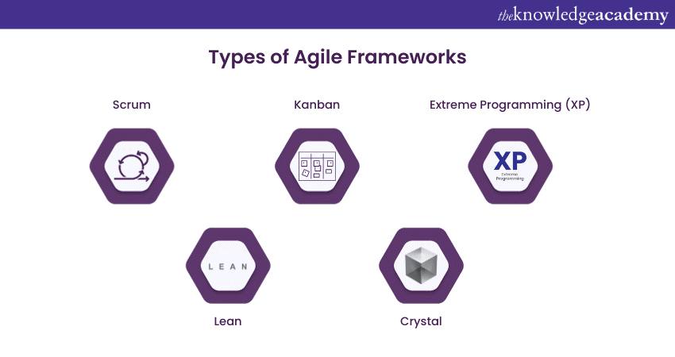
Agile types

What is Scrum?
Scrum is a popular Agile framework used to manage software development.
- It focuses on short, iterative sprints, team collaboration, and continuous delivery of value.
- Scrum helps teams organize work, track progress, and adapt to changes quickly.
Think of Scrum like a well-organized sports team: everyone has a role, short practice sessions (sprints), daily check-ins, and constant feedback to win the game.

Key Roles in Scrum
- Product Owner (PO)
  - Represents the customer/stakeholder.
  - Creates and prioritizes the Product Backlog.
  - Ensures the team builds the right features.
In short
- Project vision
- Requirements
- priorities
- Scrum Master (SM)
  - Facilitator of the Scrum process.
  - Removes obstacles for the team.
  - Ensure Scrum rules are followed.
- Development Team(6+-3 people)
  - People who build the product (developers, testers, designers).
  - Self-organizing and cross-functional.
  - How best the meet of product owner

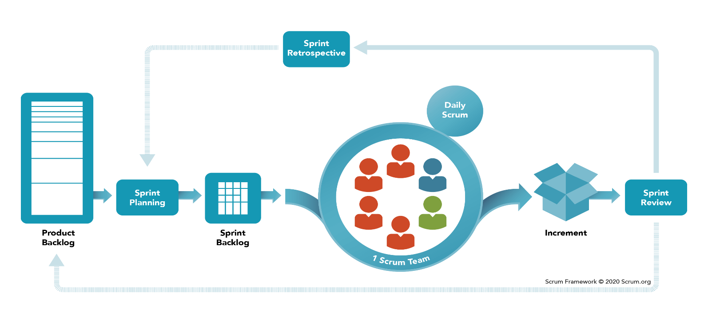
Scrum Artifacts

- Product Backlog – Complete list of all features, improvements, and bug fixes.
- Sprint Backlog – Selected items from the product backlog for the current sprint.
- Increment – The working software delivered at the end of a sprint.

Scrum Events
- Sprint Planning – Decide which backlog items to work on in the sprint.
- Daily Stand-up (Daily Scrum) – Short 15-minute meeting to discuss:
  - What I did yesterday
  - What I will do today
  - Any obstacles I’m facing
- Sprint Review / Demo – Show completed work to stakeholders.
- Sprint Retrospective – Discuss what went well, what can improve, and actions for the next sprint.

Sprint Example in Scrum
Imagine building a food delivery app:
- Product Backlog: Login, menu, cart, payment, tracking, reviews.
- Sprint 1 (2 weeks) → Implement login + menu display.
- Sprint 2 (2 weeks) → Cart + Checkout.
- Sprint 3 (2 weeks) → Tracking + reviews.
Daily Stand-up:
- Developer 1: “Yesterday, I completed login page. Today, I’ll start menu page. No blockers.”
- Developer 2: “Yesterday, menu UI done. Today, connecting it to backend. Blocker: API not ready.”
At the end of each sprint, the app is partially usable and improved over time.

Advantages of Scrum
- Flexible to changes in requirements.
- Delivers working software quickly.
- Improves team collaboration and transparency.
- Frequent feedback from the customer.

Disadvantages
- Requires experienced team members.
- Needs high customer involvement.
- Can be chaotic if Scrum rules are not followed.

Quick Tip:
Scrum = Agile framework + sprints + defined roles + daily communication.

What is Kanban?
Kanban is an Agile framework for managing work visually, focusing on continuous delivery and workflow efficiency.
- It uses a board with columns to track tasks from start to finish.
- Helps teams see what’s being worked on, what’s done, and what’s next.
- Unlike Scrum, no fixed sprints – work flows continuously.
Think of it like a restaurant kitchen: orders come in, chefs work on them, and finished dishes go out.
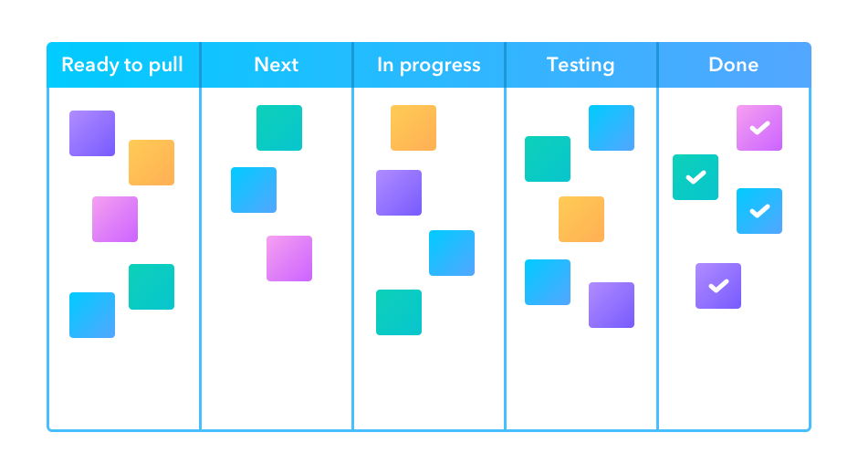
Kanban Board

A Kanban board usually has 3 main columns:
- To Do – Tasks waiting to be started.
- In Progress – Tasks currently being worked on.
- Done – Completed tasks.
# Optional columns can include Review, Testing, or Blocked depending on the team’s workflow.

Key Principles of Kanban
- Visualize the workflow – Use cards and columns to track tasks.
- Limit Work in Progress (WIP) – Only a certain number of tasks can be in progress at once.
- Focus on flow – Move tasks smoothly from start to finish.
- Continuous improvement – Regularly analyze and improve workflow.

Example
Imagine building a food delivery app using Kanban:
- To Do: Login, Menu, Cart, Payment, Tracking, Reviews
- In Progress: Login page being developed
- Done: Home screen ready
As tasks are finished, they move from To Do → In Progress → Done.
- You can add new tasks anytime, and there’s no fixed sprint.

Advantages of Kanban
- Simple, visual, easy to understand.
- Flexible – no fixed deadlines.
- Encourages continuous delivery.
- Helps identify bottlenecks in workflow.

Disadvantages
- Not ideal for projects needing strict deadlines.
- Less structure than Scrum – may lead to chaotic management if not careful.
- Progress tracking can be harder for large projects without proper tools.

# Quick Tip:
Kanban = Visual workflow + continuous work + limit work in progress.

What is Lean Agile?
Lean Agile combines Lean principles (from manufacturing) with Agile software development to deliver high-value software efficiently.
- Focuses on eliminating waste, optimizing processes, and delivering value quickly.
- Works well for fast-moving projects where efficiency and quality are crucial.
Think of it like streamlining a kitchen: only cook what customers need, remove unnecessary steps, and deliver food quickly and perfectly.

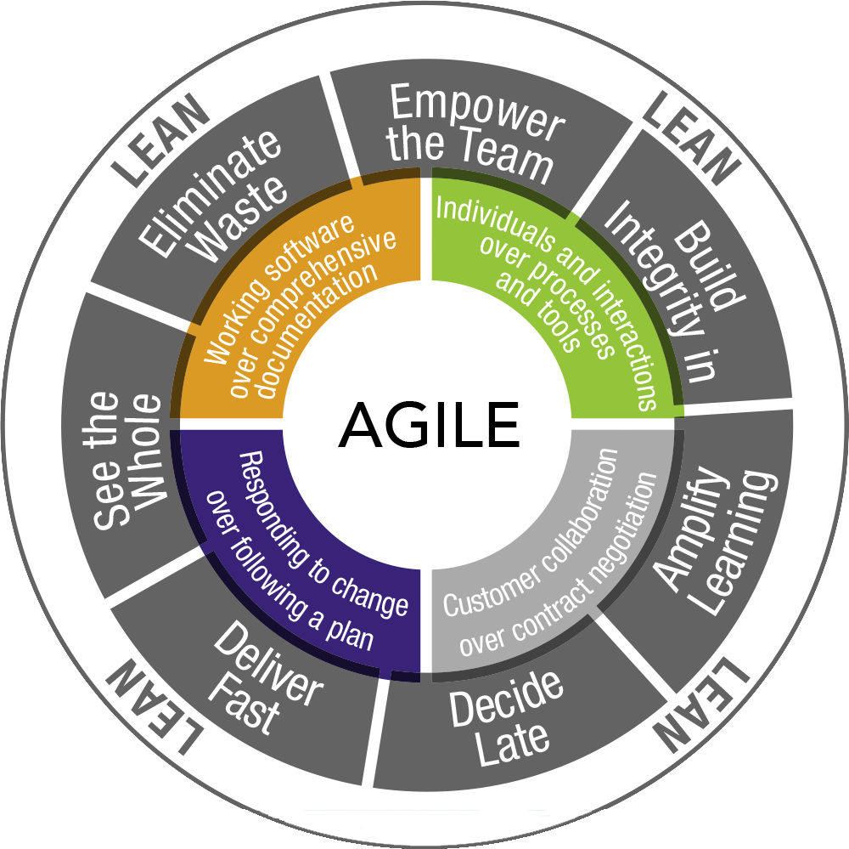
Core Principles of Lean Agile
- Eliminate Waste – Remove unnecessary work, features, or steps that don’t add value.
  - Example: Skip building features no one will use.
- Amplify Learning – Encourage continuous feedback and learning.
  - Example: Test early, learn from mistakes, improve quickly.
- Decide as Late as Possible – Keep options open until the last responsible moment.
  - Example: Don’t finalize UI design until requirements are clearer.
- Deliver as Fast as Possible – Focus on delivering usable software quickly.
  - Example: Release a minimum viable product (MVP) first.
- Empower the Team – Teams should self-organize and make decisions.
- Build Integrity In – Ensure quality from the start, don’t fix it later.
- See the Whole – Focus on the overall system, not just individual tasks.

How Lean Agile Works
- Break work into small, valuable chunks (like Agile sprints).
- Continuously analyze processes and remove anything that slows down delivery.
- Focus on customer value rather than just completing tasks.

Example
Imagine building a food delivery app:
- Instead of building login + menu + cart + payment + reviews all at once:
  - Deliver MVP first: Login + menu + basic order.
  - Get user feedback: Learn which features are most important.
  - Add features incrementally: Cart → payment → tracking → reviews.
- Remove unnecessary steps like overly complicated backend setup until required.

Advantages of Lean Agile
- Faster delivery of high-value features.
- Reduces waste and unnecessary work.
- Continuous improvement and learning.
- Empowers teams and increase collaboration.

Disadvantages
- Requires experienced teams to make correct decisions.
- It can be chaotic without strong process discipline.
- It is harder to plan long-term because of flexibility.

Quick Tip:
Lean Agile = Agile mindset + Lean efficiency → deliver value fast, smart, and efficiently.

What is XP (Extreme Programming)?
Extreme Programming (XP) is an Agile software development methodology that focuses on:
- Improving software quality
- Responding to changing customer requirements quickly
- Frequent releases and continuous feedback
Think of XP like “taking best practices in software development and doing them to the extreme”.

Core Values of XP
- Communication – Developers and customers must communicate constantly.
- Simplicity – Always implement the simplest solution that works.
- Feedback – Continuous feedback from customers and tests.
- Courage – Have the courage to make changes when needed.
- Respect – Team members respect each other’s work and ideas.

Key Practices of XP
- Pair Programming – Two developers work together on the same code.
  - One writes code, the other reviews in real-time.
- Test-Driven Development (TDD) – Write tests before coding.
  - Ensures code works correctly from the start.
- Continuous Integration (CI) – Code is integrated and tested frequently.
- Refactoring – Continuously improve code without changing functionality.
- Small Releases – Frequent, small releases to get early feedback.
- Simple Design – Avoid overcomplicating the code or design.

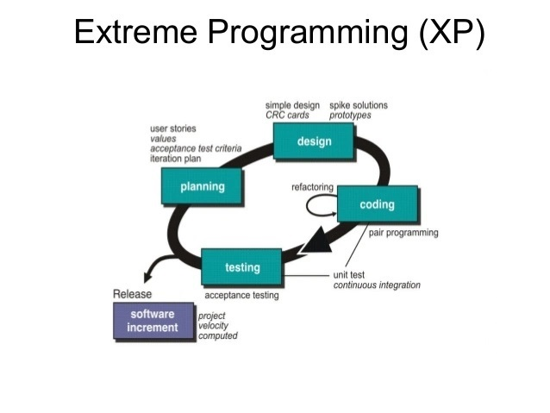
XP Process

- Planning – Customer creates user stories (requirements).
- Small Releases – Implement a few stories at a time.
- Continuous Testing – Run tests for every small change.
- Customer Feedback – Get feedback after each release.
- Refactor – Improve code and design based on feedback.

Example
Imagine building a food delivery app:
- Customer story: “I want to log in and see the menu.”
- Pair Programming: Two developers work together to build this.
- TDD: First, write tests to check login works.
- Small Release: Deploy login + menu to test users.
- Feedback: Users suggest menu categories.
- Refactor: Update menu design without breaking login.
Repeat for each new feature.

Advantages of XP
- High-quality code due to TDD and pair programming.
- Very responsive to changing requirements.
- Frequent releases keep customers engaged.
- Encourages teamwork and communication.

Disadvantages
- Requires highly skilled and disciplined team.
- Needs constant customer involvement.
- It can be expensive due to pair programming and continuous testing.

Quick Tip:
XP = Agile + Extreme focus on quality, testing, and collaboration.

What is Crystal Agile?
Crystal is an Agile software development framework that emphasizes:
- People and interactions over processes and tools
- Flexibility depending on team size, project criticality, and priorities
- Lightweight documentation and easy communication
Think of Crystal like a family of Agile methods, where the exact approach changes based on project size and risk.

Key Principles of Crystal
- People over processes – Skilled and motivated people are more important than rigid rules.
- Frequent delivery – Deliver usable software frequently.
- Reflective improvement – Teams continuously improve how they work.
- Osmotic communication – Encourage natural communication by working closely.
- Simplicity – Avoid unnecessary work or documentation.

Crystal Family
Crystal is not a single method—it has different variants based on project size and criticality:
Variant |  | Team Size | Criticality
Crystal Clear |  | Up to 6 | Low (loss of comfort only)
Crystal Yellow |  | 7–20 | Medium (loss of money)
Crystal Orange |  | 20–50 | Medium-High
Crystal Red |  | 50+ | High (loss of life possible)
The color shows the risk/criticality of the project—the darker the color, the higher the criticality.

How Crystal Works
- Frequent Delivery: Work is delivered in small increments.
- Reflective Improvement: Teams meet regularly to improve processes.
- Osmotic Communication: Team works close together so knowledge flows naturally.
- Lightweight Documentation: Only essential documentation is maintained.

Example
Building a small school management app with Crystal Clear:
- Team size: 5 people
- Project is low-risk (no critical financial data)
- Daily conversations, frequent mini-deliveries (like student registration module)
- Minimal documentation, focus on working software

Advantages of Crystal
- Highly flexible and adaptive.
- Emphasizes team communication and collaboration.
- Lightweight—less bureaucracy and documentation.
- Works well for small to medium-sized teams.

Disadvantages
- Not suitable for large, highly critical projects.
- Less structure can lead to chaos if the team is inexperienced.
- Customer involvement is crucial—without it, risk increases.

Quick Tip:
Crystal Agile = people-focused, flexible, lightweight Agile.
Choose the variant based on team size and project risk.

What is the V-Model?

The V-Model (Validation and Verification Model) is a Software Development Life Cycle (SDLC) model where testing activities are planned in parallel with development activities.
- It’s called “V-Model” because the process diagram looks like the letter “V”.
- Left side of V: Development phases(verification) (requirements → design → coding)
- Right side of V: Corresponding testing/validation phases (unit testing → integration testing → system testing → acceptance testing)
Think of it like a mirror image: for every development step, there is a matching testing step.

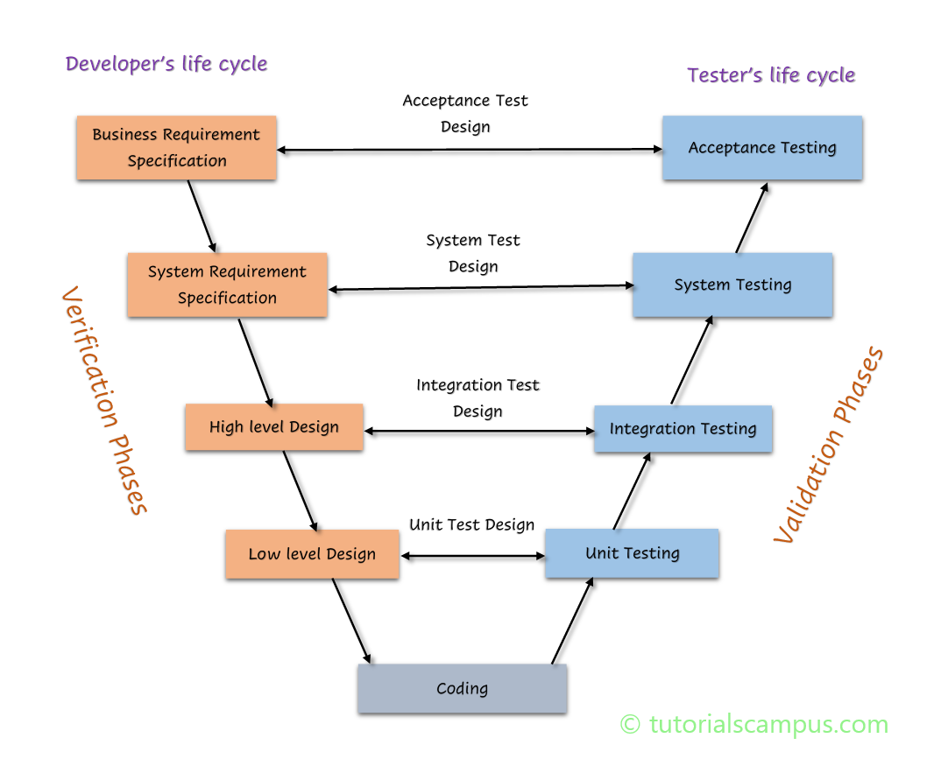
Phases of V-Model

Left Side (Development Phases)
- Requirement Analysis
  - Gather functional and non-functional requirements.
  - Create Software Requirement Specification (SRS).
- System Design
  - Create system architecture and define hardware/software requirements.
- High-Level Design (HLD)
  - Design modules and their relationships.
- Low-Level Design (LLD)
  - Detailed design of each module for coding.
- Coding / Implementation
  - Developers write actual code based on designs.

Right Side (Testing Phases)
- Unit Testing
  - Tests individual modules (matches LLD).
- Integration Testing
  - Tests interactions between modules (matches HLD).
- System Testing
  - Tests the entire system against requirements (matches System Design).
- User Acceptance Testing (UAT)
  - Tests system against user requirements (matches Requirement Analysis).

Characteristics of V-Model
- Verification and Validation at every stage
- Highly structured and disciplined
- Emphasizes early test planning

Advantages
- Early detection of defects – Testing is planned in parallel.
- Well-structured and easy to understand.
- Clear documentation at each stage.
- Each phase has corresponding test activity, reducing chances of missing bugs.

Disadvantages
- Very rigid – Difficult to accommodate changes once a phase is completed.
- Not suitable for large, complex projects with evolving requirements.
- High risk if requirements are incorrect initially.

Example
Building a library management system:
- Requirement Analysis → UAT: Test if system meets all user needs (book search, issue/return).
- System Design → System Testing: Test overall system integration (database + UI + backend).
- HLD/LLD → Unit/Integration Testing: Test individual modules (book module, user module) and their interactions.

Quick Tip:
Think of the V-Model like a ladder:
- Left side: Build the software step by step
- Right side: Test each step at the same leve
What is the Spiral Model?
The Spiral Model is an SDLC model that combines iterative development (like Agile) with risk analysis.
- The project goes through repeated cycles (spirals).
- Each cycle consists of planning, risk analysis, engineering, and evaluation.
- Focuses on reducing risk early and delivering progressively.
Think of it like climbing a spiral staircase: with each loop, you move higher (progress) while reviewing and improving.

Phases of the Spiral Model (per cycle)

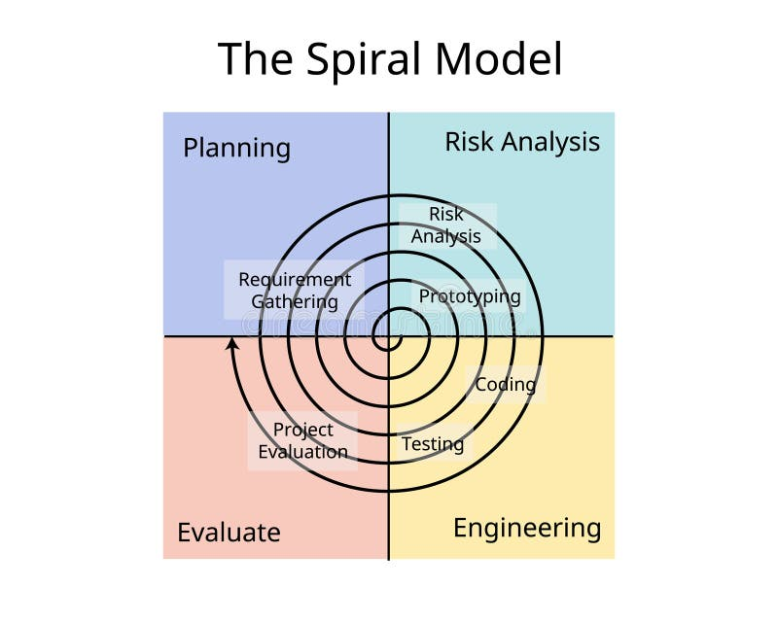
- Planning
  - Gather requirements, define objectives, and plan the next iteration.
  - Decide what to build in this cycle.
- Risk Analysis
  - Identify potential risks (technical, financial, schedule).
  - Prepare strategies to mitigate risks.
- Engineering / Development
  - Design, develop, and test the software for this iteration.
  - Can include coding, prototyping, or building modules.
- Evaluation / Customer Feedback
  - Present the software or prototype to the client.
  - Get feedback and plan improvements for the next spiral.

Key Characteristics
- Iterative & incremental – Software is built in loops.
- Risk-driven – Focuses on identifying and solving risks early.
- Customer involvement – Feedback is used to refine the product.
- Flexible – Requirements can evolve with each spiral.

Advantages
- Early identification and reduction of risks.
- Frequent customer feedback improves software quality.
- Supports large and complex projects.
- Flexible in changing requirements.

Disadvantages
- Can be expensive due to repeated risk analysis and iterations.
- Requires experienced team to manage risk properly.
- Complex management compared to simpler models like Waterfall.

Example
Imagine building a banking application:
- Spiral 1: Prototype login + account summary → test → feedback → adjust design.
- Spiral 2: Add fund transfer → test → feedback → refine.
- Spiral 3: Add loan management → test → feedback → refine.
With each spiral, the app grows in functionality while risks are mitigated early.

Quick Tip:
Spiral Model = Iterative + Risk-focused → deliver software step by step while minimizing risks.
What is the Iterative Model?
The Iterative Model is indeed a technique where software development processes are repeated multiple times to gradually improve the system.
- Each repetition is called an iteration.
- The system grows and improves after each iteration.
- Instead of building the entire system at once, you repeat processes like design → coding → testing multiple times.
.
Think of it like painting a wall in layers: first, you paint a rough base, then add details layer by layer until it’s complete.

Phases of Each Iteration
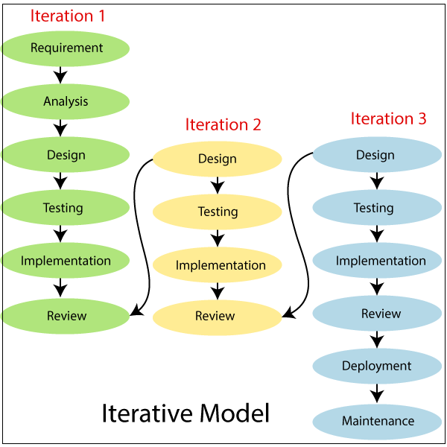
- Requirement Gathering (Partial)
  - Identify a subset of requirements for this iteration.
- Design
  - Design the system or module for this iteration.
- Implementation / Coding
  - Develop and code the module.
- Testing
  - Test the module to ensure it works correctly.
- Evaluation / Feedback
  - Review results and plan the next iteration.
Repeat these steps until the full system is complete.

Key Characteristics
- Incremental development – Build software piece by piece.
- Early delivery of partial software – Users can see progress early.
- Allows requirement changes – Later iterations can adapt to new requirements.
- Focus on risk reduction – Problems are discovered early in each iteration.

Advantages
- Early detection of issues – Testing in each iteration finds bugs early.
- Flexible to changes – Can incorporate new requirements in future iterations.
- Customer can see progress – Provides working software early.
- Reduces overall risk – Issues are identified gradually, not at the end.

Disadvantages
- Requires good planning to manage iterations properly.
- Can be complex for large projects with many iterations.
- May lead to scope creep if requirements keep changing.

Example
Imagine building a food delivery app:
- Iteration 1: Build login + menu display → test → feedback
- Iteration 2: Build cart + checkout → test → feedback
- Iteration 3: Add tracking + reviews → test → feedback
After each iteration, the app works partially and improves gradually.

💡 Quick Tip:
Iterative Model = Step-by-step + incremental + feedback-oriented development.

Two Types of Iterative Model
- Incremental Model
  - The system is built and delivered in small parts (increments).
  - Each increment adds functional features to the system.
  - At the end, all increments together form the complete system.
  - Example:
    - Iteration 1: Login module
    - Iteration 2: Cart + Checkout
    - Iteration 3: Order tracking + Reviews
  - After all increments, you have a fully functional app.
- Evolutionary Model
  - The system evolves through repeated refinement.
  - Each iteration improves existing functionality based on feedback.
  - Focus is more on adapting to changes than just delivering increments.
  - Example:
    - Iteration 1: Basic login system
    - Iteration 2: Improve login with social login options
    - Iteration 3: Add security and performance improvements
  - Over time, the system evolves into the final product.

Difference Between Incremental and Evolutionary
Feature | Incremental Model | Evolutionary Model
Focus | Adding new functionality | Improving existing functionality
Delivery | Functional increments delivered | System evolves gradually
Feedback | Less frequent | Continuous and heavily used
Example | Food delivery app: add modules one by one | Login system evolves with features and improvements

Summary:
- Iterative = repeat processes multiple times
- Incremental = deliver small functional parts repeatedly
- Evolutionary = improve and refine the system repeatedly

What is RAD?
RAD (Rapid Application Development) is an SDLC model that focuses on fast development and quick delivery of software.
- Emphasizes prototyping, user feedback, and iterative development.
- Goal: deliver a working system in a short time.
- Ideal for projects where requirements can change frequently.
Think of it like building a clay model of a car first, showing it to the customer, then improving it based on feedback until the final car is ready.

Phases of RAD

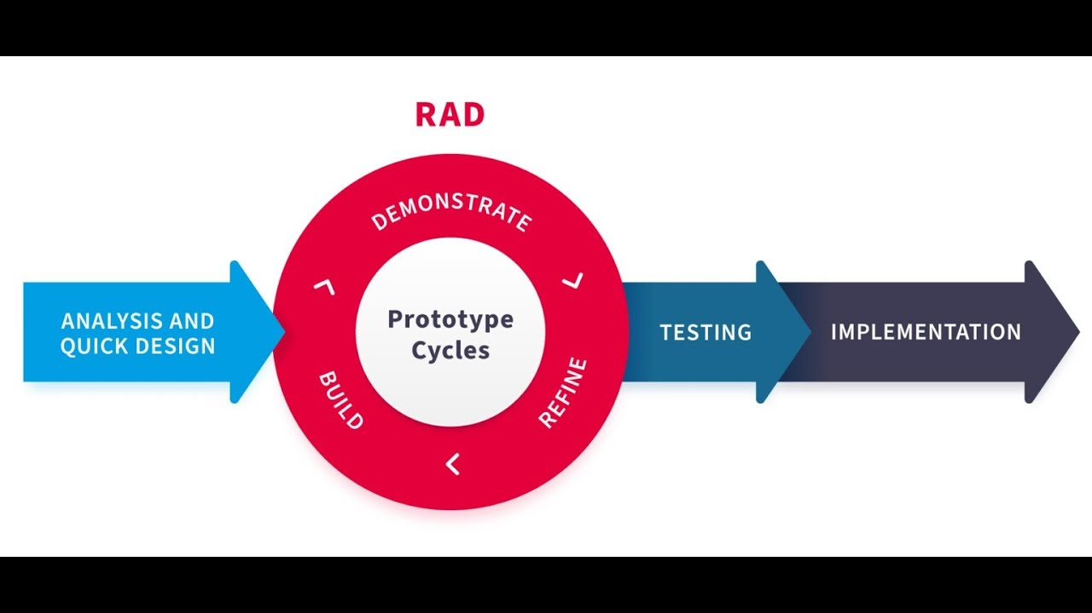
Think: Instead of building the whole software at once, you make small working versions (prototypes) quickly, show them to the user, and improve step by step.
- Goal: Finish software quickly with user feedback
- Best for: Small or medium-sized projects where requirements can change

4 Simple Steps of RAD
- Planning → Decide what the software should do.
  - Example: “We want a food delivery app.”
- Prototype / Design → Build a small version to show the user.
  - Example: “Here’s login and menu pages.”
- Build / Improve → Keep adding features and improving based on feedback.
  - Example: Add cart, checkout, tracking, reviews.
- Final Delivery → Give the final app to the user.
  - Example: Complete food delivery app is ready to use.

Easy Features
- Make quick versions → users see and comment
- Improve step by step → don’t wait till the end
- Fast delivery → usable software in short time

Example in Real Life
Imagine building a cake for a party:
- First, bake a small sample cake → show to friends → they say “more chocolate!”
- Then bake a bigger cake with chocolate → show again → refine toppings
- Finally, bake the full cake for the party → everyone is happy
RAD works just like that, but for software

Key Characteristics
- Prototyping-based: Users see early versions of the software.
- Iterative and incremental: Each prototype improves the system.
- Focus on user involvement: Continuous feedback.
- Time-focused: Faster delivery compared to traditional Waterfall.

Advantages of RAD
- Fast development – Reduced time to deliver.
- High user involvement – Users see prototypes and provide feedback.
- Flexible – Requirements can change during development.
- Encourages reuse of components, saving effort.

Disadvantages
- Requires highly skilled developers.
- Not suitable for large, complex projects.
- Can be expensive due to prototyping and iterations.
- Less focus on documentation – can cause issues later.

Example
Imagine building a food delivery app using RAD:
- Prototype 1: Login and menu display → user feedback
- Prototype 2: Add cart + checkout → feedback → refine
- Prototype 3: Add tracking + reviews → refine → final deployment
Users see and interact with the app early, so developers can adapt quickly.

Quick Tip:
RAD = Rapid + Prototyping + User Feedback → Fast, flexible development

Model | Type / Approach | Key Idea | Pros | Cons | Use Case
Waterfall | Linear, sequential | Complete one phase before next | Simple, structured | Rigid, hard to change, late testing | Fixed requirements
V-Model | Verification & validation | Each dev phase has matching test phase | Early defect detection, structured | Rigid, hard to change | Critical quality projects
Iterative | Repeated cycles | Build small parts repeatedly & improve | Flexible, early feedback | Needs planning, can cause scope creep | Projects with evolving requirements
Incremental (Iterative type) | Build in parts | Deliver functional parts step by step | Early delivery, reduced risk | Partial system may not be useful alone | Medium-sized projects
Evolutionary (Iterative type) | Refine repeatedly | Improve system iteratively | Adapts to changes, reduces risk | Can go off-track if uncontrolled | Projects with changing requirements
Spiral | Risk-driven iterative | Planning → Risk → Dev → Feedback | Reduces risk, supports complex projects | Expensive, complex | Large, high-risk projects
RAD | Prototyping + iterative | Build prototypes fast, get feedback, improve | Fast delivery, high user involvement | Skilled team required, less documentation | Small/medium projects, flexible requirements
Agile | Iterative & incremental | Deliver in sprints, adapt to changes | Flexible, fast delivery, customer-focused | Needs discipline & customer involvement | Projects needing continuous change
Scrum (Agile) | Sprint-based | Roles (PO, SM, Dev), short sprints | Frequent delivery, feedback-driven | Needs committed team | Most Agile projects
Kanban (Agile) | Visual workflow | Tasks move To Do → In Progress → Done | Simple, flexible, continuous flow | Less structure, no fixed deadlines | Continuous delivery projects
XP (Extreme Programming) | Agile quality-focused | Pair programming, TDD, CI | High-quality code, frequent feedback | Needs skilled developers, intensive testing | Small/medium projects requiring quality
Crystal (Agile) | People-focused | Flexible, lightweight based on team size & risk | Lightweight, team collaboration | Not for large critical projects | Small/medium teams, low-medium risk
Lean Agile | Agile + Lean efficiency | Eliminate waste, deliver value fast | Efficient, reduces waste | Needs disciplined team | Fast-moving, efficiency-focused projects

Memory Tip for Interviews:
- Waterfall & V-Model → Sequential / Structured
- Iterative, Spiral, RAD, Agile → Iterative / Flexible
- Agile frameworks = Scrum, Kanban, XP, Crystal, Lean

Model | Shortcut / Idea | Example
Waterfall | Linear, one phase at a time | Library system
V-Model | Test planned with each dev phase | ATM software
Iterative | Repeat cycles, improve each time | Food delivery app
Incremental | Deliver small functional parts step by step | E-commerce app
Evolutionary | Refine system iteratively | Login system
Spiral | Risk-driven iterative | Banking app
RAD | Prototype + fast feedback | Food delivery app
Agile | Iterative sprints, adaptable | Chat app
Scrum | Agile + sprints + roles | Chat app with PO/SM/Dev
Kanban | Visual workflow, continuous | Bug fixing board
XP | Agile quality-focused | Calculator app with TDD + pair programming
Crystal | Agile, people-focused | Small school app
Lean Agile | Agile + eliminate waste | Startup app

Quick interview tip:
- Waterfall / V-Model → Rigid / Sequential
- Iterative / Spiral / RAD / Agile → Flexible / Iterative
- Agile frameworks: Scrum, Kanban, XP, Crystal, Lean

