WQMSys:Smart Water Quality Monitoring System with IoT for Santo Tomas Davao del Norte Water District



**DAVAO DEL NORTE STATE COLLEGE**

**New Visayas, Panabo City**

**Institute of Computing**

**A Proposed Project Title Submitted by:**

Kent Jun K. Gil

Macky Mar B. Layao

Mhel Jhon D. Leones

Alexandra May T. Pis-ing

**May 2024**

Table of Contents

INTRODUCTION 3

Background of the Study 3

Objectives of the Study 7

Significance of the Study 8

Scope and Limitations 8

Related Systems and Works 9

Comparative Analysis 12

Chapter 2 14

Methodology 14

Project Team Organization 16

GANTT Chart 17

System Analysis 18

System Architecture 18

Conceptual Framework 19

System Requirements 20

Non-Functional: 21

Use Case Diagram 23

Context Flow Diagram 24

Level 1 Data Flow Diagram 24

System Design 25

JSON Schema Diagram 25

Data Dictionary 25

System Development and Testing 28

Systems Implementation Plan 29

Feasibility Plan 29

System Maintenance 30

Systems Security Plan 30

Risk Plan 30

Systems Maintenance Plan 31

Problem Tree Analysis 33

Objective Tree Analysis 34

34

References 35

# INTRODUCTION

Background of the Study

Potable water, also known as drinking water, comes from surface and ground sources and is treated to levels that that meet state and federal standards for consumption [1]. The need of it on day-to-day basis is significant, which is why water distributors in the community sources out for any possible natural resources. There are various natural water resources, and not all of them provide drinkable water. This fact complicates our understanding of past events related to water quality, the impact of environmental variables, and the efficient utilization of these resources. This study aligns with Sustainable Development Goal number 6 Clean Water and Sanitation which focuses on ensuring the availability and sustainable development of water and sanitation for all [2].

Access to safe drinking water is important as a health and development issue at national, regional and local levels [3]. Effective water management and infrastructure improvements are essential to achieving sustainable development. It has shown that efforts to improve access to safe water particularly benefit the poor, whether they live in rural or urban areas. These interventions can be an effective component of poverty alleviation strategies [3]. Globally at least four billion people do not have access to water, whether it is safe to drink or that it is perceived as not safe to drink without point-of-use treatment systems [4].

Groundwater is widely regarded as a safe source of drinking water for humans. However, it is not entirely free from contaminants. Regular monitoring is essential to ensure the water remains safe and usable, and that its quality meets acceptable standards [5]. Sandy water can be caused by particles that have accumulated over time in the distribution system or from unfiltered water systems. If the problem persists, flushing of the service main may be required [6]. Not only that it can appear from the distribution system, this also include the deep well drilled water source. When the well is drilled through sandstone, limestone, or any other sand-laden geological formations, there’s a chance that particles of sand or silt can infiltrate the water supply. It is often the case in shallow wells which draw water from less compacted strata [7]. Sand can make the water look muddy or cloudy and, if left undisturbed, can settle in the bottom of glasses or toilet tanks.

Characteristics of deep well water sources in barangays Aguit-itan, West Awang, Central and East Awang in terms of pH, temperature and total dissolved solid passed the permissible limits of the Philippine National Standards for Drinking Water (PNSDW). Turbidity, salinity, dissolved oxygen, biochemical oxygen demand and total suspended solids exceeded the PNSDW [8]. The quality of water as detected is a concerning problem for the community. Deep well water sources of the urban barangays are not suitable for drinking if left untreated, but can be used for bathing and washing clothes. In Addition, the municipality of Santa Ignacia in the Province of Tarlac is highly dependent on groundwater as its major water supply for various purposes. Water contamination degrades the quality of water making it unsafe to use, leading to detrimental health effects [9].

The parameters of water quality will be based on its potability thus the turbidity A nephelometric turbidimeter measures turbidity in NTU (Nephelometric Turbidity Units). One NTU is equal to 1 mg/L of silica in suspension. Turbidity above 5 NTU is visible to the average person, while muddy water exceeds 100 NTU [20]. Above the accepted pH level is alkaline and below the accepted pH level is acidic. The basis that is accepted is from 6.5 to 8.5 should be the normal range.

The water quality distributed by the water works in the municipality of Santo Tomas is situated and is compromised. Residents have complained of discolored usually occurs when surrounding rocks and soils in the aquifer feeding the well has high concentrations of iron. The other reason for discoloration of well water is the presence of high levels of tannic acid in the water [10], gaseous water when groundwater contains significant amounts of methane gas, it sometimes causes gas-locking problems in submersible water pumps. In a typical gas-lock situation [11], and sandy water in their water the presence of sand can cause water to appear turbid or cloudy and, if left undisturbed, can accumulate at the bottom of glasses or toilet tanks. This visual indication often serves as the first sign of a potential issue [7]. Not all the time but there are times that the water distributed is poor quality and it includes uncontrolled levels of chlorination.

Addressing the issue of sand in well water necessitates a customized approach, as there is no universal solution. The appropriate method should be determined based on the volume of sand, particle size, and the source of contamination [7]. Initiating this process with a comprehensive water test is crucial to accurately assess the severity of the sand issue and identify any additional contaminants. Professional water testing can precisely determine the presence of sand, as well as the composition of sediments and other pollutants, including bacteria, metals, and pH levels. Ongoing testing and monitoring of water quality are essential for early detection of potential issues before they become noticeable or problematic [7]. Developing a regular water testing schedule and strictly adhering to it is vital for maintaining water quality. This proactive approach ensures continuous awareness of water conditions and facilitates timely interventions when necessary.

Deep well water sources from selected urban barangays in Calbayog City Samar were analyzed for salinity, pH, temperature and turbidity using the tools and instruments College of Arts and Sciences, Environmental Science and Agriculture Laboratory, Northwest Samar State University. pH was measured using the Hanna portable pH meter. For the turbidity, Secchi disk was used to analyze with indices such as very clear, clear and not clear. Total Dissolved Solid (TDS) were submitted to DOST Regional Office No. VIII, Testing and Calibration Services, Regional Standard and Testing Laboratory [8]. Health problems may arise if there will be a continued lack of regular monitoring of the physical and chemical quality of groundwater used for drinking in the municipality [9].

Most of the drawbacks revolve around the water quality situation in Santo Tomas Davao Del Norte. Specifically, the past observations gathered and analyzed were mostly sandy, discolored, and gaseous water. This means there are instances that the water available to residents and communities may contain sediments, which give it a sandy texture, and it may also appear discolored, indicating potential contamination or other issues affecting its purity, and this also includes gaseous water. Residents have complained of discolored, gaseous, and sandy water in their water supply. Not all the time but there are times that the water distributed is poor quality and it includes uncontrolled levels of chlorination. These factors pose significant health and usability concerns for residents. In addition, personnel from the water works manually visit the water analysis laboratory every month to monitor and assess the water quality of groundwater in Santo Tomas. The traditional way of having the water analyzed negates the efficiency and it is unsustainable if the water is not monitored regularly.

The essential need for effective water management in the area is addressed by the Smart Water Quality Monitoring System with IoT. The Santo Tomas Davao Del Norte Water District aims to leverage the latest advances in technology to enhance its system for monitoring and maintaining water quality. By strategically deploying IoT devices and sensors throughout the water distribution network, the system continuously monitors various parameters in real-time, including temperature, clarity, pH, and chloride levels. Furthermore, this integration aims to improve real-time data collection and analysis, resulting in more informed decision-making and prompt interventions for the personnel of the Water District.

Objectives of the Study

The general objective of this study is to integrate the Internet of Things (IoT) into sensors for a smart water quality monitoring system. It is specifically designed to promote efficiency and efficacy for the Water District of Santo Tomas, Davao del Norte. Additionally, this integration aims to enhance real-time data collection and analysis, leading to more informed decision-making and timely interventions from the personnel of Water District.

* To add algorithm and compare three algorithms for forecasting.
* To include forecasting algorithm to predict water quality based on season (months, weeks, day).
* To add indicator to know if the water is potable or not.
* To create data visualization to enhance data collection and data analysis.
* To develop and implement an intervention system for automated alerts and response protocols based on real-time data readings.

Significance of the Study

The aim of this study is to develop a smart water quality monitoring system that integrates sensors with the Internet of Things (IoT) and includes advanced data visualization for enhanced data collection and analysis. This study delves into the significance and potential impacts of such a system in the field of water management. Specifically, this study will benefit the following:

**Local Government Water System Managers.** This study serves as a valuable tool, providing real-time data to assist Water Managers in effectively monitoring and managing water quality, thereby ensuring the supply of clean and safe water to communities.

**Department of Health (DoH).** In this study its significance for the primary government agency that is tasked with regulating and supervising drinking water quality, the DOH plays a critical role in safeguarding public health. By overseeing general sanitation activities, the DOH ensures that water sources are free from contaminants and adhere to established standards for potability. By providing real-time data and insights, our system will not only complement the efforts of the DOH but also contribute to enhancing the effectiveness of drinking water quality regulation and sanitation practices.

**Future Innovators.** The development of this Smart Water Quality Monitoring System serves as a foundation for future research and innovations in water management technologies. It offers insights into the integration of IoT devices for efficient and reliable monitoring, paving the way for advancements in water quality assessment and management practices.

Scope and Limitations

The scope of this study includes the development and deployment of a smart water quality monitoring system utilizing the Internet of Things (IoT) to integrate various sensors. Specifically, the system will employ sensors to measure pH levels, turbidity, Total Dissolved Solids (TDS), water temperature, and water levels. These parameters were chosen to provide a comprehensive overview of water quality. Real-time data collection and analysis will be facilitated through IoT technology, enhancing the interpretation and utility of the data via advanced data visualization tools. The study also involves the implementation of three forecasting algorithms to predict water quality based on seasonal variations, such as months, weeks, and days. Additionally, indicators will be developed to determine the potability of the water, ensuring safe drinking water. An automated alert and response system will be created to notify and guide personnel in the Water District of Santo Tomas, Davao del Norte, based on real-time data readings.

However, there are several limitations to the system. The scope of sensors is limited to only measuring pH levels, turbidity, TDS, water temperature, and water levels. It does not extend to monitoring specific chemical contaminants, heavy metals, or biological agents, which could also affect water quality. The accuracy of the forecasting algorithms is contingent on the quality and extent of historical data available, and predictions may not account for unforeseen environmental changes or events. The system's deployment is tailored specifically to the Water District of Santo Tomas, Davao del Norte, and its efficacy in different locations may vary due to differing environmental conditions and infrastructure. Furthermore, the automated alert and response system is limited to providing notifications and suggested actions, without incorporating automated mechanical interventions or repairs. Real-time data collection is dependent on continuous and stable internet connectivity. Any disruptions could compromise data accuracy and timeliness. Lastly, the overall performance of the monitoring system is reliant on the proper functioning of all sensors, and any sensor malfunction could adversely affect the system's performance.

Related Systems and Works

This section is the review of related literature for delving deeper on what water quality monitoring is all about. It highlights how important it is for the stakeholders of the system and the community will benefit to it.

Safe and easily accessible water is crucial for public health, whether it's used for drinking, household tasks, food production, or recreation. Enhancing water supply and sanitation, along with better water resource management [11]. This shows how effective and useful the water quality monitoring device is for the consumers within the community. Common water quality is sandy, colorized, and gaseous after a deep well drill activity.

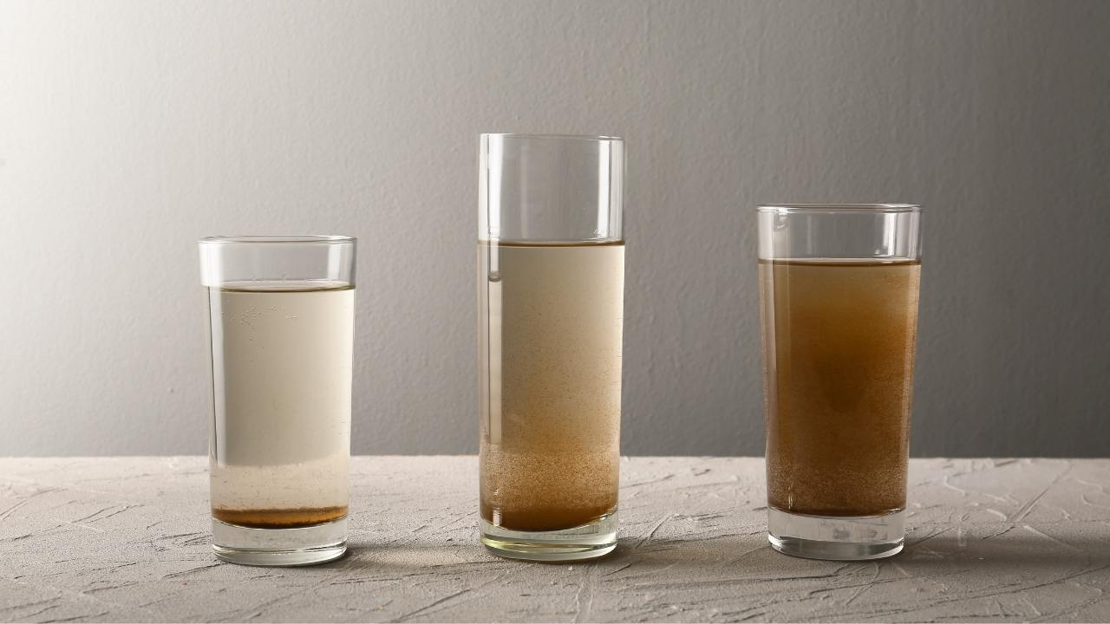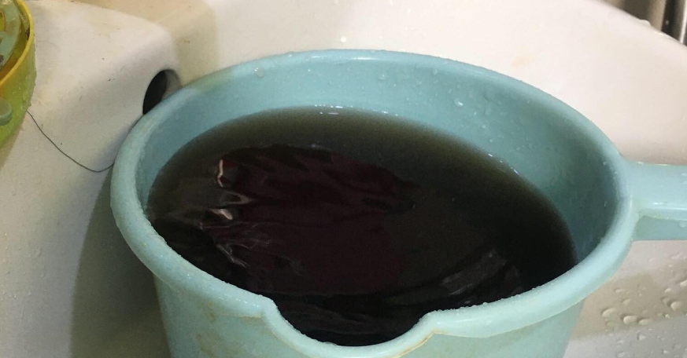

Figure 2: Sandy Water Sample

Figure 1: Colorized Water Sample

Wireless communication developments are creating new sensor capabilities. The current developments in the field of sensor networks are critical for environmental applications. Internet of Things (IoT) allows connections among various devices with the ability to exchange and gather data [12]. The system is an efficient, inexpensive IoT solution for real-time water quality monitoring. An efficient algorithm is developed in real-time, to track water quality. The measured pH value ranges from 6.5 to 7.5 for Hyderabad Metropolitan city supply water and 7 to 8.5 for groundwater. The measured value of turbidity ranges from 600 to 2000 and the accepted value for turbidity is NTU for both Hyderabad Metropolitan city supply water and groundwater. A web-based application is used to monitor the parameters such as pH value, the turbidity of the water, level of water in the tank, temperature and humidity of the surrounding atmosphere through the webserver [12]. (NTU) Nephelometric Turbidity Unit and (TSM) Total Suspended Matter.

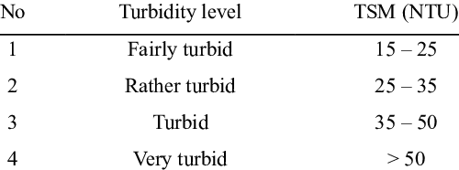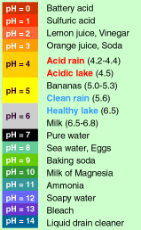

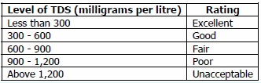

Figure 3: pH Level, Turbidity, and TDS sample

The Internet of things (IoT) brings an exciting new dimension to the world of field research, where researchers are able to access their data and insights in real time, wherever they are [13]. This is particularly valuable for water quality monitoring, as it can help to provide real-time data that can be used to make decisions about water usage and treatment. Inexpensive IoT solution for real-time water quality monitoring [12]. IoT technologies offer a number of benefits for water quality monitoring, including the ability to continuously collect data, the ability to remotely access and analyze data, and the ability to quickly respond to any issues that may arise. With the help of these technologies, it is possible to more effectively manage and protect the quality of our water resources [14].

The system consists of several sensors used to measure physical and chemical parameters of the water. Parameters such as temperature, pH, turbidity, and flow rate can be measured. The measured values from the sensors are processed by the core controller, which can be an Arduino model. Finally, the sensor data can be viewed on the internet using the Wi-Fi system [15]. This real-time data accessibility allows for continuous monitoring and timely interventions, making the management of water resources more proactive and responsive to potential issues.

Incorporating the latest sensors to detect various additional quality parameters, utilizing advanced wireless communication standards for enhanced connectivity, and integrating IoT technology, a more efficient water quality monitoring system can be developed. This approach ensures the safety of water resources through prompt response [16]. Furthermore, combining these advanced technologies allows for more accurate data collection and analysis, providing a robust framework for ongoing water quality management and environmental protection.

Comparative Analysis

This section is the comparison table of this study, the first three systems have similarities to this study’s system and the table will be the indicator of what the related system has similar features. 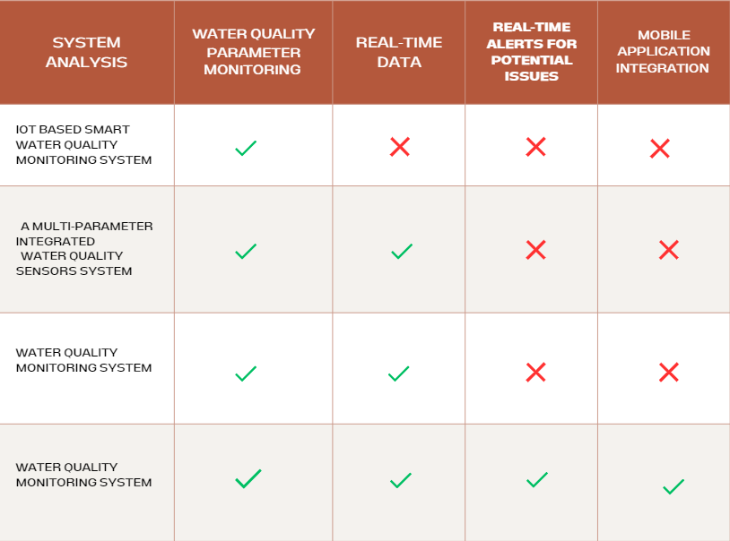

Figure 4: Comparison Table

The first system on the table has Water Quality Parameters Monitoring, the values will be monitored continuously to check if the sensor value exceeds the threshold. If it does, the relevant end user will be notified for action. Otherwise, alternative water sources will be considered [17]. The proponents indicated that the study has areas where it could be enhanced in terms of creating real-time data shown, real-time alert for potential issues, and mobile integration for mobility and efficiency.

The second system has water quality parameters monitoring and real-time monitoring. The application layer receives data from the process layer, storing it in flash memory before uploading it to a PC. Users can configure sensor parameters and access real-time data for each channel through the UniLog software within this layer [18]. The proponents indicated that the study has areas where it could be enhanced in terms of creating real-time web-based application for monitoring and admin access, real-time alerts for potential issues, and mobile integration for flexibility.

The third system is an Internet of Things-based system comprising pH, temperature, and turbidity sensors, which are all integrated into a mobile phone application interface for a water monitoring system [19]. There can also be areas where it could be enhanced with real-time alerts for potential issues on water, and web-based applications for monitoring including the admin access.

This study stands as a more well-rounded system that checks all the features on the table, designed to address critical aspects of effective management. At its foundation, the system prioritizes thorough monitoring of key water quality parameters, ensuring a comprehensive understanding of the water's condition. Real-time data, real-time alerts for potential issues, and Web-based application for monitoring including admin access and has Mobile integration. This improvised the lacking functionality from other compared systems. Its monitoring capabilities, the system incorporates advanced features such as real-time alerts for potential issues and a user-friendly Web-based application with administrative access. These elements provide a centralized platform for monitoring and managing water quality, facilitating informed decision-making and proactive intervention strategies. Multifaceted approach that addresses the limitations of existing systems, this study represents a significant advancement in the field of water quality monitoring.

# Chapter 2

Methodology

Chapter provides a comprehensive discussion of the methodology used in this study. It presents the different methodologies used by the researchers in pursuing the study. This section outlines the methods and approaches employed to collect and analyze data for this study. The methodology is designed to align with the System Development Life Cycle (SDLC) that is most suitable for the development of this project, ensuring both the utility of the software and the effectiveness of the monitoring methods

The development and project management approach that emphasizes flexibility, collaboration, and client satisfaction. WQMSys was based on the Agile method and the objectives mentioned in previous sections, while also ensuring reliability and accuracy. This section in figure 4 includes a detailed description of the organization including the System Planning, System Analysis, System Design, Testing and Implementation, and Maintenance of the system.

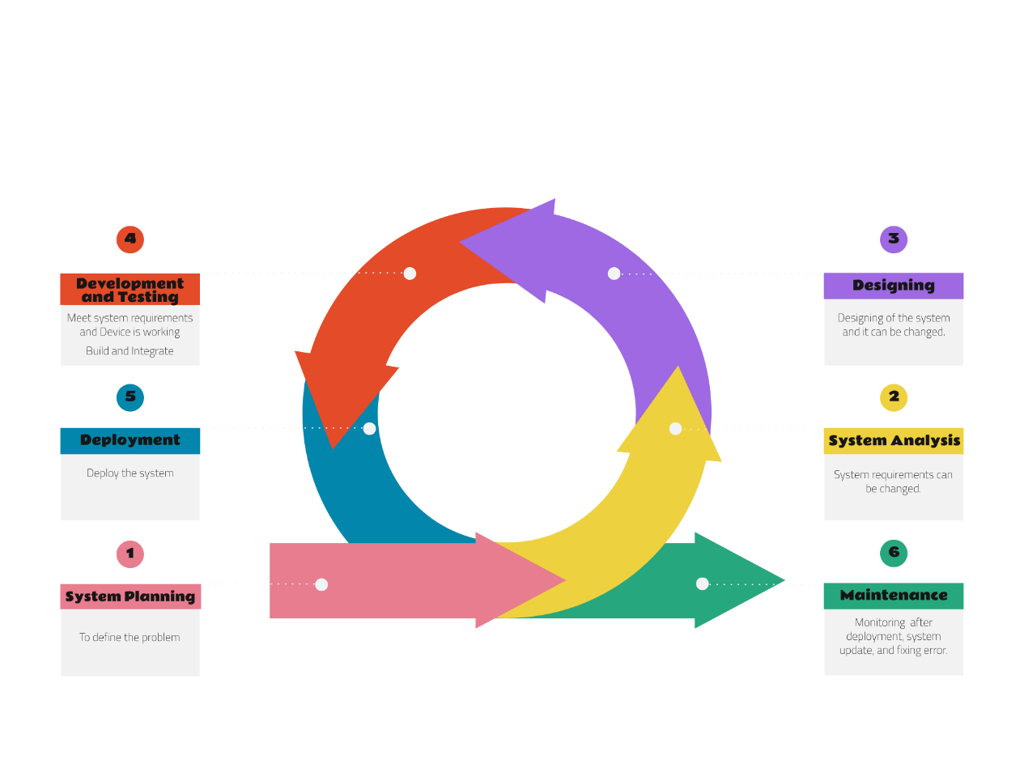

**Agile Method**

Figure 5: Agile Software Development Life Cycle

**System Planning.** Entails delineating the project's scope by identifying the parameters related to water quality and the contaminants to be detected.

**System Analysis.** Evaluates the gathered requirements to assess the project's technological feasibility in detecting water quality issues.

**Designing.** Involves selecting appropriate algorithms for water quality assessment and contaminant detection. Create detailed designs this includes diagrams and table for both hardware and software requirements. User Interface for user interaction with the system and will be presented its prototype.

**Development and Testing.** Build the system components based on the design specification. To integrate IoT with sensors, processing algorithms, visualization tools, and ensuring real-time data collection form sensors. For testing ensuring that the system meets the required standards and functions correctly.

**Deployment.** Deploy the system into the water district assigned pump station and ensure that the device and web-application work properly.

**Maintenance.** Provide ongoing support and improvements to ensure the system remains functional and effective.

Following this method as the project will benefit from a clear structure and iterative improvement. To know if the water is potable, it is if the detected data from the sensor’s pH level, turbidity, and TDS exceeds its limit or in below average state. All sensors that are integrated the collected data from it is viewable through the systems dashboard for much improved data water analysis. This approach ensures that the WQMSys meets the needs of the Water District of Santo Tomas, Davao del Norte, and delivers reliable and actionable data.

Project Team Organization

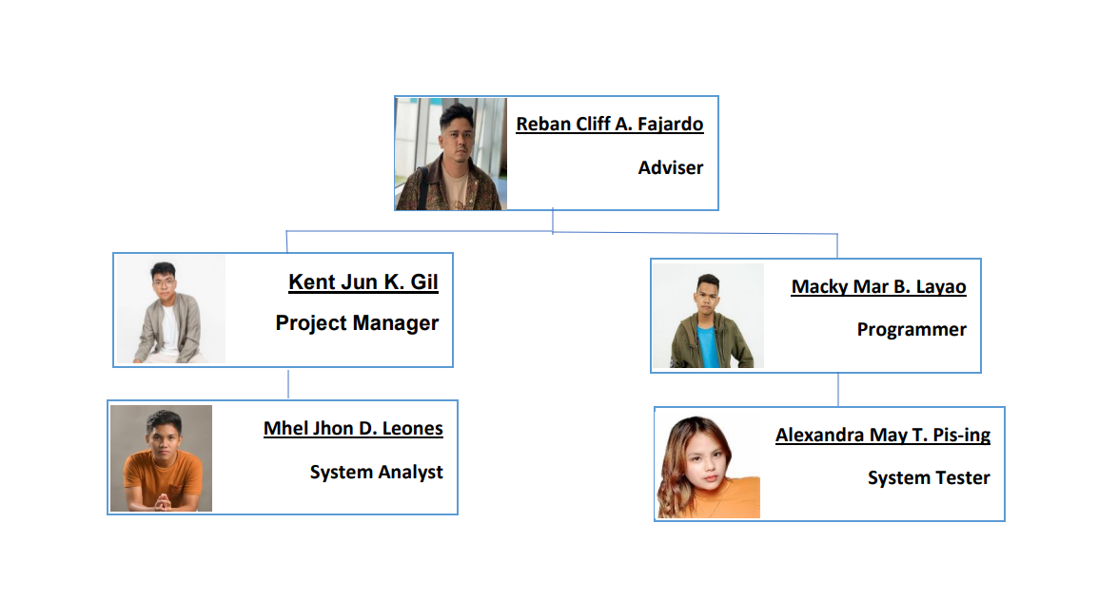The figure 5 below represents the project team. The diagram shows additional information about the organizational structure and displays the specific roles of each person involved in the system's development.

Figure 6: Organizational Structure

The project manager is responsible for supervising the entire process of project planning, execution, and delivery. Their primary duty is to ensure that the project is finalized within the specified timeframe, adheres to the budgetary constraints, and achieves its objectives.

A system developer is in charge of developing software or systems in accordance with the specifications and requirements established in the project plan.

The system designer is responsible for the system's architecture and design. They collaborate closely with system analysts and developers to ensure that the system is structured and developed to satisfy the requirements of the project.

Lastly, system analysts play a crucial role in comprehending and identifying the requirements of the system. They ensure that the final system meets the expectations of the users by assisting in bridging the gap between its needs and technical solutions.

GANTT Chart

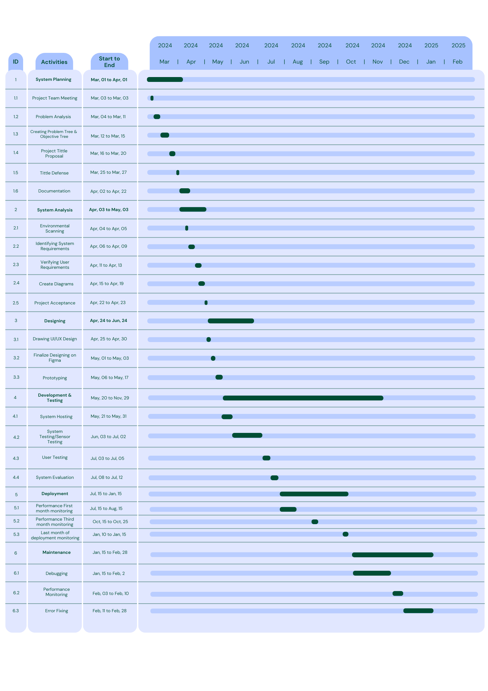This section Gantt chart is a graphical representation of a project schedule that shows the progress of several tasks or activities over a period of time. It is a well-known project management tool whose role and purpose in this project.

Figure 7: GANTT Chart

System Analysis

This section is all about conducting system analysis, the team deliberately targets inefficiencies to aid the water district in terms of advancements in technology. The proponents gathered vital information on what aspects to improve for system development. The Water District water supply quality for the community has noticeable issues stemming from its natural source, affecting how people benefit from it. The Water District is not equipped with real-time monitoring capabilities, the challenging factor of promptly detecting and addressing water quality issues from the detection.

Recognizing these deficiencies, our analysis guided the conceptualization of an innovative IoT-based smart water quality monitoring system. This system integrates sensors to collect data and features a web-based application for data visualization that revolutionizes water quality monitoring. It is a user-friendly visualization tool that provides real-time monitoring, data analysis, and prompts alerts to properly address certain issues in water quality. By leveraging modern technology, our proposed system aims to revolutionize water quality management, enhancing efficiency, reliability, and ultimately, safeguarding public health in the Santo Tomas community.

System Architecture

This section is where the details on the activities that happened after conducting system analysis during the environmental scanning phase, the proponents visited the Santo Tomas Davao del Norte Water Works to gather important information for developing an effective water quality monitoring system. These visits included direct conversations with water district personnel to understand the current challenges and inefficiencies in their water quality management. Key issues identified were the lack of real-time monitoring and the labor-intensive manual data collection process. These problems make it difficult to quickly detect and fix water quality issues. Understanding these conditions helped designing a better system.

The users of the water quality monitoring system are the water district personnel, including technicians, engineers, and administrative staff. These individuals are responsible for monitoring and maintaining water quality. Its user-friendly interface aims to make the daily tasks of the water district personnel more efficient and effective in monitoring.

The system is designed to be easy to use, requiring minimal technical skills. It features a web-based dashboard that allows users to monitor real-time data and receive alert notification when water quality parameters are not within acceptable ranges.

The system includes the sensors to continuously collect data on important water quality parameters such as pH levels, turbidity, total dissolved solids (TDS), water level, and temperature. These sensors are connected to an Arduino Uno microcontroller, which processes the data and sends it wirelessly to a cloud-based database managed by Firebase. Firebase ensures secure and real-time data storage and management, supporting real-time database operations, file storage, user authentication, and crash reporting. The collected data is visualized through a web-based dashboard, giving water district personnel a clear view of water quality in real-time and generates automated alerts when water quality standards are not met. The admin access offers historical trends.

Conceptual Framework

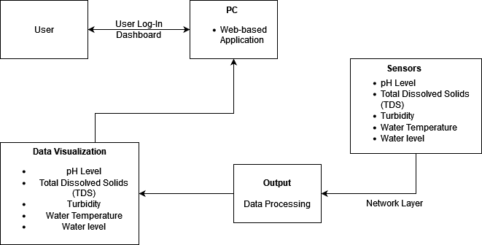 This section will show from the figure 7 below the concept on how the system works, in input, process, including the output to visualization of data for the end user.

**User Input**

**Water Management**

Figure 8: Conceptual Framework

This figure illustrates the conceptual framework of the study, that is centered around WQMSys. The input involves the users which is the water district personnel to Log-in and gain access of the web application. The sensors communicate through the network layer to deliver data for data processing and to visualize the data processed to display it on the web-application. This process is way to collect data with real-time data output for the end users.

System Requirements

This section focuses on functional and non-functional requirements of the system. Functional Requirements define the specific features, functionality, and behavior of the water quality monitoring system must be worked on.

Functional Requirements

* To include user log-in to access the system.
* To include a dashboard providing at a glance view of data.
* To include an accounts page for users to edit personal information on the account.
* Include the primary function which is water potability and be capable of knowing if the water is potable or not.
* To include pH level data visualization collected from the sensor.
* To include turbidity data visualization collected from the sensor.
* To include Total Dissolved Solids (TDS) data visualization collected from the sensor.
* To include water level data visualization collected from the sensor.
* To include water temperature data visualization collected from the sensor.
* To include alert notification which triggers when water quality parameters are not within the acceptable range.
* To include a data history page for enabling users to gain access to past results of the data collected and better understanding of water quality.

Non-Functional:

This section will discuss the specification of the system in terms of software and hardware requirements of the device in this study.

* **Visual Studio Code**. The developers can efficiently write, debug, and manage code related to data collection from sensors, data analysis algorithms, visualization tools, and integration with other systems.
* **TensorFlow.** Empowers efficient analysis, prediction, and informed decision-making. Open-source software library for machine learning and different computational-based simulations.
* **Firebase.** In water quality monitoring systems for its real-time database, scalability, security features, and seamless deployment options. Its integration with complementary services enhances functionality, ensuring timely insights and informed decision-making.
* **Programming Languages.** The system uses the languages HTML, CSS, and JavaScript for website development, C++ for the device including sensor integration, and Python for machine learning.
* **Arduino IDE.** The system uses an Arduino microcontroller with five accommodating sensors: pH, Temperature, Turbidity, water level, and Total Dissolved Solids (TDS).
* **Water Potability.** By including potability in the output, monitoring systems support decision-making, promote community awareness, and safeguard public health.
* **Water Monitoring.** is essential for assessing ecosystem health, managing resources sustainably, safeguarding public health, ensuring regulatory compliance, and providing early disaster warnings.
* **Display Water Parameters-** is vital for real-time monitoring, informed decision-making, regulatory compliance, and community awareness. It enables prompt responses to changes, enhances understanding, and supports compliance efforts on water potability.

Hardware Requirements

|  |  |  |
| --- | --- | --- |
| **No.** | **Item** | **Purpose** |
| 1. | Arduino Uno | Microcontroller to process and transmit sensor data |
| 2. | pH Level Sensor | To know the acidity of the water. |
| 3. | Turbidity Sensor | To know if there are any undetected on any |
| 4. | TDS Sensor | To know if there are any undetected particles that bare eye cannot see |
| 5. | Water Level Sensor | To detect the water level of the water at the water district distribution |
| 6. | Water Temperature  Sensors | To detect the temperature of the water. |
| 7. | ESP-32 (Wi-fi Module) | To enable the system’s data transmission from the microcontroller to cloud base and to the system website. |
| 8. | Power Supply | Through an AC-DC adapter to plug the device for power source. |

Figure 9: Hardware Requirement Table

Use Case Diagram

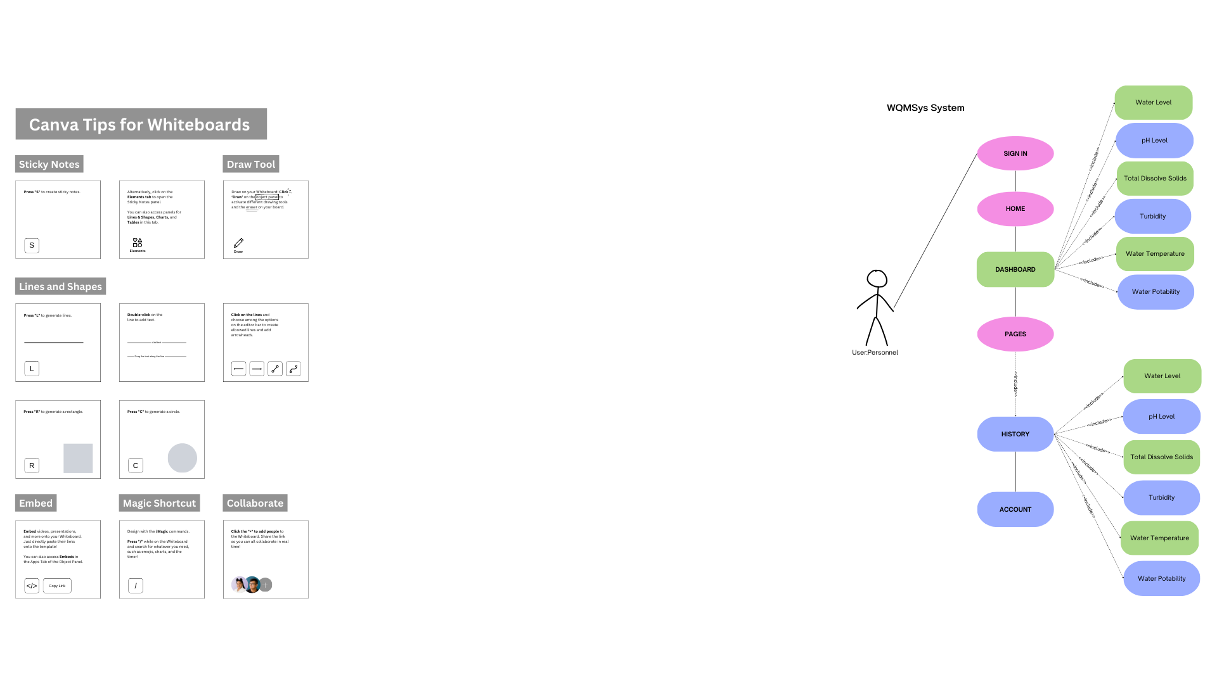 This section the use case diagram is a visual presentation that illustrates how users interact with a system to accomplish particular tasks or specific goals. It highlights the detailed process of updating and providing information within the system.

Figure 10: Use Case Diagram

Context Flow Diagram

This table illustrates the diagram and represents the entire system process, highlighting the boundaries of the system. This diagram shows how the user interacts with this system will be receiving data.

Figure 11: Level 0 Context Flow Diagram

Level 1 Data Flow Diagram

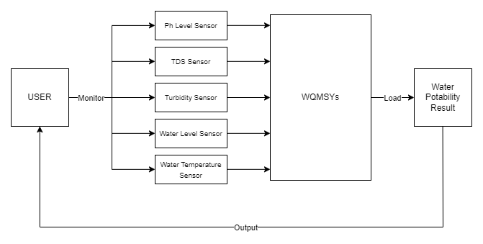This diagram, a data flow diagram (DFD), illustrates the movement of information within a system or process. It shows the detailed use cases updating and providing information when the user interacts with the system.

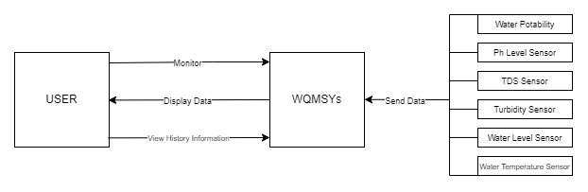

Figure 12: Level 1 Data Flow Diagram

System Design

This Section will show the totality of how system works from the structure of how the systems database including the information that is shown in data dictionary. User Interface is also the key factor for users to know the interaction simulated.

JSON Schema Diagram

This section describes the figure 13 in the field of users as their personal information are structured on the user’s database. Users will gain access to the WQMSys field which has data visualization for water potability, pH level, TDS, Turbidity, water temperature, and the date and time is for the data history records.

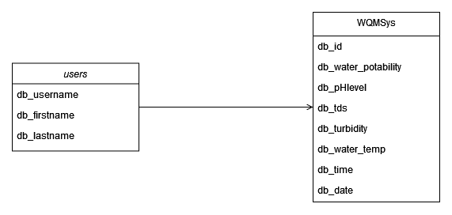

Figure 13: JSON Schema Diagram

Data Dictionary

This section is the detailed description of the JSON Schema Diagram consisting of Field Name, Data Type, Data Format, and Description and these are within the table of data dictionary.

|  |  |  |  |
| --- | --- | --- | --- |
| **Field Name** | **Data Type** | **Data Format** | **Description** |
| db_id | INT | Integer | Unique ID |
| db_water_potability | VARCHAR | String | Water Potability |
| db_pHlevel | FLOAT | float | Water pH Level |
| db_tds | INT | Integer | Water Total DIssolved Solids |
| db_turbidity | INT | Integer | Water Turbidity |
| db_water_temp | INT | Integer | Water Temperature |
| db_time | TIME | Time | Current Time |
| db_date | DATE | Date | Current Date |

Figure 14: Data Dictionary Table

This section is all about how the device works as it is shown on the figure below. The sensors are pH level, TDS, Turbidity, Water Temperature, and water level act as the data collector that is connected to the network layer. Connected to the internet to go through the cloud to store data on the database and process the data and will go through the network layer again for data visualization and data mining.

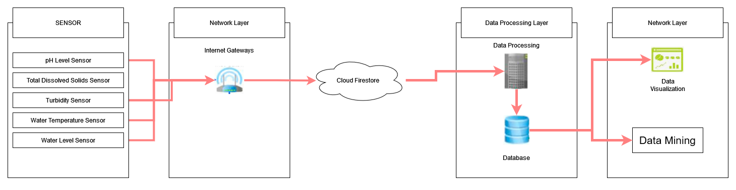

Figure 15: IoT Device Process Description Diagram

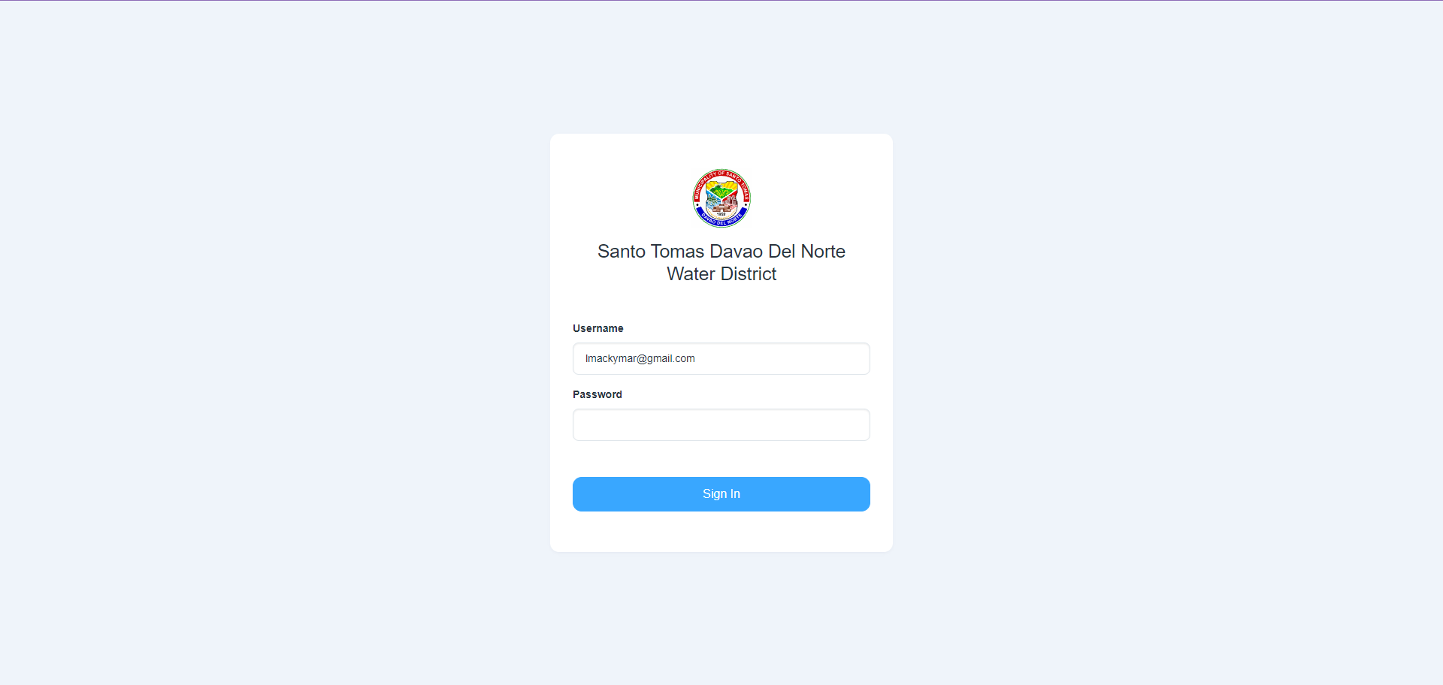This section is the user interface or the website of this study. The website user interface landing page will be the user Log-in and after it the dashboard is accessible to view.

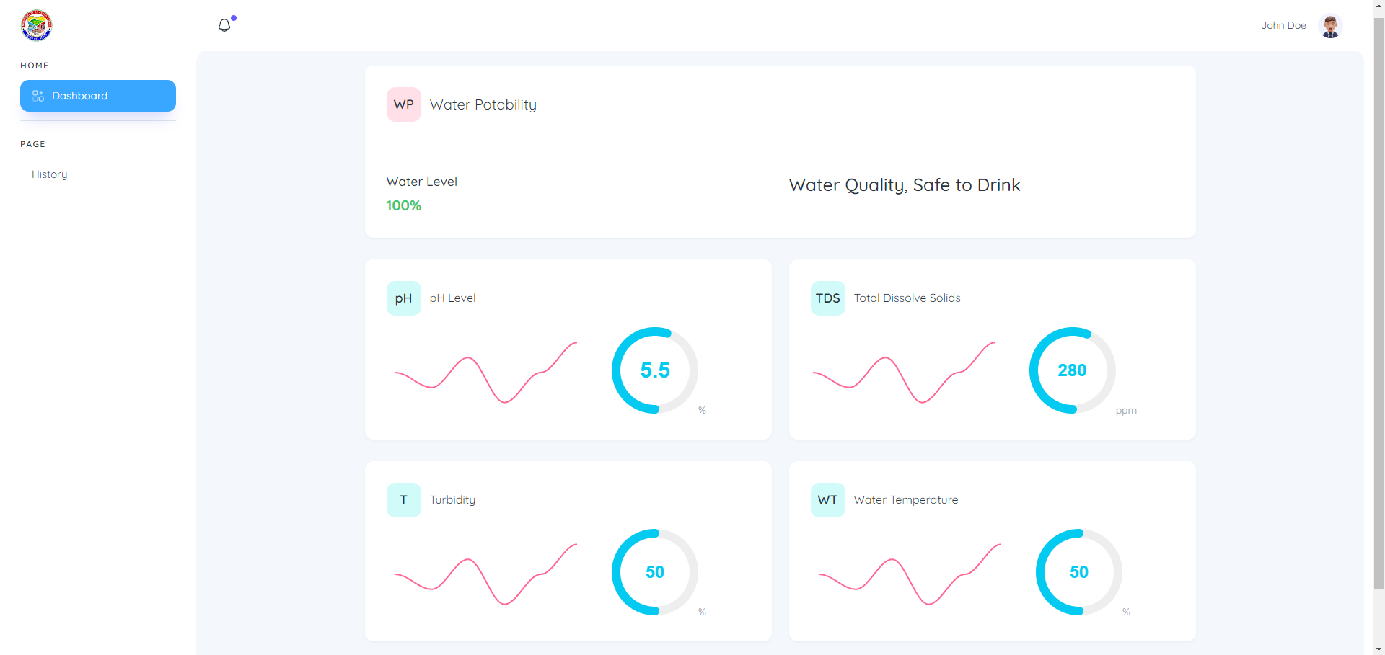 The dashboard shows the detection of the sensors and to know the water potability that is shown in the interface.

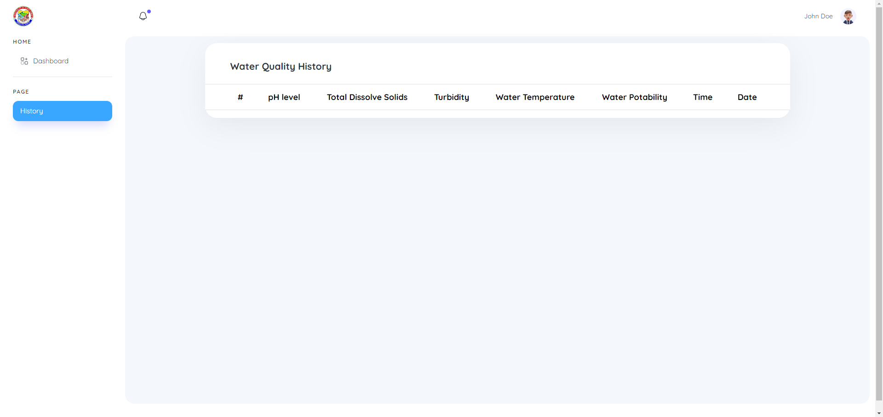

This part of the pages in the interface is the data history to access past results from the detection, this includes the time and date.

System Development and Testing

This section, SDT involves creating software and making sure its functionalities and effectiveness. The process begins with planning and designing the system according to user requirements. Unit testing, which examines each part, ensures they work together, and confirms the entire system meets user expectations. This process ensures that the system is reliable, secure and ready to be used.

Systems Implementation Plan

This section, SIP outlines the steps needed to deploy a system successfully. It includes tasks such as installation, configuration, data migration, and testing. The plan ensures that the system is integrated smoothly into the existing environment and functions as intended.

Feasibility Plan

In this section are the details of the feasibility which are the software, hardware, miscellaneous, and total estimated budget.

|  |  |  |  |
| --- | --- | --- | --- |
| Type | Item | Quantity | Price |
| Software | Firebase (Web Hosting) | - | N/A |
| JSON Schema | - | N/A |
| Hardware | Arduino Uno (Mega) | 1 | ₱ 900.00 |
| pH Sensor | 1 | ₱ 1,800.00 |
| Turbidity | 1 | ₱ 850.00 |
| TDS (Total Dissolved Solids) | 1 | ₱ 875.00 |
| Water Level Sensor | 1 | ₱ 230.00 |
| Temperature Sensor | 1 | ₱ 150.00 |
| Wi-Fi Module (ESP-01) | 1 | ₱ 285.00 |
| Power Supply AC-DC Adapter | 1 | ₱ 90.00 |
| Miscellaneous | Travel Fare | - | ₱ 700.00 |
| Foods | - | ₱ 700.00 |
| Total Estimated Budget for the Device: ₱ 5,880.00  Figure 16: Feasibility Table | | | |

This Feasibility Table provides a clear breakdown of the items needed for a project, categorized into software, hardware, and miscellaneous expenses. It lists specific components required, such as sensors, modules, and adapters, along with their quantities and prices. The total estimated budget for all necessary components is ₱5,880.00, including both hardware and miscellaneous expenses like travel fare and food. This detailed list assists in budget planning and resource allocation for the project.

System Maintenance

This section, we concentrate on the methods used for the system maintenance of WQMSys. In order to guarantee the system’s ongoing availability, reliability, and functionality, effective maintenance procedures are crucial to its successful implementation and operation.

Systems Security Plan

This section is security countermeasures on securing the system's data for data privacy, improper usage or damage, shall be laid down in the Systems Security Plan. To protect sensitive data, prevent cyber threats, and comply with regulations, it includes security policies, procedures, and controls.

Risk Plan

This section is for the system mitigation plans for risk that may occur during deployment.

|  |  |  |
| --- | --- | --- |
| **Risk** | **Risk**  **Level** | **Mitigation** |
| System Corruption | **High** | Create regular backups to Google Drive to ensure data can be restored. |
| Systems Maintenance Plan | **Medium** | Ensuring that the knowledge transfer and project documentation are up to date with a view to facilitating smooth transitions. |
| Natural Calamities | **Medium** | Implement a Disaster Recovery Plan (DRP), including offsite backups and alternative operational locations. Ensure that the data is backed up in a variety of geographical locations |
| Device Corruption | **High** | Regularly update and patch all systems and software. Use antivirus software and conduct regular security scans. Ensure that the data is encrypted and backed up to secure cloud storage. |
| Reformat Laptop | **High** | Ensure all important data and system configurations are backed up before reformatting. Use imaging software to create a complete backup of the system. |
| Developer No Longer Capable of Maintaining the System | **Medium** | Ensure that the architecture, code and operating procedures of the system are documented in full. Team members and maintain a backup developer or a development support contract with an external agency. |

Figure 17: Risk Plan Table

Systems Maintenance Plan

This section, after the deployment of WQMSys, we'll keep an eye on it regularly to make sure it keeps working smoothly. The client will handle the bills for any software or services it needs to run. As for the hardware, like computers or servers, the organization will take care of those costs to make sure everything stays up to date. We'll set up a plan for regular maintenance, which includes fixing any bugs, updating the system, and helping users when they need it. The maintenance fee will be $15,000, but that is only when it needs to be fixed.

Scheduling regular updates every month to keep the system secure and running smoothly. If we need to make any big changes after the initial setup, we'll talk about it separately. Any extra costs for those changes will be covered by the client. To keep improving the system, we'll set up a maintenance fee. This fee will pay for ongoing development work and any upgrades we make to the system.

If we need extra help with significant updates or improvements, the client will need to find and pay a programmer as necessary. We'll provide guidance on the process and requirements for transferring ownership of the system. Ownership can be transferred once all payments are completed, and we've provided all the necessary documentation.

To ensure ongoing support and maintenance, the original developer will be available for hire at an agreed-upon hourly rate. The support contract will specify its duration and cover services like troubleshooting, system updates, and minor feature enhancements.

This Systems Maintenance Plan offers clear guidance on activities following deployment, delineates financial responsibilities, and outlines support arrangements, thereby guaranteeing the system's long-term reliability and effectiveness.

Problem Tree Analysis

The Water District relies on the deep well drilling technique as a primary means of accessing natural water reservoirs to meet the needs of the community. This method involves penetrating deep into the earth's crust to tap into underground aquifers or water tables. While it provides a crucial source of water, the process often yields water with inconsistent quality. This variability can manifest in various forms, such as water containing sand particles, exhibiting unusual coloration, or even containing dissolved gasses. One of the core challenges is the lack of regular monitoring of water quality. Without consistent monitoring practices in place, the Water District may overlook fluctuations in water quality or fail to detect potential contaminants. As a result, there is a heightened risk of distributing water that does not meet safety standards for human consumption.

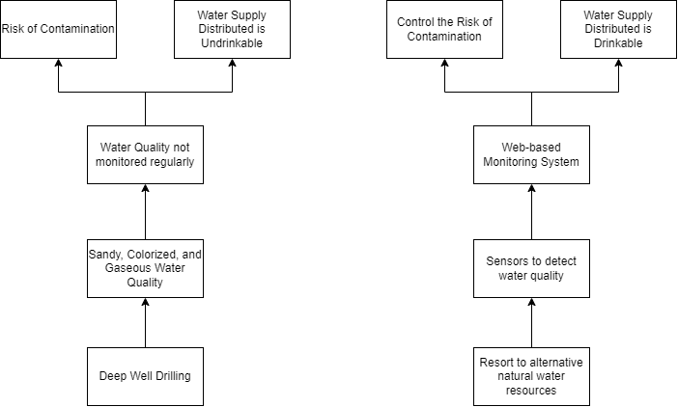

Effect

Main Problem



Cause



Figure 18: Problem Tree



Objective Tree Analysis

To address the challenges posed by the lack of regular monitoring and the inconsistent quality of water obtained through deep well drilling, the Water District can implement a comprehensive water quality monitoring system. This system would involve installing sensors to continuously monitor key parameters and the presence of contaminants. Data collected by these sensors would be transmitted in real-time to a central monitoring station. Automate the process of data collection and analysis, this enables the timely detection of any deviations from expected water quality standards, triggering immediate alerts to relevant personnel for further investigation and intervention. Water District can ensure the consistent delivery of safe and potable water to the community, mitigating health risks associated with contaminated water.

## 

Goal



Objective

Figure 19: Objective Tree

Activity

Activity

References

[1] “Potable Water - Water Education Foundation,” Water Education Foundation, Jun. 22, 2020. https://www.watereducation.org/aquapedia-background/potable-water

[2] United Nations, “The 17 Sustainable Development Goals,” *United Nations*, 2024. https://sdgs.un.org/goals

[3] World Health Organization, “Guidelines for drinking-water quality: Fourth edition incorporating the first and second addenda,” *World Health Organization*, Mar. 21, 2022. https://www.who.int/publications/i/item/9789240045064

[4] A. K. Biswas and C. Tortajada, “Water quality management: a globally neglected issue,” *International Journal of Water Resources Development*, vol. 35, no. 6, pp. 913–916, Oct. 2019, doi: https://doi.org/10.1080/07900627.2019.1670506.

[5] J. G. M. Inson, C. E. Supsup, and M. J. C. Flores, “Spatial mapping of groundwater quality in the municipality of Santa Ignacia, Tarlac, Philippines,” *Applied Water Science*, vol. 11, no. 11, Oct. 2021, doi: https://doi.org/10.1007/s13201-021-01513-2.

[6] “Dirty or Discolored Water,” *www.sfpuc.org*. https://www.sfpuc.org/accounts-services/water-quality/dirty-or-discolored-water

[7] Shannon, “Ultimate Guide to Understanding & Managing sand in Well water,” #No.1 Well Drilling Company, Mar. 19, 2024. https://johnswelldrilling.com/understanding-and-managing-sand-in-well-water-a-comprehensive-guide

[8] M. Sudaria, C. Burca, B. Francisco, M. Paloma, K. Rodrigo, and M. Caber, “Potability of deep-well water sources in calbayog samar Philippines,” Journal of Agriculture and Ecology, vol. 09, no. 01, pp. 30–40, Jan. 2020, doi: 10.53911/jae.2020.9103.

[9] J. G. M. Inson, C. E. Supsup, and M. J. C. Flores, “Spatial mapping of groundwater quality in the municipality of Santa Ignacia, Tarlac, Philippines,” *Applied Water Science*, vol. 11, no. 11, Oct. 2021, doi: 10.1007/s13201-021-01513-2.

[10] “Smelly or yellow Well water | Weeks Drilling & Pump Co.,” Weeks Drilling & Pump Co. https://www.weeksdrilling.com/blog/what-causes-smelly-or-yellow-well-water-and-how-can-it-be-fixed/

[11] World Health Organization: WHO, “Drinking-water,” Sep. 13, 2023. https://www.who.int/news-room/fact-sheets/detail/drinking-water

[12] S. Pasika and S. T. Gandla, “Smart water quality monitoring system with cost-effective using IoT,” Heliyon, vol. 6, no. 7, p. e04096, Jul. 2020, doi: 10.1016/j.heliyon.2020.e04096.

[13] M. Miller, A. Kisiel, D. Cembrowska-Lech, I. Durlik, and T. Miller, “IoT in Water Quality Monitoring—Are We Really Here?,” Sensors, vol. 23, no. 2, p. 960, Jan. 2023, doi: https://doi.org/10.3390/s23020960.

[14] Liu P., Wang J., Sangaiah A.K., Xie Y., Yin X. Analysis and Prediction of Water Quality Using LSTM Deep Neural Networks in IoT Environment. Sustainability. 2019;11:2058. doi: 10.3390/su11072058.

[15] S. Chougule, A. Kamate, S. Kothale, P. Nitave, and A. Naik, “IoT Based Water Quality Monitoring System,” *International Journal of Advanced Research in Science, Communication and Technology (IJARSCT)*, vol. 2, no. 5, pp. 2581–9429, 2022, doi: https://doi.org/10.48175/IJARSCT-4030.

[16] I. Essamlali, H. Nhaila, and M. E. Khaili, “Advances in machine learning and IoT for water quality monitoring: A comprehensive review,” *Heliyon*, p. e27920, Mar. 2024, doi: 10.1016/j.heliyon.2024.e27920.

[17] V. Lakshmikantha, A. Hiriyannagowda, A. Manjunath, A. Patted, J. Basavaiah, and A. A. Anthony, “IoT based smart water quality monitoring system,” *Global Transitions Proceedings*, vol. 2, no. 2, pp. 181–186, Nov. 2021, doi: https://doi.org/10.1016/j.gltp.2021.08.062.

[18] M. Li, D. Li, Q. Ding, Y. Chen, and C. Ge, “A Multi-parameter Integrated Water Quality Sensors System,” *IFIP advances in information and communication technology*, pp. 260–270, Jan. 2013, doi: https://doi.org/10.1007/978-3-642-36124-1_32.

[19] V. Angadi, A. Karadge, N. Sanadi, A. Shingade, and P. D. Ghate, “Water Quality Monitoring System,” International Journal of Research Publication and Reviews, <https://ijrpr.com/uploads/V3ISSUE7/IJRPR5902.pdf>

[20] N. H. Omer, Water Quality Parameters. IntechOpen, 2019. Available: https://www.intechopen.com/chapters/69568

‌

‌

‌