**1.ASSIGNMENT QUESTION 1**

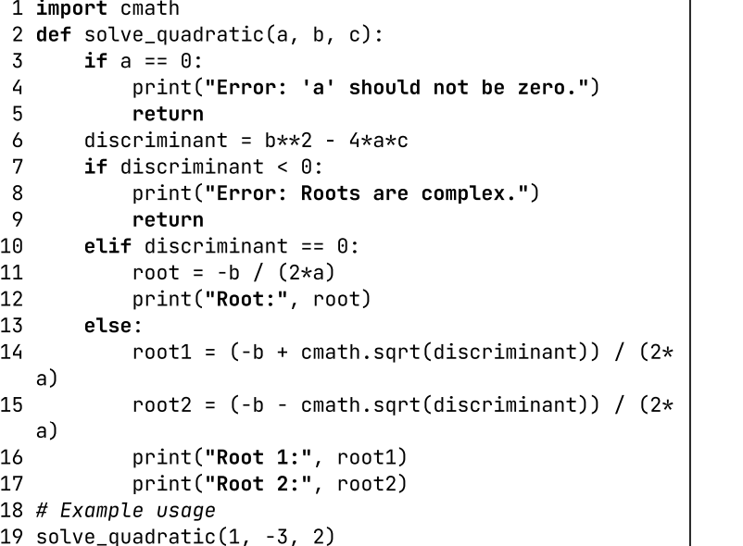

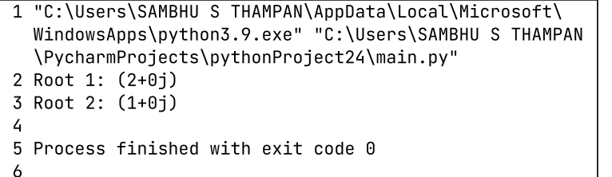

**ASSIGNMENT QUESTION 2**

def count_word_frequency(text):

word_counts = {}

words = text.lower().split()

for word in words:

word = word.strip(".,!?-") # Remove common punctuation marks

word_counts[word] = word_counts.get(word, 0) + 1

return word_counts

# Example usage

text = input("Enter some letters >>> ")

frequency_table = count_word_frequency(text)

# Print the frequency table

for word, count in frequency_table.items():

print(word.capitalize(), "-", count)

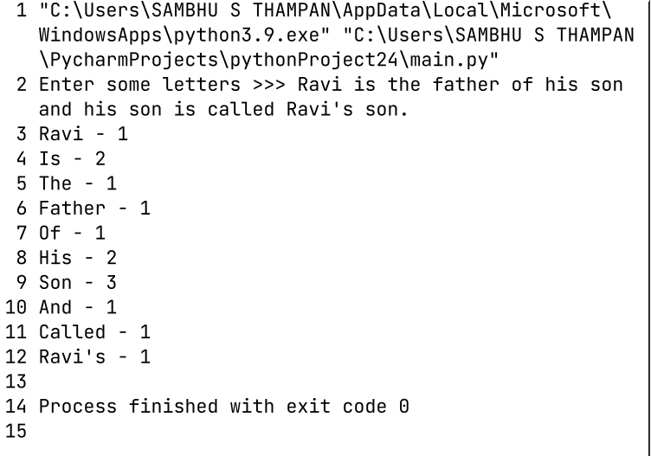

**ASSIGNMENT QUESTION 3**

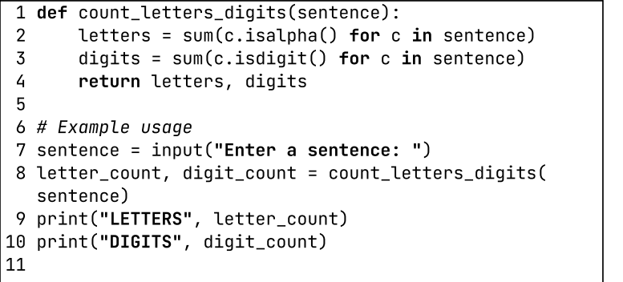

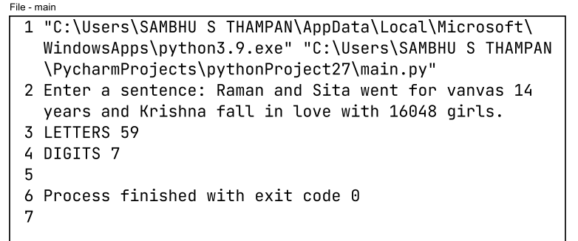

**ASSIGNMENT QUESTION 4**

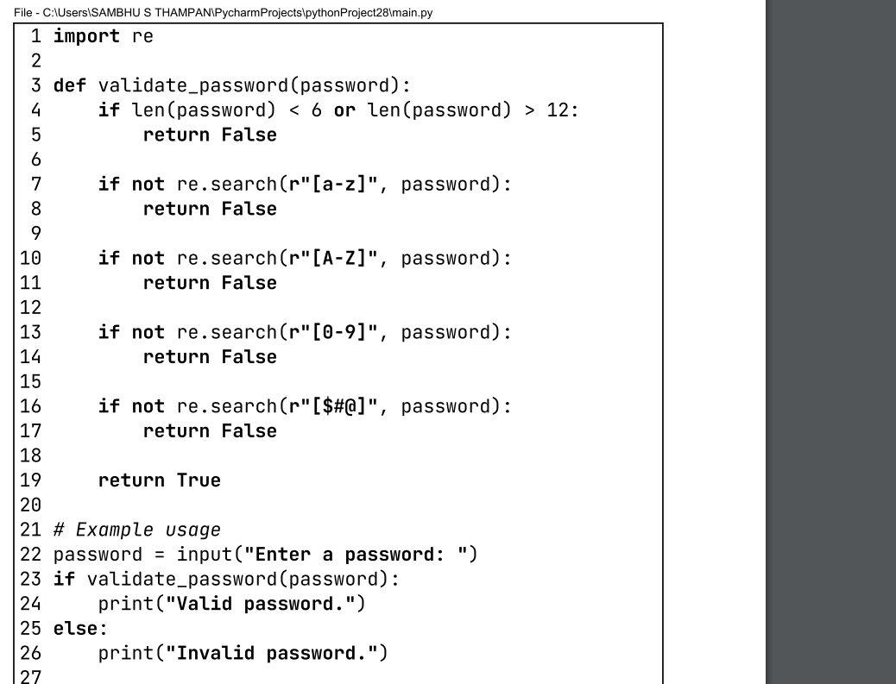

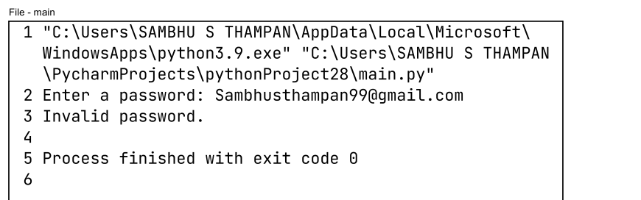

**ASSIGNMENT QUESTION 5**



