Chat Application
Full Documentation
Blue Matrix

Contents
1 Tech Stack 3
2 Features 3
2.1 Authentication Features 3
2.1.1 User Registration 3
2.1.2 User Login 3
2.2 User Management Features 4
2.2.1 List All Users 4
2.2.2 View User Profile 4
2.3 Messaging Features 4
2.3.1 Send Message (Realtime) 4
2.3.2 Chat History (per user) 4
2.3.3 Message Timestamps 5
2.3.4 Real-time Delivery 5
2.4 WebSocket Realtime Features 5
2.4.1 Join Personal Room 5
2.4.2 Real-time Message Event 5
2.5 Frontend Features (Next.js UI) 5
2.5.1 Login Page 5
2.5.2 Sign Up Page 5
2.5.3 Chat App Layout 5
2.5.4 User List Sidebar 6
2.5.5 Chat Window Features 6
2.5.6 Message Input Box 6
2.5.7 Responsive UI 6
3 Architecture 7
4 Database Schema (Prisma Example) 7
5 API Endpoints 8
5.1 Auth Route 8
5.2 User Routes (Protected) 8
5.3 Message Routes (Protected) 8

Chat Application – Full Documentation
A full-stack real-time chat application built using Next.js, NestJS, WebSockets, and PostgreSQL. This system includes user authentication, contact listing, real-time messaging, and clean architecture following best practices.
You can find the project code here: https://github.com/BinuMDX/Chat-Application

Tech Stack
This project demonstrates a production-ready real-time chat system with authentication, user management, and messaging. It uses:
- NestJS for backend APIs & WebSockets
- Next.js for frontend UI & client-side socket connection
- Prisma + PostgreSQL to store users & messages

Features

Authentication Features

User Registration
- New users can create an account with:
  - Name, Email, Password
- Backend validates:
  - Email format, Password strength (optional), Email uniqueness
- Passwords are hashed using bcrypt.
- Upon successful registration:
  - JWT token is generated
  - User details (except password) returned

User Login
- Existing users can log in with:
  - Email, Password
- Backend verifies:
  - User existence, Password correctness
- Responds with:
  - JWT access token, Authenticated user info (id, name, email)

User Management Features

List All Users
- Authenticated user can fetch all registered users.
- List excludes the logged-in user.
- Response includes:
  - User ID, Name, Email (optional)

View User Profile
- Fetch profile of any user by ID.
- Includes:
  - Name, Email, CreatedAt
- Does not return password or sensitive data

Messaging Features

Send Message (Realtime)
- User sends a message with: { "receiverId": "...", "content": "Hello" }
- Backend handles:
  - Stores message in database
  - Sends real-time event to receiver using WebSocket
  - Updates chat window instantly for both users

Chat History (per user)
- User can open a chat with someone and retrieve history: GET chat/messages/receiverId
- Messages sorted by timestamp ascending.
- Attributes:
  - Text messages
  - Timestamps
  - Sender/receiver id

Message Timestamps
- Each message includes:
  - CreatedAt (ISO format)
- Frontend shows:
  - Time (e.g., 10:30 AM)

Real-time Delivery
- As soon as sender sends message:Receiver sees the message instantly

WebSocket Realtime Features

Join Personal Room
- After login, client emits: socket.emit("join", { userId })
- Backend creates a dedicated room for the user.

Real-time Message Event
- Backend emits: "receive_message" with sender info + content.

Frontend Features (Next.js UI)

Login Page
- Email and password fields
- Error handling
- Redirects to chat page on success
- Uses API via Axios

Sign Up Page
- Name, email, password fields
- Validations
- Success toast notification
- Redirect to login

Chat App Layout
- Sidebar (user list)
- Chat window
- Message box
- Real-time updates

User List Sidebar
- All users
- Clicking a user opens chat

Chat Window Features
- Displays entire conversation
- Auto-scrolls to bottom on new message
- Shows sender/receiver differently (left/right align)
- Timestamp under each message
- Loading indicators

Message Input Box
- Textbox + Send button
- Enter key to send
- Auto-clears after sending

Responsive UI
- Mobile-friendly
- Sidebar collapses on small screens
- Optimized for both desktop and mobile

Architecture
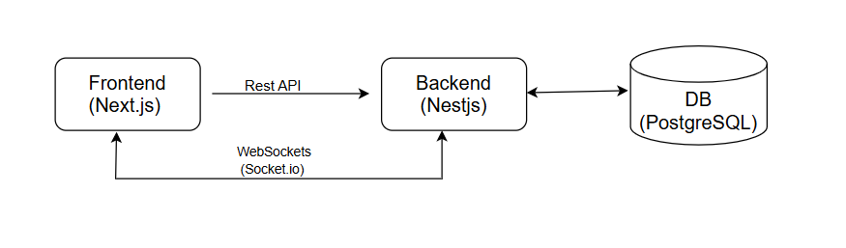

Database Schema (Prisma Schema)
1. model User {
2. id Int @id @default(autoincrement())
3. username String @unique
4. email String @unique
5. hashpassword String
6. conversations ConversationParticipant[]
7. messages Message[]
8. createdAt DateTime @default(now())
9. updatedAt DateTime @updatedAt
10. hashedRt String?
11.
12. @@map("users")
13. }
14.
15. model Conversation {
16. id String @id @default(cuid())
17. participants ConversationParticipant[]
18. messages Message[]
19. createdAt DateTime @default(now())
20. updatedAt DateTime @updatedAt
21. }
22.
23. model ConversationParticipant {
24. id Int @id @default(autoincrement())
25. userId Int
26. conversationId String
27.
28. user User @relation(fields: [userId], references: [id])
29. conversation Conversation @relation(fields: [conversationId], references: [id])
30.
31. @@unique([userId, conversationId])
32. }
33.
34. model Message {
35. id Int @id @default(autoincrement())
36. text String
37. senderId Int
38. conversationId String
39. readAt DateTime?
40.
41. sender User @relation(fields: [senderId], references: [id])
42. conversation Conversation @relation(fields: [conversationId], references: [id])
43. createdAt DateTime @default(now())
44. updatedAt DateTime @updatedAt
45. }

API Endpoints

Auth Route
POST | /auth/signup | Register a new user
POST | /auth/login | Login user & return access token

User Routes (Protected)
Requires Authorization header:
Authorization: Bearer <token>
GET | /users | Get all users except the logged-in user

Message Routes (Protected)
Requires Authorization header:
Authorization: Bearer <token>
POST | chat/messages/:conversationId | deprecated
GET | chat/messages/:conversationId | Get chat history between logged user & :userId
GET | chat/conversations | Join to a conversation
POST | chat/conversations | Create or get conversation

