CMPE283 - Assignment 1

Student ID: 015293460 Name: Parvathi Pai

Student ID:015304393 Name: Shreya Ghotankar

1. For each member in your team, provide 1 paragraph detailing what parts of the lab that member implemented / researched.

* **Parvathi Pai**:
* Identified the information from SDM.
* Updated the code in cmpe283-1.c for the MSRs 0x482, 0x48B, 0x483, 0x484
* Generated the desired output and took snapshots of it.
* Created the initial documentation.
* **Shreya Ghotankar**:
* Re-built and tested the modified code.
* Added test snapshots of output.
* Updated the documentation.

1. Steps followed –
2. Install VMware Fusion (Mac OS) /Workstation (Windows) and Ubuntu
3. Create a VM machine that will run on Ubuntu.
4. Install git: *sudo apt-get install git*
5. Install make: *sudo apt-get install make*
6. Install gcc: *sudo apt-get install gcc*
7. Clone the Kernel code from GitHub: *git clone* [*https://github.com/torvalds/linux.git*](https://github.com/torvalds/linux.git)
8. Downloaded the Makefile and cmpe283-1.c file from the SJSU canvas
9. Build the file using *make*

8) After building the file check if there is kernel object file is created.

9) After *sudo insmod ./cmpe283-1.ko* and *dmesg* the configuration of kernel is –

10) Then in the cmpe283-1.c file added the configuration of the various controls and build the file.

11) To rebuild the file use commands –

* sudo rmmod cmpe283-1
* sudo insmod ./cmpe283-1.ko,
* dmesg

**Output:**

1. Output of Procbased controlsText

   Description automatically generated

After testing: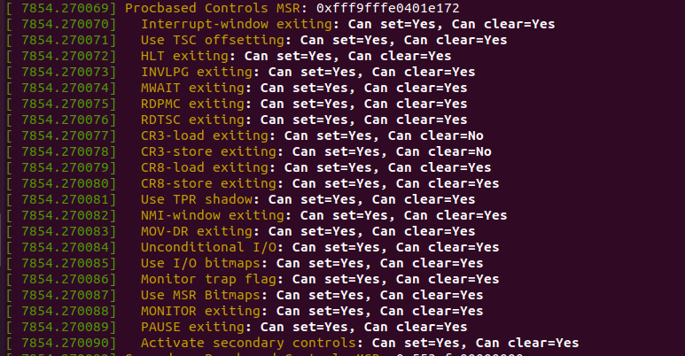

1. Secondary Procbased controls

After testing: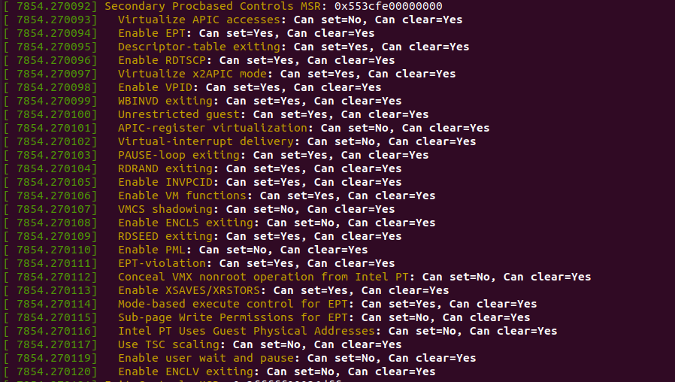

1. VM Exit controlsGraphical user interface, text

   Description automatically generated

After testing: 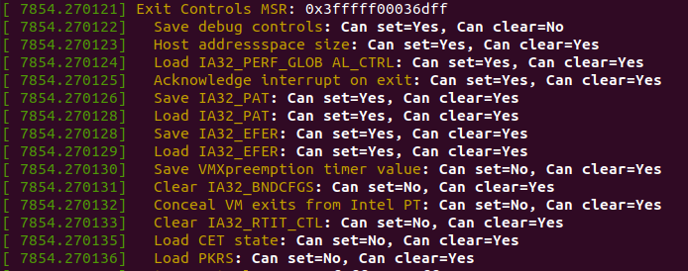

1. VM Entry controlsGraphical user interface, text

   Description automatically generated

After testing:

