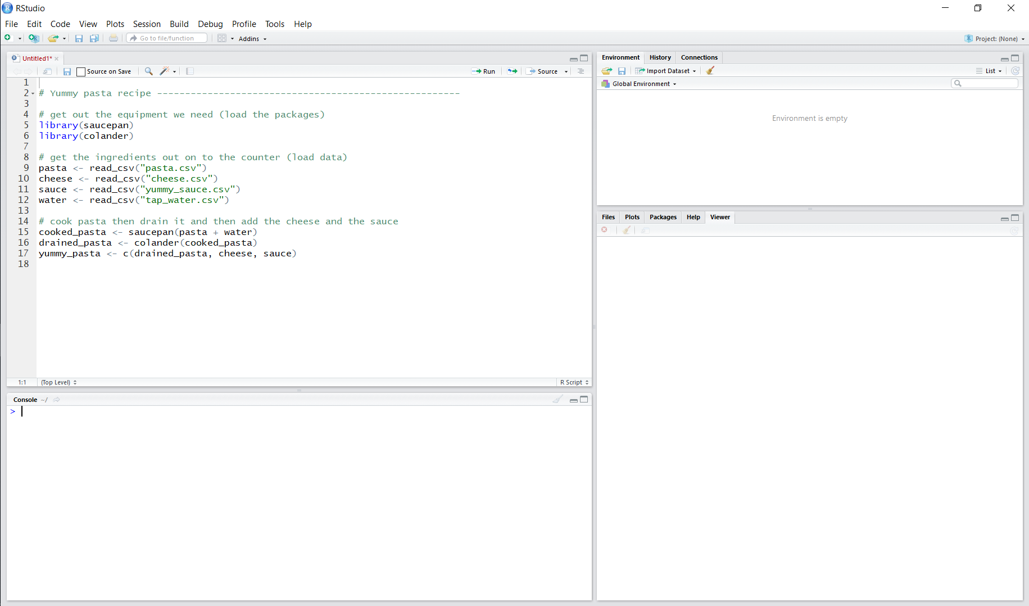
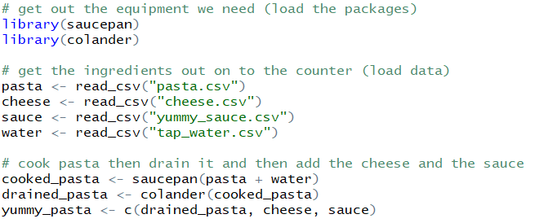
Scripts are recipes (records) of how to do things.
Write and save your recipes here so that R knows what to cook.
The console is where the cooking happens - send recipes here (run code) to cook them.
You can cook here without using a recipe, but you’ll struggle to remember exactly how to recreate the dish in the future.
It’s better to use a recipe!
The environment is like the kitchen counter - you can put ingredients (data) and finished dishes (model outputs) here to use while you cook.
Files are like ingredients in your cupboard - you need to get them out on to the kitchen counter (the environment) to use them.
The files that you need can be specified in the recipe so you know exactly what you need to get out.
Packages are like tools - when you need to use a saucepan, you go out and buy one that someone has already designed and made [install.packages()].
Each time you want to use that pan, you just take it out of the cupboard [library()].

