1. Cat
2. Cat –c

Select only those characters.

$cat –c 1 myfile

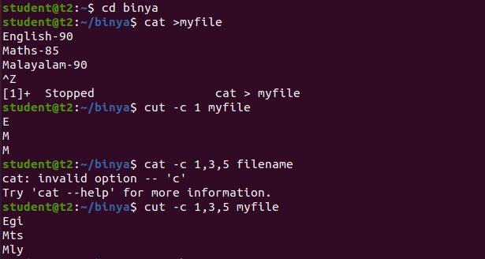

1. Cut –b

Select only these bytes

$cut b 2 myfile



1. Cut –d

Display a specific column

$cut –d - -f1 myfile



1. Cut –complement

Cut by complement pattern

$cut –complement –c 1 myfile



1. Paste
2. Paste : paste the content



1. Paste –d

Paste command is used to join files consisting of lines from each file horizontally by outputting lines



1. Copy
2. Cp: To copy a file



1. Cp –r:To copy a directory

