1. Pwd -The pwd command writes to standard output the full path name of your current directory (from the root directory)

$pwd

C:\Users\user\Downloads\1.png

1. ls- It's used to display a list of files and sub-directories in the current directory.

$ ls



1. ls –R

list all files and directories with their corresponding subdirectories

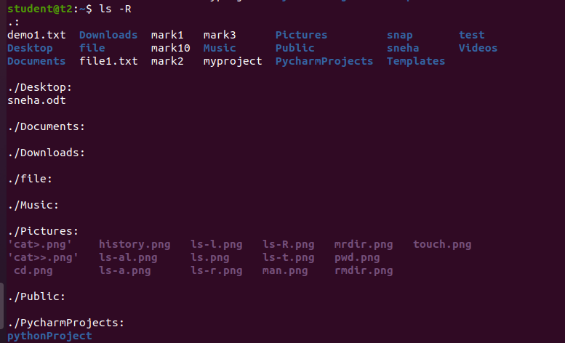

1. ls –l

It will show the list in a long list format.

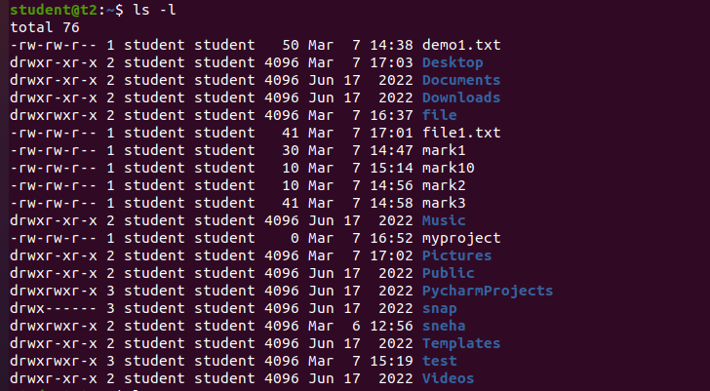

1. ls –a

list files or directories including hidden files or directories.

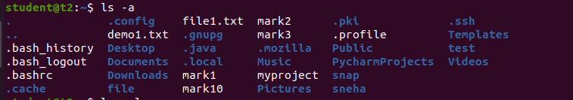

1. ls –al

list files or directories in a table format with extra information including hidden files or directories:

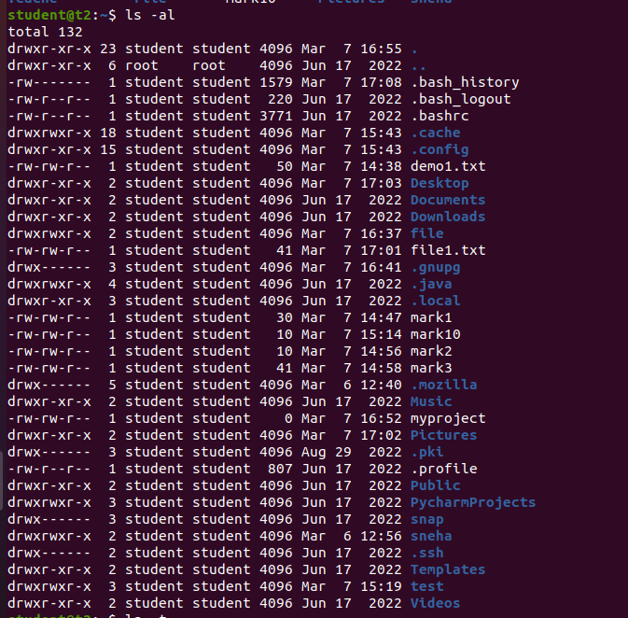

1. ls –t

sort by time & date.

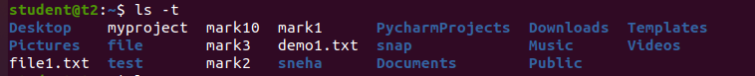

1. ls -r

It is used to print the list in reverse order.

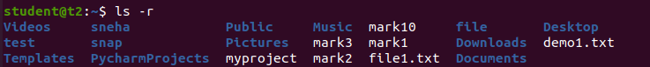

1. mkdir

The mkdir stands for 'make directory'. With the help of mkdir command, you can create a new directory wherever you want in your system.

$mkdie binya

C:\Users\user\Downloads\3 (1).png

1. cd

The "cd" stands for 'change directory. cd command is used to change the current working directory

C:\Users\user\Downloads\4.png

1. cd ..

this command is used to move to the parent directory of current directory, or the directory one level up from the current directory. “..” represents parent directory.

C:\Users\user\Downloads\5.png

1. history

history command is used to view the previously executed command.

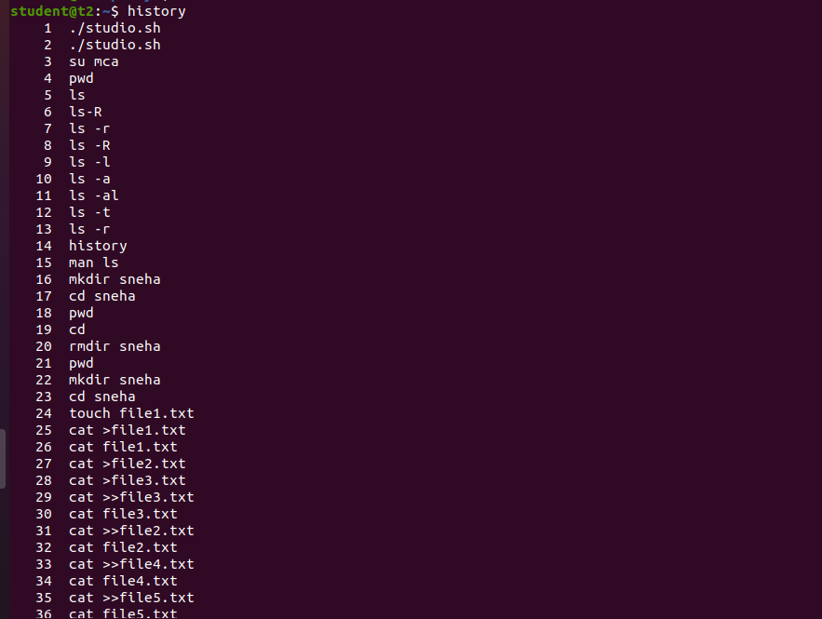

1. man

The man command is a built-in manual for using Linux commands. It allows users to view the reference manuals of a command or utility run in the terminal.

C:\Users\user\Downloads\7man1.png

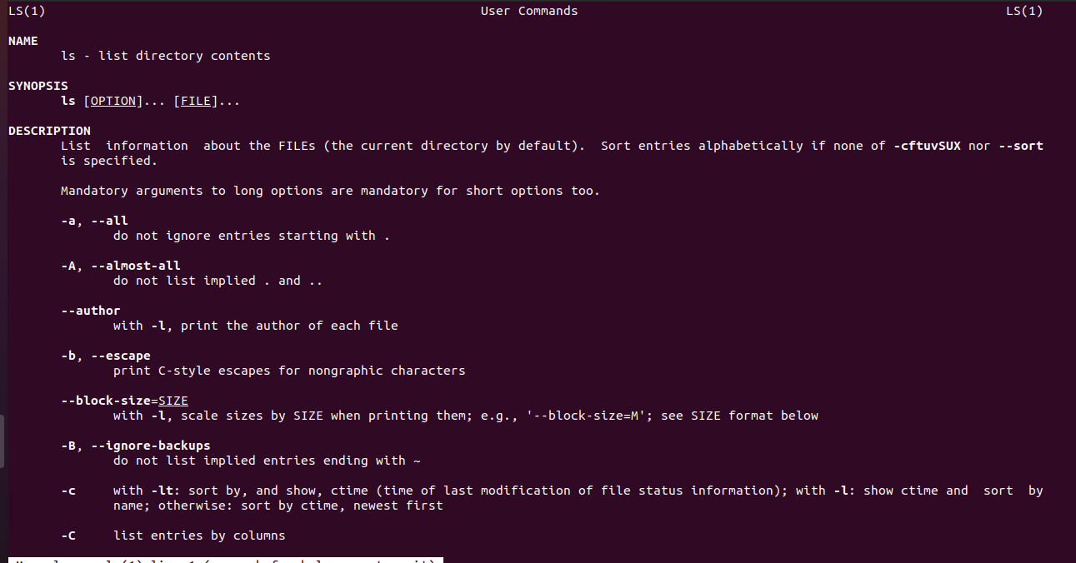

1. cat >filename

To create a file.

$cat >first

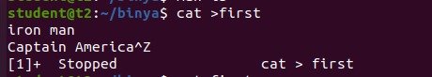

1. cat filename

This command displays the contents

C:\Users\user\Downloads\9.png

1. cat >>filename

The 'cat' command with double greater than sign (>>) append (add something in the last of a file) something in your already existing file.

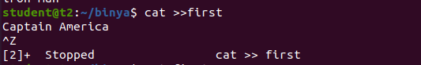

1. cat –n filename

To display line numbers.

C:\Users\user\Downloads\11.png

1. cat –b filename

To remove numbering of the empty line

