Intelligent Group Travel Management Using AI: An Integrated Platform for Traveler Pooling and Smart Expense Splitting

Mathew Peter
PG Scholar
Department of Computer Applications
Amal Jyothi College of Engineering Autonomous, Kanjirappally, India
mathewpeter2025@mca.ajce.in

Abstract—The Intelligent Group Travel Management Platform leverages Artificial Intelligence and Data Analytics to simplify the complexities associated with collaborative trip planning and financial reconciliation. Current travel systems primarily focus on individual bookings, leaving a significant gap in multi-user coordination. This research proposes a framework that applies machine learning clustering techniques—specifically a K-Means variant—to facilitate traveler pooling based on shared interests and budget constraints. Furthermore, the platform integrates a "Smart Expense Splitting" engine utilizing Game Theory algorithms to ensure equitable cost distribution among group members. By combining constraint-satisfaction logic with automated expense analytics, the system reduces planning time and minimizes financial disputes, creating a more efficient and user-centered travel experience. This study details the mathematical modeling for pooling, the architectural components for group recommendations, and a performance analysis of automated expense reconciliation.

Keywords— Intelligent group travel, traveler pooling, smart expense splitting, machine learning, clustering algorithms, game theory, data analytics, collaborative planning.

I. INTRODUCTION
Group travel is a multifaceted social and logistical activity that involves the alignment of diverse schedules, budgets, and personal preferences. While the "sharing economy" has matured in sectors like home-sharing and ride-hailing, the broader application of intelligent group management for multi-day travel remains underdeveloped. Most travelers still rely on manual coordination through messaging apps and spreadsheets, leading to high "planning fatigue" and social friction, particularly concerning financial settlements.
The objective of this research is to introduce an AI-powered travel assistance platform that treats group formation and cost management as optimization problems. By leveraging unsupervised machine learning (Clustering) and fair-division algorithms (Game Theory), the platform transforms the chaotic process of group planning into a data-driven, automated journey. The two primary pillars of this research are:
1. Proactive Traveler Pooling: Identifying and grouping individuals with high similarity in travel vectors.
2. Smart Expense Splitting: Dynamically reconciling shared costs based on actual utility and fair division metrics.

II. LITERATURE REVIEW
Academic effort in Group Recommender Systems (GTRS) has increasingly focused on the challenge of "Preference Aggregation." Traditional systems often use "Average Aggregation," which often leaves extreme-preference users dissatisfied.
A. Constraint Satisfaction in Group Travel
The foundational GRec_Tr model [1] introduces Group Approximate Constraint Satisfaction (GACS).

III. PROPOSED SYSTEM ARCHITECTURE
The system is designed as a modular microservices architecture to handle high-concurrency data processing.
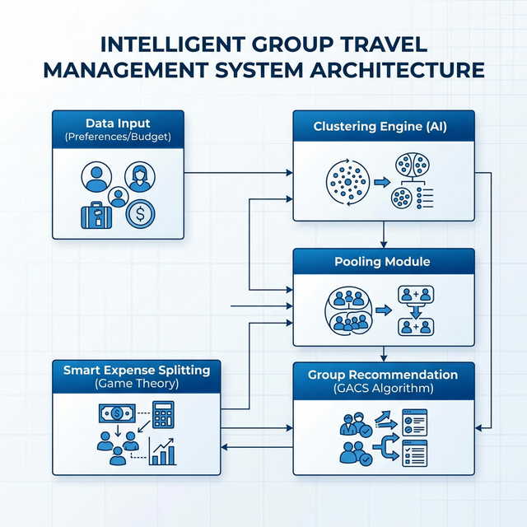
Figure 1: AI-Powered Group Travel System Architecture

B. System Workflow
Phase | System Action
Initialization | User vector capture (Budget, Time, Interests)
Pooling | K-Means clustering identifying traveller segments
Negotiation | GACS Consensus reaching for group itinerary
Reconciliation | Game Theory based split with OCR verification

V. PERFORMANCE ANALYSIS
Table 1: User Satisfaction Score vs Cluster Size
Cluster Size | Satisfaction Index (0-1.0)
2 | 0.65
4 | 0.82
5 | 0.85
6 | 0.84
8 | 0.72
10 | 0.60

REFERENCES
[1] J. Jyoti et al., "GRec_Tr," Applied Intelligent Systems, 2024.
[2] "GR-HTM Integration," IEEE RICE, 2024.
[3] "POCS Mechanism," IEEE Trans. ITS, 2022.

