**Surveillance of respiratory illness using pathogen specific diagnostic test utilization: an alternative to influenza-like illness**

**Introduction**

In the United States (US), epidemiological reporting of respiratory illness typically focuses on influenza-like illness (ILI), which healthcare professionals use to monitor seasonal disease onset, duration, and severity. The Test Utilization Rate Normalized (TURN) metric we calculate using data from FilmArray® Trend, a cloud-based epidemiology system, measures generalized respiratory illness based on the rate that physicians order FilmArray® Respiratory Panel (RP) tests. Patients with respiratory symptoms are tested with RP, which can identify 20 pathogens in a single test, at Trend sites. TURN is based on test utilization, and is therefore a broader respiratory disease surveillance system in comparison to ILI, which focuses on influenza and may mask other etiologies of respiratory disease.

**Methods**

RP test frequency is an indicator of respiratory illness; however, greater adoption of FilmArray products increased test frequency unrelated to disease severity in our dataset. Linear regression was used to normalize the rate at which physicians ordered over 300,000 RP tests starting in 2013. TURN was overlaid with ILI and Google Flu to evaluate differences. A multiple regression of TURN with pathogen detection was performed to determine pathogens that contributed most significantly to respiratory disease.

**Results**

TURN varies annually, corresponding to traditional influenza seasonality; however, upticks in the metric can potentially identify outbreaks that ILI cannot, such as non-Polio Enterovirus (EV-D68) in 2014. TURN cross-correlates with ILI better than Google Flu (R = 0.83 and 0.80, respectively), with RSV, Influenza A, and Human Rhinovirus/Enterovirus contributing most significantly to test utilization.

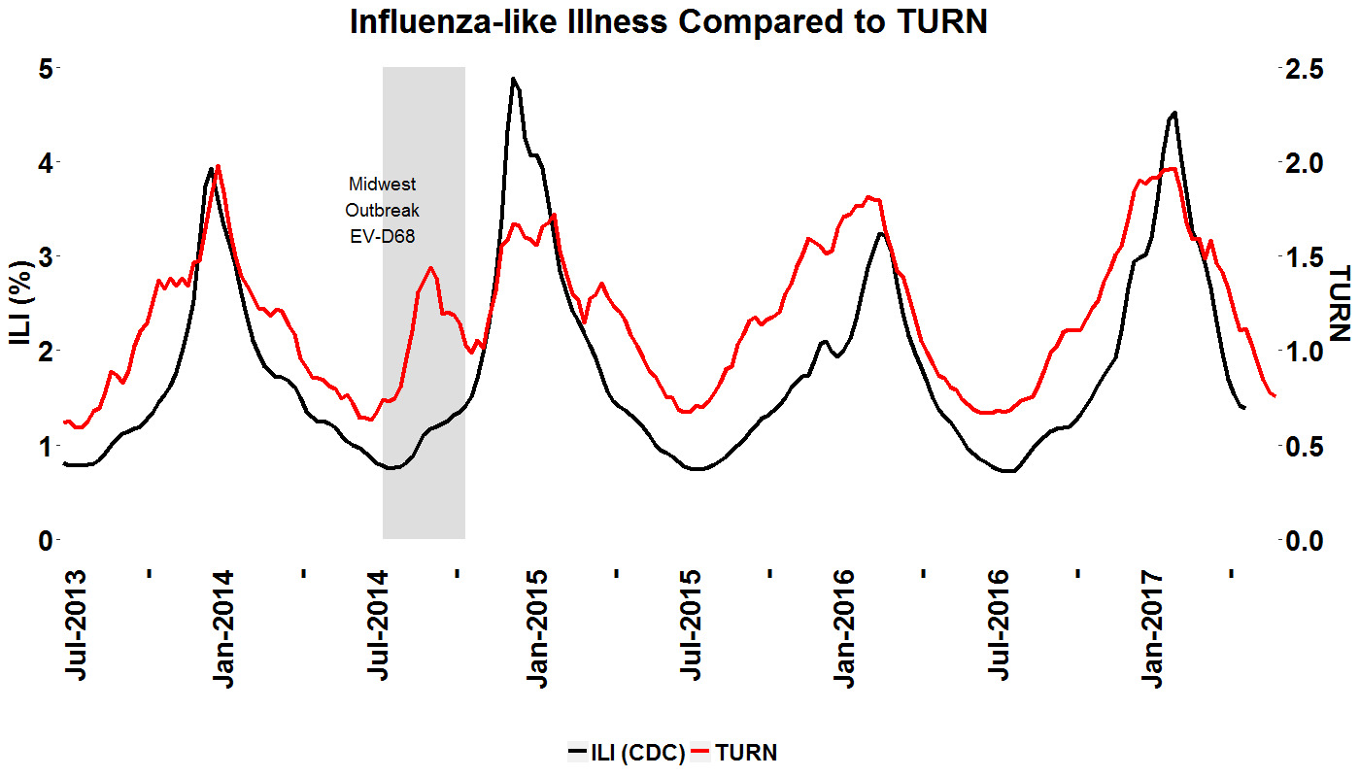

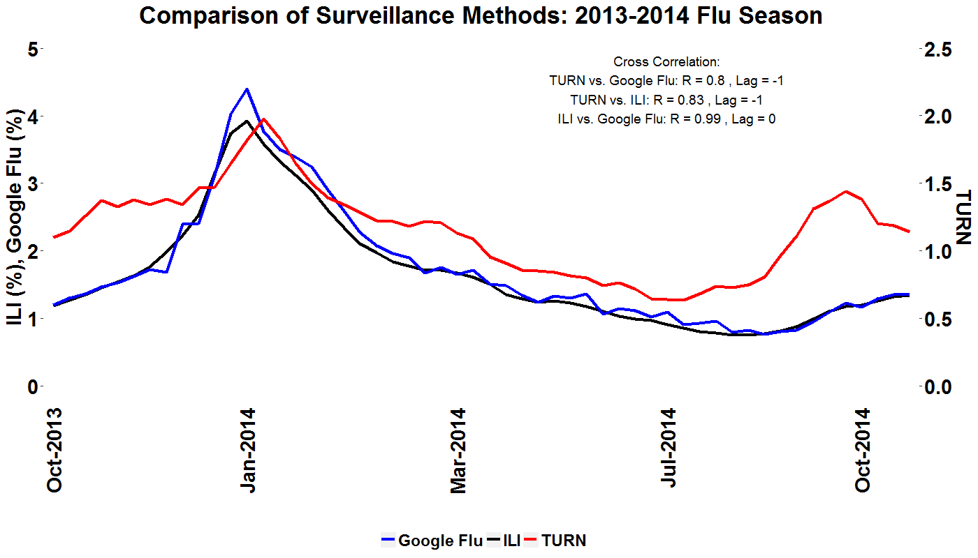



**Conclusion**

TURN can be used to monitor respiratory season in the US caused by an array of pathogens, a departure from current surveillance methods. This has implications for the diagnosis, treatment, and epidemiology of respiratory illness, as our results show that pathogens other than influenza are stronger contributors to test utilization and respiratory illness prevalence.