Title:
Surveillance of respiratory illness using pathogen specific diagnostic test utilization: an alternative to influenza-like illness
Authors & affiliations:
A. Faucett¹, J. Nawrocki¹, A. Hoffee¹, B.M. Althouse^{2,3}, S.V. Scarpino⁴, M.A. Poritz⁵, L. Meyers¹
¹BioFire Diagnostics, Salt Lake City, UT; ²University of Washington, Seattle, WA; ³New Mexico State University, Las Cruces, NM; ⁴Northeastern University, Boston, MA; ⁵BioFire Defense, Salt Lake City, UT
Abstract: (Your abstract must use Normal style and must fit in this box. Your abstract should be no longer than 300 words. The box will ‘expand’ over 2 pages as you add text/diagrams into it.)
Preparation of Your Abstract
1. The title should be as brief as possible but long enough to indicate clearly the nature of the study. Capitalise the first letter of the first word ONLY (place names excluded). No full stop at the end.
2. Abstracts should state briefly and clearly the purpose, methods, results and conclusions of the work.
Introduction: Clearly state the purpose of the abstract
Methods: Describe your selection of observations or experimental subjects clearly
Results: Present your results in a logical sequence in text, tables and illustrations
Discussion: Emphasize new and important aspects of the study and conclusions that are drawn from them
Introduction
In the United States (US), epidemiological reporting of respiratory illness typically focuses on influenza-like illness (ILI), which is used by healthcare professionals to monitor seasonal disease onset, duration, and severity. We have developed the Test Utilization Rate Normalized (TURN) metric using FilmArray® Trend, a cloud-based epidemiology system, to measure generalized respiratory illness based on the rate that physicians order FilmArray® Respiratory Panel (RP) tests. Patients with respiratory symptoms are tested with RP, making TURN a general respiratory disease surveillance system. RP tests for 20 pathogens; therefore, TURN is more comprehensive than ILI, which focuses on influenza and may mask other etiologies of respiratory disease.

Methods
The RP test frequency is used as an indicator of respiratory illness; however, increased adoption of FilmArray products may increase utilization unrelated to disease severity. We use a linear regression model to normalize the rate at which physicians ordered over 300,000 RP tests starting in 2013. TURN is overlaid with ILI and legacy Google Flu to evaluate differences. We performed a multiple regression of TURN with pathogen detection to determine which pathogens contribute most significantly to respiratory disease.

Results
TURN varies annually, corresponding to traditional influenza seasonality; however, upticks in the metric can potentially identify outbreaks that ILI cannot, such as non-Polio Enterovirus (EV-D68) in 2014. TURN cross-correlates with ILI better than Google Flu (R = 0.83 and 0.80, respectively), with RSV, Influenza A, and Human Rhinovirus/Enterovirus contributing most significantly to test utilization in the dataset.
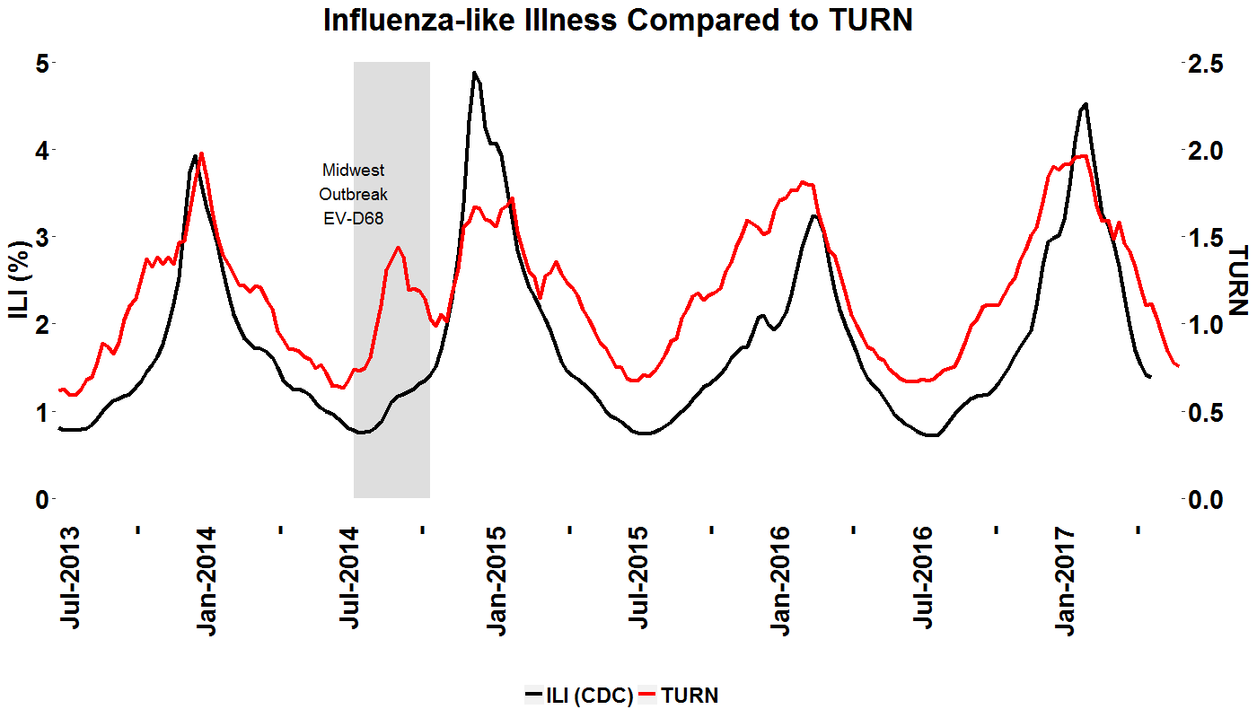

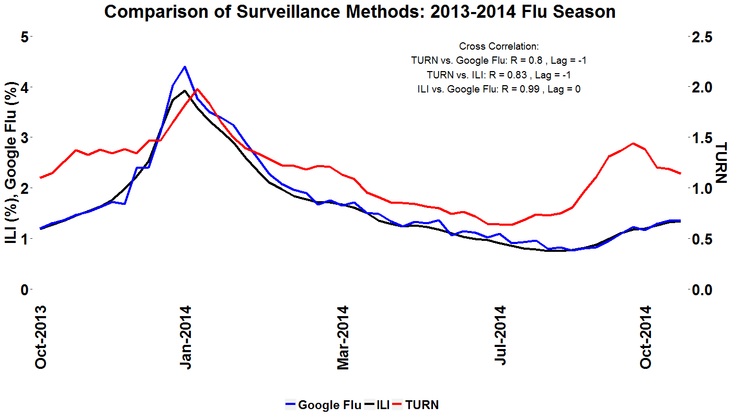

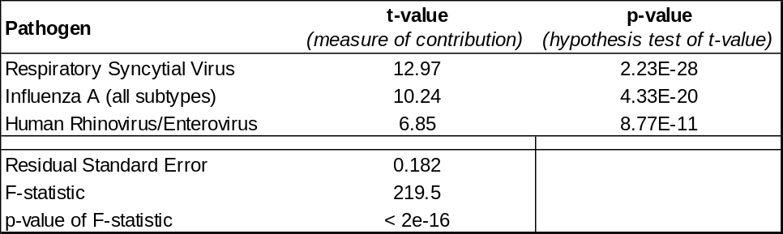

Conclusion
TURN can be used to monitor respiratory season in the US due to an array of pathogens, a departure from current surveillance focusing on few pathogens. This has implications for the diagnosis, treatment, and epidemiology of respiratory illness, as we have identified that pathogens other than influenza are stronger contributors to test utilization and respiratory illness prevalence.

