**Technical guide to grassDT-model**

The following document provides information on the folder and file structure as well as code structure of the modelling component for the prototype Digital Twin of Grassland Biodiversity Dynamics.

**(1) Folder structure**

In the following a scheme of the folder structure found under the GitLab repository (link) is outlined.

grassDT-model/

│

├── .vscode

|

├── build/

| ├── include/

| | ├── module_input/

| | | └── input.h

| | └── …

| ├── grassmind.exe

| └── …

|

├── docs/

│ ├── README.md

│ ├── ModelDocumentation.pdf

│ ├── TechnicalGuide.pdf

│ ├── Tutorial.pdf

│ ├── Guideline.pdf

│ └── LICENSE

|

├── parameters/

│ ├── BioDT-generic/

| | ├── parameters_generic_v1.txt

│ ├── GCEF-pilot/

| | ├── parameters_pilot_v1.txt

|

├── scenarios/

│ ├── weather/

| | ├── weather_lat_lon_startyear_endyear.txt

│ ├── soil/

| | ├── soil_lat_lon_refYear2020.txt

| ├── management/

| ├── management_lat_lon_startyear_endyear.txt

|

├── simulations/

│ ├── project1

| | ├── results/

| | | ├── output_lat_lon_startyear_endyear_generic_v1.txt

| | ├── runSimulation.cmd

| | ├── sterr.txt

| | ├── stout.txt

| | ├── configuration_lat_lon_startyear_endyear_generic_v1.txt

| | ├── outputWritingDates_lat_lon_startyear_endyear.txt

| ├── …

|

├── src/

| ├── main.cpp

| ├── module_input/

| │ ├── input.cpp

| │ └── input.h

| ├── module_output

| │ ├── output.cpp

| │ └── output.h

| └── utils/

| ├── utils.cpp

| └── utils.h

|

└── CMakeLists.txt

TODO: ein paar Erläuterungen zu den Ordnern und was darin zu finden ist

**(2) How to compile the model code?**

TODO: Anleitung für first use, Hinweise, CMake

Endresultat: grassmind.exe im Build Ordner

**(3) How to run a model simulation?**

**3.1 The *simulations* folder**

**3.1.1 The *configuration* file**

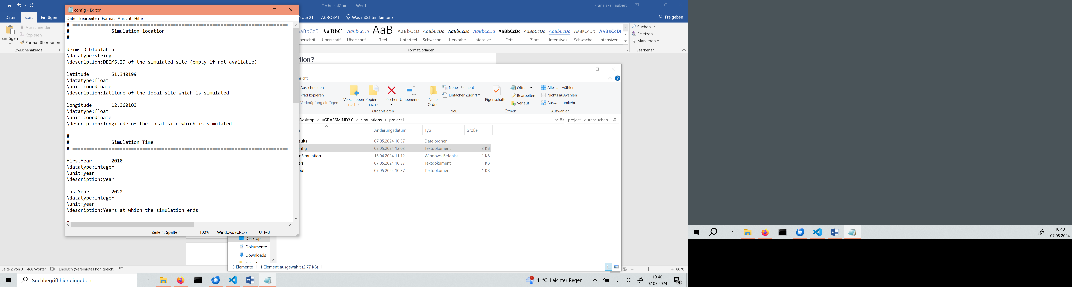

|  |  |  |  |
| --- | --- | --- | --- |
| Model parameter name | Type | Unit | Description |
| deimsID | string | - | DEIMS.ID of grassland site (if available) |
| latitude | float | - | Latitude of the grassland site |
| longitude | float | - | Longitude of the grassland site |
| firstYear | int | year | First year at which simulation starts |
| lastYear | int | year | Last year at which simulation ends |
| weatherFile | string | - | File name of daily weather data |
| soilFile | string | - | File name of soil properties |
| managementFile | string | - | File name of management actions (mowing, fertilization, irrigation) |
| speciesFile | string | - | File name of model parameters for species or plant functional types |
| resultFileBiomass | bool | - | Select if the output file is written to the created results folder |
| outputWritingDates | string | - | File name of selected dates at which simulation results should be written (instead of every day) |
| clippingHeightForBiomassCalibration | float | meter | Clipping height of aboveground biomass (only needed if simulations results will be used for model calibration with observation data) |
| reproducibleResults | bool | - | De-/Activation of reproducible simulation results.  Value = true: simulation results are reproducible (r*andomNumberGeneratorSeed* is used as initializer for generating random numbers).  Value = false: simulation results are not reproducible (local machine time is used as initializer). |
| randomNumberGeneratorSeed | integer | - | Initializer for the random number generator. Only needed if r*eproducibleResults* is set true. |

**3.3 The scenarios folder**

1. Weather data file
2. Soil properties file
3. Cultivation planning file

**3.4 The species_trait_parameter folder**

Species/PFT parameter trait file

3.5. Internal model parameter

|  |  |  |  |
| --- | --- | --- | --- |
| Model parameter name | Type | Unit | Description |
| day | int | day | Current simulated day (cumulative) |
| numberOfDaysToSimulate | int | days | Total number of days to be simulated based on *firstYear* and *lastYear* (including leap years) |
|  |  |  |  |
|  |  |  |  |
|  |  |  |  |
|  |  |  |  |
|  |  |  |  |
|  |  |  |  |
|  |  |  |  |
|  |  |  |  |
|  |  |  |  |
|  |  |  |  |
|  |  |  |  |
|  |  |  |  |

3.5 Plant attributes

|  |  |  |  |
| --- | --- | --- | --- |
| Model variable name | Type | Unit | Description |
|  |  |  |  |
|  |  |  |  |
|  |  |  |  |
|  |  |  |  |
|  |  |  |  |
|  |  |  |  |
|  |  |  |  |
|  |  |  |  |
|  |  |  |  |
|  |  |  |  |
|  |  |  |  |
|  |  |  |  |
|  |  |  |  |
|  |  |  |  |