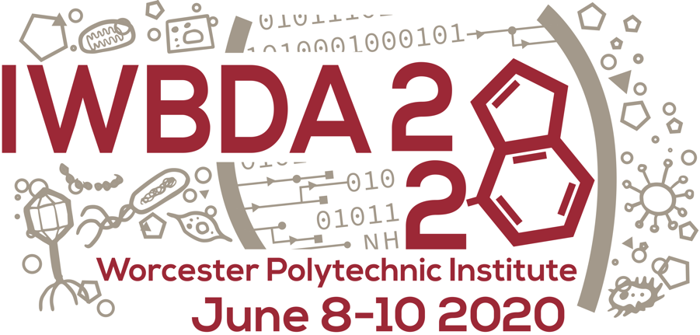

**6th Annual Allan Kuchinsky International Workshop on Bio-Design Automation Scholarship**

This year IWBDA will be soliciting applications for the 6th annual Allan Kuchinsky International Workshop on Bio-Design Automation Scholarship. Allan was a tremendous supporter of both synthetic biology as well as design automation. His contributions to projects such as Cytoscape and Eugene as well as numerous Agilent efforts was crucial in helping academic and industrial researchers develop state-of-the-art technologies and tools to lay the foundation for this field. This scholarship in some small measure attempts to recognize his tireless efforts by highlighting a student who shares Allan’s vision for the field.

This scholarship will provide support for one recipient to attend IWBDA (registration, airfare, hotel, and small travel stipend) along with a recognized poster presentation slot. Interested individuals should provide the following:

* CV/Resume
* 1-2 page essay detailing your interest in BDA and how attending the workshop will benefit you **and** the larger BDA community.
* 1 recommendation letter from someone **within** the BDA or synthetic biology community familiar with your work.
* IWBDA formal abstract submission for consideration in the workshop (will be considered regardless of your final scholarship status).

Successful applicants will likely be senior PhD students, post docs, or early career researchers (pre-tenure). However, there are not any formal education requirements. If selected, you be required to attend the workshop in person for the entirety of the workshop and present a poster.

**Past Recipients:**

1. – Dr. Swapnil Bhatia, Boston University
2. – Dr. Nicholas Roehner, Boston University and Broad Institute of MIT and Harvard
3. – Dr. Curtis Madsen, Boston University
4. – Dr. Steve Shih, Concordia University

2019 – Dr. Martín Gutiérrez Pescarmona, Universidad Diego Portales, Santiago

**Deadline: March 31st, 2020**

**Submission Process:** Send PDFs of your CV/resume and essay to AKS@bio-design-automation.org with the subject: AKS_2020_<lastname>. Please have the person writing your letter email it directly to AKS@bio-design-automation.org with the subject: AKS_2020_<lastname>.