IWBDA 2023 Abstract Template

|  |  |  |
| --- | --- | --- |
| First Author  Second Author∗  first@corporation.com second@institute.edu | Third Author  University  City, Country third@no.name.org | Fourth Author  Research Institute  City, Country fourth@name.org |

# **INTRODUCTION**

Join us for the 15th annual IWBDA meeting, in Boston, September 11-15, 2023. This year, IWBDA will take place during Bio-Design Week and will include presentation and poster talks selected from submitted abstracts, Birds of a Feather discussions, and breakout sessions on selected topics. We aim to bring together academic researchers and industry partners to push the field of bio-design automation for synthetic biology forward.

The field of biology is still lagging behind the industry when it comes to implementation and adoption of computational and digital solutions. This is primarily because it is extremely difficult to offer a one-size-fits-all solution to engineer biology. Some BDA solutions serve as templates for a larger problem, but, to make it usable in a practical setting, the solutions often have to be redesigned for bespoke biological workflows. Without understanding the requirements of the broader synthetic biology community, it is hard to design a solution that can have a wider impact.

Increasing the efficiency of biological processes and workflows with bio-design automation is a continuous journey that requires fresh exchange of ideas. It is crucial for the BDA community to have a forum where they can collaborate, gather new perspectives, and understand the requirements of the broader synthetic biology community. IWBDA provides this forum for cross-disciplinary discussion, with the aim of seeding and fostering collaboration between the researchers from the synthetic biology, systems biology, and design automation communities.

Topics of interest include:

* Design methodologies for synthetic biology
* Standardization of biological components
* Biosecurity in lab automation processes
* Biopreparedness through bio-design automation
* Artificial intelligence and machine learning in synthetic biology
* Computer aided design tools and automation for engineering biology
* Biofoundries and their impact on synthetic biology
* Formalized protocol capture
* Design Build Test Learn case studies
* Synthetic biology education and outreach

This document is a MS Word template for an IWBDA abstract.

# **CONTENTS OF THE ABSTRACT**

The abstracts must use this MS Word template or the LaTeX ACM template (SIGCHI version). **Abstracts should be submitted in pdf format and should not exceed two pages excluding figures and tables.**

# **Figures**

Figures are highly encouraged in your abstract. It always helps having a visual representation of your methods or results. Figure 1 shows an example of a smaller figure that spans just 1 column.

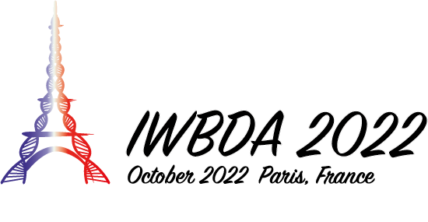

Figure 1: A figure spanning just one column

Figure 2 shows how large figures that span both columns can be displayed. Figure captions must appear beneath a figure.

# **Tables**

Figure 2: You can show a figure that spans both columns.

A table’s heading must appear above the table. Table 1 shows an example of a table. Like figures, large tables may span multiple columns.

**Table 1: Table Heading**

|  |  |
| --- | --- |
| Column 1 | Column 2 |
| a | 1.0 |
| b | 2.0 |

# **Bibliography**

For the bibliography, please make sure you use the ACM style as in the References section of this template. This is an example of a citation [1].

**SUBMISSION**

Abstracts must be submitted via EasyChair using [this](https://easychair.org/my/conference?conf=iwbda23) [link.](https://easychair.org/conferences/?conf=iwbda22) If you do not have an EasyChair account, please create one by following the instructions specified [here](https://easychair.org/help/account_creation). Please make sure that you include the full names, affiliations and contact information of all authors. Please make sure you indicate whether you would like your abstract considered for a poster presentation, an oral presentation, or both. Abstracts will be reviewed by the Program Committee. Those that are selected for oral and poster presentations will distributed to workshop participants and posted on the workshop website.

While submitting your abstract for review, please make sure that you include line numbers in the document to assist with the review process. To add line numbers in your Word document, go to Layout, and select “Continuous” under the “Line Numbers” option. This will add the numbers to the side of the document which makes it easier to review your abstract. If your abstract is accepted, please make sure you remove the line numbers.

**The deadline for Abstract Submission is: June 23 (early) and July 14 (regular), 2023, anywhere on Earth.**

# **Contact**

If you have any questions regarding this template or submissions, please send an email to [Natasa Miskov-Zivanov](mailto:nmzivanov@pitt.edu?subject=IWBDA%202023). You can find the CFP and the latest information on the IWBDA 2023 [website](https://www.iwbdaconf.org/2023/). You can also contact the committee by sending an [email](mailto:iwbda-exec@lists.bio-design-automation.org).

# **REFERENCES**

[1] Lamport, L. *LATEX: a document preparation system: user’s guide and reference manual*. Addison-wesley, 1994.