BioEchem Portal — Design Document
Audience: Developers and technical leads.
Plain-language guide for staff, teachers, and partners: DESIGN-FOR-TEAM.md

Field | Value
Portal URL | https://portal.bioechem.com (For now)
Marketing URL | https://www.bioechem.com (Wix, prepaid ~3 years)

1. Executive summary
The current public presence is a Wix marketing site. This document defines the BioEchem Portal—a separate, long-lived web application for authenticated users: learning, curriculum delivery, submissions, career pathways, partnerships, and internal administration.

Design goals:

- Keep Wix for all public marketing for the prepaid term—no duplicate brochure site in code.
- Build the portal to be scalable (multi-school, multi-year growth) and cost-efficient (metered infrastructure, upgrade only on defined triggers).

2. System context

2.1 Two-site architecture
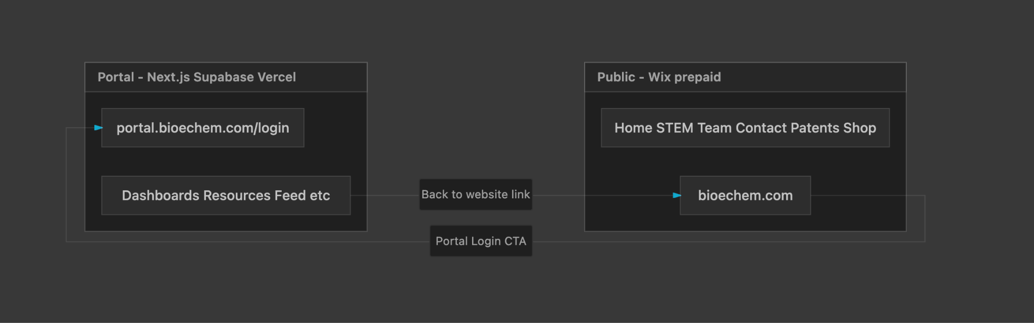

Property | Wix (bioechem.com) | Portal (portal.bioechem.com)
Audience | Public visitors | Authenticated users only
Content | Marketing, overview curriculum, contact | Operational data, kits, submissions, messaging
Edited by | BioEchem staff (Wix Editor) | Portal admin console + developers
Lifespan | Prepaid ~3 years; replaceable | Primary asset (5–10+ years)
Cost | Sunk (prepaid) | $0–15/mo pilot → $50–80/mo production → scales on usage

2.2 Wix integration requirements
- Top navigation: “Portal Login” → https://portal.bioechem.com/login
- DNS: CNAME portal → Vercel; root domain unchanged on Wix

3. Users and roles

3.1 Role definitions
Role | Code | Primary goals
Student | student | Learn, submit work, explore careers, register for events
Teacher | teacher | Deliver classes, manage roster, curriculum, kits, semester reporting
School administrator | school_admin | School-wide oversight (extends teacher permissions where applicable)
Industry partner | industry_partner | Post internships, collaborations, field trips, MoU/Letter of Support
BioEchem admin | bioechem_admin | Global operations, content, partners, analytics, all portals

4. Information architecture

4.1 Global navigation (authenticated)
Nav item | Route (proposed) | Roles
Dashboard | /dashboard | All
Resources | /resources | All (filtered)
Feed | /feed | All
Messages | /messages | All
Calendar | /calendar | All
Assignments | /assignments | Student, Teacher, Admin
Internships | /careers | Student, Teacher, Partner, Admin
Media Hub | /media | All (filtered)
Profile | /profile | All
Settings | /settings | All
Admin Console | /admin | bioechem_admin only

4.2 Feature map by role

Dashboard — Student
- Upcoming classes/events (name, age, class, time of year)
- Today’s materials; quick access to assignments, modules, career opportunities, announcements
- Event registration (summer camp / science camp); guidance resources (college and other paths)
- Career pathway / interests questionnaire; internships; post-HS navigation (college, internships, trade school, co-op)
- Job offers; certificates (lucky draw / cash award); resume
- DM with BioEchem

Dashboard — Teacher / School administrator
- Name, class, time, kits to prepare, contact email, superintendent’s name
- Today’s classes; class roster; curriculum quick links; recent submissions; announcements
- Teacher activity; student activity; resource usage metrics; partnership opportunities
- Kit/curriculum feedback; semester program update (student count, content, class title, when kits used — required each semester)
- Gallery per school folder (field trips, class activity); curriculum uploads, handouts, questionnaires
- Events / field trips / science fair / conference
- DM with BioEchem

Dashboard — Industry partner
- Invitations to collaborations; ways to engage schools
- Internship postings; grant app info; field trip offers; job offers
- Collaboration projects; Letter of Support / MoU
- DM with BioEchem

Dashboard — BioEchem admin
- Global metrics (schools onboarded, active users)
- Ongoing programs (time, school, teacher, student count, class time, prep, due dates)
- Partners; master calendar (all classes/workshops)
- Content management; analytics; impersonate/view all role portals
- Rules/policies; collaboration opportunities; customer contacts; internships/jobs; grants

Resource library (shared structure, role-filtered)
Permission | Student | Teacher | Partner / Admin
View student materials | Yes | Yes | Manage uploads
Download / organize | — | Yes | Yes
Internships + student profiles (applications) | — | Yes | Post + manage

Communication feed
- Types: announcements, posts, class updates, project/event media, comments, references
- Permissions: all users create, view, comment (moderation by admin)
- UI: LinkedIn / Google Classroom style

Calendar and scheduling
- Appointments via Cal.com embed; workshops, school events, partner collaborations
- Google Calendar embed; later OAuth write sync for teachers

Submissions
Actor | Actions
Student | Homework (Bio Battery Kit, etc.), project photos, resume, questionnaires, feedback; history
Teacher | Review, comment, upload assignments, document kit/facility prep for next class
Admin | Oversight, export

Career and internships hub
Actor | Actions
Student | Explore, bookmark, apply; pathway guides; career navigation
Teacher | Recommend; track aggregated interests
Partner | Post opportunities; partnership documents
Admin | Approve posts; manage partners

Media hub
- Searchable archive: class photos, workshops, events, videos, success stories
- Filters: school, grade, topic (hashtag), date

Profile and settings
- Profile, role badge, school affiliation; account settings; notification preferences

5. Technical architecture (summary)
Layer | Choice
Frontend | Next.js 15, TypeScript, App Router
UI | Tailwind, shadcn/ui
Host | Vercel
Data | Supabase (Postgres + Auth + Storage + Realtime)
Email | Resend
Scheduling | Cal.com embed
Media at scale | Supabase Storage → Cloudflare R2

Scalability + cost rules
- Multi-tenant school_id + RLS; pagination everywhere; signed URLs
- lib/storage abstraction; image compression; versioned migrations; staging + prod

Cost model by user tier (portal only; USD/month)
Users | Vercel | Supabase | Resend | Storage extras | Other | Typical total
0–100 | Hobby $0 | Free $0 | Free $0 | incl. | Cal.com $0, Sentry $0 | $0–15
100–500 | Pro $20 | Pro $25 | $0–20 | $0–10 | Cal.com $0–12 | $45–90
500+ | Pro $20 | Pro $25–75+ | $20–40 | R2 $5–50+ | Meilisearch $0–30, Sentry $0–26 | $90–250+

6. Data model (conceptual)
Core tables: schools, profiles, classes, enrollments, resources, posts, comments, conversations, messages, events, calendar_entries, submissions, submission_feedback, internships, applications, career_pathways, bookmarks, media_assets, programs, partners, documents, agreements, semester_updates, audit_logs.

Storage buckets: resources, submissions, media (RLS per bucket).

7. Permissions matrix (summary)
Capability | Student | Teacher | School admin | Partner | BioEchem admin
View student materials | ✓ | ✓ | ✓ | — | ✓
Download/organize curriculum | — | ✓ | ✓ | — | ✓
Upload resources | — | Limited | ✓ | Partner scope | ✓
Feed post/comment | ✓ | ✓ | ✓ | ✓ | ✓
Submit homework | ✓ | — | — | — | View all
Review submissions | — | ✓ | ✓ | — | ✓
Post internships | — | ✓ | ✓ | ✓ | Approve
Global admin | — | — | — | — | ✓

Enforced via PostgreSQL RLS.

8. Phased delivery (design scope)
Step | What you get
Step 1 — Foundation | Login, basic dashboards, curriculum library, homework upload, admin tools to add schools
Step 2 — Stay connected | Feed, messaging, calendar, email reminders
Step 3 — Careers | Internships, partner portal, approvals
Step 4 — Rich media & reporting | Photo/video hub, program tracking, usage insights
Step 5 — Polish | Deeper calendar sync, @bioechem.com email, session feedback surveys

