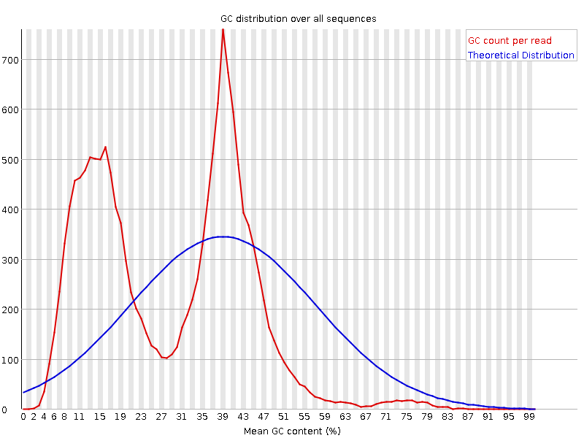

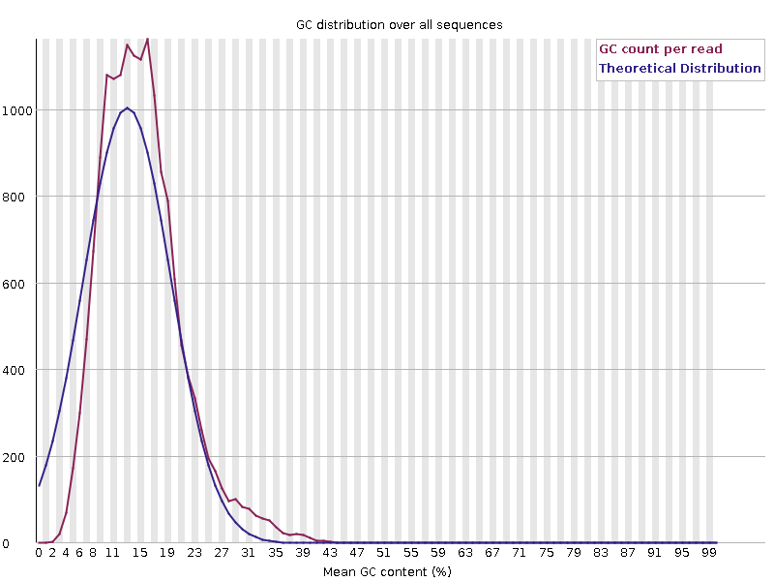

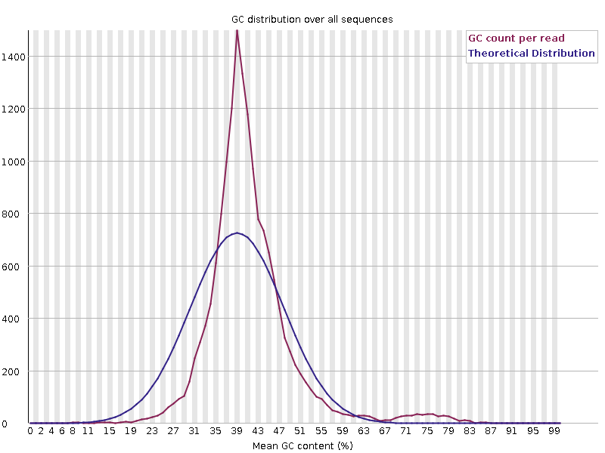

Downsample to largest 100x, assemble (Flye, with same options as we used for the genome)

Sample: assembly.fasta

Genome(bp): 64655

Contigs: 1

GC(%): 16.23

A(%): 42.58

T(%): 41.18

G(%): 8.56

C(%): 7.66

N50: 64655

Max Contig: 64655

Min Contig: 64655

N count: 0

N(%): 0

Gap(-): 0

Uncertain(bp): 0

<https://blast.ncbi.nlm.nih.gov/Blast.cgi?CMD=Get&RID=W78EGVTU013>

| [**Description**](https://blast.ncbi.nlm.nih.gov/Blast.cgi?CMD=Get&RID=W78EGVTU013) | [**Scientific Name**](https://blast.ncbi.nlm.nih.gov/Blast.cgi?CMD=Get&RID=W78EGVTU013) | [**Max Score**](https://blast.ncbi.nlm.nih.gov/Blast.cgi?CMD=Get&ADV_VIEW=yes&ADV_VIEW=on&ALIGNDB_BATCH_ID=733843672&ALIGNDB_CGI_HOST=blast.be-md.ncbi.nlm.nih.gov&ALIGNDB_CGI_PATH=/ALIGNDB/alndb_asn.cgi&ALIGNDB_MASTER_ALIAS=SD_ALIGNDB_MASTER&ALIGNDB_MAX_ROWS=100&ALIGNDB_ORDER_CLAUSE=seq_evalue%20asc,aln_id%20asc&ALIGNDB_WHERE_CLAUSE=seq_evalue%20is%20not%20null&ALIGNMENTS=100&ALIGNMENT_VIEW=Pairwise&CONFIG_DESCR=ClustMemNbr,ClustComn,Ds,Sc,Ms,Ts,Cov,Eval,Idnt,AccLen,Acc&DATABASE_SORT=0&DESCRIPTIONS=100&DYNAMIC_FORMAT=on&FIRST_QUERY_NUM=0&FORMAT_OBJECT=Alignment&FORMAT_PAGE_TARGET=&FORMAT_TYPE=HTML&GET_SEQUENCE=yes&I_THRESH=&LINE_LENGTH=60&MASK_CHAR=2&MASK_COLOR=1&NUM_OVERVIEW=100&PAGE=MegaBlast&QUERY_INDEX=0&QUERY_NUMBER=0&RESULTS_PAGE_TARGET=&RID=W78EGVTU013&SHOW_LINKOUT=yes&SHOW_OVERVIEW=yes&STEP_NUMBER=&USE_ALIGNDB=true&WWW_BLAST_TYPE_URL=&ADV_VIEW=on&DISPLAY_SORT=1&HSP_SORT=1) | [**Total Score**](https://blast.ncbi.nlm.nih.gov/Blast.cgi?CMD=Get&ADV_VIEW=yes&ADV_VIEW=on&ALIGNDB_BATCH_ID=733843672&ALIGNDB_CGI_HOST=blast.be-md.ncbi.nlm.nih.gov&ALIGNDB_CGI_PATH=/ALIGNDB/alndb_asn.cgi&ALIGNDB_MASTER_ALIAS=SD_ALIGNDB_MASTER&ALIGNDB_MAX_ROWS=100&ALIGNDB_ORDER_CLAUSE=seq_evalue%20asc,aln_id%20asc&ALIGNDB_WHERE_CLAUSE=seq_evalue%20is%20not%20null&ALIGNMENTS=100&ALIGNMENT_VIEW=Pairwise&CONFIG_DESCR=ClustMemNbr,ClustComn,Ds,Sc,Ms,Ts,Cov,Eval,Idnt,AccLen,Acc&DATABASE_SORT=0&DESCRIPTIONS=100&DYNAMIC_FORMAT=on&FIRST_QUERY_NUM=0&FORMAT_OBJECT=Alignment&FORMAT_PAGE_TARGET=&FORMAT_TYPE=HTML&GET_SEQUENCE=yes&I_THRESH=&LINE_LENGTH=60&MASK_CHAR=2&MASK_COLOR=1&NUM_OVERVIEW=100&PAGE=MegaBlast&QUERY_INDEX=0&QUERY_NUMBER=0&RESULTS_PAGE_TARGET=&RID=W78EGVTU013&SHOW_LINKOUT=yes&SHOW_OVERVIEW=yes&STEP_NUMBER=&USE_ALIGNDB=true&WWW_BLAST_TYPE_URL=&ADV_VIEW=on&DISPLAY_SORT=2&HSP_SORT=1) | [**Query Cover**](https://blast.ncbi.nlm.nih.gov/Blast.cgi?CMD=Get&ADV_VIEW=yes&ADV_VIEW=on&ALIGNDB_BATCH_ID=733843672&ALIGNDB_CGI_HOST=blast.be-md.ncbi.nlm.nih.gov&ALIGNDB_CGI_PATH=/ALIGNDB/alndb_asn.cgi&ALIGNDB_MASTER_ALIAS=SD_ALIGNDB_MASTER&ALIGNDB_MAX_ROWS=100&ALIGNDB_ORDER_CLAUSE=seq_evalue%20asc,aln_id%20asc&ALIGNDB_WHERE_CLAUSE=seq_evalue%20is%20not%20null&ALIGNMENTS=100&ALIGNMENT_VIEW=Pairwise&CONFIG_DESCR=ClustMemNbr,ClustComn,Ds,Sc,Ms,Ts,Cov,Eval,Idnt,AccLen,Acc&DATABASE_SORT=0&DESCRIPTIONS=100&DYNAMIC_FORMAT=on&FIRST_QUERY_NUM=0&FORMAT_OBJECT=Alignment&FORMAT_PAGE_TARGET=&FORMAT_TYPE=HTML&GET_SEQUENCE=yes&I_THRESH=&LINE_LENGTH=60&MASK_CHAR=2&MASK_COLOR=1&NUM_OVERVIEW=100&PAGE=MegaBlast&QUERY_INDEX=0&QUERY_NUMBER=0&RESULTS_PAGE_TARGET=&RID=W78EGVTU013&SHOW_LINKOUT=yes&SHOW_OVERVIEW=yes&STEP_NUMBER=&USE_ALIGNDB=true&WWW_BLAST_TYPE_URL=&ADV_VIEW=on&DISPLAY_SORT=4&HSP_SORT=0) | [**E value**](https://blast.ncbi.nlm.nih.gov/Blast.cgi?CMD=Get&ADV_VIEW=yes&ADV_VIEW=on&ALIGNDB_BATCH_ID=733843672&ALIGNDB_CGI_HOST=blast.be-md.ncbi.nlm.nih.gov&ALIGNDB_CGI_PATH=/ALIGNDB/alndb_asn.cgi&ALIGNDB_MASTER_ALIAS=SD_ALIGNDB_MASTER&ALIGNDB_MAX_ROWS=100&ALIGNDB_ORDER_CLAUSE=seq_evalue%20asc,aln_id%20asc&ALIGNDB_WHERE_CLAUSE=seq_evalue%20is%20not%20null&ALIGNMENTS=100&ALIGNMENT_VIEW=Pairwise&CONFIG_DESCR=ClustMemNbr,ClustComn,Ds,Sc,Ms,Ts,Cov,Eval,Idnt,AccLen,Acc&DATABASE_SORT=0&DESCRIPTIONS=100&DYNAMIC_FORMAT=on&FIRST_QUERY_NUM=0&FORMAT_OBJECT=Alignment&FORMAT_PAGE_TARGET=&FORMAT_TYPE=HTML&GET_SEQUENCE=yes&I_THRESH=&LINE_LENGTH=60&MASK_CHAR=2&MASK_COLOR=1&NUM_OVERVIEW=100&PAGE=MegaBlast&QUERY_INDEX=0&QUERY_NUMBER=0&RESULTS_PAGE_TARGET=&RID=W78EGVTU013&SHOW_LINKOUT=yes&SHOW_OVERVIEW=yes&STEP_NUMBER=&USE_ALIGNDB=true&WWW_BLAST_TYPE_URL=&ADV_VIEW=on&DISPLAY_SORT=0&HSP_SORT=0) | [**Per. Ident**](https://blast.ncbi.nlm.nih.gov/Blast.cgi?CMD=Get&ADV_VIEW=yes&ADV_VIEW=on&ALIGNDB_BATCH_ID=733843672&ALIGNDB_CGI_HOST=blast.be-md.ncbi.nlm.nih.gov&ALIGNDB_CGI_PATH=/ALIGNDB/alndb_asn.cgi&ALIGNDB_MASTER_ALIAS=SD_ALIGNDB_MASTER&ALIGNDB_MAX_ROWS=100&ALIGNDB_ORDER_CLAUSE=seq_evalue%20asc,aln_id%20asc&ALIGNDB_WHERE_CLAUSE=seq_evalue%20is%20not%20null&ALIGNMENTS=100&ALIGNMENT_VIEW=Pairwise&CONFIG_DESCR=ClustMemNbr,ClustComn,Ds,Sc,Ms,Ts,Cov,Eval,Idnt,AccLen,Acc&DATABASE_SORT=0&DESCRIPTIONS=100&DYNAMIC_FORMAT=on&FIRST_QUERY_NUM=0&FORMAT_OBJECT=Alignment&FORMAT_PAGE_TARGET=&FORMAT_TYPE=HTML&GET_SEQUENCE=yes&I_THRESH=&LINE_LENGTH=60&MASK_CHAR=2&MASK_COLOR=1&NUM_OVERVIEW=100&PAGE=MegaBlast&QUERY_INDEX=0&QUERY_NUMBER=0&RESULTS_PAGE_TARGET=&RID=W78EGVTU013&SHOW_LINKOUT=yes&SHOW_OVERVIEW=yes&STEP_NUMBER=&USE_ALIGNDB=true&WWW_BLAST_TYPE_URL=&ADV_VIEW=on&DISPLAY_SORT=3&HSP_SORT=3) | [**Acc. Len**](https://blast.ncbi.nlm.nih.gov/Blast.cgi?CMD=Get&RID=W78EGVTU013) | **Accession** |
| --- | --- | --- | --- | --- | --- | --- | --- | --- |
| [Saccharomyces bayanus mitochondrial DNA, complete genome, strain: CBS380](https://blast.ncbi.nlm.nih.gov/Blast.cgi?CMD=Get&RID=W78EGVTU013#alnHdr_974000788) | [Saccharomyces bayanus](https://www.ncbi.nlm.nih.gov/Taxonomy/Browser/wwwtax.cgi?id=4931) | 96220 | 1.273e+05 | 100% | 0.0 | 99.84% | 64836 | [AP014933.1](https://www.ncbi.nlm.nih.gov/nucleotide/AP014933.1?report=genbank&log$=nucltop&blast_rank=1&RID=W78EGVTU013) |
| [Saccharomyces bayanus strain CBS 380 mitochondrion, complete genome](https://blast.ncbi.nlm.nih.gov/Blast.cgi?CMD=Get&RID=W78EGVTU013#alnHdr_1088473807) | [Saccharomyces bayanus](https://www.ncbi.nlm.nih.gov/Taxonomy/Browser/wwwtax.cgi?id=4931) | 73854 | 1.272e+05 | 100% | 0.0 | 99.90% | 64736 | [NC_031513.1](https://www.ncbi.nlm.nih.gov/nucleotide/NC_031513.1?report=genbank&log$=nucltop&blast_rank=2&RID=W78EGVTU013) |
| [Saccharomyces uvarum strain CBS7001 mitochondrion, complete genome](https://blast.ncbi.nlm.nih.gov/Blast.cgi?CMD=Get&RID=W78EGVTU013#alnHdr_2419034275) | [Saccharomyces uvarum](https://www.ncbi.nlm.nih.gov/Taxonomy/Browser/wwwtax.cgi?id=230603) | 73815 | 1.272e+05 | 100% | 0.0 | 99.89% | 64728 | [CP113780.1](https://www.ncbi.nlm.nih.gov/nucleotide/CP113780.1?report=genbank&log$=nucltop&blast_rank=3&RID=W78EGVTU013) |
| [Saccharomyces bayanus strain FM677 mitochondrion](https://blast.ncbi.nlm.nih.gov/Blast.cgi?CMD=Get&RID=W78EGVTU013#alnHdr_2075167032) | [Saccharomyces bayanus](https://www.ncbi.nlm.nih.gov/Taxonomy/Browser/wwwtax.cgi?id=4931) | 62323 | 1.219e+05 | 100% | 0.0 | 98.75% | 64226 | [CP080221.1](https://www.ncbi.nlm.nih.gov/nucleotide/CP080221.1?report=genbank&log$=nucltop&blast_rank=4&RID=W78EGVTU013) |
| [Saccharomyces uvarum strain CBS 395 mitochondrion, complete genome](https://blast.ncbi.nlm.nih.gov/Blast.cgi?CMD=Get&RID=W78EGVTU013#alnHdr_1088473762) | [Saccharomyces uvarum](https://www.ncbi.nlm.nih.gov/Taxonomy/Browser/wwwtax.cgi?id=230603) | 45050 | 1.270e+05 | 100% | 0.0 | 99.74% | 64779 | [NC_031512.1](https://www.ncbi.nlm.nih.gov/nucleotide/NC_031512.1?report=genbank&log$=nucltop&blast_rank=5&RID=W78EGVTU013) |
| [Saccharomyces uvarum strain r23 mitochondrion](https://blast.ncbi.nlm.nih.gov/Blast.cgi?CMD=Get&RID=W78EGVTU013#alnHdr_1573428112) | [Saccharomyces uvarum](https://www.ncbi.nlm.nih.gov/Taxonomy/Browser/wwwtax.cgi?id=230603) | 17682 | 1.153e+05 | 90% | 0.0 | 99.91% | 64682 | [MH718505.1](https://www.ncbi.nlm.nih.gov/nucleotide/MH718505.1?report=genbank&log$=nucltop&blast_rank=6&RID=W78EGVTU013) |