**Hardware**

1. *Casing*

All casings are created with AutoCAD (please see the .stl files) and printed with a 3D printer. PLA was used as the printing material. The components are assembled in the order displayed below. Arduino and the light sensor are placed in the electronics housing and protected by the Cover Lid. The Touch Screen and the LED are attached to the Touch Screen Holder. Light is passed through the sample holder to the sensor placed directly below the Cover Lid.

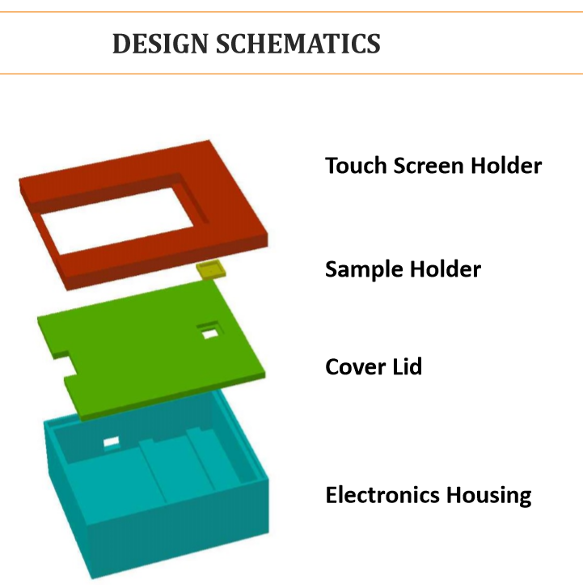

1. *Hardware connections*

|  |  |  |
| --- | --- | --- |
| Company | Components | Quantity |
| Arduino | Arduino UNO | 1 |
| 4D Systems | gen4-uLCD-32DT | 1 |
| Seeed Studio | The Grove - Light Sensor v1.2 | 1 |
| SEEED Studio | Sidekick Basic Kit for Arduino V2 -> LED -> Cables | 1 -> 1 -> 1 |

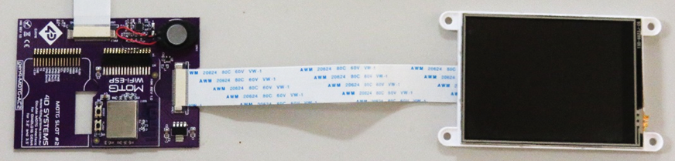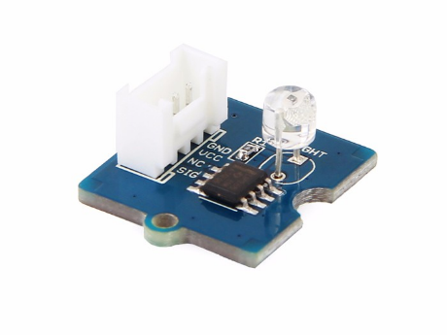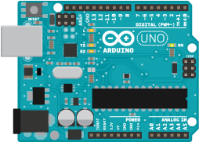

**Power Supply**

