demo.py

62 coords = np.vstack((sparse_mx.row, sparse_mx.col)).transpose()

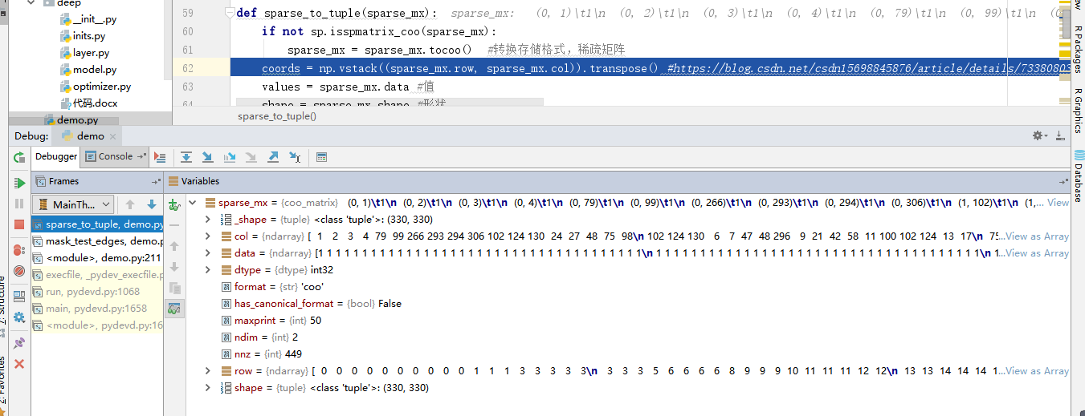

demo.py

130 rows_close = np.all((a - b[:, **None**]) == 0, axis=-1)

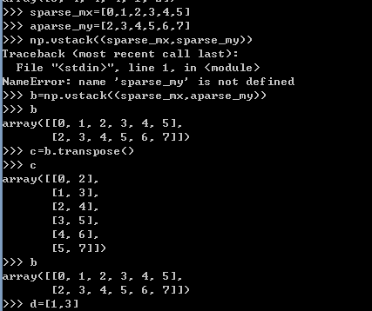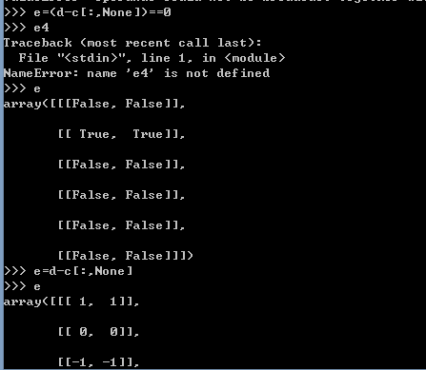

demo.py

100 all_edge_idx = list(range(edges.shape[0]))

