The BIOMASS AGBD Validation Strategy
Input for discussion at Biomass MAG#41

General background on CEOS principles etc to be in a preamble covering the whole validation strategy.

- The BIOMASS AGBD product and its accuracy specification
Above-ground forest biomass (AGB) is the most critical of the three BIOMASS primary products and is defined in the MRD as the dry weight of woody matter, expressed in Mg ha⁻¹, where 1 Mg ha⁻¹ = 100 g m⁻² in SI units. These units in fact describe above-ground biomass density (AGBD), so this more correct term will be used here but AGB will also appear, for example when referring to the biomass of an individual tree.
The AGBD product will be supplied as maps with grid cells of 4 ha (200 m x 200 m), and its required accuracy is given in the MRD as:
Measurements should be within 10 t ha⁻¹ of the true biomass for biomass < 50 t ha⁻¹ and within 20% of true biomass for biomass > 50 t ha⁻¹.
This accuracy requirement can be interpreted in various ways, so an essential first step in the validation strategy is to define the metric(s) that will be tested. One possibility would be to define the accuracy in terms of a confidence interval (CI), along the lines of “the 95% CI of the biomass estimates will have upper and lower limits within 20% of the true biomass”, as adopted by NISAR. However, we propose to define accuracy in terms of bias and require bias to lie within the specified limits. This is then a condition on the AGBD estimator and the ensemble of measurements.
There are several reasons why bias is the preferred quantity for measuring accuracy of the BIOMASS AGBD product:
- A key GCOS principle for climate monitoring is that random errors and time-dependent biases in satellite observations and derived products are identified (GCOS, 2016)
- Map users prefer AGBD maps to be unbiased and to have spatially explicit uncertainty information (Quegan and Ciais, 2018)
- The grid cells used by global climate and carbon models typically have dimensions of 10s of km; given unbiased AGBD estimates, spatial averaging to this scale will provide estimates of the true mean AGBD of a grid cell with very small dispersion
Current global AGBD maps exhibit significant biases over some biomass ranges when aggregated to landscape level (Araza, 2022; Soja, 2024). Under-estimation typically occurs for high AGBD and over-estimation for low AGBD, but the spatial structure of bias across the full biomass range differs between maps. This indicates that the structure of the bias is important and should be captured by the validation procedure. It is therefore proposed that bias is estimated in a set of sub-ranges (bins) that cover the full range of AGBD. On the basis of the ALS data, each pixel in the ALS map will be assigned to one of the bins. The width of the bins will be a trade-off between reducing variance of the estimated means (wide bins) and tracking variation in bias across the AGBD range (narrow bins) (see Annex 2).
To be precise:
validation aims to test whether the mean of the BIOMASS estimates of AGBD is within 20% of the true mean AGBD for each bin.
Meeting the 20% goal in terms of bias over the whole AGBD range would be a substantial advance beyond current capabilities.
The lowest level AGBD bin may present special problems since here the vegetation signal will be strongly corrupted by soil scattering and ground conditions and is likely to vary significantly as soil moisture changes. Ground cancellation will not be useful in these low biomass forests, so these effects cannot be removed. Validation of the lowest level bin is also likely to be hampered by bias in the reference data statistics, as discussed in Annex 2.
- Sources and properties of validation data
Validation requires reference data. The validation dataset for BIOMASS is being developed within a more general framework of the need for very high quality in situ data suitable for validating the estimates of AGBD provided by any spaceborne sensor. The first step towards this was the ESA-funded Forest Observation System (FOS: Schepaschenko et al. 2019), now rebranded data.geo-trees.org whose aim is to establish and maintain a global in situ forest biomass database of AGBD and canopy height estimates, with their associated uncertainties, at 0.25 ha scale from field measurements made in permanent research plots across the world’s forests.
While the FOS was initially based on already available data, studies of the ideal properties of a validation dataset led to the concept of a Forest Biomass Reference Measurement (BRM) system (Chave et al., 2019; Labrière et al., 2023). This stressed the need for a permanent, global, in situ, site-based forest biomass reference measurement system relying on ground data of the highest possible quality that provides a representative sample of forest types globally. A fundamental principle of the BRM is that data must comply with a common standard for high-quality data acquisition, transparent measurement protocols, long-term monitoring, and measurements traceable to SI units. In particular, it recommends that the in situ measurement principles set out in the CEOS Validation Protocol for Aboveground Biomass (Duncanson et al. 2021) are followed. A list of around 200 high-quality sites were identified (Fig. 1) that give representative coverage of environmental conditions, but there are significant gaps in geographical and structural coverage compared to forests worldwide. The analysis in Labrière et al. (2023) indicates where new investment is needed to fill these gaps, and what the balance should be as regards tropical, temperate and boreal validation sites. However, since the emphasis of BIOMASS is on filling the major gaps in our knowledge of tropical forest biomass, most important for BIOMASS validation are tropical sites.
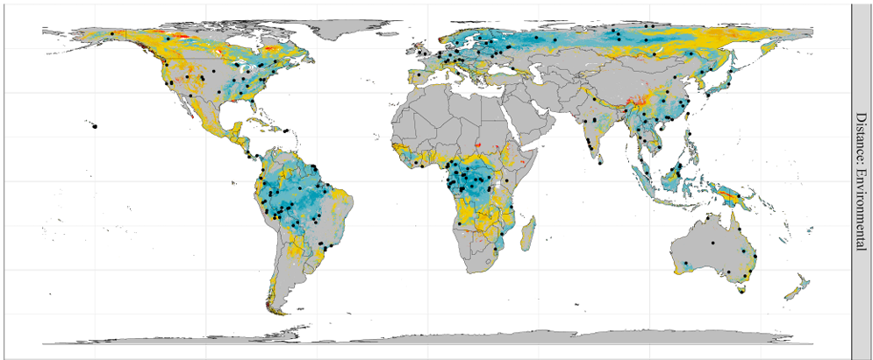
Fig. 1. Location of potential BRM sites (n = 195) (Labrière et al., 2023)
A major evolution of the FOS is the GEO-TREES initiative (https://geo-trees.org/). GEO-TREES aims to set up a network of 100 core BRM sites and 200 supplementary BRM sites representing forests around the world, with the priority on the tropics. Fig. 2 shows the status of GEO-TREES sites as of August 2024: site names and descriptions are provided in Annex 1. Each GEO-TREES site consists of a collection of at least 10 1-ha forest inventories (or larger plots with a cumulative area of at least 10 ha), together with airborne laser scanning (ALS) coverage of the forest over at least 1000 ha. Combining the two yields an estimated AGBD map at 0.25 ha resolution over at least 1000 ha of landscape. Since many forest landscapes are today disturbed it is expected that most of the GEO-TREES sites will cover the full range of AGBD variation. While core sites will consist of long-term intensive measurements of forest biomass, the additional 200 supplementary BRM sites will be used to ensure full representation of the main environmental and anthropogenic dimensions covered globally by forests. These supplementary sites will involve less intensive biomass sampling, and no ALS coverage, but will provide a means of gap-filling under-represented areas.
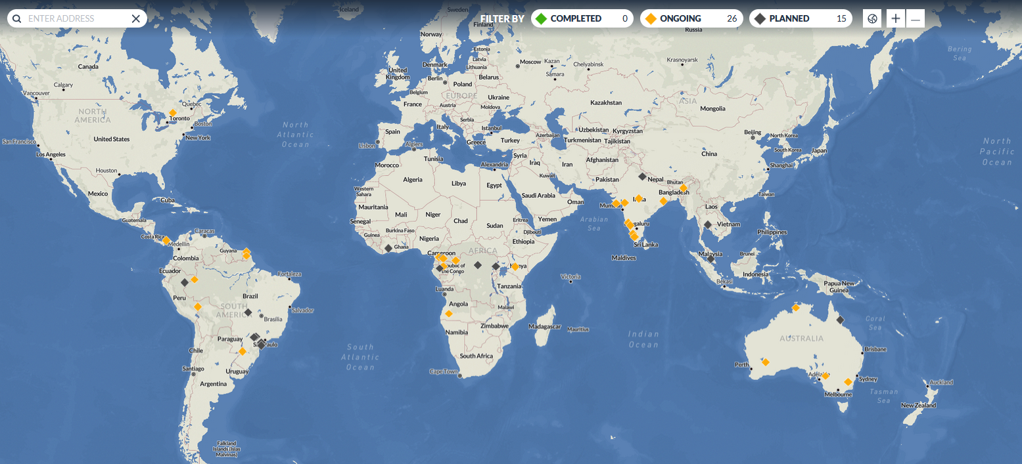
Fig. 2. The current status of GEO-TREES sites
GEO-TREES sits under the GEO umbrella so has a wider scope than just validation of the BIOMASS AGBD products, including collaboration with the GEDI and NISAR missions, together with partnerships with resource networks and field locations where AGBD is measured and monitored. It also provides data sharing instruments that facilitate information exchange while ensuring that all research communities are equitably part of the advancement of knowledge. Such international collaboration is essential in making best use of historical field measurements, ALS and satellite data.
  - Conditions on validation data
Inclusion in the GEO-TREES dataset requires rigorous conditions to be met. Ground measurements at each plot must include tree size (diameter, height), wood specific gravity (by identifying plants), accurate GPS measurements to characterize the plot location, altitude, shape and size (< 3 m accuracy), and other ancillary data such as local climatology. Ground-estimated AGB must use established and consistent standards, including documented allometric models and must include any uncertainties associated with the ground-estimated AGB. Ground plot data include 0.25-ha plot-scale AGBD estimates with accurate location and size of plots given restrictions on disseminating the tree level measurements.
The ground plot size must be ≥ 1 ha, preferably square, but rectangular will be (50x200 m) acceptable. Thin strips are not recommended because edge effects then become a dominant effect in estimating AGBD. Depending on vegetation type and heterogeneity, smaller plot sizes may be acceptable (e.g., in temperate forests), though with a minimum area of 0.25 ha, since below this size it becomes difficult to define AGBD operationally.
ALS data must cover the minimum site area (>1000 ha) with sufficient point density to measure vegetation vertical structure and height and produce a digital terrain model (DTM) with less than 1 m vertical resolution and uncertainty at plot scale (at least 4 points m⁻², depending on vegetation type, but preferably > 10 points m⁻²). The ALS data may include the point density data (LAS files) or only the 1-m DTM and Digital Surface Model (DSM) (≤ 1 m horizontal resolution depending on vegetation type) if there are restrictions on disseminating the point density data.
Ground plots will be used to derive Lidar-AGBD models that convert ALS vegetation height metrics to AGBD at 0.25 ha scale. These models will be used to generate high-quality AGBD maps with 0.25 ha grid cells around the validation sites, together with the map precision at this scale (Fig. 3). Potentially there will be one model for each site.
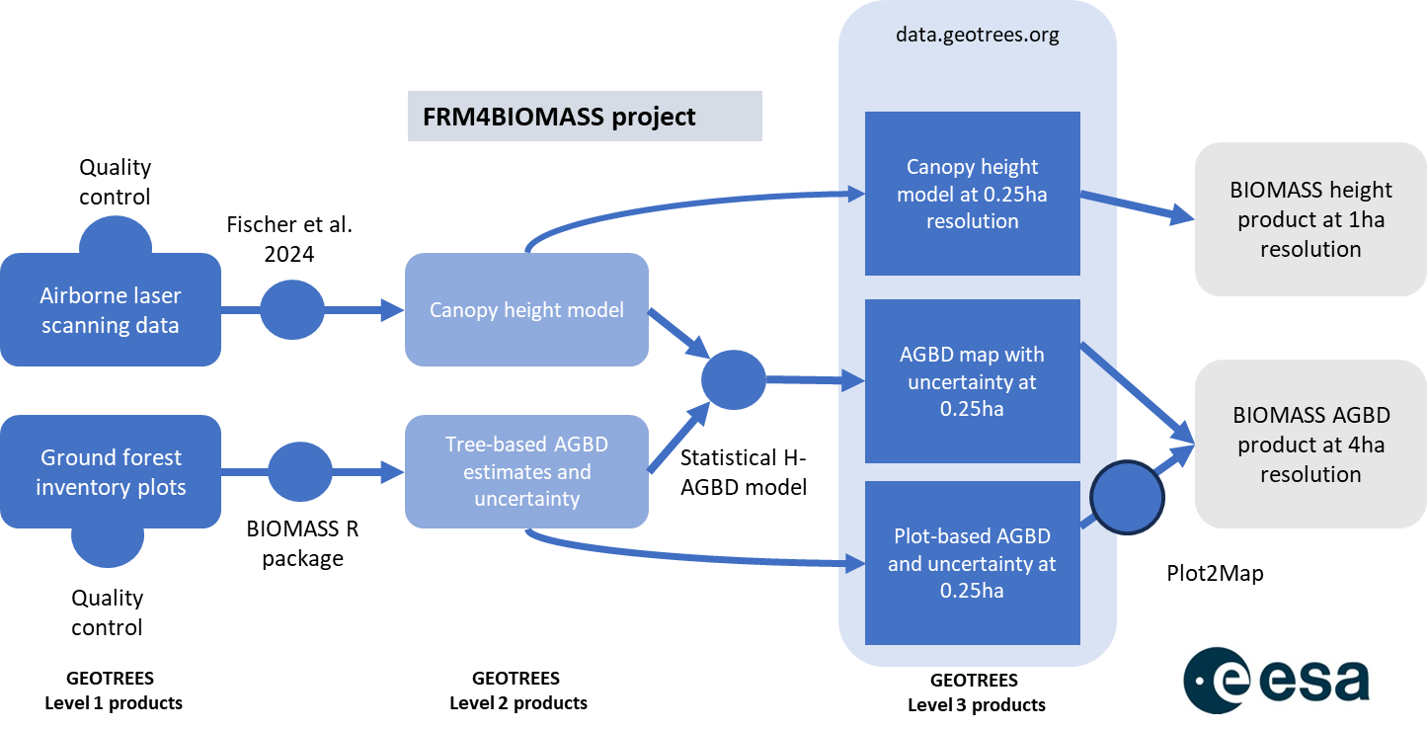
Fig. 3. The process adopted by the ESA FRM4BIOMASS project for producing ALS AGBD and height maps at 4 ha scale by combining plot and ALS data
Use of GEO-TREES ALS as the reference will provide evidence that accuracy is assessed relative to the best available estimate of “true” AGBD based on Fiducial Reference Measurements (FRM) according to well established community-agreed and peer-reviewed protocols. In addition, provision of landscape scale AGBD maps tailored to BIOMASS will mitigate possible sampling errors from using a set of plots.
2.2 Issues affecting the ALS data
Validating the BIOMASS AGBD product against AGBD maps produced from ALS data at the GEO-TREES sites imposes some conditions on the ALS data, as summarized in Table 1 and the following comments.

Table 1. Requirements on ALS data
Requirement | Comment
Unbiasedness at the scale used for validation (4 ha). | Crucial since bias is the key metric used in validating BIOMASS AGBD
Reliable provision of the variance at 4 ha scale | Essential for quantifying the significance of differences between ALS and BIOMASS AGBD maps and estimating the random component of the errors in the BIOMASS AGBD
Dispersion significantly better than 20% | The lower, the better
Reliable assessment of spatial correlation of the errors at the native scale (0.25 ha) of the reference data and any aggregated scale | Spatial correlation is needed to predict the dispersion of the aggregated ALS map
Sufficient number of sites to represent the variability within a forest biome | Minimization of selection bias
It is desirable that the ensemble of sites contains a variety of terrain slopes | Terrain slope is expected to play a major role on AGBD estimation error

Since BIOMASS provides estimates of the mean AGBD in a 200 m x 200 m pixel, a required first step is to average the 0.25 ha ALS data to 4 ha. These 4 ha values are the reference data. The ALS data at each site covers 1000 ha, so this provides 250 reference values.
A key requirement/assumption is that the ALS AGBD estimator is unbiased at 0.25 ha scale, so averaging to 4 ha will provide an unbiased estimator. Some information on the effects of scale is provided in Rodda et al. (2024), e.g. for a Cameroon dataset the RMSE between plot and ALS data varied between 17 and 33% at 0.16 ha scale but between 9 and 19% at 1 ha scale.
Quantitative comparison with BIOMASS AGBD values relies on knowing the accuracy (bias) and precision (dispersion) of the ALS estimator and is at its most powerful when the standard deviation (SD) of the estimator is as small as possible. Factors affecting the dispersion include:
- Errors in the plot data used to calibrate the ALS models.
- Errors in the model converting ALS metrics to AGBD, including sampling variability (McRoberts et al, 2022).
- Spatial correlation of the errors in the 0.25 ha resolution ALS data, which increases the SD when aggregated to 4 ha. Quantifying the precision of the 4 ha ALS map relies on having a reliable estimate of this correlation.
- Time differences between the acquisitions of the plot, ALS and BIOMASS data, during which changes in ground conditions may have occurred, due to forest growth or disturbance; the latter should be minimal at the GEO-TREES sites.
The first two points are explicitly dealt with in FRM4BIOMASS (Fig. 3) but it is not clear what approach will be taken to point 3. Point 4 needs special attention since temporal change on the ground may cause bias in the ALS data relative to the true AGBD at the time of the BIOMASS acquisition. Methods to mitigate such effects are described in Araza et al. (2022) involving rejecting validation site showing signs of disturbance.
A range of terrain slopes within the ensemble of reference data is indicated as desirable in Table 1 because slopes are likely to have a significant impact on AGBD estimation error, both bias and dispersion.
- The validation approach
Several factors have a major impact on AGBD product validation:
- Scale: The BIOMASS AGBD product is at 4 ha scale, which is considerably larger than most in situ plots. This implies that in situ plots cannot be directly used for validation. Instead plot data will be used in a two-step process (Fig. 3):
- In situ field measurements of forest characteristics will be used to estimate AGBD using allometric equations at the hectare or sub-hectare scale.
- These in situ estimates will be used to calibrate models relating ALS forest canopy metrics to AGBD, from which the landscape scale distribution of AGBD can be estimated in the form of maps with a minimum area of 1000 ha, depending on the vegetation and topography. These maps will be used to validate the BIOMASS AGBD product. The ALS estimates of AGBD will be validated by splitting the in situ estimates of AGBD into two disjoint and independent sets of data, where one set is used to train the ALS AGBD estimator and the other to validate this estimator (e.g., leave-one-out method). The ALS validation should use a binned approach as described in section 1 and the validation measures described in Sections 3.1 and 3.2.
- Reference Data quality: Estimation of AGBD from census and ALS depends on various factors including GPS positioning of the ground vs ALS data, quality of allometric models, species variability and identification.
- Data sparsity: SOTR restrictions rule out the use of any validation plots in N America or Europe, and there is very sparse coverage by BRM sites outside these regions (Fig. 1). Hence there is limited capability to provide rigorous assessment of the accuracy of BIOMASS AGBD in the boreal and temperate forest biomes. (Ongoing discussions with the US DoD may make it possible for BIOMASS to acquire data over selected sites in North America or Europe. Should this be confirmed, some boreal and temperate GEO-TREES sites will be included in the validation.)
  - Validation measures
The key metric for validating BIOMASS AGBD is bias within a set of biomass ranges covering the full AGBD range. Denoting AGBD values produced by BIOMASS and ALS as $x_{b}$ and $x_{r}$ respectively ($r$ denoting “reference”), the estimated value of bias within AGBD range $\left[a, b\right]$ t ha⁻¹ is given by:
$\hat{B}\left[a, b\right]=\frac{1}{n_{r}}\sum_{S[a,b]}{\left(x_{b}\left(i\right)- x_{r} \left(i\right)\right)}=\frac{1}{n_{r}}\sum_{S[a,b]}{x_{b}\left(i\right)}-\frac{1}{n_{r}}\sum_{S[a,b]}{x_{r}\left(i\right)}$ (1)
where $n_{r}$ is the number of reference data in that range and $S[a,b]$ is the set of pixels, $i$ , for which the reference data lie within the range $[a,b]$. Note that the locations, $i$ , in $S[a,b]$ can be dotted randomly across the ALS map, so this measure tells us nothing about spatial structure; this is addressed in Section 3.2.
The mean square difference over this range is
$MSD\left[a, b\right]=\frac{1}{n_{r}}\sum_{S[a,b]}{{\left(x_{b}\left(i\right)- x_{r}\left(i\right)\right)}^{2}}$ (2)
but for validation this is not the relevant measure of dispersion since it refers to dispersion at the pixel level. Instead, we want dispersion of the estimated bias, whose variance (denoted by $V(..)$ here and elsewhere), under the assumption that there is no correlation between: (a) the individual BIOMASS AGBD estimates; (b) the individual ALS estimates; (c) the BIOMASS and ALS estimates, is given by
$V\left(\hat{B}\left[a, b\right]\right)=\frac{1}{n_{r}}\left(V\left(x_{b}\left(i\right)\right)+V\left(x_{r}\left(i\right)\right)\right)$ (3)
Hence to calculate the variance of the bias we need the variances of both the BIOMASS and ALS estimates of AGBD within the given reference range. Note that both variances may depend on the average AGBD.
The accuracy requirement is that
$\left|\hat{B}\left[a, b\right]\right|≤0.2×\frac{1}{n_{r}}\sum_{S[a,b]}{x_{r}\left(i\right)}$ (4)
for each AGBD range $[a,b]$, except in the lowest bin, where we require:
$\left|\hat{B}\left[a, b\right]-\frac{1}{n_{r}}\sum_{S[a,b]}{x_{r}\left(i\right)}\right|≤10$ t/ha (4a)
where $S[a,b]$ is the set of pixels in which the reference biomass < 50 t ha⁻¹. This is simple and practical to apply, but masks some significant statistical problems:
- What we really want to know is whether the BIOMASS estimate is within 20% of the true mean AGBD, but the test in (4) is against the estimate of AGBD provided by ALS.
- Both the BIOMASS and ALS estimates of AGBD suffer from dispersion, so condition (4) may not be met simply because of random fluctuations.
- Because of dispersion in the ALS estimates of AGBD, some of the reference data appearing in the range $\left[a, b\right]$ t ha⁻¹ actually comes from pixels whose true AGBD lies outside this range.
These statistical issues are discussed further in Annex 2.
Although the main validation measure is bias within given AGBD ranges, we are also interested in the statistics of the AGBD error at the pixel scale. This is not the same as the difference from the reference data because the latter also contain errors. However, if the reference data are assumed to be unbiased, we can estimate the RMS error relative to the true AGBD since, if the bias in the BIOMASS AGBD estimator is constant across the indicator set $S[a,b]$, then the expectation of (2) is:
$〈MSD\left[a, b\right]〉={bias}^{2}+V\left(x_{b}\left(i\right)\right)+V\left(x_{r}\left(i\right)\right)$ (5)
The MSE of the BIOMASS estimator is given by
$MSE={bias}^{2}+V\left(x_{b}\left(i\right)\right)$ (6)
So its value can be estimated by subtracting the variance in the ALS estimator from the MSD. However, since $〈MSD\left[a, b\right]〉$ is only approximated by (2) and we only have an estimated value for the variance of the reference data, dispersion in these two estimates can result in this operation yielding $MSE< 0$. Two possible ways to prevent this are:
- At 4 ha, lower bound the RMSE to that of the ALS data
- Specify the RMSE as a single number per site with no AGBD binning
  - Overall structural measures
The validation protocol described in the previous section aims at the estimation of the bias within a set of biomass ranges covering the full AGBD range. To complement this, we recommend an additional set of structural measures.
3.2.1 Histogram comparison
An instructive way of comparing the BIOMASS and ALS maps is simply by displaying their histograms. This will reveal if there are significant differences in their representations of the population of AGBD values and help to diagnose any systematic types of error. Rigorous comparison of the histograms is possible using the Kolmogorov-Smirnov test.
3.2.2 Systematic deviation from proportionality
If BIOMASS produces an accurate representation of the ALS map, the scatterplot $\left(x_{b}\left(i\right), x_{r}\left(i\right)\right)$ will be grouped around the 1:1 line. Systematic differences from this line indicate bias over some parts of the biomass range. A quantitative measure of systematic differences can be provided using the runs test (Siegel, 1956).
3.2.3 Spatial correlation between BIOMASS and ALS maps
How well BIOMASS reproduces the spatial structure of an ALS map can be quantified using the correlation coefficient between the two maps. This is important because the correlation coefficient is unaffected by an overall shift between the AGBD produced by BIOMASS and ALS, e.g., due to a calibration problem causing a bias. It is also unaffected by variations in the scaling between the two datasets.
References
Araza A, de Bruin S, Herold M, Quegan S, Labriere N, Rodrıguez-Veiga P, Avitabile V, Santoro M, Mitchard ETA, Ryan CM, Phillip O, Willcock S, Verbeeck H, Carreiras J, Hein L, Schelhaas M-J, Pascagaza AMP, da Conceição Bispoo P, Laurin GV, Vieilledent G, Slik F, Wijaya A, Lewis SL, Morelv A, Liang J, Sukhdeo H, Schepaschenko D, Cavlovic J, Gilaniac H and Lucas R (2022). A comprehensive framework for assessing the accuracy and uncertainty of global above-ground biomass maps, Remote Sens. Env., 272, 112917, https://doi.org/10.1016/j.rse.2022.112917
Baccini, A., Goetz, S.J., Walker, W.S., Laporte, N.T., Sun, M., Sulla-Menashe, D., Hackler, J., Beck, P.S.A., Dubayah, R., Friedl, M.A., Samanta, S., Houghton, R.A. (2012). Estimated carbon dioxide emissions from tropical deforestation improved by carbon-density maps. Nature Climate Change 2, 182{185. https://doi.org/10.1038/nclimate1354
BIOMASS L2 Implementation Study CCN3: Science Report
Chave, J., Davies, S. J., Phillips, O. L., Lewis, S. L., Sist, P., Schepaschenko, D., ... & Saatchi, S. (2019). Ground data are essential for biomass remote sensing missions. Surveys in Geophysics, 40, 863-880.
Duncanson, L., Armston, J., Disney, M., Avitabile, V., Barbier, N., Calders, K., Carter, S., Chave, J., Herold, M., MacBean, N., McRoberts, R., Minor, D., Paul, K., Réjou-Méchain, M., Roxburgh, S., Williams, M., Albinet, C., Baker, T., Bartholomeus, H., Bastin, J.F., Coomes, D., Crowther, T., Davies, S., de Bruin, S., De Kauwe, M., Domke, G., Dubayah, R., Falkowski, M., Fatoyinbo, L., Goetz, S., Jantz, P., Jonckheere, I., Jucker, T., Kay, H., Kellner, J., Labriere, N., Lucas, R., Mitchard, E., Morsdorf, F., Naesset, E., Park, T., Phillips, O.L., Ploton, P., Puliti, S., Quegan, S., Saatchi, S., Schaaf, C., Schepaschenko, D., Scipal, K., Stovall, A., Thiel, C., Wulder, M.A., Camacho, F., Nickeson, J., Román, M., Margolis, H. (2021). Aboveground Woody Biomass Product Validation Good Practices Protocol. Version 1.0. In L. Duncanson, M. Disney, J. Armston, J. Nickeson, D. Minor, and F. Camacho (Eds.), Good Practices for Satellite Derived Land Product Validation, (pp. 236): Land Product Validation Subgroup (WGCV/CEOS), doi:10.5067/doc/ceoswgcv/lpv/agb.001
Labrière, N., Davies, S. J., Disney, M. I., Duncanson, L. I., Herold, M., Lewis, S. L., Phillips, O. L., Quegan, S., Saatchi, S. S., Schepaschenko, D. G., Scipal, K., Sist, P., & Chave, J. (2023). Toward a forest biomass reference measurement system for remote sensing applications. Global Change Biology, 29, 827–840. https://doi.org/10.1111/gcb.16497
McRoberts RE, Næsset E, Saatchi S and Quegan S (2022). Statistically rigorous, model-based inferences from maps, Remote Sensing of Environment, 279, doi.org/10.1016/j.rse.2022.113028
Quegan S and Ciais P (2018). CCI Biomass User Requirement Document, v. 1.0
Rodda SJ et al. (2024). LiDAR-based reference aboveground biomass maps for tropical forests of South Asia and Central Africa, Nature Sci Data 11:334 doi.org/10.1038/s41597-024-03162-x
Santoro, M., Cartus, O., 2019. ESA biomass climate change initiative (Biomass CCI): Global datasets of forest above-ground biomass for the year 2017, v1, https://doi.org/10.5285/BEDC59F37C9545C981A839EB552E4084.
Schepaschenko, D. G. et al. (2019). The Forest Observation System, building a global reference dataset for remote sensing of forest biomass, Nature Sci. Data, 6:198, https://doi.org/10.1038/s41597-019-0196-1
Siegel, S (1956). Nonparametric Statistics for the Behavioral Sciences, Mc Graw Hill.

Annex 1: BRM sites (geo-trees)

realm | country | site | rough_latitude | rough_longitude | t0
America | Peru | Tambopata | -12.993 | -69.381 | 2024
SE Asia | Thailand | Mo Singto | 14.26 | 101.22 | 2024
Africa | Angola | Bicuar | -15.378 | 14.753 | 2024
Africa | Cameroun | Dja | 3.15 | 13 | 2024
Africa | Côte d'Ivoire | La Tene | 6.52 | -5.47 | 2024
Africa | DRC | Yangambi | 0.781 | 24.46 | 2024
Africa | Kenya | Mpala | 0.293 | 36.899 | 2024
America | Argentina | Misiones | -26.92 | -54.23 | 2024
America | Colombia | Amacayacu | -3.809 | -70.268 | 2024
America | Costa Rica | San Emilio Forest Dynamics Plot (Guanacaste) | 10.492 | -85.339 | 2024
America | Mexico | Alamos | 23.273 | -105.869 | 2024
America | Peru | Jenaro Herrera | -4.905 | -73.646 | 2024
SE Asia | Philippines | Palanan | 17.012 | 122.369 | 2024
America | Brazil | Caetetus ecological Station | -22.403 | -49.702 | 2024
America | Brazil | Parque estadual Carlos botelho | -24.131 | -47.949 | 2024
America | Brazil | Assis | -50.39 | -22.6 | 2024
SE Asia | Malaysia | Pasoh | 2.982 | 102.313 | 2024
Oceania | Australia | Robson Creek | -17.12 | 145.632 | 2024
Oceania | Australia | Lichefield Savanna | -13.179 | 130.794 | 2024
Oceania | Australia | Calperum Mallee | -34.002 | 140.586 | 2024
Oceania | Australia | Great Western Woodland | -30.192 | 120.586 | 2024
Oceania | Australia | Tumbarumba | -35.656 | 148.152 | 2024
Africa | Cameroun | Mbalmayo | 3.548 | 11.49 | 2024
Africa | Congo | Loundoungou | 2.41 | 17.014 | 2024
Africa | DRC | Yoko | 0.3 | 25.33 | 2024
Africa | Gabon | Ipassa | 0.513 | 12.803 | 2024
Africa | Uganda | Kibale | 0.383 | 30.356 | 2024
Africa | Tanzania | Kilwa | -9.118 | 39.185 | 2025
America | Brazil | Jari | -0.917 | -52.333 | 2025
America | Brazil | Nova Xavantina | -14.538 | -52.199 | 2025
America | Brazil | Dois Mil Madeireira | -2.965 | -58.66 | 2025
America | Suriname | CELOS (Kabo) | 5.257 | -55.75 | 2025
SE Asia | Vietnam | Bidoup | 12.172 | 108.186 | 2025
Africa | DRC | Salonga | -2 | 21.002 | 2026
America | Brazil | Cikel | -3.567 | -48.683 | 2026
America | Brazil | Iracema | -9.64 | -66.69 | 2026
Africa | Gabon | Mondah | 0.6 | 9.3 | 2026
Africa | Nigeria | Ngel Nyaki | 7.068 | 11.057 | 2026
America | Brazil | Manaus BDFFP+km41 | -2.413 | -59.915 | 2026
America | Brazil | Ilha do Cardoso | -25.102 | -47.938 | 2026
America | Brazil | Carlos Botelho | -24.138 | -47.988 | 2026
America | Ecuador | Yasuni | -0.686 | -76.397 | 2026
America | Peru | Yanachaga | -10.333 | -75.313 | 2026
East Asia | China | Xishuangbanna | 21.987 | 100.912 | 2026
East Asia | Taiwan | Fushan | 24.761 | 121.555 | 2026
Oceania | Papua New Guinea | Wanang | -4.959 | 145.047 | 2026
SE Asia | Malaysia | Danum | 4.98 | 117.831 | 2026
SE Asia | Thailand | Huai Kha Khaeng | 15.606 | 99.32 | 2026
SE Asia | Thailand | Khao Chong | 7.544 | 99.798 | 2026
SE Asia | Thailand | Mae Ping | 17.566 | 98.8 | 2026
South Asia | Sri Lanka | Sinharaja | 6.407 | 80.46 | 2026
America | French Guiana | Nouragues | 4.066 | -52.679 | 2024 (2015-2022)
America | French Guiana | Paracou | 5.273 | -52.923 | 2024 (2022)
South Asia | India | Tapi forest, Gujarat | 21.045 | 73.673 | 2024 (2023)
South Asia | India | Similipal, Odisha | 21.628 | 86.241 | 2024 (2023)
South Asia | India | Karbi Anglong, Assam | 26.188 | 93.393 | 2024 (2023)
South Asia | India | Gir Forests, Gujarat | 21.122 | 70.819 | 2024 (2023)
South Asia | India | Shimoga, Karnataka | 13.814 | 75.559 | 2024-2025
South Asia | India | Hoshangabad, Madhya Pradesh | 22.568 | 77.889 | 2024-2025
South Asia | India | Haldwani, Uttarakhand | 29.258 | 79.505 | 2024-2025
South Asia | India | Nilambur, Kerala | 11.272 | 76.206 | 2024-2025
America | Panama | BCI | 9.154 | -79.846 | 2024-2025 (2021-2022-2023)
SE Asia | Malaysia | Sepilok | 5.846 | 117.948 | 2025 (2017-2020-2021-2022-2023)
Africa | Gabon | Lope | -0.155 | 11.46 | 2025 (2016-2022)
America | Colombia | La Planada | 1.156 | -77.994 | #N/A
America | Costa Rica | Osa Peninsula | 8.581 | -83.529 | #N/A
America | Costa Rica | La Selva | 10.425 | -84.016 | #N/A
America | Guyana | Iwokrama | 4.567 | -58.767 | #N/A
America | Mexico | Chamela | 19.474 | -105.05 | #N/A
Africa | Central African Republic | M'Baiki | 4.5 | 18.6 | #N/A
Africa | Congo | Nouabale Ndoki | 2.64 | 16.55 | #N/A
Africa | Congo | Ekolongouma | 1.19 | 17.84 | #N/A
Africa | DRC | Kahuzi | -2.265 | 28.724 | #N/A
Africa | Gabon | Rabi | -1.868 | 9.802 | #N/A
Africa | Ghana | Ankasa | 5.213 | -2.649 | #N/A
Africa | Mozambique | Gorongosa | -18.816 | 34.509 | #N/A
America | Bolivia | INPA | -16.2 | -62 | #N/A
America | Bolivia | La Chonta | -15.783 | -62.917 | #N/A
America | Brazil | Chico Mendes | -10.65 | -68.5 | #N/A
SE Asia | Indonesia | STREK | 2 | 117.25 | #N/A
SE Asia | Malaysia | Gunung Rara | 4.5 | 117.033 | #N/A
SE Asia | Malaysia | Tekam | 3.917 | 102.5 | #N/A
South Asia | India | Mudumalai | 11.626 | 76.529 | #N/A
South Asia | India | Yellapur, Karnataka | 14.971 | 74.486 | #N/A

Annex 2 Statistical issues in estimating bias in the AGBD estimator
Both the BIOMASS and GEO-TREES values for mean AGBD are estimates that are subject to dispersion, which should be accounted for when estimating the bias in the BIOMASS AGBD. Hence it is imperative to build a statistical characterization of GEO-TREES errors, to provide a firm basis on which to provide a reliable assessment of BIOMASS performance relative to the true AGBD.
Stated symbolically and using (4), the AGBD product is considered valid if
$0.8×\frac{1}{n_{r}}\sum_{S[a,b]}{x_{r}\left(i\right)≤\frac{1}{n_{r}}\sum_{S[a,b]}{x_{b}\left(i\right)}}≤1.2×\frac{1}{n_{r}}\sum_{S[a,b]}{x_{r}\left(i\right)}$ (7)
However, this statement is inadequate as condition (7) may fail simply because of dispersion in the reference and AGBD data. A more useful formulation would be in terms of a Confidence Interval on the bias on the BIOMASS AGBD. This topic is deemed to need further investigation in the context of DISC activities.
This sub-section provides a preliminary discussion of this problem by addressing two aspects:
- The standard error in the mean AGBD per AGBD bin
- Systematic errors in the GEO-TREES estimates of mean AGBD per AGBD bin
A.1 Bin size and the standard error in the mean AGBD per bin
Selection of the bin size is a classic estimation problem involving trade-off between two factors:
- making the bins narrow to better track the structure of the estimated bias across the AGBD range, but at the cost of increased variance of the estimates of mean AGBD;
- making the bins wide to increase the number of reference samples, hence reducing the standard error and making it easier to assess if differences between the BIOMASS and reference data can be considered significant.
The mean AGBD per bin is estimated by averaging, so its distribution will tend to be Gaussian (Central Limit Theorem) and increasingly so as the number of samples averaged increases. This simplifies the problem of putting a CI on the difference between the BIOMASS and ALS estimates of mean AGBD given by (1) but requires us to have estimates of their variances, as in (3). Methods to estimate these variances need to be specified and we also need to establish what would be an acceptable level for them. From (3), the standard error of the difference declines as $1/\sqrt{n_{r}}$, so achieving this level requires a minimum number of $n_{r}$ within each bin to be specified, which in turn depends on knowing the variance of the original reference data.
A.2 Systematic errors in the GEO-TREES estimates of mean AGBD per AGBD bin
The bias in the BIOMASS AGBD estimator in the range $[a, b]$ t ha⁻¹ is calculated using (1), i.e., by subtracting the average of the reference AGBD in that range from the average of the corresponding BIOMASS values. However, dispersion in the reference data means that some of those appearing in the range $[a, b]$ come from pixels whose true value is outside that range. This can be described by the conditional pdf $p\left\{x_{r} | t\right\}$ which is the distribution of the reference estimates, $x_{r}$, given the true AGBD, $t$. An individual reference estimate can therefore come from many possible true AGBD values, which can be written symbolically as:
$p\left\{x_{r}\right\}= \int_{0}^{B}{p\left\{x_{r} | t\right\}×p\{t\}dt}$ (8)
where $B$ is the maximum true AGBD and $p\{t\}$ is the pdf of the true AGBD. An example of how $p\{t\}$ and $p\left\{x_{r}\right\}$ might differ is illustrated in Fig. 4. Note that this example is conceptual since we do not have access to the true AGBD distribution.

Fig. 4. The true AGBD distribution (left) is modified to the reference AGBD distribution (right) by the dispersion in the ALS data. This example was built under the following assumptions: i) true AGBD is a mixture of two Gaussian populations (low and high AGBD); ii) each reference sample is affected by a zero-mean Gaussian random error with a standard deviation equal to 10% of the corresponding true AGBD value.
Using (6) and expressions for $p\left\{x_{r} | t\right\}$ and $p\{t\}$ we can quantify the distribution of true values that contribute to a given range of reference values. This is illustrated by Fig. 5, which shows the conditional distribution of the true AGBD given two ranges of the reference data, 25 – 75 t ha⁻¹ on the left and 475 – 525 t ha⁻¹ on the right.

Fig. 5. Conditional distribution of the true AGBD given that the reference data lie within the range (left) 25 – 75 t ha⁻¹ and 475 – 525 t ha⁻¹ (right).
A clearer idea of how this may affect validation is given by Fig. 6, which is an enlarged version of Fig. 5 (left). As can be seen, there is a significant contribution to the 25-75 t ha⁻¹ reference bin from pixels whose true AGBD is outside the range. As a result, an unbiased estimator (which would reproduce the blue curve) would yield a mean estimate of AGBD that exceeds the mean of the reference data in this bin; this would be interpreted incorrectly as a bias in the estimator. Note that this depends on both $p\{t\}$, i.e., the distribution of the true AGBD across the range $[a, b]$, and $p\left\{x_{r} | t\right\}$, the distribution of the reference AGBD given $t$. For example, if the true AGBD were uniformly distributed across the range and the distribution of the reference AGBD was symmetric around the true AGBD then the means of the reference and true data would be the same, i.e., the estimator would be unbiased.

bin
Conditional distribution of true AGBD given that reference AGBD is within (25,75) Mg/ha

Fig. 6. Conditional distribution of the true AGBD for reference data within the range 25 – 75 t ha⁻¹

Expressed symbolically, the true average AGBD in the range $[a, b]$ t ha⁻¹ is
$\overline{t}= \int_{a}^{b}{tp\{t\}dt}$ (9)
but from the reference data we would calculate
$\overline{x_{r}}= \frac{1}{n_{r}}\sum_{S[a,b]}{x_{r}\left(i\right) \sim } \int_{a}^{b}{x_{r}p\{x_{r}\}dx_{r}}$ (10)
Even though the ALS estimator is thought to be unbiased, these two values may differ because of dispersion in the ALS data.
Similarly for the BIOMASS data we have the conditional pdf $p\left\{x_{b} | t\right\}$, i.e., the probability that we estimate AGBD as $x_{b}$ given that the true value is $t$, and would calculate the average AGBD as
$\overline{x_{b}}=\frac{1}{n_{r}}\sum_{S[a,b]}{x_{b}\left(i\right) }$ (11)
All three of these may differ. So even if the BIOMASS estimator is unbiased, it may appear to be biased because $\overline{x_{b}}$ is not the same as $\overline{x_{r}}$.

Depending on the actual distribution of true and reference AGBD, this phenomenon may lead to both under- and over-estimation of both bias and standard deviation in the reference data, as illustrated in Fig. 7. However, the right-hand figure in Fig. 5 indicates that under-estimation is very likely to occur in the topmost bin. A similar effect will occur for the lowest bin.
Fig. 7. Estimates of (top) bias relative to the true mean and (bottom) coefficient of variation (both expressed as a percentage) within AGBD bins of width 50 Mg/ha. The assumptions about the distributions $p\left\{t\right\}$ and $p\left\{x_{r} | t\right\}$ used to build this example are the same as those described for Fig. 4.
Quantifying the over/under-estimation of bias and dispersion relies on prior knowledge or assumptions about:
- The true AGBD distribution at landscape scale, $p\left\{t\right\}$. In practice this is not available since the best information we have on it is from the ALS maps which are distorted due to dispersion in the ALS data, as discussed above.
- The conditional distribution of the reference data, $p\left\{x_{r} | t\right\}$. If the shape of this distribution were independent of $t$, the distribution of the reference data would be given by the convolution $p\left\{t\right\}*p\left\{x_{r} | t\right\}$ and calculating summary statistics would be straightforward. However, in practice the shape varies with $t$ (e.g. see BIOMASS L2 Implementation Study CCN3: Science Report, Ch. 6).
Further research is needed to assess how significant this problem is; this will require analysis based on GEO-TREES data.

