R Style Guide

J. Kyle Wathen

Fei Chen

Add other Authors

3/31/2020

Table of Contents

# Introduction

This document provides a list of programming guidelines for use in R software development in the Biopharmaceutical industry with a main focus on biostatistics.

This style guide was based on input of many people, many years of software development experiences and utilizing the Google R Style guide and Tidyverse Style guide. Both guides provided useful information and are very similar in structure and nature. The Tidyverse guide was originally based on the Google style guide, but Google’s current guide is derived from Tidyverse style guide.

All style guides are a matter of opinion, therefore, the rational and thinking behind each recommendation is provided with examples. While one may develop software without a style guide, utilizing a style guide can make reading the software source much easier for people other than the original developer. As a developer, it is recommended to make your software source read like a book rather than a file of “code” intended to be difficult to understand and interpret.

When developing software, the developer should always have a goal in mind. This style guide strives to help R developers in creating an easy to ready, predictable and testable software source utilizing the following:

1. Balance between readability and efficiency. When given the option between the two following development approaches: a) a really efficient, very difficult to follow and understand approach vs b) a less efficient but easily understood option, ALWAYS take the less efficient option that is easy to follow and less likely to have bugs. The efficient version can be provided as alternative and comparison of results for testing is suggested.
2. Use descriptive and meaningful names for files, functions and variables.
3. Extremely long files can be very difficult to follow and test and should be avoided.
4. Where there are style options, pick a option and be consistent within a set of code such as a project, package or shiny app.
5. Keep in mind that, programming, like writing, is a naturally individualistic endeavor. But unlike writing, software development is often a joint and collaborative effort. Therefore great attention must be paid on balancing of individual style against collective consistency.

## References

Google’s R Style Guide <https://google.github.io/styleguide/Rguide.html>

Tidyverse Style Guide Used within the Tidyverse <https://style.tidyverse.org/>

Tidyverse Style Guide Git Repository <https://github.com/tidyverse/style> Several files in this document are modified versions from the Tidyverse GitHub repository.

# Files

## File Naming

File names should be meaningful and end in .R. This style agrees with Google’s recommendation of using BigCamelCase for file names. Do not use special characters in the file names and use only letters or numbers. That is, no spaces, - or _ should be included in a file name. While - or _ do make the file names more readable than running words together like runningwordstogether, the use of - or _ requires extra key strokes when compared to BigCamelCase where the first letter of each word is capitalized.

File names should be descriptive and provide insight into what the file contains. Generic names like foo.r or stuff.r should not be used. Vague file names like calculate.r are discouraged and more descriptive like CalculatePosteriorProbs.R are preferred.

Examples:

# Good Examples  
CalcuatePosteriorProbs.R  
AnalyzeSurvivalData.R   
InputFunctions.R  
  
# Bad   
calculate.r  
foo.r  
get file name.r  
functions for stuff.r

If files should be viewed or executed in a particular order, prefix the file name with a number using two digit format starting at 00.

00_SimulateData.R  
01_SimulateArrivalTimes.R  
02_CreateDataSet.R  
...  
09_LogisticRegressionModel.R  
10_BetaBinomialModel.R

Capitalization can be important when sharing files with collaborators on differing operating systems and source control systems. Do not name files where the only difference is the capitalization.

## File Organization

## Internal Structure

Files should be kept as short as possible and not include numerous functions or R source. If a file contains many functions and is very long, it should be broken into meaningful files to group common functionality. Break the file into meaningful code blocks, preferably as functions, and separate code blocks by comments using -, # or =. [ QUESTION: Should we allow all 3 for comments, eg -, # and = or just a subset like the first two? ]

# Create simulated data ------   
  
# Plot results ====  
  
# Save output ####

Each comment should end with 4 consecutive -, # or = as this helps with providing well organized outline in R studio. In addition, If you create a comment block, surrounded by —–, ===== or #### then please make sure you put a space preceding the last charter. The space is to help with creating organized document outline in RStudio for R files.

# Good Example - The extra space creates the document outline in figure below  
#------------------------------------------------------ -  
# Add2 - This function adds 2 to x  
#------------------------------------------------------ -  
Add2 <- function(x){  
 return(x + 2)  
}  
   
#------------------------------------------------------ -  
# Subtract2 - This function subtracts 2 from x  
#------------------------------------------------------ -  
Subtract2 <- function(x){  
 return(x - 2)  
}  
  
#--------------------------------------------- -   
# Divide variable by 2  
#--------------------------------------------- -   
Divide2 <- function(x){  
 return(x/2)  
}

Good example with red arrows to indicate the extra space and resulting file outline to the right. 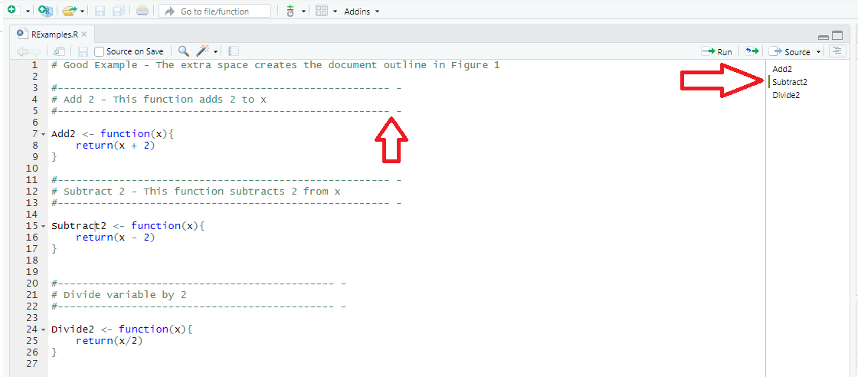

# Bad Example - Ending a solid line of 4 - or = result in an (Untitled) in the outline  
#-------------------------------------------------------  
# Add 2 - This function adds 2 to x  
#-------------------------------------------------------  
Add2 <- function(x){  
 return(x + 2)  
}  
  
#-------------------------------------------------------  
# Subtract 2 - This function subtracts 2 from x  
#-------------------------------------------------------  
Subtract2 <- function(x){  
 return(x - 2)  
}  
  
#-------------------------------------------------------  
# Divide variable by 2  
#-------------------------------------------------------  
Divide2 <- function(x){  
 return(x/2)  
}

Bad example of comments, notice how the (Untitled) appears in the document outline 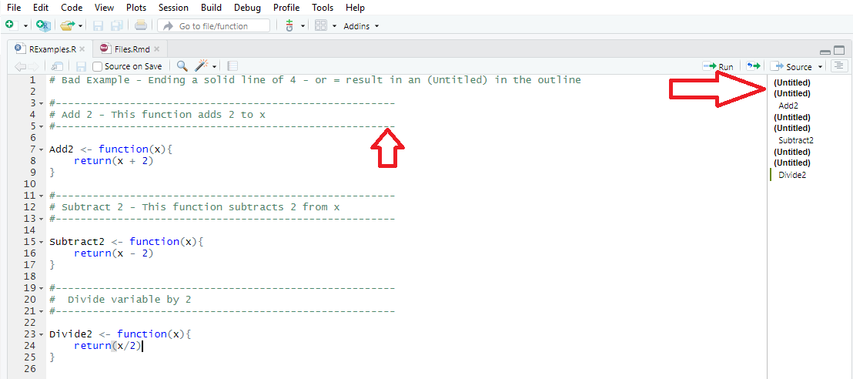

# Functions

## Naming

Function names should be meaningful and descriptive and provide insight to what the function does. This style agrees with Google’s recommendation of using BigCamelCase for function names. Do not use special characters in the function name, but use letters or numbers is acceptable. That is, -, . and _ should not be included in a function name. While - or _ do make the function names more readable than running words together like functionname, the use of - or _ requires extra key strokes when compared to BigCamelCase where the first letter of each word is capitalized. To avoid confusion with S3 methods a . should not be used in a function name unless it is to define an S3 method, see example below.

In addition, it is recommended that function names should contain verbs or a word that describes the action the function performs. Vague generic function names like PerformTasks() or Com() should not be used.

# Good Example   
ComputePosteriorParameters()  
ComputePosteriorParameters.BetaBinom() # If ComputePosteriorParameters is a generic function this is fine  
SimulatePatientArrivalTimes()  
  
# Bad Example  
post.par() # Incorrect name capitalization and including ., non-descriptive  
arrival-time() # Incorrect name capitalization and including -  
addhr() # Capitalizaiton and vague  
ComputePosteriorParameters.BetaBinom() # If ComputePosteriorParameters is NOT a generic function this is not acceptable

## Structure

Functions should be self contained and only depend on the arguments. They should NOT use variables in a higher scope. A call to a function with the same arguments should always return the same value, unless the function is supposed to produce random variables ect. [QUESTION: What does everyone thing about there not being a preceding and trailing space before the first argument and after the last argument? I prefer function( x, y ), but Tidyverse suggests not putting spaces inside or outside side of parentheses see <https://style.tidyverse.org/syntax.html#spacing> so it would allow function(x, y) but not function( x, y ).

Also, I have always put the { } for a function in line with each other and the first letter of the function name like the examples below but both TV and Google recommend the opening { after function, for example Add2 <- function(x) { X <- x + 2 return(x) }

I am okay with either approach. ]

# Example  
  
#--------------------------------------------------------------------------------------  
# VERY BAD STYLE - What this function returns depends on what y was before the call  
#--------------------------------------------------------------------------------------  
MyFunction <- function(x)  
{  
 x <- x + y  
 return(x)  
}  
  
y <- 5  
MyFunction(4) # return 9  
y <- 10  
MyFunction(4) #returns 14  
  
  
#--------------------------------------------------------------------------------------  
# Acceptable example - a call to the function only depends on arguments  
#--------------------------------------------------------------------------------------  
MyFunction2 <- function( x, y )  
{  
 x <- x + y  
 return( x )  
}  
  
y <- 5  
MyFunction2( 4, 7 ) # return 11  
y <- 10  
MyFunction2( 4, 7 ) #returns 7

## Explicit Returns

Do NOT rely on R’s implicit return feature as an explicit return is much clearer for the reader. Tidyverse and Google do not agree on this recommendation and this guide follows Google as it is much more transparent to developers that may not be as familiar with R.

# Good Example - explicit return  
MyFunction(x, y)  
{  
 return(x + y)  
}  
  
# Bad Example - rely on explicit return can be confusing and more error prone  
MyFunction(x, y)  
{  
 x + y  
}

## Local function

A local function refers to defining a function within another function. Local functions are difficult to test, understand and prone to errors. Local functions should be avoided unless necessary.

## Good Example   
  
  
  
## Bad Example  
AnalyzeData <- function( strType, dfData ){  
 if( strType == "ONE" ) ana <- function( dfData ) lm( dfData$y ~ dfData$x )  
 if( strType == "TWO" ) ana <- function( dfData ) lm( dfData$y ~ dfData$x + dfData$x*dfData$Trt )  
 if( strTYpe == "Three" ) <- function( dfData ) lm( dfData$y ~ dfData$x + dfData$x2 )  
   
 fit <- ana( dfData )  
}

[TODO: Add more here]

# Variables

## Naming

Variable names should be meaningful and descriptive. Do not use special characters in the variable names, use only letters or numbers. That is, no spaces, - or _ should be included in a variable name. While - or _ do make the variables names more readable than running words together like runningwordstogether, the use of - (not allowed in R) or _ requires extra key strokes. Do not use a . in variable names as this can cause confusion for the S3 object system.

Variable names should be in camelCase with the first letter being lower case. For example, sampleMean and not SampleMean as the the first letter capital is reserved for function names.

Abbreviating long words with a common abbreviation is acceptable but be consistent within a code base or repository. For example, Qty or Quant for Quantity, Pat or Pats for Patients. Avoid using single letter abbreviations.

Single letter variable names should only be used for looping variables, but it is often easier to read and follow your source code if the looping variable is meaningful. For example, using iPat is better than i as an variable that loops over patients in a vector and is easier to follow.

Since R does not require types, for example integer, double, vector etc it can be VERY help and there for strongly encouraged to use common prefixes for variable names.

Use the following prefixes to help others understand what the intended type of a variable is. a. Prefix integer variable with an n then camel case, eg nQtyOfReps would be an integer variable for the quantity of replications, nQtyOfPats = quantity of patients b. Prefix double of float variables with d, eg dMean would be a double/float variable for mean. c. Prefix vectors with v, eg vMeans would be a vector of means d. Prefix matrix with m, eg mVarCov would be a matrix for the variance-covariance. e. Prefix list with a l, eg lData would be list of data f. Prefix a class variable with a c, eg cAnalysis = structure( list(), class= “TTest”" )

# Good Examples  
qtyOfPatients   
nQtyOfPatient # Better name because it is clear it should be an integer  
  
sampleMeans   
vSampleMeans # Better name because it is clear that a vecor of values is expected  
  
dStdDev # Std Dev is a common abbrivation for standard diviation  
  
for(i in vPatients){  
 vTreatment[i] <- vPatients[i]  
}  
  
# Better example because more complex loops the iPat is clearer than i  
for(iPat in vPatients){  
 vTreatment[iPat] <- vPatients[iPat]  
}  
  
# Bad Examples  
xxx  
sd   
x.m.3   
x.mad

# Syntax

[TODO: Add more here]

## Spacing

Spacing is important so others can browse your code with more ease. Put space around arithmetic and logical operators, and after “,”. Whether space should be inserted immediately after ( or [ and before ) or ] is a matter of personal choice, but whatever style you prefer, adhere to it throughout your project.

# Bad Examples  
 m=1  
 s=2  
 x=rnorm(1000,mean=m,sd=s)  
  
# Good Examples  
 dMean <- 1 # mean  
 dSd <- 2 # standard deviation  
 nSize <- 1000 # sample size  
 vSamp <- rnorm(n = nSize, mean = dMean, sd = dSd)  
  
# Depends on preferece  
 x[i,] vs x[i, ] vs x[ i, ]  
 f(x) vs f( x )

## Code Blocks

Code should be organized so that there is less repetition and more abstraction.

# Bad Example  
 a <- sin(1.2) + exp(5.7)  
 b <- sin(2.4) + exp(-2)  
 c <- a + b  
  
# Better Example  
 f <- function(x, y){ return( sin(x) + exp(b) ) }  
 a <- f(2.4, -2)  
 b <- f(1.2, 5.7)  
 c <- a + b

One liner function definitions are reasonable if the line is short, simple and follow the explicit return, however for readability and testing the following is preferred.

# Even Better Example  
 f <- function(x, y)  
 {  
 sin(x) + exp(b)  
 }  
   
 a <- f(2.4, -2)  
 b <- f(1.2, 5.7)  
 c <- a + b

## Assignment

There are five ways to assign a variable values in R.

# Five ways to say thank you  
thx <- 1  
thx <<- 1  
thx = 1  
1 -> thx  
1 ->> thx

Even though “=” and “<-” are interchangeable, typical R style guides urge the use of “<-”, one for historical reasons, another for consistency with the double “<<-” operator for which “=” has no counterpart. The rightwards form work naturally in conjunction with pipe operator “%>%” although the use of “%>” lends to obfuscation and is discouraged.

## Semicolons

Don’t put ; at the end of a line and don’t use ; to put multiple commands on one line.

# Good Examples  
x <- 5  
y <- 2  
z <- 3  
  
#Bad Examples  
x <- 5; y <- 2; z <- 3;  
  
  
x <- 5; y <- 2;   
z <- 3;  
  
x <- 5;   
y <- 2;   
z <- 3;

## Comments

Comments should be meaningful and add understanding to the code.  
If your code requires a comment for most lines, consider  
rewritting be clearer. Utilizing naming conventions is helpful.  
In addition, using organized files and creating functions for  
complex code blocks can be helpful.

## Furthermore

There are tools to help you better format your code, packages such as “formatR”, “styler”, that can manage spacing and indentation reasonably.