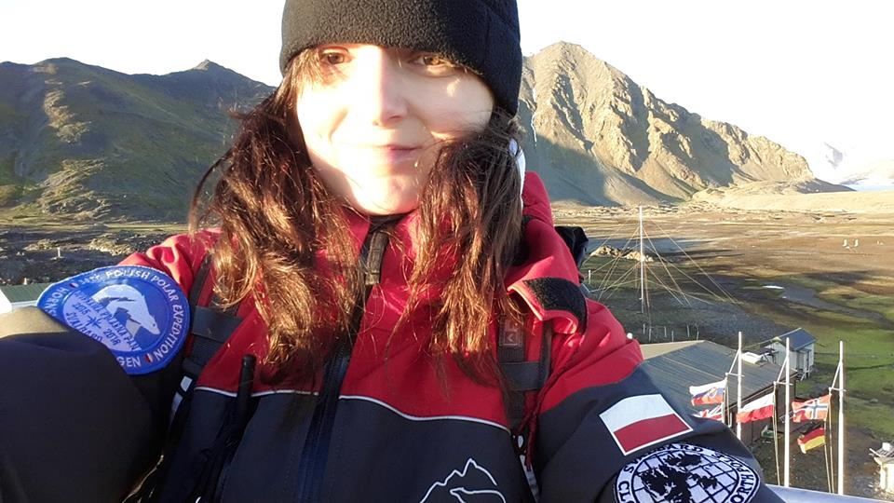

Dominika (Saikkonen-) Dabrowska, PhD
Formosa Arctica, Svalbard
Dominika completed her PhD in 2014 at the Instituto de Astrofísica in Granada, Spain. Her doctoral thesis was titled "Scattering on Martian Dust Analogues." She served as a meteorologist for the 38th Polish Polar Expedition in Hornsund (2015/2016) and has also worked frequently as a field assistant.
She became a resident of Svalbard and is a Svalbard guide. Dominika is the founder of Formosa Arctica, a company dedicated to facilitating logistics and organizing scientific expeditions in Svalbard, as well as conducting educational presentations about the region.
During my speech, I would like to make this amazing place, Svalbard, more familiar to you. I will share with you what it is like to live here, in a land of polar bears, harsh climate, and long polar night. Additionally, I will explain the kind of science that is conducted in this remote yet captivating location

