**Colorimetric Microscopy (C-Microscopy) – Quantifying Colors at Microscale**

Benedykt R. Jany

Marian Smoluchowski Institute of Physics, Faculty of Physics, Astronomy and Applied Computer Science, Jagiellonian University, Lojasiewicza 11, 30348 Krakow, Poland

e-mail: benedykt.jany@uj.edu.pl

The color is the main property of the objects around us and is a direct consequence of light-matter interactions. Color information is used in many different fields of science, technology and industry to investigate material properties. The color is usually measured as a global parameter in macro scale. The Colorimetric Microscopy (C-Microscopy) approach [1,2] based on reflected light digital optical microscopy and free software will be presented. The approach allows color quantification at micro level scale in physically meaningful way by dominant wavelength and excitation purity mapping together with hyperspectral reflectance data recovery. The C-Microscopy approach could be used to quantify the local optical properties of various materials at microscale in an accessible way. During the presentation examples of the use of C-Microscopy approach for imaging of metallic surfaces, minerals and biological systems will be given.

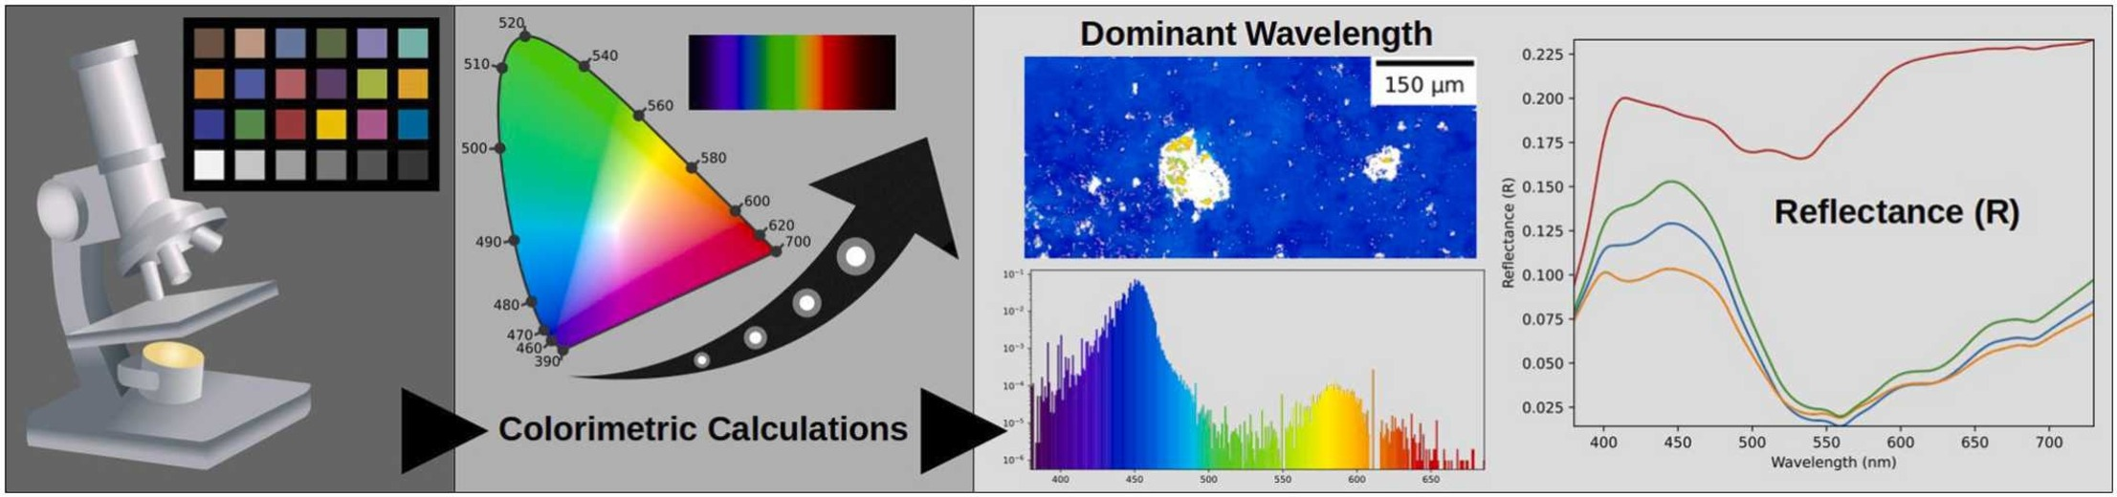Graphical presentation of the idea of Colorimetric Microscopy (C-Microscopy) [1].

**References:**

[1] Benedykt R. Jany, Quantifying Colors at Micrometer Scale by Colorimetric Microscopy (C-Microscopy) Approach, Micron 176, 103557 (2024)

https://doi.org/10.1016/j.micron.2023.103557

[2] Benedykt R. Jany. (2023). Python Jupyter Notebooks and Data for Colorimetric Microscopy (C-Microscopy) Approach. Zenodo.

https://doi.org/10.5281/zenodo.7789585