*Title of the lecture*

**Optical Coherence Tomography (OCT) - seeing beneath the (sample) surface**

Virgil-Florin Duma

Polytechnic University of Timisoara,

National University of Science and Technology “Politehnica” Bucharest (Romania)

*Abstract*

Optical Coherence Tomography (OCT) is an imaging technique based on the principles of low coherence interferometry. The lecture presents the main types of OCT: Time Domain (TD), Spectral Domain (SD), and Swept Source (SS) OCT, with an emphasis on the later. Techniques on which OCT are based are pointed out, including laser scanning. Differences with regard to other techniques are pointed out, for example with confocal microscopy. Applications of OCT in biomedical imaging are presented, starting from the most common ones (i.e., in ophthalmology), but with a focus on dental medicine. The way OCT is capable to see beneath the surface of a sample (for example teeth and dental works) is presented, for a range of applications. The results of our studies regarding the synergy between OCT and the gold standard in dental medicine (i.e., X-ray imaging) are revised. Other comparisons and synergies, with Scanning Electron Microscopy (SEM) and micro-Computed Tomography (CT) are also highlighted. Perspectives of the technique are discussed, including for industrial applications. Acknowledgement: This work has been supported by the Romanian IPCEI (Important Project of Common European Interest) on microelectronics, via Continental Automotive Romania.

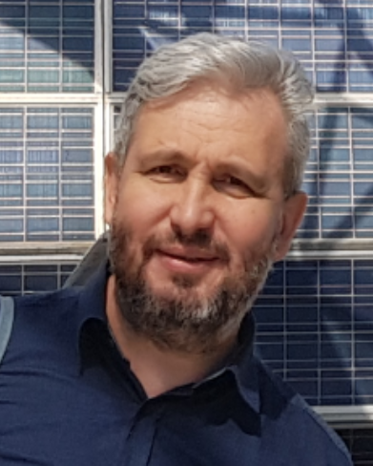

*Short Bio*

Virgil-Florin Duma is Professor and director of the Research Center in Mechanical Engineering and Mechatronics. He proposed in 2008 the 3OM field (in Opto-Mechatronics, Opto-Mechanics, and Optical Metrology) and founded the 3OM Group (https://3om-group-optomechatronics.ro/home/). He received his PhD cum laude from the Polytechnic University of Timisoara (UPT) in 2001, where he graduated valedictorian in Fine Mechanics & Optics in 1991. He was awarded in 2009-2010 a Fulbright Senior Research Fellowship at The Institute of Optics, University of Rochester, NY, USA, where he is Visiting Researcher. Also, he is Honorary Professor at the University of Kent, UK, as well as adjunct professor at several universities, including at UPT as PhD advisor. He defended his Habilitation Thesis in 2013 at the Polytechnic University of Bucharest. He is author of more than 60 papers in ISI WOS journals (with a cumulated impact factor of more than 135), more than 130 conference papers in WOS, 15 books, 2 patents awarded, and 2 patent applications (https://www.researchgate.net/profile/Virgil-Florin-Duma). Prof. Duma delivered more than 50 invited lectures at international universities and conferences, including as Fulbright or SPIE Visiting Lecturer. He is reviewer for more than 40 ISI journals and several grant programs, and has been chair of several SPIE conferences, including the one he initiated, "Advances in 3OM" (https://3om-group-optomechatronics.ro/advances-in-3om-conference-2023/). His research interests are in opto-mechatronics, measuring systems, as well as in imaging techniques and applications. Prof. Duma is member of OSA, senior member of SPIE, and life member of the Fulbright Association.