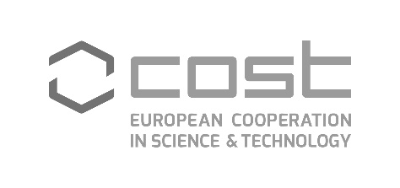

**COST action CA21159 (PhoBioS) WG meeting in Riga, 9-10/09/2024**

***„Nature-inspired materials: Applications & Properties”***

Agenda (tentative)

Monday 9 September 2024

Location: Science Building, University of Latvia, No. 3 Jelgavas Str., room 650

Public transport: Bus #23, stop “LU Akadēmiskais centrs”

08:30 – 09:00 Registration, welcome coffee

09:00 – 09:15 Introduction (J.Spigulis, Univ. Latvia, LV)

09:15 – 10:30 Reports on the recent activities of PhoBioS:

* Training Schools at Spitsbergen - Photonic structure in Arctic enviroment" (M. Gnyba, M. Szczerska, K. Jankowska, Gdansk Univ. Techn., PL)
* WG meeting at University of Jaen (S. Garcia Galan, Univ. Jaen, SP)

10:15 – 10:35 Raman spectroscopy in environmental protection (M. Gnyba, A. Władziński, Gdansk Univ. Techn., PL)

10:35 – 11:00 Preparation of the book on PhoBioS topics, discussions on contents and editors (N. Pop, Polytechn. Univ. Timisoara, RO)

11:00 – 11:30 Coffee break

11:30 - 12:00 An example of nature inspired materials: dynamic phantoms of the mouse brain (I.Meglinski, Aston Univ., UK)

12:00 – 12:30 Quantum optic games (D.Fixler, Bar-Ilan Univ., IL)

12:30 – 13:30 Lunch break

13:30 – 16:00 Visits to laboratories of the Institute of Atomic Physics and Spectroscopy, UL:

* Quantum Optics Laboratory
* Laboratory of Optical Biosensors and Functional Materials
* Biophotonics Laboratory

16:00 – 16:30 Coffee break

16:30 – 17:00 Networking, concluding remarks

18:30 – 20:00 Dinner at “LIDO Alus sēta”, <https://www.lido.lv/lv/restorani-un-veikali/lido-alus-seta>.

Tuesday 10 September

Location: Radisson Blu Latvia hotel, No. 55 Elizabetes Str. (city center)

Attendance of the IEEE conference “Nanomaterials: Applications & Properties”,

<https://ieeenap.org/>.

08:30 Registration

08:45 – 12:30 Keynote and invited presentations (coffee break 10:30 - 11:00)

12:30 – 14:00 Lunch at Dzirnavu Str. 57A

14:00 – 17:30 Regular Talks (coffee break 15:30 - 16:00)

17:30 Bus to the Poster session at Science Building, UL

18:00 – 19:30 Poster session

19:30 Return bus to Radisson Blu Latvia hotel