Choose either option 1 or 2:

Option 1:

FROM: https://doi.org/10.1007/s00592-022-01956-2

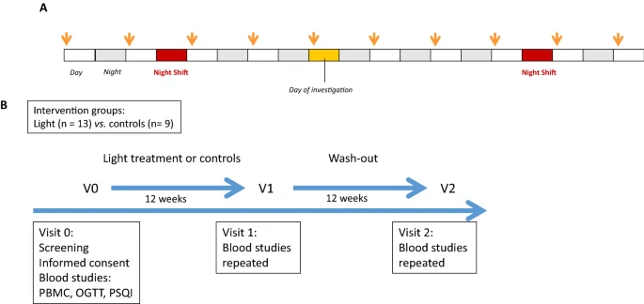

A Schedule used for light therapy. Each participant was provided with 1 h of 10,000 lx (see arrows) within the first three hours after awakening. B Study protocol used for light therapy and controls.

2
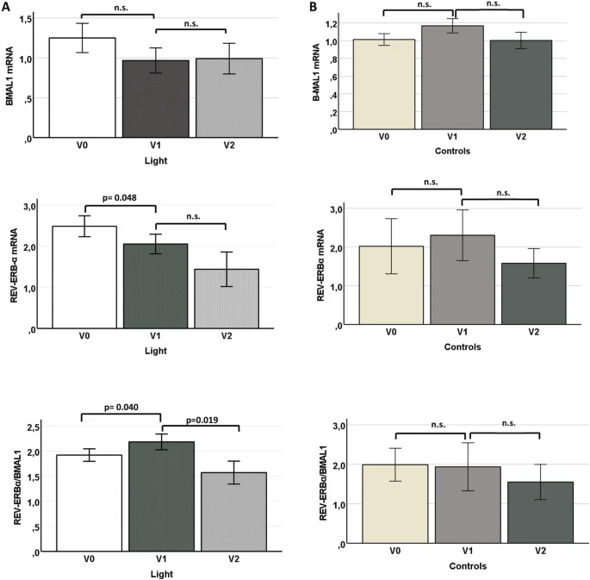

Differential expression of clock genes BMAL1 and REV-ERBαin PBMCs from r-NSWs A treated with light therapy or B controls; V0, visit 0; V1, visit 1; V2, visit 2

CONSIDER adding actigraphy

Option 2:

FROM: https://www.ncbi.nlm.nih.gov/pmc/articles/PMC10391662/

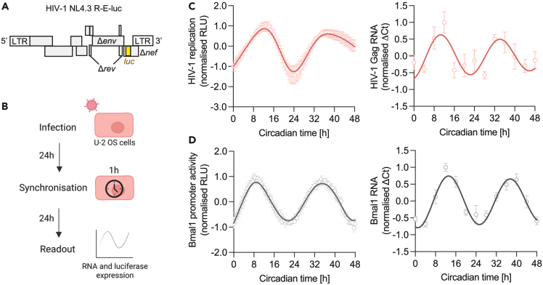
HIV-1 replication is rhythmic
(A) Cartoon of the HIV-1 NL4.3 R-E-luc (NL4.3-luc) reporter, encoding HIV genes with flanking long terminal repeats (LTR), including defective envelope (Δenv), regulator of expression of virion proteins (Δrev) and negative regulator factor (Δnef) and the luciferase (luc) gene which is the readout for viral replication.
(B) U-2 OS cells were infected with HIV-1 NL4.3-luc VSV-G for 24 h followed by serum shock synchronization for 1 h. 24 h later, luciferase activity was measured at 30 min intervals or cells harvested at 4 h intervals for RNA extraction for a total of 48 h.
(C) U-2 OS cells were infected with HIV-1 NL4.3-luc VSV-G, synchronized and HIV-1 replication measured by luciferase activity (mean ± S.E.M., n = 6) or cells were harvested at 4 h intervals for RNA extraction and HIV-1 Gag transcripts measured relative to a B2M housekeeper by qPCR (mean ± S.E.M., n = 4). Analysis of luciferase data: eJTK cycle p < 0.00001, period = 24.7 h, peak expression = 12.2 h (FFT-NLLS analysis, BioDare2).
(D) U-2 OS cells stably expressing luciferase under control of the Bmal1 promoter (Bmal1-luc) were synchronized and promoter activity measured at 30 min intervals (mean ± S.E.M., n = 7). Wild-type U-2 OS cells were synchronized, harvested at 4 h intervals, followed by RNA extraction and qPCR detection of Bmal1 RNA relative to a B2M housekeeper (mean ± S.E.M., n = 4). All data are normalized to peak expression.

