FROM:

<https://doi.org/10.7554/eLife.77029>

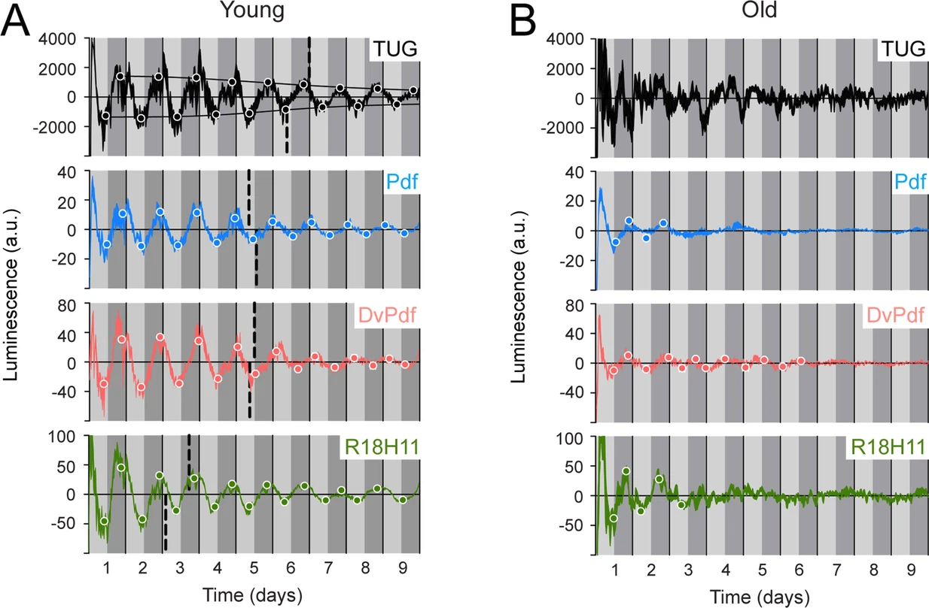

###### **Luminescence oscillations of distinct clocks measured in young and aged flies.**

Luminescence signal using different Gal4 drivers to activate LABL compared in young (1–3 day old) and old (39–41 day old) flies. Drivers used to activate LABL are TUG (black), Pdf-Gal4 (blue), DvPdf-Gal4 (pink), or R18H11-Gal4 (green) in otherwise wild-type flies. Luminescence values are normalized and averaged into 30 minute bins, and the mean of four experiments presented, +/-SEM (thickness of curve). Light grey and dark grey backgrounds represent subjective day and subjective night, respectively. Vertical solid black lines divide days. The peaks and troughs of the presented curves are represented by dots, which are the mean of four experiments, +/-SEM. Where dots are absent, no peak/trough could be fitted. Lines connecting peaks or troughs are best-fit S-curves. The vertical dashed lines define the point of inflection of each S-curve, which is used to define the A50. Where a vertical dashed line is absent, either no S-curve could be fitted, or no decay could be detected.

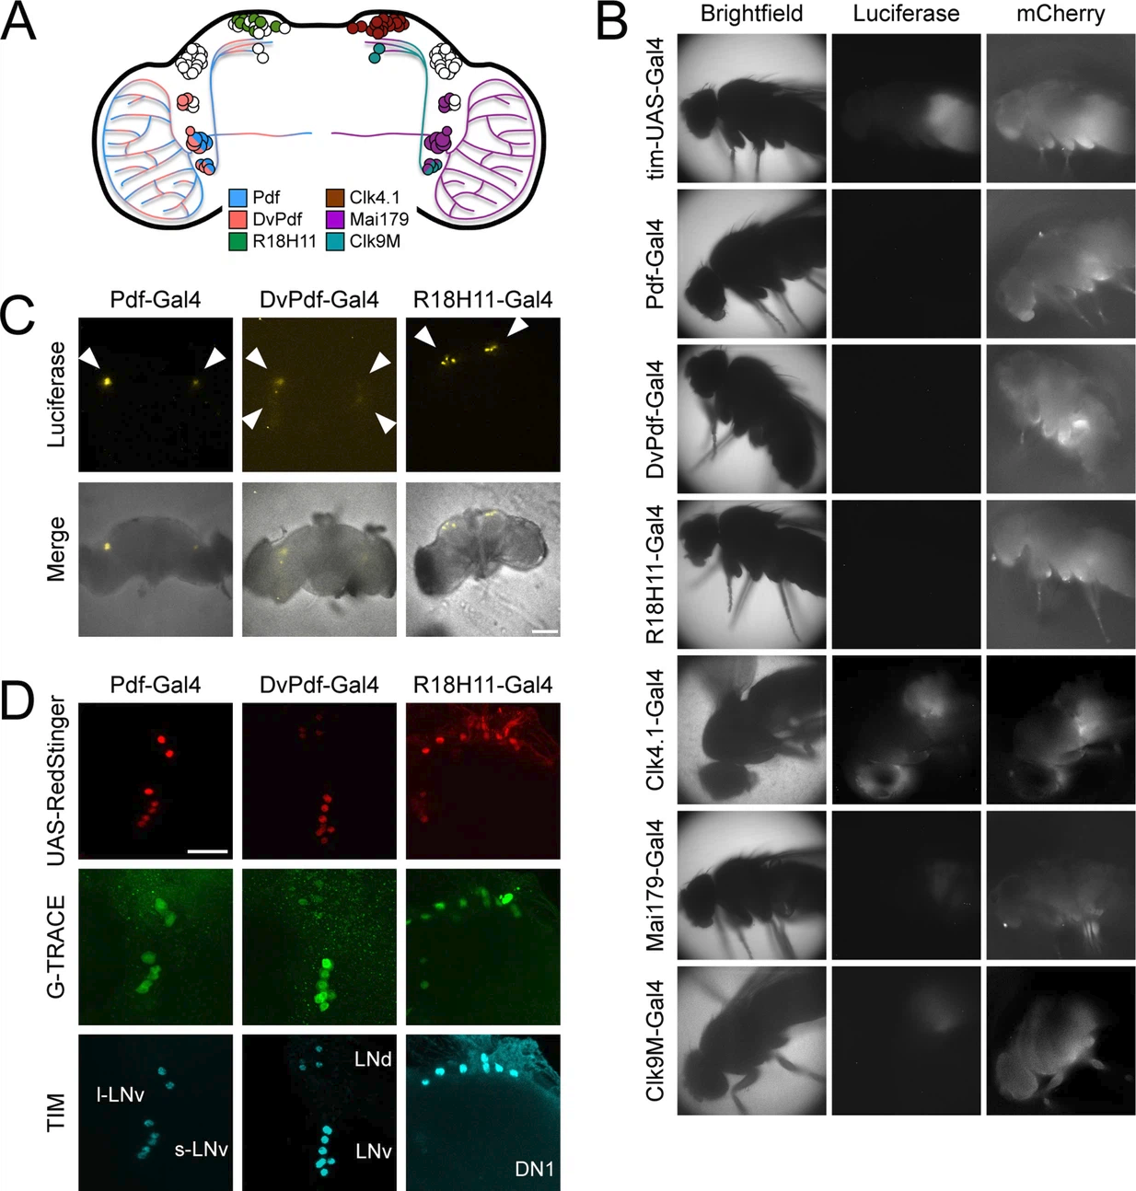

###### **Different circadian Gal4 drivers activate LABL in distinct neurons and tissues.**

(**A**) Schematic of a *Drosophila* brain and Gal4 driver expression patterns. Pdf-Gal4 (blue): LNvs. DvPdf-Gal4 (pink) and Mai179-Gal4 (purple): LNvs, 3 LNds and 5th s-LNv. R18H11-Gal4 (green) and Clk4.1-Gal4 (brown): DN1s. Clk9M-Gal4 (teal): DN2s and small LNvs. (**B**) Luminescence and fluorescence images of whole flies. Flies are shown in bright field (first column), imaged for luminescence (Luciferase; second column) and fluorescence (mCherry; third column). Drivers described in panel A were used to activate LABL in the flies, as indicated. (**C**) Luminescence images of explanted brains. Explanted live brains were imaged for luminescence (Luciferase; top row) and imaged in bright field merged with luminescence (bottom row) to determine sites of LABL activation by the indicated Gal4 drivers. White arrow heads denote estimated location of clock neurons: LNvs in Pdf-Gal4 neurons, LNvs and LNds in DvPdf-Gal4 neurons and DN1s in R18H11-Gal4 neurons. Scale bar represents 50 μm. (**D**) Sites of Flipase activity in fly brains. Fly lines expressing UAS-RedStinger (red fluorescence protein, shown in red) and the indicated driver were crossed into G-TRACE flies and brains were stained for TIM (cyan), RedStinger (red) and GFP (G-TRACE; green). Identity of fluorescence neurons labelled in bottom row. l-LNv: large ventral lateral neurons. s-LNv: small ventral lateral neurons. LNd: dorsal lateral neurons. DN1: dorsal neurons 1. GFP expression is indicative of FLP activity. Pdf-Gal4 driver targets LNvs, DvPdf-Gal4 driver targets LNvs, 5th s-LNv, 3 LNds, and R18H11-Gal4 driver targets DN1s. Scale bar represents 20 μm.