Choose either option 1 or 2:

**Option 1:**

FROM: <https://doi.org/10.1007/s00592-022-01956-2>

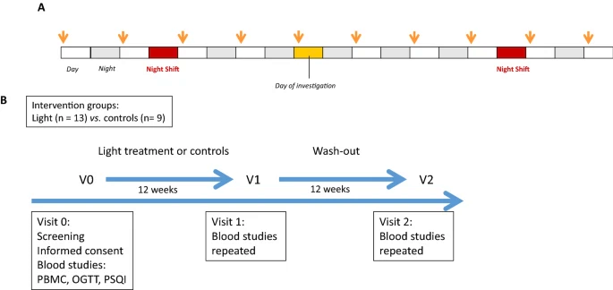

**A** Schedule used for light therapy. Each participant was provided with 1 h of 10,000 lx (see arrows) within the first three hours after awakening. **B** Study protocol used for light therapy and controls.

2

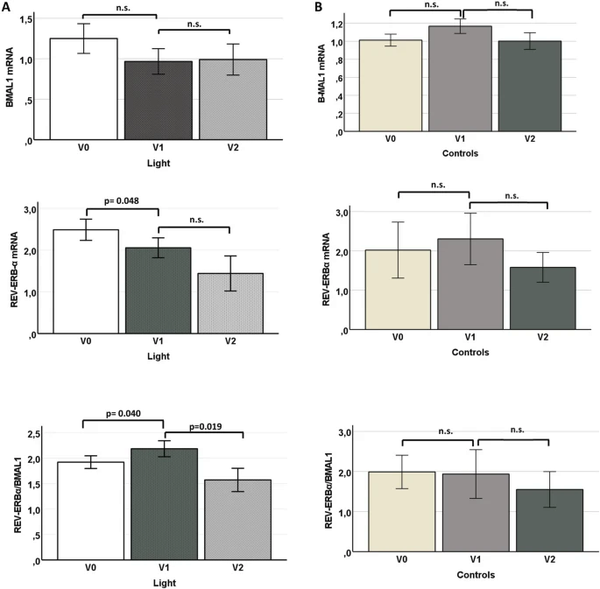

Differential expression of clock genes BMAL1 and REV-ERBαin PBMCs from r-NSWs **A** treated with light therapy or **B** controls; V0, visit 0; V1, visit 1; V2, visit 2

CONSIDER adding actigraphy

**Option 2:**

FROM: <https://www.ncbi.nlm.nih.gov/pmc/articles/PMC10391662/>

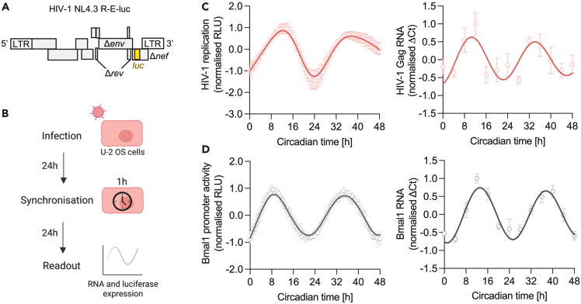

HIV-1 replication is rhythmic

(A) Cartoon of the HIV-1 NL4.3 R-E-luc (NL4.3-luc) reporter, encoding HIV genes with flanking long terminal repeats (LTR), including defective envelope (*Δenv*), regulator of expression of virion proteins (*Δrev*) and negative regulator factor (*Δnef*) and the luciferase (*luc*) gene which is the readout for viral replication.

(B) U-2 OS cells were infected with HIV-1 NL4.3-luc VSV-G for 24 h followed by serum shock synchronization for 1 h. 24 h later, luciferase activity was measured at 30 min intervals or cells harvested at 4 h intervals for RNA extraction for a total of 48 h.

(C) U-2 OS cells were infected with HIV-1 NL4.3-luc VSV-G, synchronized and HIV-1 replication measured by luciferase activity (mean ± S.E.M., n = 6) or cells were harvested at 4 h intervals for RNA extraction and HIV-1 Gag transcripts measured relative to a B2M housekeeper by qPCR (mean ± S.E.M., n = 4). Analysis of luciferase data: eJTK cycle p < 0.00001, period = 24.7 h, peak expression = 12.2 h (FFT-NLLS analysis, BioDare2).

(D) U-2 OS cells stably expressing luciferase under control of the Bmal1 promoter (Bmal1-luc) were synchronized and promoter activity measured at 30 min intervals (mean ± S.E.M., n = 7). Wild-type U-2 OS cells were synchronized, harvested at 4 h intervals, followed by RNA extraction and qPCR detection of Bmal1 RNA relative to a B2M housekeeper (mean ± S.E.M., n = 4). All data are normalized to peak expression.