Table of Contents

Initial screen – Choose Operation 2

Deposit 2

Update 2

Use Case 1 – Deposit SBOL Files to a Single New Collection 3

Inputs 3

Outputs 3

Typical Errors 4

Collection Already Exists 4

Use Case 2 – Deposit Files to Multiple New Collections 6

Inputs 6

Outputs 6

Typical Errors 7

Collection(s) Already Exists 7

Use Case 3 – Deposit New SBOL Files to an Existing Collection 8

Inputs 8

Outputs 8

Use Case 4 – Deposit SBOL Files to Update an Existing Collection 10

Inputs 10

Outputs 10

Use Case 5 – Updating Existing Designs in an Existing Collection 12

Inputs 12

Outputs 13

# Initial screen – Choose Operation

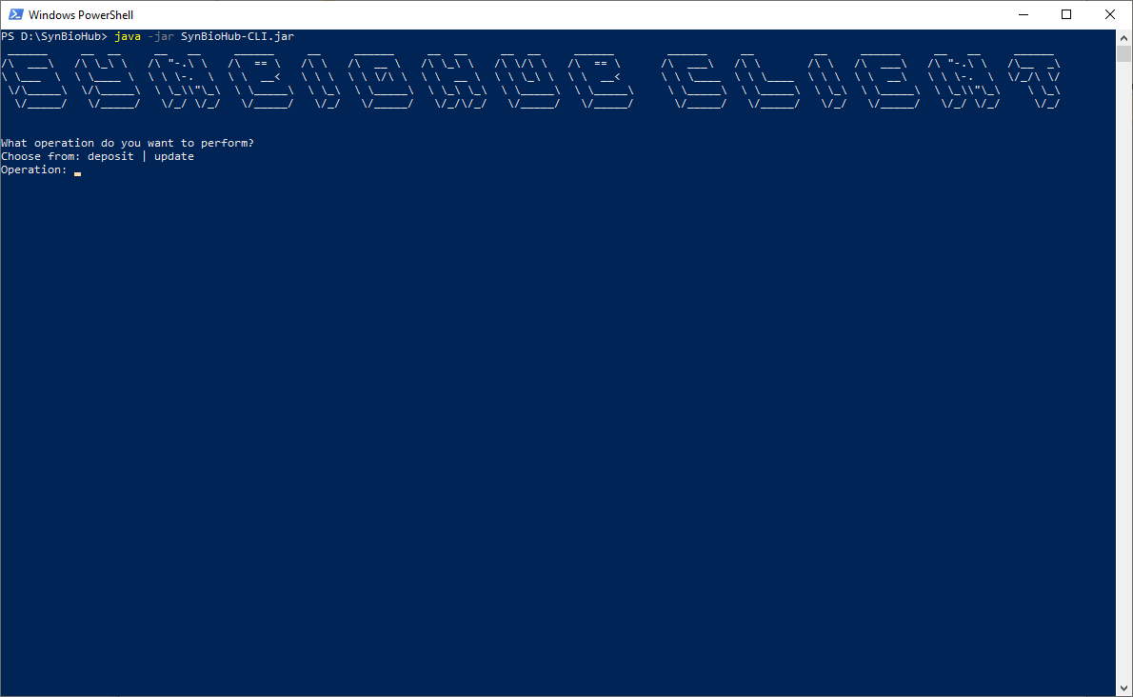

## Deposit

This operation is for uploading SBOL files into new or existing collections, and updating or overwriting the objects in existing collections. This is the operation used in Use Cases 1-4.

## Update

The update operation is for adding more metadata and file attachments to designs that already exist in a collection on a target SynBioHub server. This operation is described in Use Case 5.

# Use Case 1 – Deposit SBOL Files to a Single New Collection

In this common use case, the user intends to upload all files in a specified directory into a new collection on the target SynBioHub server. The user can specify a file extension filter to select only particular types of files in the directory that they wish to deposit.

## Inputs

1. Choose ‘deposit’
2. Enter the path to the directory containing the files you wish to upload, e.g. ‘C:\my_data\cyano_source’. Alternatively, if your data are in the same directory as where the application was launched, press <ENTER>
3. Enter the appropriate file name extension for the files you wish to upload, e.g. ‘.xml’, or press <ENTER> to select files of all types
4. Enter ‘n’ when asked to create multiple collections
5. Enter ‘y’ when asked to create a new collection
6. Enter a new name for the collection
7. Enter the URL for the target SynBioHub server, or press <ENTER> to specify the default ‘https://synbiohub.org’
8. Enter a version number or press <ENTER> to accept the default ‘1.0’ version
9. Enter your SynBioHub username, usually your email address
10. Enter your SynBioHub password

## Outputs

* The program will report the URL for the newly created
* The program will report which files were successfully deposited and those which failed
* Any files that failed to be deposited most likely failed because they contain invalid SBOL

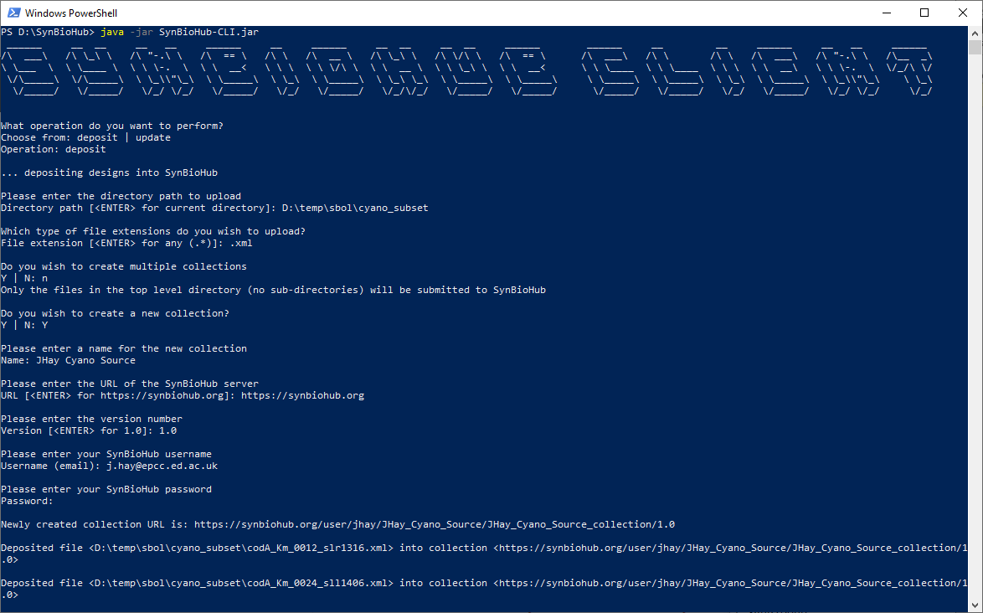

## Typical Errors

### Collection Already Exists

If you choose to create a new collection, but you specify a name and version for a collection that already exists in the server, you will receive an “Invalid collection specified” error as shown below.

N.B. The arguments for ‘new collection name’ and ‘version’ are case sensitive: therefore, a collection named “JHay Cyano Source” is different than one named “JHay Cyano source” and version “v1.0” is different than “V1.0”, for example.

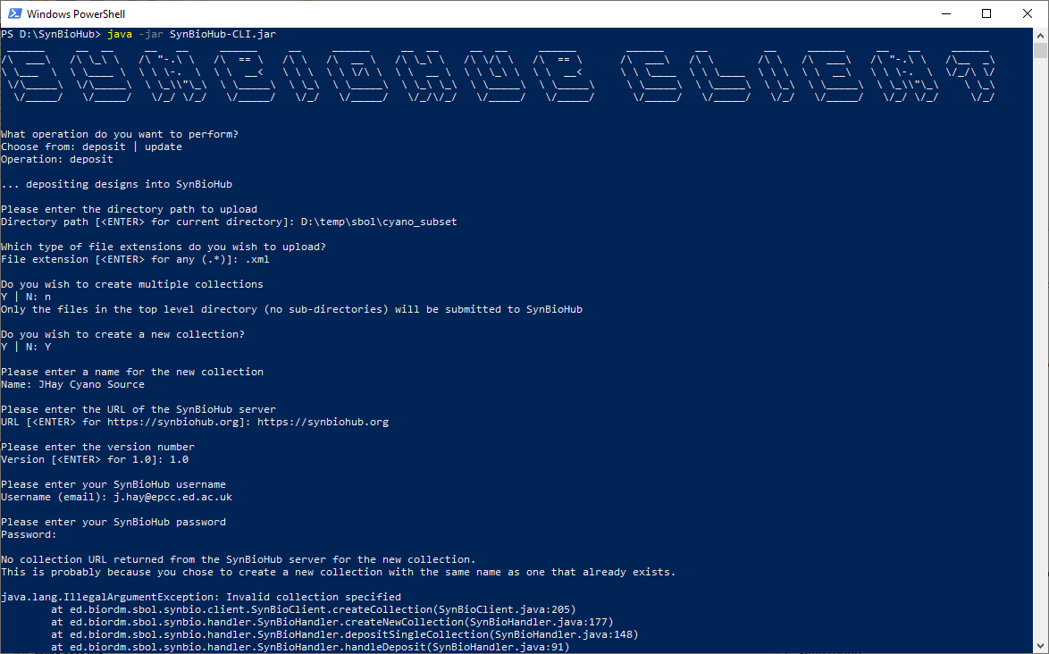

# Use Case 2 – Deposit Files to Multiple New Collections

In this use case, the user intends to upload the contents of each sub-directory in a specified directory into a new collection on the target SynBioHub server. The user can specify a file extension filter to select only particular types of files in the sub-directories that they wish to deposit. This feature is non-recursive, so only sub-directories that are immediate children of the specified parent directory will be traversed for their file contents to be uploaded.

## Inputs

1. Choose ‘deposit’
2. Enter the path to the directory containing the files you wish to upload, e.g. ‘C:\my_data\cyano_source’. Alternatively, if your data are in the same directory as where the application was launched, press <ENTER>
3. Enter the appropriate file name extension for the files you wish to upload, e.g. ‘.xml’, or press <ENTER> to select files of all types
4. Enter ‘Y’ when asked to create multiple collections
5. Enter a prefix that will be prepended to each sub-directory name to create the new collection names, or press <ENTER> for no prefix (and only the directory names)
6. Enter the URL for the target SynBioHub server, or press <ENTER> to specify the default ‘https://synbiohub.org’
7. Enter a version number or press <ENTER> to accept the default ‘1.0’ version
8. Enter your SynBioHub username, usually your email address
9. Enter your SynBioHub password

## Outputs

* The program will report the new URL for each collection that was created for a sub-directory
* The program will report which files were successfully deposited and those which failed
* Any files that failed to be deposited most likely failed because they contain invalid SBOL

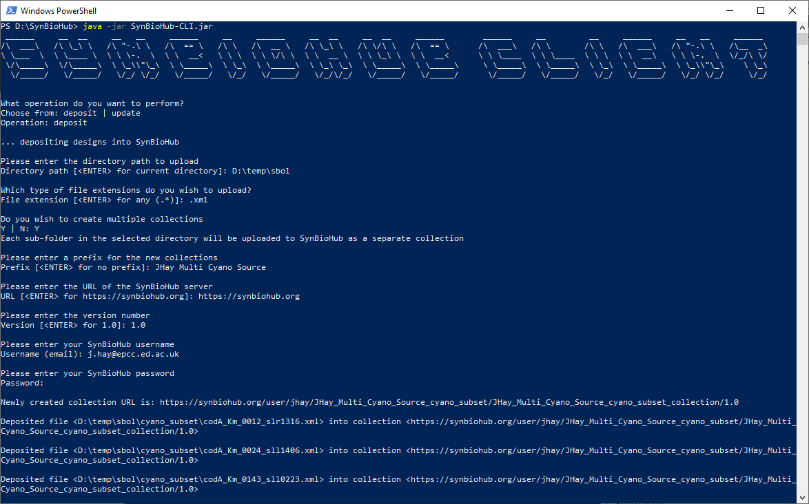

## Typical Errors

### Collection(s) Already Exists

If you specify a prefix and version for collections that already exist in the server, you will receive an “Invalid collection specified” error as shown below.

N.B. The arguments for ‘new collection prefix’ and ‘version’ are case sensitive: therefore, a prefix named “JHay Multi Cyano Source” is different than one named “JHay Multi Cyano source” and version “v1.0” is different than “V1.0”, for example.

# Use Case 3 – Deposit New SBOL Files to an Existing Collection

In this use case, the user intends to deposit new SBOL files in the specified directory into an existing collection on the target SynBioHub server. Any SBOL files that contain objects which already exist on the server will not be overwritten, but the objects contained in new files will be uploaded if they do not conflict with any existing objects.

## Inputs

1. Choose ‘deposit’
2. Enter the path to the directory containing the files you wish to upload, e.g. ‘C:\my_data\cyano_source’. Alternatively, if your data are in the same directory as where the application was launched, press <ENTER>
3. Enter the appropriate file name extension for the files you wish to upload, e.g. ‘.xml’, or press <ENTER> to select files of all types
4. Enter ‘n’ when asked to create multiple collections
5. Enter ‘N’ when asked to create a new collection
6. Enter the URL for the existing collection, e.g. ‘https://synbiohub.org/user/jhay/JHay_Cyano_Source/JHay_Cyano_Source_collection/1.0’
7. Enter ‘n’ when asked to overwrite designs if they exist
8. Enter your SynBioHub username, usually your email address
9. Enter your SynBioHub password

## Outputs

* The program will report which files were successfully deposited and which files failed to be deposited
* The files that failed to be deposited are the ones that contain objects that already exist on the server, or contain invalid SBOL

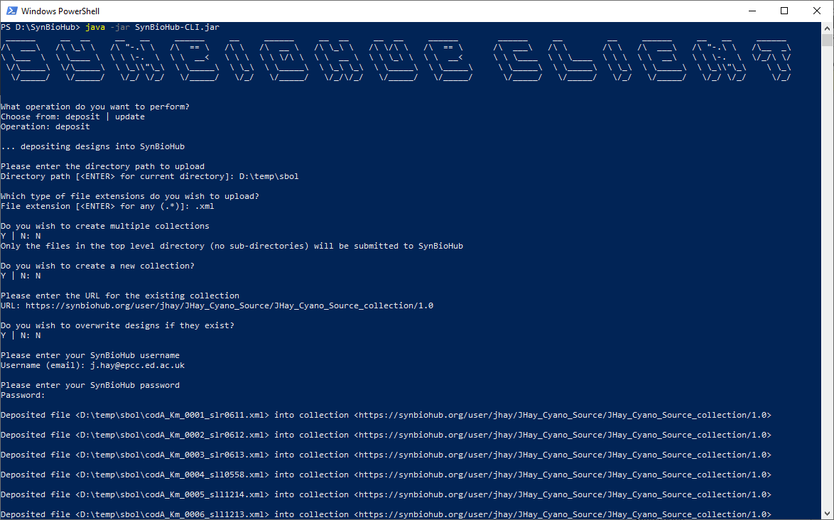

# Use Case 4 – Deposit SBOL Files to Update an Existing Collection

In this use case, the user intends to deposit SBOL files in the specified directory into an existing collection on the target SynBioHub server. All objects contained in the SBOL files which already exist on the server will be overwritten, so this sequence of commands should be used with caution!

## Inputs

1. Choose ‘deposit’
2. Enter the path to the directory containing the files you wish to upload, e.g. ‘C:\my_data\cyano_source’. Alternatively, if your data are in the same directory as where the application was launched, press <ENTER>
3. Enter the appropriate file name extension for the files you wish to upload, e.g. ‘.xml’, or press <ENTER> to select files of all types
4. Enter ‘n’ when asked to create multiple collections
5. Enter ‘N’ when asked to create a new collection
6. Enter the URL for the existing collection, e.g. ‘https://synbiohub.org/user/jhay/JHay_Cyano_Source/JHay_Cyano_Source_collection/1.0’
7. Enter ‘Y’ when asked to overwrite designs if they exist
8. Enter your SynBioHub username, usually your email address
9. Enter your SynBioHub password

## Outputs

* The program will report which files were successfully deposited and which files failed to be deposited
* Any files that failed to be deposited most likely failed because they contain invalid SBOL

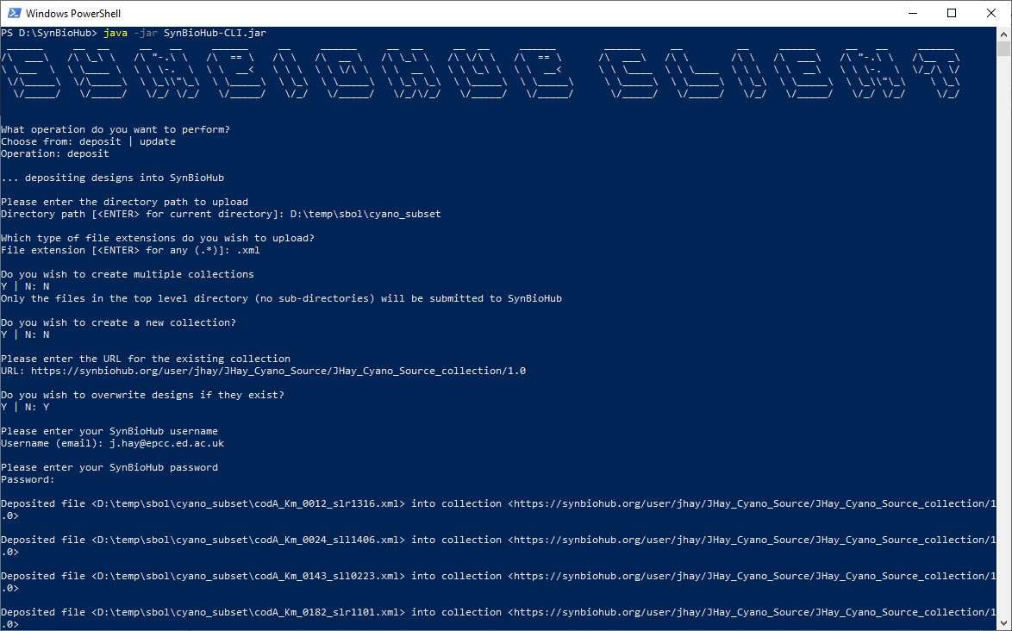

# Use Case 5 – Updating Existing Designs in an Existing Collection

In this use case, the user intends to update existing designs in an existing collection on the target SynBioHub server. There are three elements of the designs in SynBioHub that can be updated using this feature: files can be attached, and the ‘description’ and ‘notes’ text fields can be appended to. It is anticipated that users may wish to attach sequence data in other formats such as GenBank files, and append extra text metadata to enhance the FAIRness of their data in SynBioHub.

The user provides a file in MS Excel format comprised of one mandatory column and at least one of three optional columns. The mandatory column is ‘display_id’, while the other three columns are ‘attachment_filename’, ‘description’ and ‘notes’. The columns can be in any order but they must be adjacent to each other (i.e. in a contiguous block) and begin at column A of the worksheet. The values in the ‘display_id’ column must match the ‘displayId’ attribute of existing designs in a collection on the target server. The ‘attachment_filename’ column’s values can be either absolute file paths to files on the user’s local machine, or simply file names of files that are relative to the current working directory. An example is shown below.

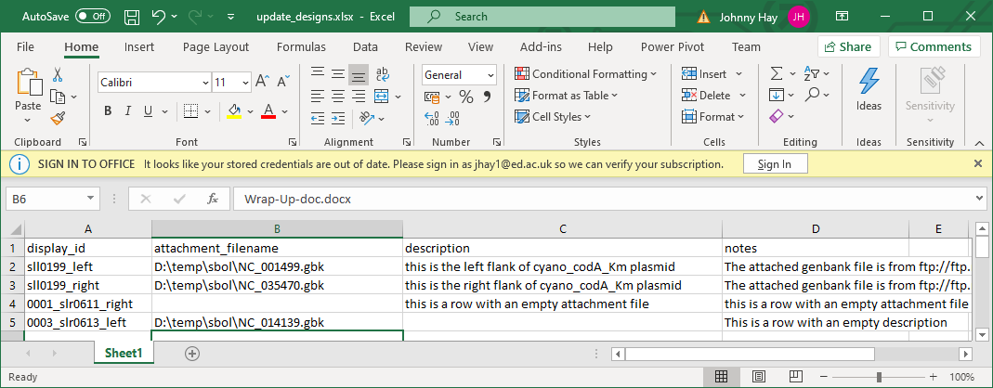

## Inputs

1. Choose ‘update’
2. Enter the absolute path to the MS Excel file containing the entity display IDs, file attachments and metadata you wish to upload, e.g. ‘C:\my_data\cyano_source\update_designs.xlsx’. Alternatively, if your Excel file is in the same directory as where the application was launched, enter the file name.
3. Enter the URL for the existing collection containing the designs you wish to update, e.g. ‘https://synbiohub.org/user/jhay/JHay_Cyano_Source/JHay_Cyano_Source_collection/1.0’
4. Enter your SynBioHub username, usually your email address
5. Enter your SynBioHub password

## Outputs

* The program will report which designs it found in the specified collection with display IDs matching those in the ‘display_id’ column of the spreadsheet
* The program will also report which display IDs it could not find in the specified collection

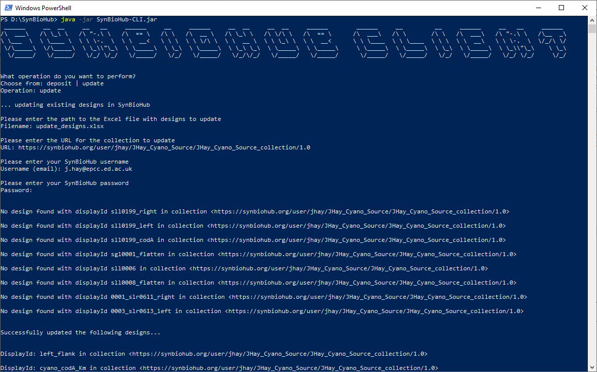

* Screenshots are 165 wide by 50 high