Daniel Hughes

Abstract

Step by step process for completing each level of BioRubeBot using concepts of the MAPK, cAMP, and G-Protein Signaling

Procedure for Level Completion

Contents

Forward 2

LEVEL 1 2

LEVEL 2 4

LEVEL 3 (Draft) 6

New parts 6

Steps to Win 7

Conclusion 10

# Forward

All items contained here within are subject to change based on the need and desires of the customer. These changes will be the result of incorrect level design, incorrect biological function, improper implementation, necessary additions to cellular function, and scientific breakthroughs. Always consult the customer for proper implementation, but also complete your own research. This was not based solely on my efforts but as a group with the help of instructors.

# LEVEL 1

**Step 1:** Place a receptor onto the cell wall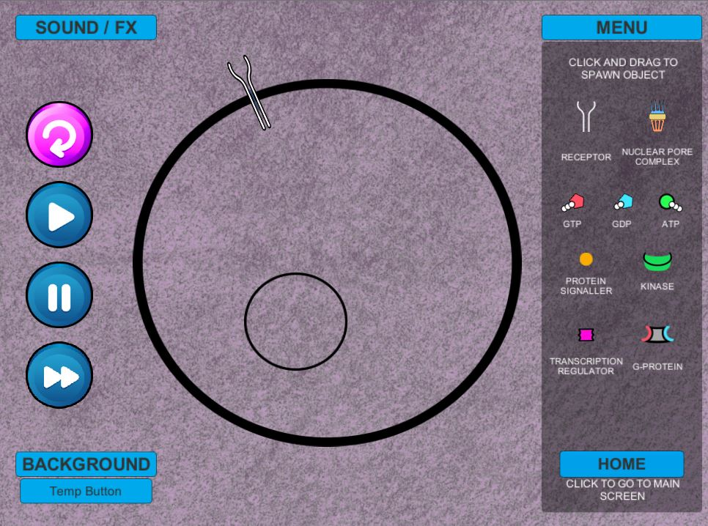

**Step 2:** Place protein signaler nearby or on the end of the receptor (this has auto tracking). This will then become activated and grey out. Notice the shape change at the end of the receptor. This will allow for the attachment of ATP.

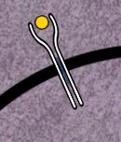 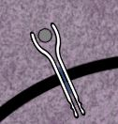

**Step 3:** Place 2 ATPs per receptor and they will track to any activated receptor and “drop” a phosphate. 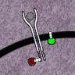

**Step 4:** Place a G-Protein into the cell, it will move toward any active receptors with phosphates. It will then activate which will cause the GDP that is attached to break off from the g-protein. It will then remain in place until it binds with a GTP. This will allow the G-protein to float free to activate the kinase.

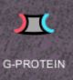🡪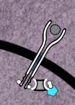 🡪 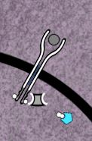🡪 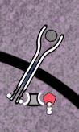🡪 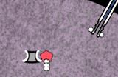

*BUG:* (FIXED)Once the G-Protein has picked up the phosphate to drop the GDP it flies out of the cell, sometimes very rapidly. Potentially making the game unwinnable. It needs to essentially be “caught” by placing a large number of GTPs within the cell. Works on PC but there are issues with this on a Mac. (FIXED)

**Step 5:** Place a Kinase within the cell. It will then bind with the free-floating G-Protein. This will allow it to also bind with the transcription regulator.

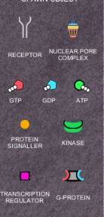🡪  🡪🡪C:\Users\ME\Desktop\CS452\TransReg.JPG🡪

**Step 6:** Place more ATP within the cell so it can phosphorylase with the activated kinase with a transcription regulator.

 🡪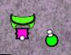🡪C:\Users\ME\Desktop\CS452\Treg P.JPG

**Step 7:** Place a nuclear pore on the wall of the nucleus of the cell. This will allow the transcription regulator to pass into the nucleus.

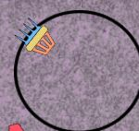🡪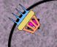🡪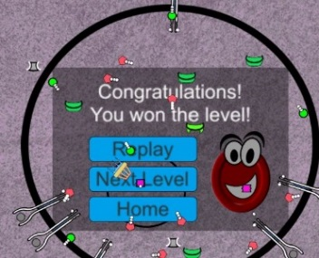

# LEVEL 2

*Note: Level 2 will follow the same functionality of level 1 but will have the receptor be in two pieces. This is more accurate to cell structure.*

**Step 1:** User will place either a right or left receptor into the cell wall. In this example, we will start with the left. *Note: The protein signaler will bind with the left receptor.*

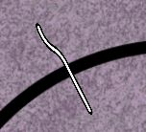

**Step 2:** The user will then place a right receptor into the cell

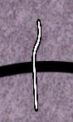

**Step 3:** Next the user will insert a protein signaler.

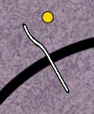

There can be two events to occur here.

1. If a right receptor is on the cell wall enough they will move to each other to create an activated receptor.

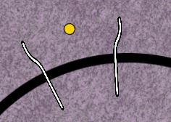🡪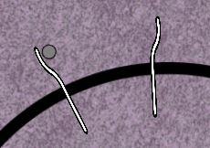🡪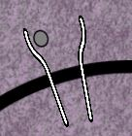🡪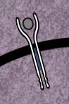

1. If a right receptor is not on the cell wall the left the signaling protein will bind to it and no further action takes place.

🡪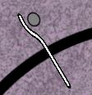

**(BUG)** if a right receptor has been placed on the nuclear membrane it will spin around indefinitely until the left binds with a right on the cell wall.

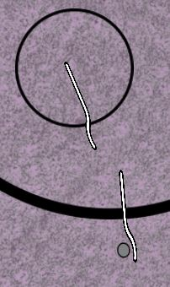🡪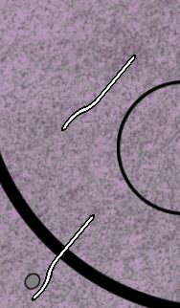

**Step 4-End:** These will follow the same procedures for winning the game as steps 3-7 in the previous level.

# LEVEL 3 (Draft)

## New parts



GPC Receptor

**Designed and placed in prefabs.**

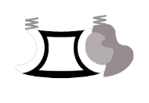🡪 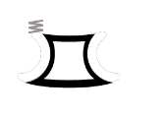🡪 

Trimeric G-Protein Alpha Subunit Beta-Gamma Complex

**Used in example and video**

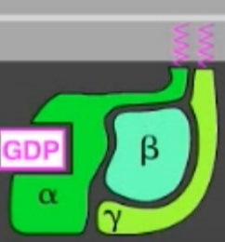 🡪 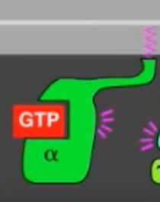🡪 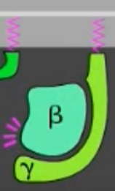

Trimeric G-Protein Alpha Subunit Beta-Gamma Complex

 🡪

Protein Kinase (PKA)



Cyclic AMP (Dr. Cline would like to differentiate this more than in the video)

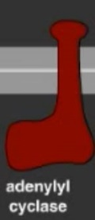

Adenylyl Cyclase

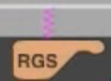

Regulatory Subunit

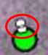

Pyrophosphate – loose phosphates (currently unsure of their role unless they just break off and float away)

## Steps to Win

Step 1: G-Protein Coupled Receptor (GCR) is placed on cell wall.



Step 2: Signaling molecule is placed outside of cell wall and moves into receptor. The receptor will then undergo a conformational change.

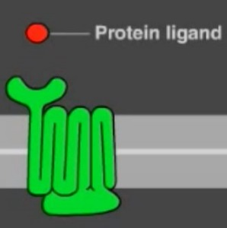🡪

Step 3: A Trimeric G-Protein will be added to the cell wall. It will remain attached and search for an activated receptor and bind with it.

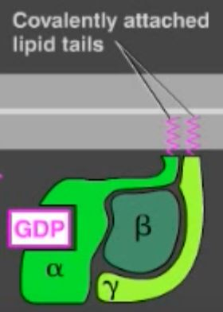 🡪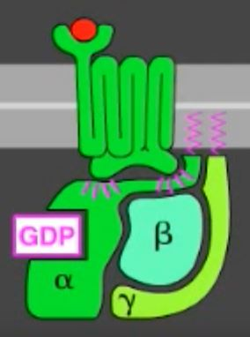

Step 4: The Tri G-Protein will under a conformational change and lose its GDP, it will then accept a GTP.

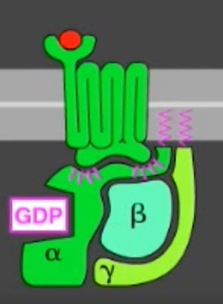 🡪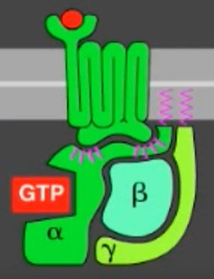

Step 5: The trimeric G-Protein will separate from the receptor and the alpha subunit and beta-gamma complex will split.

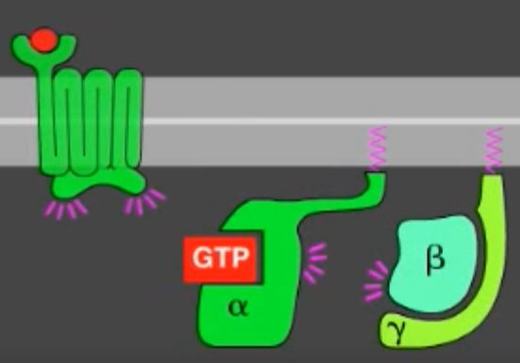

Step 6: Adenylyl cyclase will be added to the cell wall.

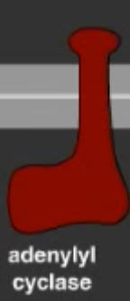

Step 7: The alpha subunit will then bind with the adenylyl cyclase and it will become activated.

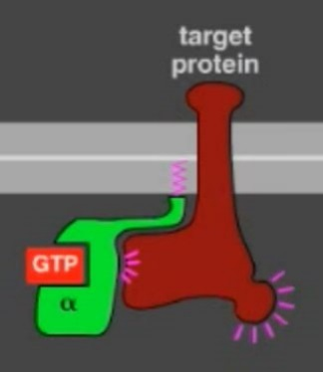

Step 8: The adenylyl cyclase will then be able to transform ATP into cAMP(cyclic AMP)

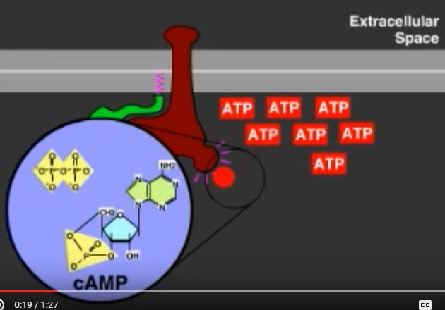🡪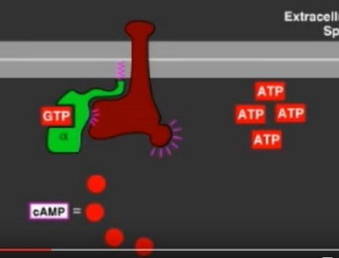

Step 9: After the cAMP is created the GTP within the alpha subunit will hydrolyze its bound GTP and it becomes a GDP which inactivates the subunit. This is sped up by a regulator of g-protein signaling (RGS). The adenylyl will then become inactive.

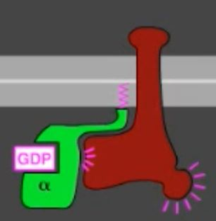🡪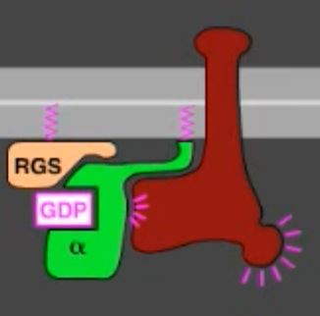🡪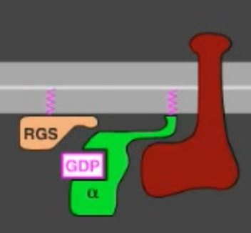

Step 10: The alpha subunit is then free to bind to a beta-gamma sub unit.

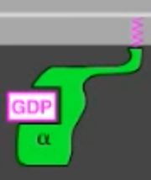🡪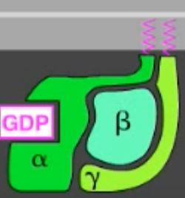

Step 9: A PKA (Protein Kinase) will be added to the cell. It will then bind with the cAMP and become activated.

🡪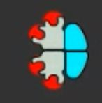🡪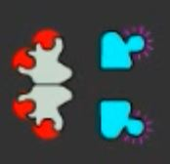🡪

Step 10: This activated subunit will enter the nucleus via the nuclear pore. It will then phosphorylate a transcription regulator. This will result in a **WIN**.

(Note: In game there will only be half of what is shown here to produce only 1 activated PKA for simplification purposes)

(Note: The trans. Regulator has changed function and will need to remain in the nucleus of a cell, it should no longer be able to move through the nuclear pore)

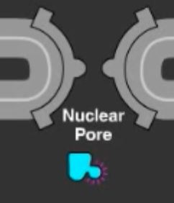🡪C:\Users\ME\Desktop\CS452\Treg P.JPG

# Conclusion

Videos where most information can be found.

MapK signaling

<https://www.youtube.com/watch?v=r7GoZ9vFCY8&t=1s>

<https://www.youtube.com/watch?v=npnLnzsWYFg&t=1s>

G-Protein signaling

<https://www.youtube.com/watch?v=V_0EcUr_txk>

cAMP Signaling

<https://www.youtube.com/watch?v=iGb93jCKVXs>

Main Website

<http://www.onkoview.com/en/the-videos.html>

*This brief report is for reference purposes only.