SUPPLEMENTARY MATERIAL
Modeling and Simulation of Hepatic Drug Disposition Using a Physiologically Based,
Multi-Agent, In Silico Liver

Li Yan, Glen E.P. Ropella, Sunwoo Park, Michael S. Roberts, and C. Anthony Hunt
Table S1 lists and describes all ISL parameter values used for the simulations in Figs. 4 and 5.
I. Expected ISL Capabilities
As stated in (2), a long-term goal for models of the ISL class is to produce increasing similarity between measurable ISL attributes following administration of a drug, and corresponding, measured hepatic attributes. To achieve that goal we need models that achieve the following ten capabilities.
1. The ISL can accurately represent targeted intrahepatic events.
2. Because ISL observables are designed to be consistent with those of perfused livers, clear physiological mappings can be established between liver and ISL components.
3. The ISLs are suitable for experimentation. To a domain expert, ISL outflow data are (in a type of Turing test) indistinguishable from liver perfusion data.
4. Simulation details need to be visualizable and measurable. Consequently, the ISL must be transparent.
5. It must be easy to reconfigure an ISL to represent different histological, physiological, or experimental conditions.
6. In order to represent the particular specifics of different experiments, it must be relatively simple to change ISL usage and assumptions, or increase or decrease detail, without requiring significant re-engineering.
7. To facilitate capabilities 5 and 6, it must be easy to join, disconnect, and replace ISL components: ISL components articulate. It must be straightforward to separately validate components.
8. The ISL must be usable for simulating the disposition, clearance, and metabolic properties of a wide variety of compounds, separately or in the same experiment.
9. It must be easy to use a validated ISL as an organ component within a larger, synthetic, physiologically based, whole organism model.
10. To enable and support the above capabilities, models of the ISL class must use discrete interactions.
Nine of these capabilities (excluding #9) have been achieved and demonstrated in (2).
II. Outflow Profiles for Four Cationic Drugs plus Sucrose Using Four Different Lobule Graph Structures
During the parameter refinement process, from among those parameterizations tested we chose a best lobule parameterization for each of four drugs. Keeping that lobule parameterization constant, we adjusted the remaining parameter values to obtain best SM value for that drug. Those results are presented in Fig. S1 and S2, and each drug’s corresponding lobule graph structure parameter and similarity values are list in Table SII. Notice that for Fig. 4 we reused for the other three drugs the lobule graph structure that worked best for antipyrine (Fig. 3), whereas for Figs. S4 and S5 below, we reused for the other three drugs the lobule graph structure that worked best for labetalol (Fig. S3).
III. Outflow Profiles for Four Cationic Drugs Plus Sucrose Using Different Single Lobule Graph Structure
Recognizing that differences exist between livers taken from matched rats and used in the same experiment, we selected and used a different (smaller) single lobule structure (Fig. S3 and Table SII column Labetalol ) while holding the remaining parameter values constant as in Fig. 4 for all four drugs. Resulting outflow profiles (Fig. S4 and S5) had acceptable SM values: Atenolol: 0.83; Antipyrine: 0.68; Labetalol: 0.91; and Diltiazem: 0.93.
From the above experimental results, we see that ISL parameter space is large, yet highly constrained. Different parameterizations can generate similarly adequate matches. This space of acceptable parameter vectors reflects biological and experimental uncertainties.

IV. Sinusodial Segment Interactive 3D Visualization

The visualization (http://furm.org/islvis/Structure9.html) is implemented in macromedia’s Director. The browser needs Shockwave plugin to view it.

Description
This movie is an interactive 3D visualization of two types of simulated compound, one that enters the in silico cells (modeling antipyrine) and one that does not (modeling sucrose), percolating through the In Silico Liver (ISL). The data driving the visualization is taken from the simulation through a combination of non-invasive instrumentation in the code as well as post-processing of simulation inputs and outputs. This visualization only shows the schematic structure of the ISL and how simulated solute travels through it. It does not show all the aspects of the model. In particular, The movie represents only a single Monte-Carlo trial through a single graph (modeling the lobule structure), whereas model results consist of many Monte-Carlo trials through several variant graphs. And it does not show the fine-grained spatial detail within each space. Metabolic events, for example, are not shown: the antipyrine simply vanishes.
The graph, shown in Screenshot 1 (Fig. S6), is the primary component of the ISL. The nodes of the graph are called Sinusoidal Segments (SSes) and the edges are idealized connections between the SSes. The SSes are arranged at two levels: in 3 zones according to proximity to the input node PV and by the network's topology. The zonal assignment of the SSes is not shown here. Solute injected as a bolus (according to the Isolated Perfused Rat Liver experimental protocol) enters the PV, travels through the graph and exits the CV. An individual SS is shown in Screenshot 2 (Fig. S7). The three grid spaces (pink: Grid A, yellow: Grid B, and blue: Grid C from Fig. S7) are rendered as concentric cylinders. Two views are provided of these cylinders. One is a side view (upper right) and the other is a head-on view (lower left). At the lower right the raw grid data is directly represented. Each grid point:
- is empty, that is, no in silico cell object is there,
- contains an empty cell (rendered as mostly transparent white),
- contains antipyrine or sucrose objects outside of a cell (red or green),
- contains a cell with one or more free antipyrine objects within it, or
- contains a cell with one or more bound antipyrine objects within it. For example: “3 bound” means 3 bound antipyrine objects in a cell.

Control
In the graph view, click on a SS to see the SS view. Then click on “View network Graph” in the bottom left hand part of the SS view to return to the graph view.
In the SS view, each “smooth” control on the upper left is used to distinguish the spaces; it causes the grid data to be blurred or not. The blurring is being applied as a texture to a cylinder and could be viewed as representing the likelihood that a compound of that type is actually in that location.
The “Show” control selects the space (Grid A + Core, Grid B, and Grid C) to be observed (or not).
Selecting “Rotate” causes the cylinder to rotate.
The “>||” and “||<” controls causes in silico time to move one step forward or backward.

Notes
- Compounds are injected into the In Silico Liver using a modified gamma function;
- ANTIPYRINE, but not sucrose, can enter cells;
- There are objects within “cells” that can bind antipyrine;
- ANTIPYRINE bound within “hepatocytes” in the Disse layer can be metabolized;
- Metabolites of antipyrine are not visualized;
- In this movie there is no more than one free solute per cell.

Supplement Figures
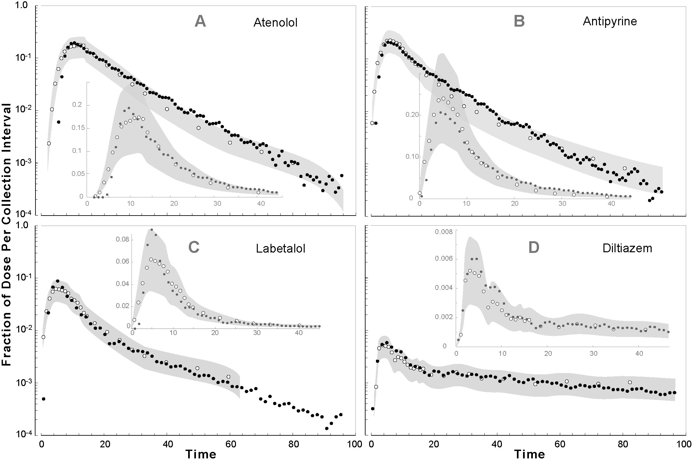
Fig. S1. Semilog and scatter plots of acceptable outflow profile matches for four drugs using the lobule graph structures in Table SII. (A) atenolol, (B) antipyrine, (C) labetalol, and (D) diltiazem were co-administrated with sucrose. For all four drugs, the SS structure parameter values along with those influenced by drug PCPs are same as in Table II, except for atenolol, which has: C2BjumpProb = 0.7 and MetabolizeProb = 0.4. The width of the gray SM band assumes the same coefficient of variation as in Fig. 4. The experimental conditions and symbols are the same as for Fig. 4. Each datum is a smoothed mean value of 48 Monte Carlo simulations of the same ISL.
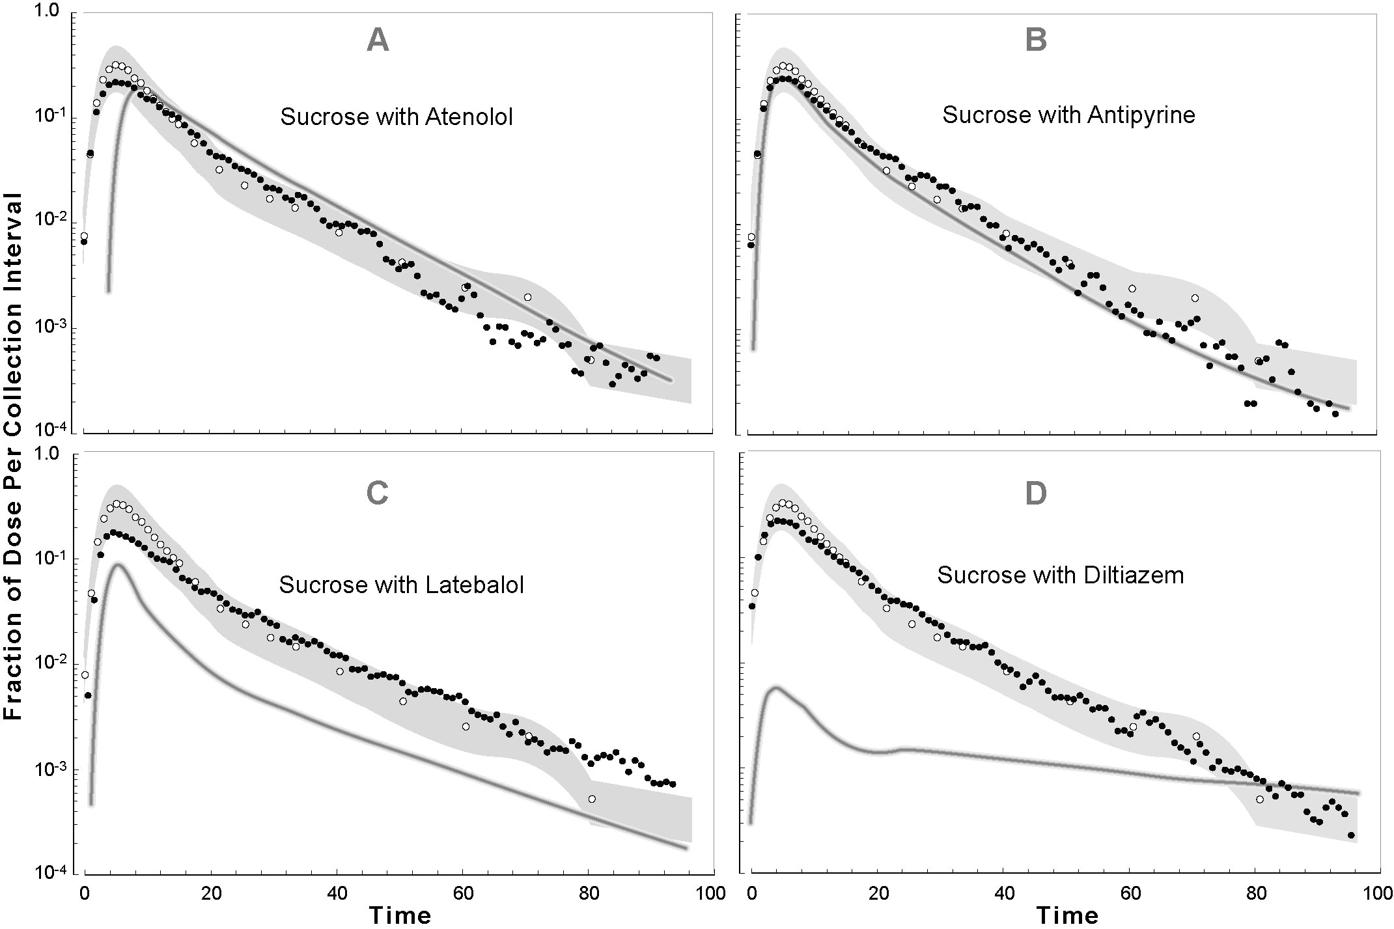
Fig. S2. Semilog plots of outflow profiles for sucrose co-administrated with (A) atenolol, (B) antipyrine, (C) labetalol, and (D) diltiazem in Fig. S1. The width of the gray SM band assumes the same coefficient of variation as in Fig. 5. The gray curve is the trend line for the co-administrated drug (from Fig. S1).
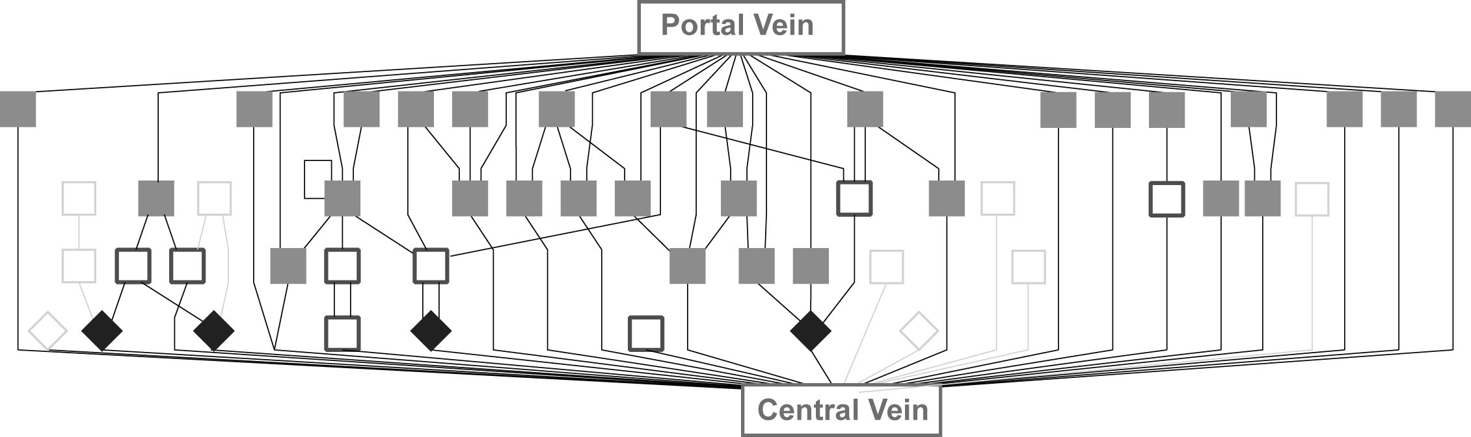
Fig. S3. An example of the 48 Monte Carlo generated ISL lobule graph structure used in Fig. S1C and in Fig. S4 A–D. As in Fig. 3, all Zone 1 nodes (gray squares) have one incoming edge from the PV. They have one outgoing edge; it can be connected to another SS or to the CV. Zone 2 nodes (unfilled squares) have an edge incoming from a Zone 1 SS; the outgoing edge can be connected to a SS in Zones 2 or 3. Zone 3 nodes (black diamonds) have one incoming edge from a Zone 2 SS; the outgoing edge is connected to the CV. The nine, light gray, unfilled squares and diamonds represent Zone 2 and 3 nodes that, by chance, were not assigned an incoming edge.
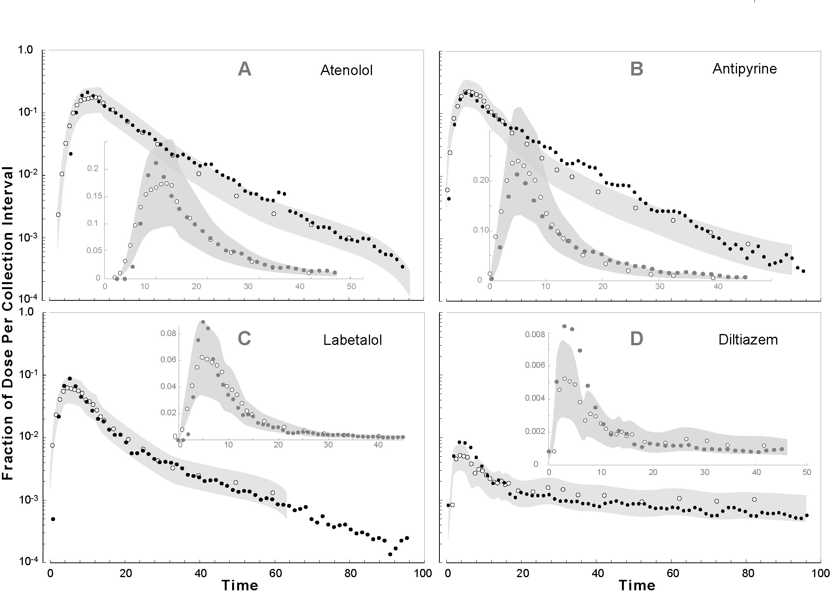
Fig. S4. Semilog and scatter plots of acceptable outflow profile matches for four drugs using the lobule graph structure exemplified in Fig. S3. (A) atenolol, (B) antipyrine, (C) labetalol, and (D) diltiazem were co-administrated with sucrose. The symbols and other experimental conditions were same as in Fig. 4.
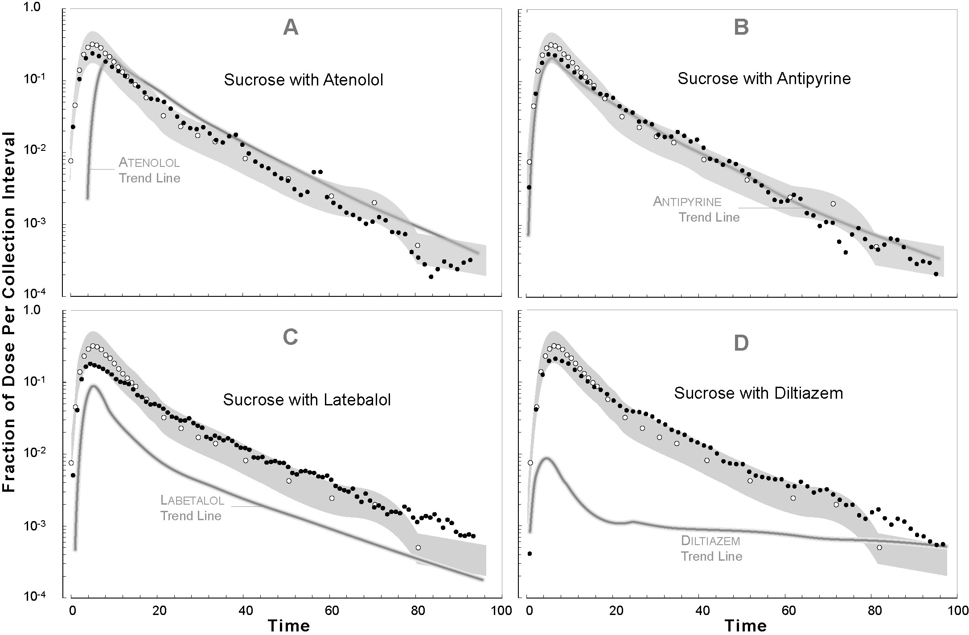
Fig. S5. Semilog plots of outflow profile data for sucrose co-administrated with (A) atenolol, (B) antipyrine, (C) labetalol, and (D) diltiazem in Fig. S4. The width of the gray SM band assumes the same coefficient of variation as in Fig. 5. The gray curve is the trend line for the co-administrated drug (from Fig. S4). Except as noted, the experimental conditions and symbols are the same as for Fig. 5.

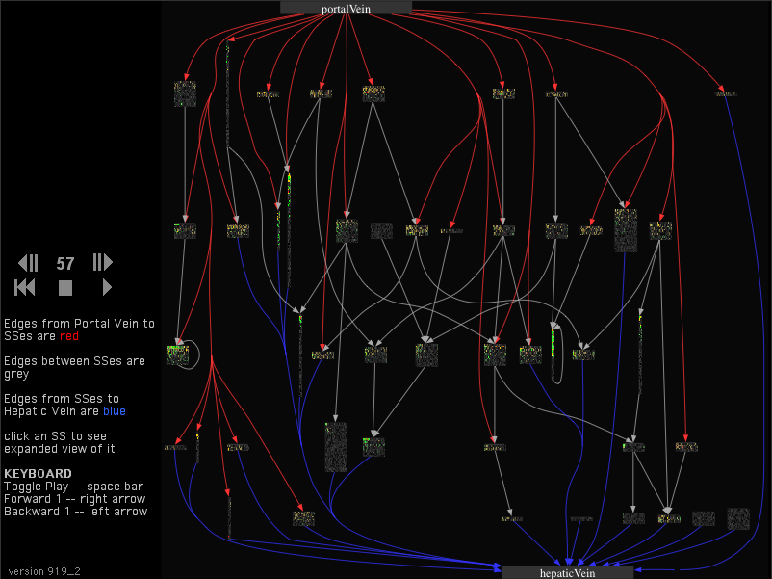
Fig. S6. Screenshot 1: Lobule graph view.

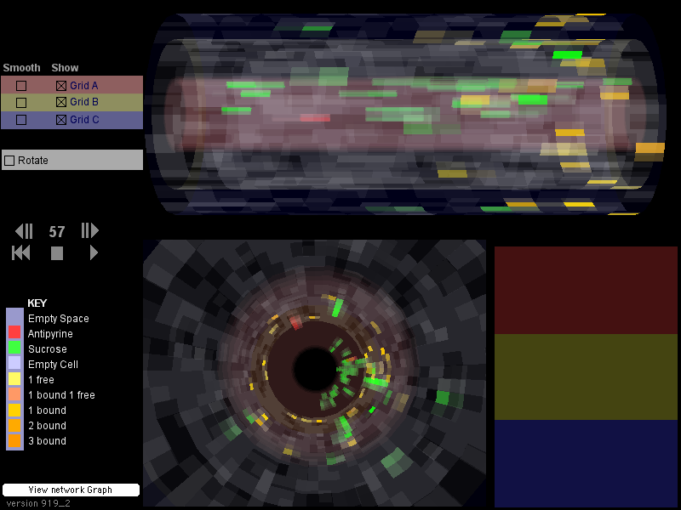
Fig. S7. Screenshot 2: Sinusoidal segment (SS) view.

Supplement Tables
Table S1. Description of ISL parameters and their values for the simulations in text Figs. 4 and 5, and for Figs. S1-S5, except where noted otherwise.
Parameter ª | Description | Values^{b} | Range ^{c}

Device Framework Parameters
cycleLimit | (B) ^{d} Provides the simulation with an artificial stopping criterion so that it will not run forever. | 200 | 200
monteCarloRuns | (I) ^{d} The number of runs in a Monte-Carlo set. Aggregate measures for the whole system are calculated at the end of all Monte-Carlo runs. | 48 | [2, 50]
similarityMeasure | Specifies which similarity measure to use. | global_sd | global_sd
nominalProfile | (S) ^{d} Specifies which model to use as the nominal for use in calculating similarity between the experimental and nominal models.
experimentalProfile | (S) Specifies which model to use as the experimental for use in calculating similarity between the experimental and nominal models.

In Silico Liver Parameters
ISL Parameters That Are Independent of a Drug’s PCPs
StepsPerCycle | (I) Parameterizes the granularity of time for the Research model (the ISL). The data has a “sampling rate” that provides a default time scale for it. Finer granularity requires interpolation between the data points. The Reference (PK) model ª is a time-reversible, continuous function, which allows sampling at any frequency. | 2 | 2
GraphInputFile | (S) Specifies the file to read if the SS graph is to be specified by an explicit graph (file format is GML) | null

GraphSpecFile | (S) Provides the lobule graphical specification, and specifies the base file name (extension .ls) to be used if the graph is to be specified according to the Lobule Specification  Nodes in Zone I  Nodes in Zone II  Nodes in Zone III  Intra-Zone I edges  Intra-Zone II edges  Intra-Zone III edges  Zone I → Zone II edges  Zone I → Zone III edges  Zone II → Zone III edges | 45  21  6  18  10  0  15  0  8 | [20, 50]]  [10, 35]  [3, 15]  [10, 30]  [5, 25]  0  [2, 45]  [0, 20]  [5, 25]
GraphSpecIterates | (I) Tells the framework to modify lobule specification and run a Monte-Carlo set (consisting of N runs) for each different lobule specification. Set to 1, it runs 1 set and provides 1 set of outputs. Set to 5, the first run uses the current contents of lobule.ls; it then runs 4 more sets, slightly modifying the lobule specification each time, resulting in 5 sets. | 1 | [1, 10]
DirSinRatio | (F) ^{d} Specifies the percentage of SS that are type S₁ (“direct”) | 0.75 | [0, 1]
TortSinRatio | (F) Specifies the percentage of SS that are S₂ (“tortuous”) | 0.25 | [0, 1]
DirSinCircMin | (I) Sets the upper and lower bounds for a pseudo-RNG (random number generator) using the uniform distribution to choose a circumference for each SS | 50 | [1, 50]
DirSinCircMax |  | 50 | [1, 100]
TortSinCircMin |  | 4 | [1, 8]
TortSinCircMax |  | 4 | [1, 20]
DirSinLenAlpha | (F) Sets the parameters for a pseudo-RNG using a modified form of the Gamma distribution; The modification consists of a left-right shift of the distribution, allowing the user to clip off the front. | 3.0 | [0.5, 5.0]
DirSinLenBeta |  | 0.215 | [0.1, 0.325]
DirSinLenShift |  | 0.0 | [-20, 20]
TortSinLenAlpha |  | 10.0 | [4.0, 18.0]
TortSinLenBeta |  | 0.125 | [0.03, 0.15]
TortSinLenShift |  | -40 | [-40.0, 40.0]
SinusoidTurbo | (F) The complement of the amount of turbulence allowed in any given SS. Lower turbo means more tendency of any one compound to wander sideways or backwards. Higher Turbo means a stronger flow from the input to the output of the SS. | 0.3 | [0.05, 0.95]
ECDensity | (F) Specifies the relative endothelial cell density, given that the number of grid points in Grid B is set by the geometry parameters of the SS; it specifies the percentage of Grid B points that index an endothelial cell. | 0.8 | [0.05, 1.0]
HepDensity | (F) Specifies the relative hepatocytes density within Grid C, given that the number of grid points in Grid C is set by the geometry parameters of the SS, it specifies the percentage of Grid C points that index a hepatocyte. | 0.6 | [0.05, 1.0]
CoreFlowRate | (I) The number of slots solute in the SS core moves forward during each step | 2 | [1, 8]
ISL Parameters That Are Sensitive to the Drug’s PCPs
isMembraneCrossing | (B) Specifies referent drug’s PCPs that will allow the adjacent solute to passively enter cells | [0, 1] | [0, 1]
A2BJumpProb | (F) Specifies the probability that, when given the option, solute will jump from the sinusoid rim space to the endothelial space | 0.1 | [0.05, 1.0]
B2AJumpProb | (F) Specifies the probability that, when given the option, solute will jump from the endothelial space to the sinusoid rim space | 0.6 | [0.05, 1.0]
B2CJumpProb | (F) Specifies the probability that, when given the option, solute will jump from the endothelial space to the space of Dissé. | 0.35 | [0.05, 1.0]
C2BJumpProb | (F) Specifies the probability that, when given the option, solute will jump from the space of Dissé to the endothelial space | 0.65 | [0.05, 1.0]
BindersPerCellMin | (I) Max and min for a uniform pseudo-random draw for the number of binding agents inside each cell. Simple binders for ECs and enzymes for hepatocytes. | 5 | [1, 30]
BindersPerCellMax |  | 10 | [10, 100]
MetabolizeProb | (F) Probability that an enzyme will metabolize a solute before it releases it. | 0.4 | [0, 1]
SoluteBindingProb | (F) Probability that, when a binder and solute make contact, the solute will be bound. | 0.5 | [0, 1]
SoluteBindingCycles | (I) Number of cycles a binder will bind a solute. | 25 | [5, 100]
ISL2WetLabScaling ^{e} | (F) Everything in the model is normalized. Each solute object represents a large number of molecules. This parameter provides the precise validation mapping from ISL output to the wet-lab (IPRL) output fraction. | 7.0 | [1.0, 8.0]
Experiment Related Parameters
BolusStartTime | (I) Dictates when to let solutes flow into the lobule | 5 | [2, 9]
DosageParamA ^{f} | (F) Parameter (A) of the dosage function:  D(t) = A(B^{C}t^{(C–1)}e^{–Bt})/(C – 1)!, where t = current cycle  Parameter (A) simply raises the amplitude of the function | 2000 | [1000, 7000]
DosageParamB | (F) Parameter (B) of the dosage function | 1 | [1, 2]
DosageParamC | (F) Parameter (C) of the dosage function | 2 | [2, 3]
 | Actual dose for Fig. 4 | 3,682
ª There are four classes of parameters: Device Framework, Research Model, Reference Model, and Data Model. Here, the Research Model is the ISL. Only a subset of the Device Framework parameters is listed here. The Data Model includes all the data against which the SM is being applied, and uses a parameter that specifies whether to interpolate between observations of the in silico data. The Reference Model is a traditional PK model previously fit to the in silico experimental data; it is run concurrently with the Research Model.
^{b} Parameter values when sucrose and antipyrine were dosed in combination.
^{c} Ranges from which values were drawn during searches of model and parameter space.
^{d} B: Boolean; F: floating; I: integer; S: string
^{e} In (2), ISL2WetLabScaling is called SoluteScale.
^{f} The total dose is the area under the dosage function curve.

Table SII. Parameter values for four different lobule graph structures.
Lobule Graph  Structure Parameter | Values
Lobule Graph  Structure Parameter | Atenolol | Antipyrine | Labetalol | Diltiazem
Node in Zone I  Node in Zone 2  Node in Zone 3  Intra-Zone I edges  Intra-Zone II edges  Intra-Zone III edges  Zone I → Zone II edges  Zone I → Zone III edges  Zone II → Zone III edges | 45  25  9  22  10  0  21  0  1 | 45  21  6  18  10  0  15  0  8 | 30  15  6  15  7  0  10  0  6 | 50  35  5  18  10  0  21  0  12
SM Values | 0.88 | 0.81 | 0.91 | 0.99

