# Note: This script is used for comparing time vs solute_concentration in three zones

# How to use this script: open terminal, cd to the directory of this script, enter command **R** will

# make the terminal work under R, then enter command **source("time_vs_solute_conc_in_3_zones.R")**, the script will start working

# Input file: XXXX-XX-XX-XXXX-XXXX_profile_mean_per_node.csv

# plot all the time vs solute_conc ("S", "nMD", "MitoDD", "oAPAP", "G", "Marker", "Repair", "N" )

# This R script plots every solute on one page. Every experiment has one plot. Every plot includes three lines.

# Example to use this script

# > source("time_vs_solute_conc_in_3_zones.R")

# Please input the working directory: /Users/yanlixu/Desktop/experiment_data/bolus_in_2016_11/161108_161111

# Enter 9 concentration values separated by comma: 0.1, 0.2, 0.3, 0.4, 0.5, 0.6, 0.7, 0.8, 0.9

# You have 9 plots, please input how many rows and columns do you want to display the plots: 3, 3

# Please input the cycleLimit of these experiments: 5000

**The following is an example output of liver experiments with useBody = F**

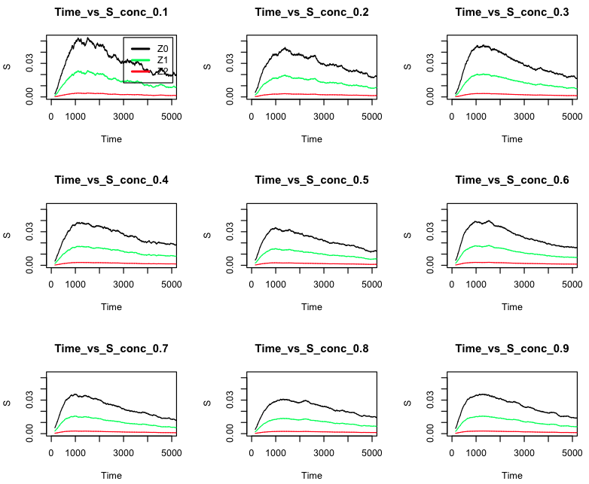

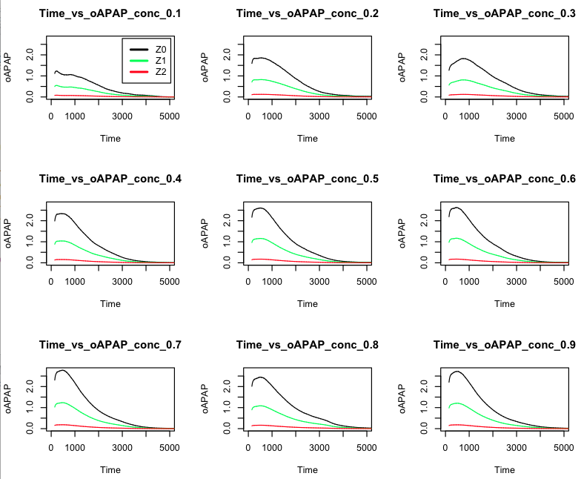

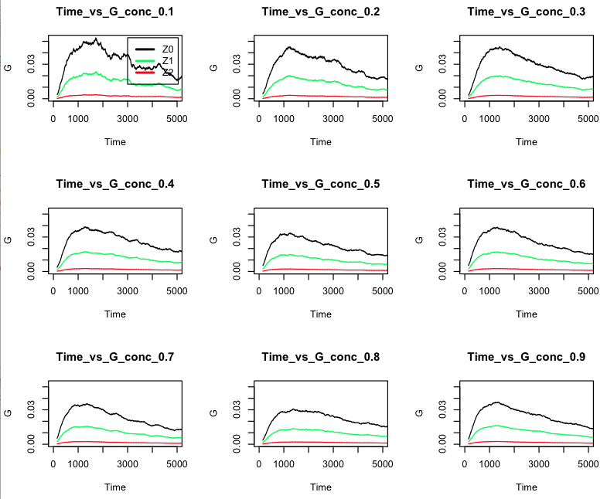

The following plots have only zone values in three zones.

